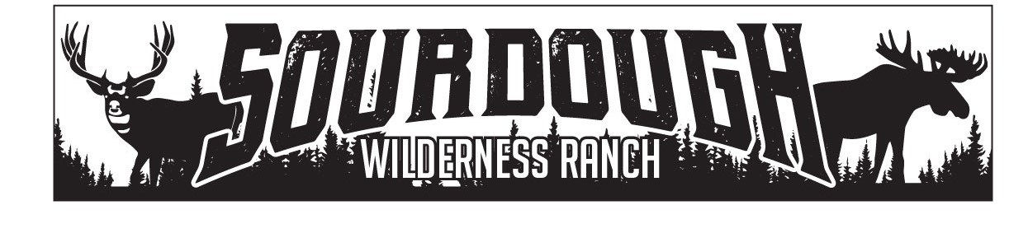
1150 N. Hwy 89 Suite B
Harrisville, UT 84404
801-773-3348
Sourdoughranch@gmail.com

Weber County
2380 Washington Blvd., Suite 240
Ogden, Utah 84401

RE: FAUST JACQUELINE: HEARTACHE 024
SHED APPROVAL
July 28, 2021
Jacqueline Faust has been approved to place a shed 100sq ft in size on Heartache 24, by the board of trustees of Sourdough Wilderness Ranch.

Sincerely,

Shawna Lee

Shawna Lee
Office Manager
Board Secretary/Treasurer

