Harmony Ranch Agritourism  CUP Narrative | Ian Silverberg, Owner  Ronda Kippen, Project Manager/Planner

Harmony Ranch Eden is designed to cultivate a connection between nature and the human spirit. Harmony Ranch emphasizes sustainable living, regenerative agriculture, land-based education, and holistic fulfillment. The community features Harmony Barn, a gathering space for residents, self-sustaining farming fields, a trail network, ponds for summer and winter activities.
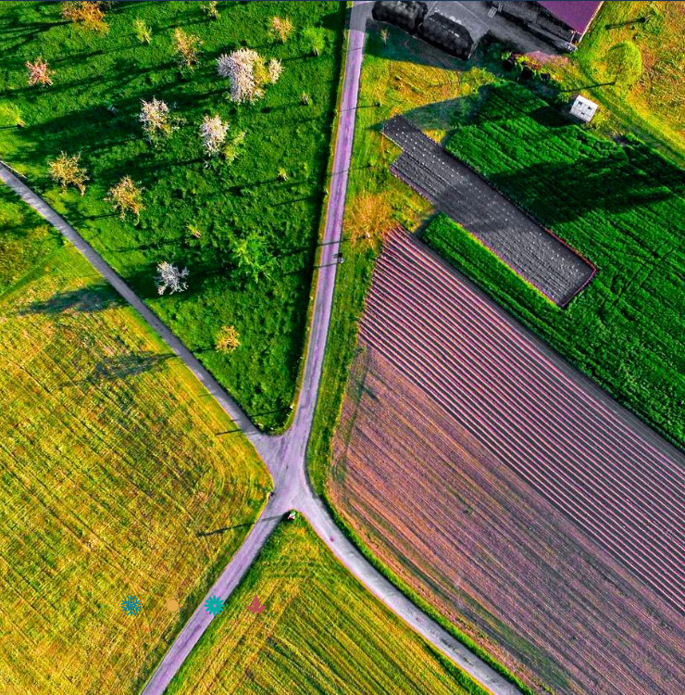

Harmony Ranch Agritourism
A collective return to living in community lands.
Harmony Ranch believes in the virtues of sustainable living, the value of regenerative
agriculture, the principles of land-based education, and the practice of living in holistic
fulfillment.
Our vision is to create a neighborhood for families that feel connected to the land, in co-operation with one another. We will achieve this with natural amenities that focus on healthful living with community projects that bring our neighbors closer to the land they live.
This is Living in Harmony™
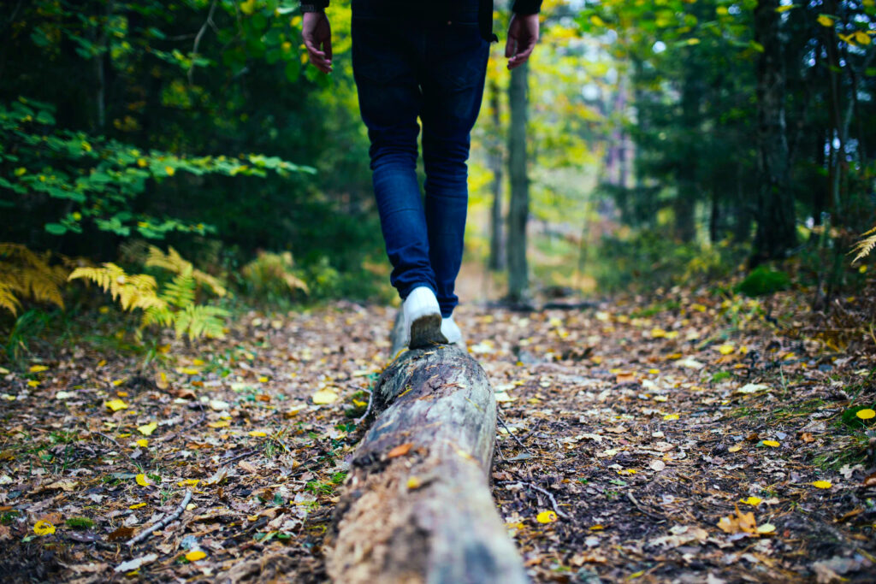

A Vision for Harmony Ranch
NOURISH – CONNECT – REGENERATE – THRIVE
Harmony Ranch celebrates our symbiotic relationship with nature through a thoughtfully planned 55-acre community of living spaces that are designed to cultivate a connection between nature and the human spirit. By practicing sustainable living, regenerative farming, intentional and nature-based education, and a holistic approach to the fundamental principles of health, we build the foundation for a balanced life of fulfillment.

Natural Aesthetics
We will mirror our surroundings in family comfort and modern farmhouse style that bridges rustic natural elements with beautifully designed living spaces.
At the heart of the community is Harmony Barn. This is where we will gather, share, learn together, and cultivate our community garden. The fields to the north of the barn are for self-sustaining farming. A trail network will encourage exploration through nature and facilitate a connected community. Ponds will provide a chance to escape the heat on a summer afternoon and lend to ice skating during the winter months. Harmony Camp will provide local entertainment, education, and a way for children in the community to connect. Residents will enjoy ski access in and out of Nordic Valley as well as a recreational corridor within the community that is ideal for sledding, skiing, biking, and other four-season activities.

Regenerative Farming
The important regenerative agricultural principals
Regenerative agriculture is an approach that focuses on improving soil health, enhancing biodiversity, and promoting environmental sustainability. The first principle involves minimizing soil disturbance by practicing no-till cropping and avoiding synthetic fertilizers and pesticides. Instead, natural alternatives such as nitrogen from chicken feces are utilized. The second principle emphasizes keeping the soil covered to prevent erosion and enhance water infiltration. This is achieved by giving pastures longer recovery times, trampling uneaten forage, and adding organic matter through livestock feces.
Diversity is the third principle of regenerative agriculture, which includes incorporating various livestock species, fostering plant diversity, and supporting wildlife habitats. This approach leads to a healthier ecosystem and better nutrient cycling within the soil. The fourth principle is maintaining live roots in the soil to support soil microbes, bind the soil together, and increase carbon sequestration. This can be achieved through cover crops and preventing overgrazing. Lastly, integrating animals into the system is essential for maintaining a productive and sustainable agricultural landscape.
Regenerative agriculture goes beyond the concept of “doing no harm” to the land by actively working to improve and revitalize soil health and the environment. This approach encompasses permaculture and organic farming practices, ultimately leading to healthier soil, nutrient-dense food, and more productive farms. Regenerative agriculture supports sustainable communities, economies, and ecosystems, making it a vital part of a greener future.

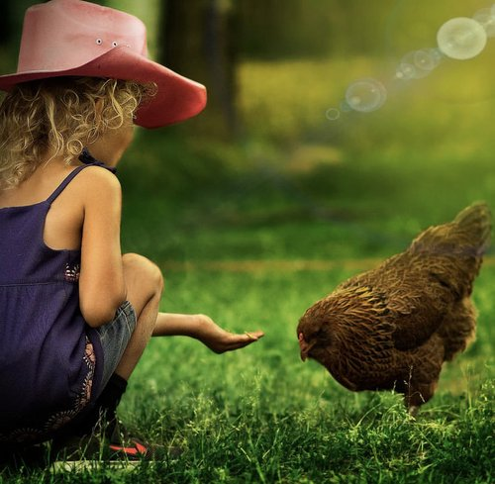

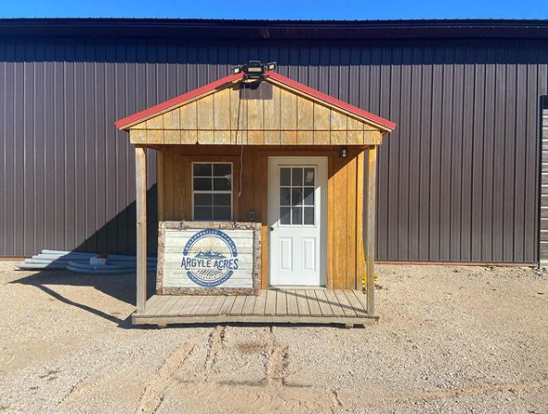

Hiking & Biking Terrain
Miles of multi-season trails
Private community campsite
Natural playground
Shaded picnic hills
Fitness and terrain facilities

The Harmony Pond
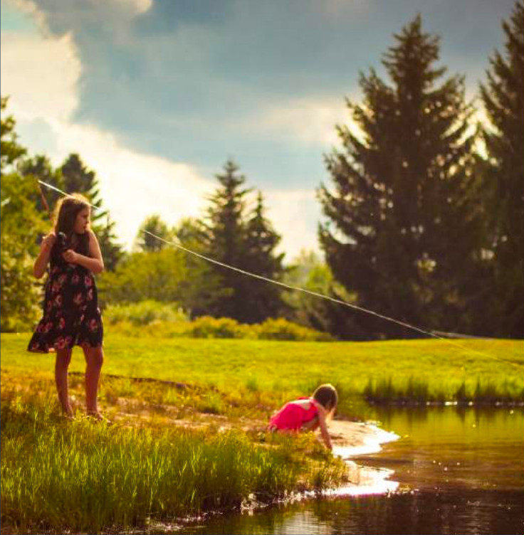
Native flora design
Water recycling
Family fun
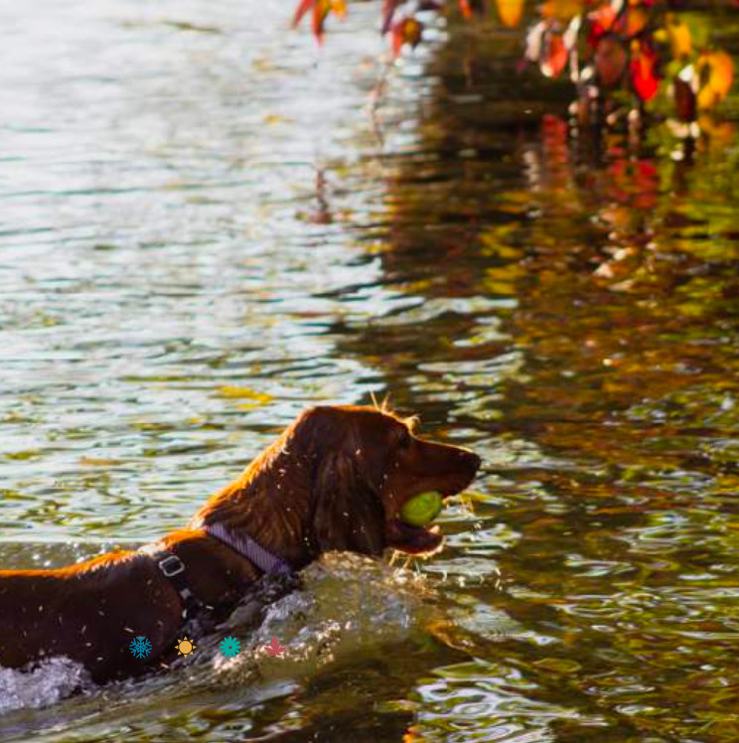
The proposed Harmony Pond is a natural community swimming hole for summer and a skating rink in winter.

Harmony Farm & Ranch Camp
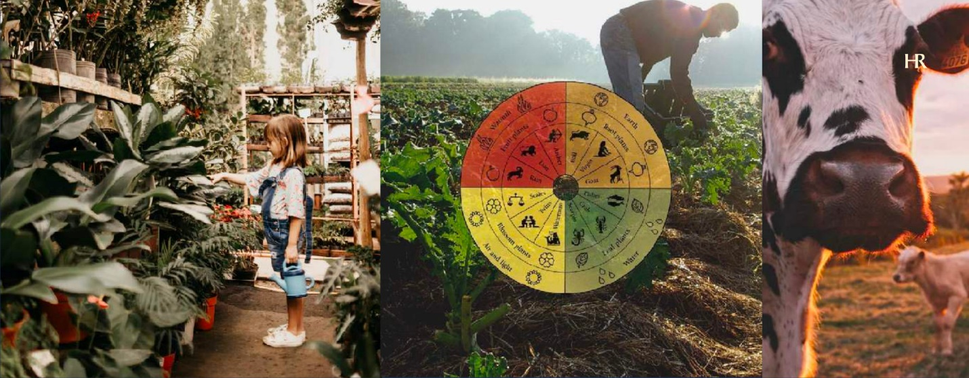

Harmony Ranch is the cornerstone of our holistic concept for balanced living.
Over the years, we will develop an alternative model to commercial agriculture, giving back to the land through biodynamic farming, symbiotic grazing, and biodiverse foods, flora, and fauna.
This dedication to a more sustainable possibility will further be developed through the Ranch Camp Education Project.
Through these community activities and platforms, we’ll begin our commitment to the living out the potential of nurturing the Earth, spirit, and bodies through a more balanced model.

Community Projects & Programming
The Harmony grounds will grow over time with the support of a community that plants seeds of shared quality of life projects together.
A series of proposals will be funded by friends and families that want to enjoy growing the community calendar, amenities, and access to quality of life spaces and goods.

