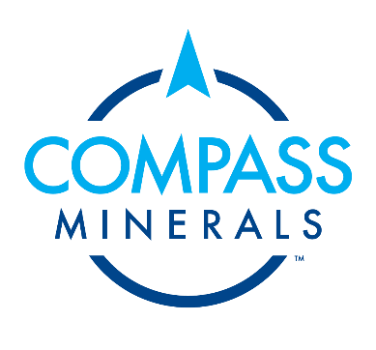

Ogden Office

REVISION: 0

Compass Lithium Project

PROJECT INTRODUCTION – OGDEN EAST PLANT

Introduction
Compass Minerals (Owner) has identified a lithium brine resource of approximately 2.5 million metric tons lithium carbonate equivalent (LCE) at its active Ogden, Utah, solar evaporation site, including an indicated lithium resource within the ambient brine of the Great Salt Lake.

For over 50 years, Compass Minerals has leveraged the high mineral concentrations within the ambient lake brine from the North Arm of the Great Salt Lake to produce sulfate of potash (SOP), salt and magnesium chloride products at its Ogden, UT facility, the largest operation of its kind in the Western Hemisphere.

Compass Minerals has completed an initial assessment to define the lithium resource at the company’s existing operations in accordance with applicable Securities and Exchange Commission (SEC) regulations, including subpart 1300 of Regulation S-K. The assessment estimates total combined indicated and inferred lithium resources of approximately 127,000 metric tons LCE within the interstitial brine (IB) held in the accumulated salt-mass reservoirs at Compass Minerals’ Ogden solar evaporation site. The assessment has also identified an additional indicated lithium resource of approximately 2.32 million metric tons LCE within the ambient brine of the Great Salt Lake, which can be accessed through the company’s existing infrastructure.

The company sustainably manages 160,000 acres of leasehold on the bed of the Great Salt Lake, together with held water rights, 55,000 acres of existing ponds and active mineral extraction permissions.

After a 24-month assessment of multiple direct lithium extraction (DLE) technologies, including two separate pilot projects to demonstrate successful lithium separation from the company’s existing brine resource, Compass Minerals has selected Energy Source Minerals as a DLE technology partner.

The company is targeting an annual production capacity from an Ogden East lithium facility of approximately 11,000 metric tons LCE of battery-grade lithium to be available by 2025. The Ogden East plant will require multiple DLE units. The plant will also include further treatment of the DLE eluate to produce battery grade lithium carbonate packaged on site.

Compass Minerals is targeting mechanical completion and pre-commissioning of the complete Ogden East facility by the end of 2025.

Stage 1 (Current Stage): Compass seeks to demonstrate DLE (Direct Lithium Extraction from brine) technology to produce Lithium Chloride (to be stored onsite) on a commercial scale prior to approval for a full plant. In order to properly assess the technology, water filtration packages, civil site preparation, and concrete and buildings will be included in the construction of the ~2-acre development site. Already zoned M-3 and is within this intended use (metals processing, non-hazardous).

Location
The Ogden East Lithium site will be located southeast of Compass Minerals Ogden operations located at 765 North 10500 West.

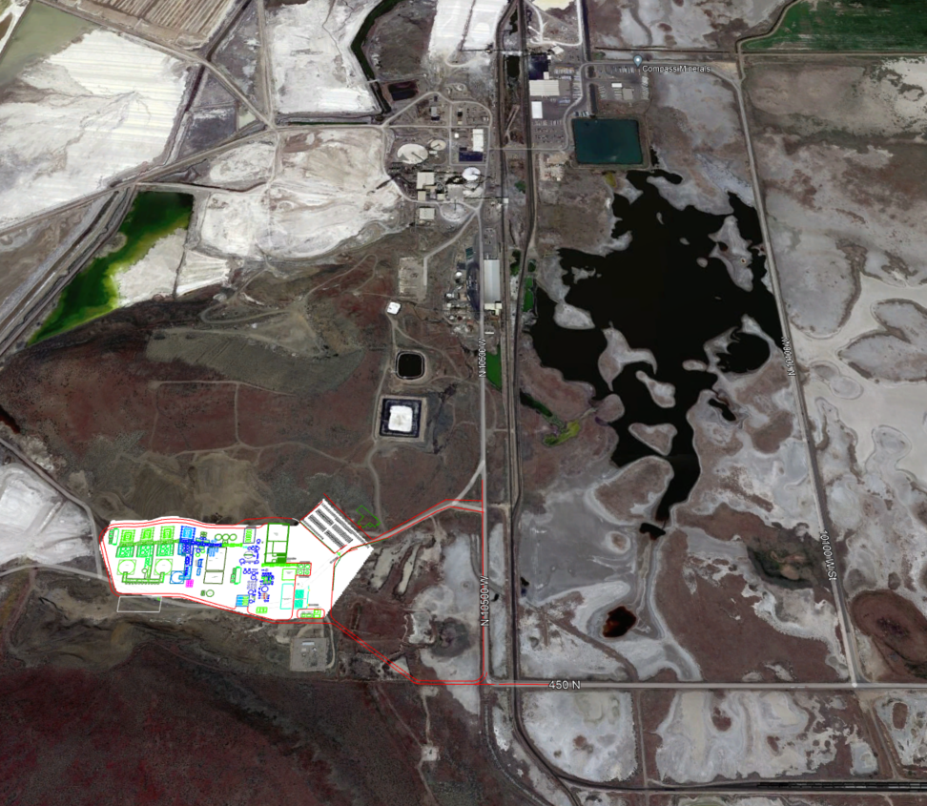
Ogden East Site
Compass Minerals Ogden
765 N. 10500 W.

