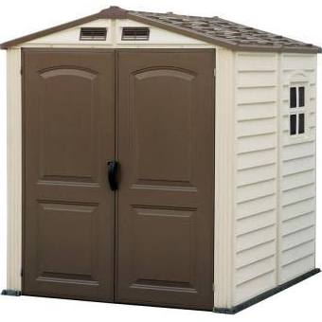

Duramax 6x6 StoreMate Vinyl Garden Storage Shed Kit [30411]
$699 online
8 reviews
Save to Shortlist
Color/Finish: -Color coordinated and aesthetically pleasing to enhance the surrounding area. Dimensions: -Door dimensions: 69'' H x 51'' W.-Overall dimensions: 83.8'' H x 74.8'' W x 75.9'' D.

