Jamila and Kenny McFarland Agri-tourism CUP

- The project narrative includes the season of operation (Mid- September through October 31). The hours of operation (Monday through Saturday 4pm. To 10pm.). Please include the times of normal day-to-day operations.
We anticipate that we will use the non-operating hours of the day, from 8 AM to 4 PM to make sure that the pumpkin patch is stocked with all of the different varieties of pumpkins, gourds and squash for customers. We will make sure the fields walking paths are clear of debris and garbage. We will also use this time to prepare to open during the evening. If we are contacting by preschool or small field trip groups, we would also allow this time of the day to be set aside for these smaller groups to come out to the pumpkin patch and learn about agriculture in the Ogden Valley.
- Include the anticipated number of daily patrons
With it being our first year we don’t know how to accurately determine a count for patrons. We hope that we will have around 1,000 patrons across the entire Fall pumpkin season (September-October 31), but we aren’t sure if anyone will come. We will make parking to accommodate 20 parking spaces surrounding the farm stand, with overflow parking, west of the farm stand, to accommodate additional vehicles.
- Show the main entrance to the property
See attached map.
- Show the location and type of lights
See attached map. We would like to use dark sky compliant patio string lights to line the fence line around the parking lot and dark sky light fixtures attached to the farm stand as soon as construction permits.
See examples:
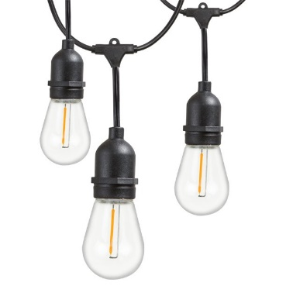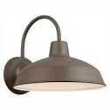

- If applicable, show where the sign will be placed and include the sign design with dimensions.
Sign will be 4’X8’ vinyl banner. It looks like this:
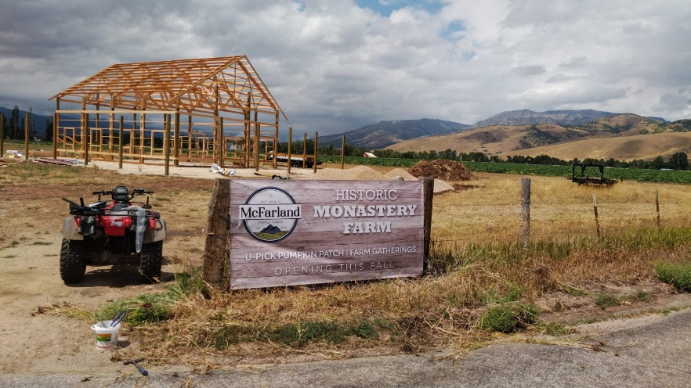
6. Please include the business name
McFarland Family Farms LLC.
7. State the exact number of acres used for the agri-tourism operation. County records indicate a parcel acreage of 38.82.
30 acres are planted in heirloom and traditional orange pumpkins. The remaining acreage was planted in Organic Oats, which will not be used for the pumpkin patch and harvested after the U-pick pumpkin patch is closed.
8. Please state the current type of crop yield of the land.
See answer to question 7.
9. Please include the plans for the farm stand (dimensions, height, architectural drawing). Please contact the building official Stan Berniche (801-399-8760) for building requirements.
See attachment uploaded titled ‘Monastery Market Plans’, for the farm stand. The farm stand will not be used until 2023 when the construction is completed. We will have all operations involved with the U-pick pumpkin patch outdoors.
10. Please state what existing infrastructure is in place, if applicable (culinary water, secondary water, irrigation water, sanitary sewer or septic infrastructure.
There is irrigation water that is administered to the pumpkin crops through a drip irrigation system. Currently there is no culinary water infrastructure.
11. “Temporary sanitary facilities are discouraged; however, if found necessary, they shall be discretely incorporated into the agri-tourism operation and completely screened from the street and adjacent property view.”
We will plan to provide temporary sanitary facilities during this year’s U-pick pumpkin season as there are no current sewer or septic tank infrastructure on this acreage. We understand that it would need to be screened from the street and located in a discrete location. We will arrange these temporary facilities with Drain Free Roto Services.

