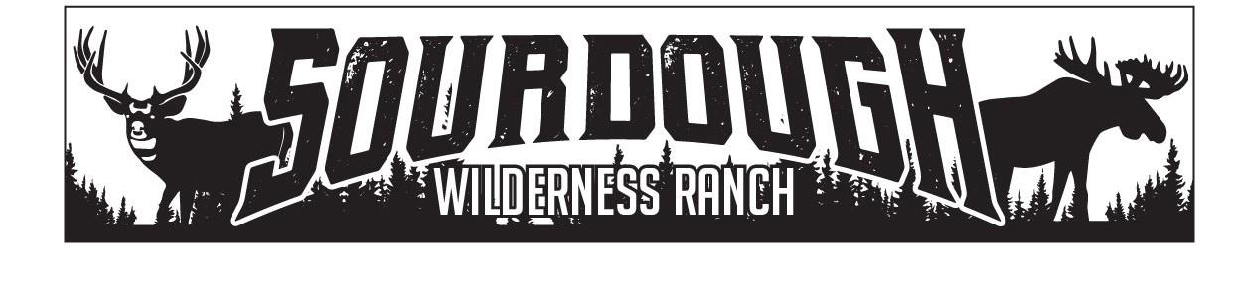
1150 N. Hwy 89 Suite B
Harrisville, UT 84404
801-773-3348
Sourdoughranch@gmail.com

Weber County
2380 Washington Blvd. Suite 240
Ogden, Utah 84401

Donald & Justin Tycz
RE: Rock Creek 21/22-Shed Approval
July 1th, 2023
Donald of Rock Creek lot 22 & Justin Rock Creek lot22 have been approved by the board of trustees to place a shed up to 100 sq ft in size on these 2 lots by the board of trustees of Sourdough Wilderness Ranch.

Sincerely,

Shawna Lee

Shawna Lee
Office Manager
Board Secretary/Treasurer

