Part II Land Use Code

…

Title 101 General Provisions

…

Sec 101-2-5 D Definitions

…

Dwelling. The term "dwelling" means a building or portion thereof, which is constructed in compliance with the county's adopted building codes and designed as a place for human habitation. This does not include a hotel or hotel room, condominium rental apartment (condo-tel), boardinghouse, lodginghouse, tourist court or apartment court.

Dwelling, four-family. The term "four-family dwelling," also referred to as a "quadplex," means a building arranged or designed to contain only four dwelling units with approximately the same floor area, and occupying one lot or parcel.

Dwelling, group. The term "group dwelling" means two or more dwellings arranged around a court.

Dwelling, multiple-family. The term "multiple-family dwelling," also referred to as a “multi-family dwelling,” means a building or portion thereof arranged or designed to contain more than four dwelling units, including an apartment building and condominium building.

Dwelling, single-family. The term "single-family dwelling" means a building or portion thereof arranged or designed to exclusively contain only one dwelling unit, unless specified otherwise by this Land Use Code, and occupying one lot or parcel.

Dwelling, single-family attached. The term “single-family attached dwelling” means a building arranged or designed to contain more than one dwelling unit, but that occupies multiple lots or parcels, each lot or parcel encompassing an entire dwelling unit from ground to sky. This is traditionally known as a townhome or townhouse.

Dwelling, three-family. The term "three-family dwelling," also referred to as a "triplex," means a building arranged or designed to contain only three dwelling units with approximately the same floor area, and occupying one lot or parcel.

Dwelling, two-family. The term "two-family dwelling" also referred to as a "duplex," means a building arranged or designed to contain only two dwelling units with approximately the same floor area, and occupying one lot or parcel.

Dwelling unit. The term "dwelling unit" means any building or portion thereof that contains living facilities, including provisions for sleeping, eating, cooking and sanitation, for not more than one family.

Dwelling unit, condominium. See “condominium dwelling unit.”

Dwelling unit, townhome. See “single-family attached dwelling.”

…

Sec 101-2-13 Lot Definitions

Lot. The term "lot" means a parcel of land capable of being occupied by an allowed use, building or group of buildings (main or accessory), and approved for human occupancy either full- or part-time; together with such yards, open spaces, parking spaces and other areas required by this title and the Land Use Code. Except when allowed otherwise in this Land Use Code, not more than one dwelling structure shall occupy any one lot.

…

Chapter 104-22 Form-Based Village Zone FBV
Sec 104-22-1 Purposes And Intent
Sec 104-22-2 Applicability
Sec 104-22-3 Land Use Table
Sec 104-22-4 Special Regulations For Specific Uses
Sec 104-22-5 Lot Development Standards
Sec 104-22-6 Building Design Standards
Sec 104-22-7 Street Types And Street Design
Sec 104-22-8 Street Regulating Plans
Sec 104-22-9 Parking
Sec 104-22-10 Signage

Editors note: Ord 2021-16, adopted May 25, 2021, merged the MV-1, M-1, M-2, and M-3 zones into a single chapter, removing them from Chapter 22, 23, 24, and 25, and placing them into Chapter 21. Ord 2022-04, adopted January 18, 2022, created the "Form-Based Village Zone" as set forth herein.

HISTORY
Adopted by Ord. 2022-04 on 1/18/2022

Sec 104-22-1 Purposes And Intent

The purpose and intent of the Form-Based Village Zone is to provide a form-based regulatory tool that focuses on the public street design and the buildings that frame the public street. This deemphasizes separation of land uses as is typically found elsewhere in this Land Use Code. Form-based regulations help enable a mixture of allowed uses, multimodal active transportation, and enhanced building design. Additionally:

- Implements the general plan. The Form-Based Village Zone regulations are intended to carry out the objectives of the 2016 Ogden Valley General Plan through the implementation of form- based small area zoning and transferable development rights.
- Creates street regulating plans. Each Village area affected by the Form-Based Village Zone shall be governed by a Street Regulating Plan. The purpose of the Street Regulating Plan is to address specific design and functionality of streets and building facades along these streets. The intent is to stimulate the creation of buildings and streets that frame the public rights-of-way with architectural and design elements that are unified under a common design theme whilst enabling unique building facades.
HISTORY
Adopted by Ord. 2022-04 on 1/18/2022

Sec 104-22-2 Applicability

- New development to comply. The principles, standards and guidelines of this chapter apply to proposals for new development, changes in land uses, and site improvements to existing buildings, lots, or parcels that are in the Form-Based Village Zone. Exterior modifications to existing development shall comply if the exterior modification exceeds either 25 percent of the street-facing facade of the building, or 25 percent of the lot's street frontage.
- Other regulations apply. In the Form-Based Village Zone, except when more specific regulations are provided in this chapter, the CV-2 zoning regulations of Section 104-20, and the design review regulations and architectural, landscape, screening, and design standards of Section 108-1 and 108-2 apply to all lots, except a lot with only one single-family dwelling.
- Street regulating plan. The applicable regulations herein are specific to the street type, as designated by the applicable street regulating plan. New development within the Form-Based Village Zone shall comply with the applicable street regulating plan. Development of any property along a street or that gains primary access from that street shall comply with the street design requirements, as provided in Section 104-22-7, and the building design standards in Section 104- 22-6, for the specific type of street. A list and explanation of each street type is provided in Section 104-22-7.
- Effect of street regulating plan and graphics. Details in a street regulating plan or any graphic in this chapter have no effect unless expressly provided by this chapter.
HISTORY
Adopted by Ord. 2022-04 on 1/18/2022

Sec 104-22-3 Land Use Table

The following land use table provides use regulations applicable for each street type. In the list, those designated for any street type as "P" will be a permitted use. Uses designated as "C" will be allowed only when authorized by a conditional use permit obtained as provided in Title 108, Chapter 4 of this Land Use Code. Uses designated "N" will not be allowed on property with frontage on, or that gains access from, that street type.
- Accessory uses. An accessory use is prohibited unless located on the same lot or parcel as the main use to which it is accessory.
 |  |  |  |  | G&I | VOC |  | MUC | MFR |  | SLR |  | MLR | LLR |  | RR |  | ELR |  | OS |  | SPECIAL REGULATIONS
 | Accessory building. A building that is accessory and incidental to the use of a main building. |  |  |  | P | P |  | P | P |  | P |  | P | P |  | P |  | P |  | P
 | Accessory dwelling unit. A dwelling unit that is accessory to a single-family dwelling residential use. |  |  |  | N | N |  | N | N |  | P |  | P | P |  | P |  | P |  | N |  | See Chapter 108-19.
 | Accessory use. A use that is accessory and incidental to the main use. |  |  |  | P | P |  | P | P |  | P |  | P | P |  | P |  | P |  | P
 | Family food production. Family food production as an accessory use to a single-family dwelling residential use. |  |  |  | N | N |  | N | N |  | N |  | N | P |  | P |  | P |  | N |  | See Section 104-22-4.
 | Home occupation. A home occupation that is accessory to a residential use. |  |  |  | P | P |  | P | P |  | P |  | P | P |  | P |  | P |  | N |  | See Chapter 108-13.
 | Household pets. Household pets that are accessory to a residential use. |  |  |  | P | P |  | P | P |  | P |  | P | P |  | P |  | P |  | N
 | Main building. A main building that is designed or used to be accessory an outdoor main use allowed in the zone. |  |  |  | P | P |  | P | P |  | P |  | P | P |  | P |  | P |  | P
 | Parking lot. A parking lot that is accessory to a main use allowed in the zone. |  |  |  | P | P |  | P | P |  | P |  | P | P |  | P |  | P |  | P |  | See Section 104-22-9.
 | Temporary building or use. A temporary building or use that is accessory and incidental to onsite construction work. |  |  |  | P | P |  | P | P |  | P |  | P | P |  | P |  | P |  | P |  | See Section 104-22-4.

- Agricultural and open space uses, generally.
 | G&I | VOC | MUC | MFR | SLR | MLR | LLR | RR | ELR | OS | SPECIAL REGULATIONS
Agriculture. | N | N | N | N | N | N | P | P | P | P
Agricultural experiment station. | P | N | N | N | N | N | N | P | P | P
Agri-tourism. | N | N | N | N | N | N | N | P | P | P | See Title 108, Chapter 21.
Aquaculture. | N | N | N | N | N | N | N | P | P | P
Botanical or community garden. Open space land for the purpose of growing plants. This use may be for private use or open to the general public with or without a fee. | P | P | P | P | P | P | P | P | P | P
Fruit or vegetable stand, for produce grown on the premises only. | P | P | P | P | P | P | P | P | P | P
Fruit and vegetable storage and packing plant, for produce grown on premises. | N | N | N | N | N | N | N | P | P | P | 10-acre minimum lot area required.
Grain storage elevator. | N | N | N | N | N | N | N | N | P | P | 10-acre minimum lot area required.
Greenhouse and nursery. Sales are limited to plants produced on the premises. | P | P | N | N | N | N | P | P | P | P
Manure spreading, drying and sales. | N | N | N | N | N | N | N | N | P | P
Wildlife sanctuaries. A wildlife sanctuary. | N | N | N | N | N | N | N | N | P | P | 10-acre minimum lot area required.
- Agricultural uses, animal-oriented. The following are animal-related uses that do not and shall not typically generate customer-oriented traffic to the lot or parcel.
 | G&I | VOC | MUC | MFR | SLR | MLR | LLR | RR | ELR | OS | SPECIAL REGULATIONS
Animal grazing. Animal grazing, as defined in Section 101-2. | N | N | N | N | N | N | P | P | P | P | See Section 104-22-4.
Apiary. The keeping of bees. | N | N | N | N | N | N | P | P | P | P
Aquaculture, animal related. The raising and potential harvesting of water animals or water plants. | N | N | N | N | N | N | P | P | P | P
Aviary. The raising of birds. | N | N | N | N | N | P | P | P | P | P | No onsite slaughtering permitted.
Corral or stable . A corral, stable, or building for the keeping of agricultural animals or fowl. | N | N | N | N | N | N | P | P | P | P | See Section 104-22-4.
Dairy farm, including milk processing and sale, when at least 50 percent of milk is produced on the farm. | N | N | N | N | N | N | P | P | P | P | 10-acre minimum lot area required.

- Amusement, entertainment, and recreation uses. The following are uses oriented toward providing amusement or entertainment for patrons.
 | G&I | VOC | MUC | MFR | SLR | MLR | LLR | RR | ELR | OS | SPECIAL REGULATIONS
Entertainment facility, large indoor. An indoor entertainment facility, As defined in Title 101, Chapter 2, using greater than 20,000 square feet of floor area. | C | C | N | N | N | N | N | N | N | N
Entertainment facility, outdoor. An outdoor entertainment facility, as defined in Title 101, Chapter 2. | C | C | N | N | N | N | N | N | N | N
Entertainment facility, small indoor. An indoor entertainment facility, as defined in Title 101, Chapter 2, limited to no more than 20,000 square feet of floor area. | C | C | C | C | N | N | N | N | N | N
Amusement park. Amusement park. | C | C | N | N | N | N | N | N | N | N
Amusement park, temporary. An amusement park, circus, petting zoo, pony ring, or carnival that is conducted for no greater than one month. | P | P | P | C | N | N | N | N | C | C
Botanical or zoological garden. A botanical or zoological garden, including petting zoo and pony ring. | P | P | P | P | P | P | P | P | P | P | 2-Acre minimum lot or parcel area required.
Campgrounds or picnic areas, commercial. A commercial campground or picnic area. | N | N | N | N | N | N | C | C | C | P | See Section 104-22-4. 2-Acre minimum lot or parcel area required.
Dude ranch. | N | N | N | N | N | N | N | P | P | P | 10-acre minimum lot or parcel area required.
Golf course. Golf course | N | N | N | N | N | N | P | P | P | P | This shall not include miniature golf.
Private park, playground or recreation area, noncommercial. A private park charging no fee or remuneration for use. | P | P | P | P | P | P | P | P | P | P
Public park, recreation grounds. Recreation grounds that are owned and operated by a public entity. | P | P | P | P | P | P | P | P | P | P
Recreation lodge. A recreation lodge, as defined in Title 101, Chapter 2. | P | P | P | P | P | N | N | N | C | N
Recreational resort. A recreation resort, as defined in Title 101, Chapter 2. | P | P | P | N | N | N | N | N | N | N
Shooting range or training course. A shooting range. | C | C | N | N | N | N | N | N | N | C | See Section 104-22-4. Five-acre minimum lot or parcel area required for an outdoor range.
Ski area. A ski area and associated skiing facilities such as lifts, lift towers, and ski runs and trails. | P | P | P | P | P | P | P | P | P | P
Ski lodge and associated services | N | N | P | P | N | N | N | N | N | P | When accessory to an allowed ski area.
Swimming pools, private. A private swimming pool. | P | P | P | P | P | P | P | P | P | P
Trails. Trails for skiing, equestrian uses, hiking, biking, and similar. | P | P | P | P | P | P | P | P | P | P
Zoo. | P | P | N | N | N | N | N | N | N | P | 10-acre minimum lot or parcel area required.
- Animal services and uses.
 | G&I | VOC | MUC | MFR | SLR | MLR | LLR | RR | ELR | OS | SPECIAL REGULATIONS
Animal groomery, small animal. Grooming for small animals. | P | P | P | P | N | N | N | N | P | N | A small animal generally weighs less than 250 lbs.
Animal shelter or pound. A dog pound or shelter. | P | C | N | N | N | N | N | N | N | N
Dog or cat facility. Dog or cat breeding, kennels, lodging, or training school. | P | C | N | N | N | N | N | C | C | C | If located completely indoors, and inaudible from adjoining lot or parcel, this use is permitted where listed as conditional.
Horse or equestrian event center. A horse or equestrian event center, including indoor concessions as an accessory use. | P | N | N | N | N | N | N | N | N | P
Horse or equestrian training facility and stabling, commercial. A commercial equestrian training facility or horse stable. | N | N | N | N | N | N | N | N | C | C
Stable for horses, noncommercial. Horses shall be for noncommercial use only. | N | N | N | N | N | N | P | P | P | P | No more than two horses shall be kept for each one-half acre of land used for the horses.
Veterinary facility. Veterinary facility. | P | P | P | C | N | N | N | N | C | N | If located completely indoors, and inaudible from adjoining lot or parcel, this use is permitted where listed as conditional.

- Food, beverage, and other products sales for human consumption.
 | G&I | VOC | MUC | MFR | SLR | MLR | LLR | RR | ELR | OS | SPECIAL REGULATIONS
Food Preparation and Services:
Alcoholic beverage production. The production, manufacturing, brewing, and wholesale sales of alcoholic beverages. | P | P | N | N | N | N | N | N | N | N
Bakery, delicatessen, or catering, large. Bakery or other food preparation services primarily intended for offsite consumption. | P | P | N | N | N | N | N | N | N | N
Bakery, delicatessen, or catering, small. Bakery or small-batch food processing and retail sales of goods produced on premises, limited to 5,000 square feet floor area. Offsite catering allowed as an incidental and accessory use. | P | P | P | P | N | N | N | N | N | N
Butcher or other custom meat products, large. A shop in which meats are cut, prepared, cured, smoked, or wrapped for the purpose of sales onsite. | P | P | N | N | N | N | N | N | N | N | This use shall not include onsite slaughtering.
Butcher or other custom meat products, small. A shop in which meats are cut, prepared, cured, smoked, or wrapped for the purpose of sales onsite; limited to 5,000 square feet floor area. | P | P | P | P | N | N | N | N | N | N | This use shall not include onsite slaughtering.
Eating and Drinking Establishments, Products Primarily for Onsite Consumption
Bar. A bar or any other establishment where the primary purpose is the sales and onsite consumption of alcoholic beverages. | P | P | P | P | N | N | N | N | N | N
Brewery or distillery in conjunction with a restaurant. | P | P | P | P | N | N | N | N | N | N
Restaurant with drive-up window. Restaurant, all food types, including those with drive-up windows. | P | P | C | N | N | N | N | N | N | N | See drive up (drive-thru) window requirements of Section 104-22-4.
Restaurant. Restaurants, all food types, excluding those with drive-up windows. | P | P | P | P | N | N | N | N | N | N
Retail, Food, and Drug; Products Primarily for Offsite Consumption.
Candy or confectionary store. The sales of candy, sweets, snacks, and small batch bakery goods and desserts. | P | P | P | P | N | N | N | N | N | N
Drugstore or pharmacy. | P | P | P | P | N | N | N | N | N | N | If applicable, see drive up (drive-thru) window requirements of Section 104-22-4.
Grocery store. A grocery story, including a store that specializes in the sales of any type of food normally found in a grocery store. | P | P | P | P | N | N | N | N | N | N
Produce stand, commercial. A commercial produce stand intended for the sales of agricultural products. | P | P | P | P | N | N | N | P | P | P
- Government and institutional uses.
 | G&I | VOC | MUC | MFR | SLR | MLR | LLR | RR | ELR | OS | SPECIAL REGULATIONS
Cemetery. | P | P | P | P | P | P | P | P | P | P
Convalescent, rest home, or sanitarium. An establishment for long-term medical treatment of people. | P | P | P | P | P | N | N | N | N | N
Child daycare. A daycare center operating in compliance with State regulation. | P | P | P | P | P | N | N | N | N | N
Fire station. Fire and emergency medical service station. | P | P | P | P | P | P | P | P | P | P
Governmental offices. The offices of a governmental entity. | P | P | P | N | N | N | N | N | N | N
Instructional facility, large. A facility in which instructional lessons are taught, such as a school or education center. | P | C | C | N | N | N | N | N | N | N
Instructional facility, small. An indoor facility in which instructional lessons are taught, such as a school or education center, limited to 10,000 square feet floor area. | P | P | P | N | N | N | N | N | N | N
Medical facility. A facility, such as a hospital or surgery center, that provides medical services that are typically unavailable from a medical or dental office. | P | C | C | N | N | N | N | N | N | N
Museum or art gallery. A museum, art gallery, or similar space for historical or educational displays. | P | P | P | P | N | N | N | N | N | N
Post office. A post office. | P | P | P | P | P | P | P | P | P | N
Preschool. A preschool operating in compliance with State regulation. | P | P | P | P | P | P | P | P | P | N
Public library. A library owned and operation by a governmental entity. | P | P | P | P | P | P | P | P | P | N
Public park. A public park and related recreation grounds and associated buildings and structures. | P | P | P | P | P | P | P | P | P | P
Public recreation or community center. A recreation or community center owned and operated by a public entity. | P | P | C | C | N | N | N | N | N | N
Public schools. A public school or a private educational facility having a curriculum similar to that ordinarily given in public schools. | P | P | P | P | P | P | P | P | P | N
Public storage facilities. Storage facilities used by a governmental entity. | P | C | N | N | N | N | N | N | N | N
Visitors center. A tourism visitor's center or offices. | P | P | P | P | N | N | N | N | N | N
Worship facility. A church, synagogue or similar building used for regular religious worship. | P | P | P | P | P | P | P | P | P | N
- Office uses.
 | G&I | VOC | MUC | MFR | SLR | MLR | LLR | RR | ELR | OS | SPECIAL REGULATIONS
Agency. An agency for real estate, travel, property rental or management, insurance, detective, employment, or similar based on frequency of visiting clientelle. | P | P | P | N | N | N | N | N | N | N
Bank or financial institution. A bank or other financial institution. | P | P | P | N | N | N | N | N | N | N | This use shall not include payday loan services.
Medical or dental office. A medical or dental office for routine out-patient care. | P | P | P | N | N | N | N | N | N | N
Office, generally. Office or studio space for office or studio uses not otherwise listed herein, In which goods or merchandise are not commercially created, exchanged or sold, and that operates with typical office equipment in a relatively quiet and nonintrusive manner. | P | P | P | N | N | N | N | N | N | N
- Residential uses.
 | G&I | VOC | MUC | MFR | SLR | MLR | LLR | RR | ELR | OS | SPECIAL REGULATIONS
Bed and breakfast dwelling. A bed and breakfast dwelling, as defined by Title 101, Chapter 2. | P | P | P | P | P | N | N | C | C | N | See Section 104-22-4.
Bed and breakfast inn. A bed and breakfast inn, as defined by Title 101, Chapter 2. | P | P | P | C | C | N | N | C | C | N | See Section 104-22-4.
Dwelling, single-family. A single-family dwelling, as defined by Title 101, Chapter 2. | N | N | N | N | P | P | P | P | P | N | See Section 104-22-4, and TDR requirements of 104-22-11
Dwelling, two-family. A two-family dwelling, as defined by Title 101, Chapter 2. | N | N | N | P | P | N | N | N | N | N
Dwelling, three-family. A three-family dwelling, as defined by Title 101, Chapter 2. | N | N | N | P | P | N | N | N | N | N
Dwelling, four-family. A four-family dwelling, as defined by Title 101, Chapter 2. | N | N | N | P | P | N | N | N | N | N
Dwelling, multi-family. A multi-family dwelling, as defined by Title 101, Chapter 2. | P | P | P | P | N | N | N | N | N | N
Dwelling unit. A dwelling unit or condominium dwelling unit, as defined by Title 101, Chapter 2 that is part of a commercial or multifamily dwelling building. | P | P | P | P | N | N | N | N | N | N
Hotel, motel, lodginghouse, condominium rental apartment (condo-tel) or timeshare condominium. A hotel, motel, lodginghouse, condominium rental apartment (condo-tel), or timeshare condominium, including lockout sleeping rooms, as defined by Title 101, Chapter 2, as an accessory use. | P | P | P | C | N | N | N | N | N | N
Residential facility for elderly persons. | P | P | P | P | P | P | P | P | P | N | See requirements of 104-22-4, and TDR requirements of 104-22-11
Residential facility for handicapped persons. | P | P | P | P | P | P | P | P | P | N | See requirements of 104-22-4, and TDR requirements of 104-22-11
Residential facility for troubled youth. | P | P | P | P | P | P | P | P | P | N | See requirements of 104-22-4, and TDR requirements of 104-22-11
Short-term rental. A short-term (nightly) rental. | P | P | P | P | C | N | N | N | N | N
Workforce housing. Workforce housing, dormitory, or residence hall, or portion thereof. | P | P | P | P | P | P | P | P | P | P | Must comply with “dwelling” requirements of Section 104-22-4.

- Sales with retail storefront.
 | G&I | VOC | MUC | MFR | SLR | MLR | LLR | RR | ELR | OS | SPECIAL REGULATIONS
Agricultural implement sales or repair. A facility that sells or repairs agricultural implements. | C | C | N | N | N | N | N | N | N | N
General retail sales, small items. The sales of small items, as qualified in Section 104-22-4. | P | P | P | P | N | N | N | N | N | N | See Section 104-22-4.
General retail sales, large items. The sales of large items, as qualified in Section 104-22-4. | P | C | N | N | N | N | N | N | N | N | See Section 104-22-4.
Nursery. A nursery, with associated greenhouses for retail sales of plants and accessory products. | P | C | N | N | N | N | N | N | N | P | See Section 104-22-5 for maximum lot coverage by buildings.
Pawn shop. A shop where a pawnbroker holds items as collateral, then sells unredeemed items to the public. | C | C | N | N | N | N | N | N | N | N
Smoke shop. A shop primarily devoted to the sale of tobacco or vaping products. | C | C | N | N | N | N | N | N | N | N
- Sales typically without retail storefront.
 | G&I | VOC | MUC | MFR | SLR | MLR | LLR | RR | ELR | OS | SPECIAL REGULATIONS
Christmas tree sales. The temporary siting of an outdoor Christmas tree sales establishment. | P | P | C | N | N | N | N | N | N | P
Fireworks sales. The siting of a temporary fireworks booth or tent. | P | P | C | N | N | N | N | N | N | N
Vendor, short term. The siting of a temporary vendor booth or vehicle for the sales of food or other hand-held items. | P | P | P | P | N | N | N | N | N | C | See Section 108-13-3 and Section 104-22-4.

- Services.
 | G&I | VOC | MUC | MFR | SLR | MLR | LLR | RR | ELR | OS | SPECIAL REGULATIONS
Dry cleaning, laundry, or linen cleaning establishment. The professional cleaning of laundry and linens. | P | P | P | P | N | N | N | N | N | N
Household item repair, large. The repair or service of devices that the average person cannot carry without aid of a moving device. | P | P | N | N | N | N | N | N | N | N
Household item repair, small. The repair or service of devices that the average person can carry without aid of a moving device. | P | P | P | P | N | N | N | N | N | N
Gathering facility, indoor. An indoor facility for rental to clubs, private groups, parties, and organizational groups for recreational activities, including dancing. | P | P | P | P | N | N | N | N | N | N
Laboratory. A laboratory for the scientific processing, testing, experimenting, etc., of samples in small enough quantities to not be explosive, toxic, or otherwise hazardous. | P | P | P | N | N | N | N | N | N | N
Laundromat. A facility that provides washers and dryers for self-serve laundry service. | P | P | P | P | N | N | N | N | N | N
Mortuary or funeral home. Mortuary or funeral home and related sales and services. | P | P | P | N | N | N | N | N | N | N
Outdoor recreation guide base-operation. A location that provides a base of operations for an outdoor recreation guide service. | P | P | P | P | N | N | N | N | N | N
Parcel drop-off service. A service for the collection and shipment of small parcels, and accessory sales or services. | P | P | P | P | N | N | N | N | N | N
Printing and copying service without retail shop. Printing, lithographing, publishing or reproductions sales and services, lithographing, including engraving and photo engraving. | P | P | N | N | N | N | N | N | N | N
Tailor services. The altering, pressing, or repairing of articles of clothing. Creation of new articles of clothing is permitted as long as the clothing is sold in an onsite retail establishment. | P | P | P | P | N | N | N | N | N | N
Taxidermist. Taxidermy services. | P | C | N | N | N | N | N | N | N | N
- Storage.
 | G&I | VOC | MUC | MFR | SLR | MLR | LLR | RR | ELR | OS | SPECIAL REGULATIONS
Outdoor storage. The storage of anything the meets the definition of "outdoor storage" pursuant to Section 101-2 | N | N | N | N | N | N | N | N | N | N
Self-storage. Indoor storage units for personal, or household items or vehicles. | P | P | N | N | N | N | N | N | N | N | See Section 104-22-4.
Warehouse storage. The storage of products or goods that are or will be for sale. | C | N | N | N | N | N | N | N | N | N
- Utility uses.
 | G&I | VOC | MUC | MFR | SLR | MLR | LLR | RR | ELR | OS | SPECIAL REGULATIONS
Public utility substations. | P | P | P | P | P | P | P | P | P | P | See Title 108, Chapter 10.
Wastewater treatment or disposal facilities. | P | P | P | P | P | P | P | P | P | P
Water treatment or storage facility. | P | P | P | P | P | P | P | P | P | P
Small wind energy system. | P | N | N | N | N | N | N | P | P | P | See Section 108-7-24
Solar energy system. | P | P | P | P | P | P | P | P | P | P | See Section 108-7-27
- Vehicle-oriented uses.
 | G&I | VOC | MUC | MFR | SLR | MLR | LLR | RR | ELR | OS | SPECIAL REGULATIONS
Airport, private and commercial. | C | N | N | N | N | N | N | N | N | N
Automobile sales or rentals, indoor. The sale or rental of a passenger automobile. | P | P | C | N | N | N | N | N | N | N
Automobile sales or rentals, outdoor. The sale or rental of a passenger automobile. | P | C | N | N | N | N | N | N | N | N | See Section 104-22-4.
Boat sales or rentals. The sale or rental of a motorized boat. | P | C | N | N | N | N | N | N | N | N | See Section 104-22-4.
Car wash. A car wash of any type that is not accessory to a gas or refueling station as regulated otherwise herein. | P | C | N | N | N | N | N | N | N | N | See Section 104-22-4.
Gas or refueling station. A gas or refueling station, which may include a convenience store and an automatic carwash as an accessory use. | C | C | N | N | N | N | N | N | N | N | See Section 104-22-4.
Motor vehicles sales or rentals. The rental or sales of motor vehicles not otherwise listed herein. | C | C | N | N | N | N | N | N | N | N | See Section 104-22-4.
Parking lot or structure. A parking lot or parking structure. | P | P | P | P | N | N | N | N | N | N
Passenger vehicle repair or service of any kind. The repair or service of any passenger automobile or any other motorized vehicle less than 10,000 lbs gross vehicle weight. | C | C | N | N | N | N | N | N | N | N
Trailer sales or rentals. | C | C | N | N | N | N | N | N | N | N
Transit terminal. | P | P | N | N | N | N | N | N | N | N
Truck gas or refueling station. A gas or refueling station oriented toward large freight vehicles, which may include a convenience store and an automatic carwash as an accessory use. | N | N | N | N | N | N | N | N | N | N
Trucking terminal. The repair or service, storage, of freight trucks, or a station for transfering freight. | N | N | N | N | N | N | N | N | N | N

Editors note: The color adjacent to each street type corresponds with the street colors on the street regulating plan map(s). The color codes for each are as follows:
RGB | G&I | VOC | MUC | MFR | SLR | MLR | LLR | RR | ELR | OS
R | 25 | 176 | 204 | 255 | 255 | 255 | 255 | 138 | 83 | 75
G | 151 | 33 | 51 | 120 | 170 | 210 | 255 | 153 | 128 | 191
B | 156 | 157 | 0 | 0 | 0 | 0 | 0 | 66 | 69 | 96
HISTORY
Adopted by Ord. 2022-04 on 1/18/2022

Sec 104-22-4 Special Regulations

Sec 104-22-4.1 Special Regulations, Generally.
- All uses, generally. All uses listed in the use table are indoor uses, unless specifically stated otherwise. All indoor uses shall not generate noise, outdoor lighting, vibration, smoke, dust or airborne particulate matter, refuse, or anything else that is uncommon to the established character of the neighborhood to such a degree as to be perceptible to constitute a nuisance to the occupants of the immediate area.
- Drive up (drive-thru) window. Any business with a drive up (drive-thru) window shall comply with the following:
  - The window shall be located on the rear of the building. The rear of the building shall be determined as the side of the building opposite from the building's facade that faces the public street. If on a corner along a government or institutional street or vehicle-oriented commercial street, the window may be located on the side of the building that is visible from the less prominent street.
  - The stacking lanes and drive up (drive-thru) queue, and the parking spaces devoted to the drive up (drive-thru) window shall be locate in an area that is not visible from the more prominent street right-of-way.
  - One drive up (drive-thru) queue space that is at least 20 feet in length may substitute a parking space required by this Land Use Code.
- Perpetual building maintenance agreement. When a building is setback less than five feet from a property line, a perpetual building maintenance agreement is required between the building owner and the affected adjacent property owner, which shall allow for construction and maintenance of the side or rear of a commercial building, and shall:
  - be reviewed for compliance with this section by the Planning Division and County Attorney's Office;
  - place responsibility on the building owner for prompt repairs and maintenance of the side or rear of the building;
  - require allowances of access to the property for repairs and maintenance purposes;
  - be signed by the owner of the building and the adjacent property owner and be recorded on the title of both properties.

Sec 104-22-4.2 Special Regulations For Specific Uses.
- Animal grazing. This use shall not include the supplementary or full feeding of the animals, except when in compliance with the following:
  - It may only be carried on during times that are reasonable and necessary due to lack of natural growing feed as a result of seasonal changes or extreme and temporary meteorological events.
  - It shall not exceed a density of 25 head per acre of used land in the AV-3 and A-1 zones, and 40 head per acre of used land in the A-2 and A-3 zones.
  - It shall not be closer than 75 feet to any dwelling, public or semi-public building on an adjoining parcel of land.
- Automobile or other vehicle related uses. The use of a lot for automobile repair of any kind, automobile sales, rental or service, boat sales, rental or service, a tire shop, or any other use governed by this section by reference shall only be conducted within a completely enclosed building that meets the standards of this chapter.
  - No vehicle awaiting service shall be stored outside.
  - Sufficient parking for all employee or customer uses, including the temporary parking of vehicles awaiting pickup from owners, shall be provided on the lot.
  - No vehicles associated with the use shall be parked on the street. However, up to 20 vehicles may be temporarily parked in a parking lot meeting all applicable parking standards of this land use code if the vehicles are available for immediate purchase, lease, or rent, and as long as all other standards of this Land Use Code are met.
- Automobile repair of any kind. Refer to paragraph (b) of this section.
- Automobile sales, rentals, or service. Refer to paragraph (b) of this section.
- Bed and breakfast dwelling. Bed and breakfast dwelling is subject to the following standards:
  - Two parking spaces shall be provided for the host family plus one space for each guest room;
  - Proprietor or owner shall occupy the property;
  - Meals shall only be served to overnight guests;
  - Signs are limited to a nameplate identification sign not exceeding two square feet in area per dwelling;
  - Not more than two guests sleeping rooms per dwelling;
  - Allowed only in existing dwellings with no exterior additions nor change in residential character;
  - Business license shall be obtained.
- Bed and breakfast inn. A bed and breakfast inn is subject to the following regulations:
  - Proprietor or owner shall occupy the premises while guest are present.
  - Not more than seven sleeping rooms per inn.
  - Two parking spaces shall be provided for the host family plus one space for each guest sleeping room.
  - The guest parking shall be in the rear of the Inn.
  - Meals shall be served to registered overnight guests only.
  - Signs are limited to one name plate or one identification sign of not more than eight square feet in area.
  - Design review approval, as provided in Title 108, Chapter 1 is required. The site shall be landscaped to provide a visual and noise buffer to adjoining property. A landscape plan shall be submitted with the design review application.
  - The inn shall be of a historic period or other distinguishable architectural style or design so as not to resemble the modern block motel appearance.
  - A business license shall be obtained.
  - All units shall be in one building, together with owner's residence.
  - As an accessory and incidental use, small events, such as weddings, family reunions, business retreats, and art or cooking classes are allowed, provided they do not exceed 75 participants and not more than four events held per calendar month.
- Boat sales or service. Refer to paragraph (b) of this section.
- Campgrounds or picnic areas, commercial. A commercial campground or picnic area shall comply with Title 108, Chapter 20. If located along any street in the FBV zone except open space, an opaque fence or wall shall surround the use. Vegetation screening shall be planted on the outside of the fence or wall to allow the use to blend in with surrounding uses. A drip irrigation system shall be installed to ensure long-term viability of the vegetation.
- Car wash. Where allowed, a car wash is subject to the following restrictions:
  - Operation hours are only allowed between 6:00 a.m. and 10:00 p.m.
  - There shall not be more than four washing bays for a manual spray car wash.
  - Car wash facilities shall be set back from the street right-of-way at least 60 feet, reserving street frontage for buildings that provide street-facing commercial facades.
  - The off-street vehicle spaces or queues required shall be as follows:
    - One bay car wash, four spaces in the approach lane;
    - Two bay car wash, three spaces in the approach lane for each wash bay;
    - Three or more bay car wash, two spaces in the approach lane for each wash bay.
- Corral or stable. This use shall be located no less than 100 feet from a public street and not less than 25 feet from any side or rear lot line
- Dwelling or dwelling unit. The regulations for a dwelling unit use listed in the land use table are as follows:
  - Types of dwellings allowed. A dwelling unit on a government and institutional, vehicle-oriented, mixed use commercial, or multi-family residential street shall be constructed to a multifamily residential standard in accordance with the International Building Code.

Dwelling unit location.

A dwelling unit proposed along a government and institutional, vehicle-oriented commercial, or a mixed-use commercial street shall be located on a lot as follows:
    - Above any street-level commercial space.
    - Behind a building that provides street-level commercial space, or if no such building exists at the time of application, behind the area reserved for street-level commercial space as otherwise required herein. The location shall provide for the existing and future planned street layout of the area, including the future street- level commercial space that will face future streets, and internal block alleyways.

Two, three, four, and multi-family residential: Unless one of the units is owner occupied, a two, three, four, and multi-family residential building shall be operated and maintained by a professional management company that specializes in multi-family residential property management.
  - Density allowance and transferable development rights. No dwelling units in excess of the base density, as defined by Title 101, Chapter 2, and as provided in Section 104-22-11, are allowed in the form-based village zone except when in compliance with the transferable development rights requirements of Section 104-22-11.
- Family food production.

As used in this subsection, a Group A animal is either one pig, one sheep, one cow, or one goat, and Group B animals or fowl are either a set of ten rabbits, ten chickens, ten pheasants, five turkeys, five ducks, five geese, or five pigeons.

No more than four sets of Group B animals or fowl may be kept on a lot or parcel that is less than 40,000 square feet.

No more than six combined sets of Group A animals and Group B animals or fowl may be kept on a lot or parcel that is less than two acres. The same applies to a lot or parcel greater than two acres, except that an additional six combined sets of Group A and Group B animals or fowl may be kept per each additional acre greater than two.
- Gas or fuel station. A gas or fuel canopy shall not be located closer to a public street right-of- way, excluding a mid-block alley, than 60 feet. The canopy shall be located to the rear of the convenience store associated with the canopy.
- General retail sales, small items. This use is any store that primarily retails or rents items to be physically taken by the customer from the store, when those items weigh less than 80 lbs, including product packaging, or that are small enough to fit in a typical passenger vehicle. The use is limited to 4,000 square feet of retail floor-area. No sales yard is permitted. No sales of items intended to be explosive or hazardous to human health, safety, or welfare is permitted.
- General retail sales, large items. This use is any store that primarily retails or rents items to be physically taken by the customer from the store, when those items weigh more than 80 lbs, including product packaging, or that are too large to fit in a typical passenger vehicle. This use may include an outdoor sales yard of no greater than 6,000 square feet as long as it is completely surrounded by an opaque wall. No sales of items intended to be explosive or hazardous to human health, safety, or welfare is permitted.
- Office uses. A use listed in the “office uses” table may only be located above or behind first-floor street-level commercial space, reserving the street frontage for first-floor street-level commercial space. A local recreation and tourism office devoted to providing services, information, and events primarily for visitors to the Ogden Valley is exempt from this requirement provided that it is open and accessible to all members of the public.
- Shooting range or training course, indoor or outdoor. The facility shall provide designated shooting positions for which ballistic backstops are designed. No shooting is allowed except in these designated shooting positions. All sides down range of a shooting position shall have a non-ricochet ballistic backstop, including overhead and on the ground or floor, capable of containing all errant bullets. For an outdoor range, the overhead backstop may be a series of baffles. Approval shall be subject to the requirements and conditions of the local fire authority. The range operator shall be onsite at all times shooting is occurring.
- Self-storage. Self-storage is only allowed if located on the same lot or parcel with a building that has street-facing commercial space. The use shall comply with the following:
  - Storage units shall be located behind or above building area that provides a first-story street-facing commercial façade and related commercial space. The building providing street-facing commercial space shall appear from the exterior as if office or residential space is offered in the area housing the storage units.
  - If located in a separate onsite building than the building providing first-story street-facing commercial space specified in Subsection (w)(1) herein, the separate building shall be located behind the building with first-story street-level commercial space, and shall be no wider than the building providing first-story street-level commercial space.
  - Storage unit bay doors or garage doors shall face away and not be visible from the nearest property line, and shall be completely obscured from view from any public right-of-way.
- Temporary building or use. The building or use shall be removed upon completion or abandonment of the construction work.
- Tire shop. Refer to paragraph (b) of this section.
- Vendor, short term. No booth or vehicle shall be permanently affixed to the ground, and shall not be stationary for more than four days at a time.
HISTORY
Adopted by Ord. 2022-04 on 1/18/2022

Sec 104-22-5 Lot Development Standards
The following site development standards apply to a lot or parcel in the Form-Based Village Zone, unless specified otherwise in this Land Use Code. The table headers provide the street types, as described in Section 104-22-7, in abbreviated form. A lot fronting or gaining access from one of these street types shall be developed in accordance with the corresponding development standard.
- Lot area.

 | STREET TYPE: | MINIMUM LOT AREA:
 | Government and Institutional (G/I) | None
 | Vehicle-Oriented Commercial (VOC)
 | Mixed-Use Commercial (MUC)
 | Multi-Family Residential (MFR)
 | Small Lot Residential (SLR) | 3,000 square feet
 | Medium Lot Residential (MLR)
 | Large Lot Residential (LLR) | 20,000 square feet
 | Rural Residential (RR) | 40,000 square feet
 | Estate Lot Residential | 3 acres
 | Open Space (OS) | None

- Lot width and frontage.

 |  | STREET TYPE: |  | MINIMUM LOT WIDTH AND STREET FRONTAGE:
 |  | Government and Institutional (G/I) |  | 12 feet
 |  | Vehicle-Oriented Commercial (VOC)
 |  | Mixed-Use Commercial (MUC)
 |  | Multi-Family Residential (MFR)
 |  | Small Lot Residential (SLR) |  | 30 feet
 |  | Medium Lot Residential (SLR) |  | 50 feet
 |  | Large Lot Residential (LLR) |  | 100 feet
 |  | Rural Residential (RR) |  | 150 feet
 |  | Estate Lot Residential
 | Open Space (OS) |  | None

- Front lot-line setback.

 | STREET TYPE: | FIRST-FLOOR STREET-LEVEL COMMERCIAL BUILDING FAÇADE |  | ALL OTHER BUILDING FAÇADES
 |  | MAXIMUM FRONT LOT-LINE SETBACK: | MINIMUM FRONT LOT-LINE SETBACK | MAXIMUM FRONT LOT-LINE SETBACK: | MINIMUM FRONT LOT-LINE SETBACK
 | Government and Institutional (G/I) | 5 feet, or 20 feet if providing public dining or gathering space.* | None | None | 40 feet**
 | Vehicle-Oriented Commercial (VOC)
 | Mixed-Use Commercial (MUC)
 | Multi-Family Residential (MFR) |  |  | 10 feet* | 5 feet
 | Small Lot Residential (SLR) | Not Applicable |  | None | 5 feet
 | Medium Lot Residential (SLR) | Not Applicable |  | 30 feet | 20 feet
 | Large Lot Residential (LLR) | Not Applicable |  | None | 30 feet
 | Rural Residential (RR)
 | Estate Lot Residential
 | Open Space (OS)
*This maximum front yard setback shall be waived if at least 90 percent of the lot's street front is already occupied by a similar building.
**Except for a public plaza, this setback distance shall remain clear from permanent building improvements or significant financial investments until or unless a first-floor street-level commercial building facade is constructed that meets the five-foot maximum building setback.

- Side lot-line setback.
 | STREET TYPE: | MINIMUM SIDE LOT-LINE SETBACK: | MAXIMUM SIDE LOT-LINE SETBACK:
 | Government and Institutional (G/I) | None. See requirements of perpetual maintenance agreement in Section 104-22-4.1 | None, however any space between buildings shall be open for pedestrian passage to internal block areas, unless designed, constructed, and actively used (when whether permits) for outdoor dining, shopping, or other street activities that are open to the public.
 | Vehicle-Oriented Commercial (VOC)
 | Mixed-Use Commercial (MUC)
 | Multi-Family Residential (MFR)
 | Small Lot Residential (SLR) |  | None
 | Medium Lot Residential (MLR) | 5 feet
 | Large Lot Residential (LLR) | 10 feet
 | Rural Residential (RR)
 | Estate Lot Residential (ELR)
 | Open Space (OS)

- Rear lot-line setback.
 | STREET TYPE: | MINIMUM REAR LOT-LINE SETBACK:
 | Government and Institutional (G/I) | None, unless the rear lot line is within 10 feet of an agricultural or residential zone, in which case the setback is 10 feet.
 | Vehicle-Oriented Commercial (VOC)
 | Mixed-Use Commercial (MUC)
 | Multi-Family Residential (MFR)
 | Small Lot Residential (SLR) | 5 feet
 | Medium Lot Residential (MLR) | 20 feet
 | Large Lot Residential (LLR) | 30 feet
 | Rural Residential (RR)
 | Estate Lot Residential
 | Open Space (OS)

- Lot coverage.

 | STREET TYPE: | MAXIMUM PERCENT OF LOT COVERAGE BY BUILDINGS: | MAXIMUM NUMBER OF RESIDENTIAL UNITS ALLOWED PER LOT:
 | Government and Institutional (G/I) | None | None
 | Vehicle-Oriented Commercial (VOC)
 | Mixed-Use Commercial (MUC)
 | Multi-Family Residential (MFR)
 | Small Lot Residential (SLR) | 85 percent | 4
 | Medium Lot Residential (MLR) | 50 percent | 1*
 | Large Lot Residential (LLR) | 30 percent | 1*
 | Rural Residential (RR) | 20 percent | 1*
 | Estate Lot Residential | 10 percent | 1*
 | Open Space (OS) | 2.5 percent | Not applicable

*Not including an accessory dwelling unit, as provided in Section 108-19.

Loading and unloading. Each building anticipated to receive deliveries from a truck that has a gross vehicle weight greater than 26,000 lbs shall be provided with an off-street loading and unloading area behind the building.
Building location. Each building shall be located on a lot in a manner that preserves space for the extension of street rights-of-way as shown in the street regulating plan, and the lot’s respective setback standard.
HISTORY
Adopted by Ord. 2022-04 on 1/18/2022

Sec 104-22-6 Building Design Standards
Sec 104-22-6.1 Building Design Standards Per Street Type
Sec 104-22-6.2 Building Design Standards By Village Area
HISTORY
Adopted by Ord. 2022-04 on 1/18/2022

Sec 104-22-6.1 Building Design Standards Per Street Type

The follow table provides regulations applicable to all buildings in the FBV zone. They are broken out by street type, as represented in the applicable street regulating plan.

- Height.
 |  | MINIMUM BUILDING HEIGHT |  |  | MAXIMUM BUILDING HEIGHT
 | STREET TYPE: | LOT IN NORDIC VALLEY VILLAGE AREA | CORNER LOT | INTERNAL LOT | LOT IN NORDIC VALLEY VILLAGE AREA | CORNER LOT | INTERNAL LOT
 | Government and Institutional (G&I) | 25 feet | 40 feet | One story | 55 feet | 45 feet | 35 feet
 | Vehicle-Oriented Commercial (VOC)
 | Mixed-Use Commercial (MUC)
 | Multi-Family Residential (MFR)
 | Small Lot Residential (SLR) | One story |  |  | 35 feet
 | Medium Lot Residential (MLR)
 | Large Lot Residential (LLR)
 | Rural Residential (RR)
 | Estate Lot Residential
 | Open Space (OS) | None |  |  | 25 feet, except a greater height is allowed for a grain storage elevator or similar agriculturally supportive use.

*A lot on the corner of a mid-block alley, as illustrated on the applicable street regulating plan, is not a corner lot for the purpose of this table.

- Building area.

 | STREET TYPE: | MAXIMUM BUILDING FOOTPRINT:
 | Government and Institutional (G&I) | 30,000 square feet*
 | Vehicle-Oriented Commercial (VOC)
 | Mixed-Use Commercial (MUC) | 10,000 square feet
 | Multi-Family Residential (MFR) | None
 | Small Lot Residential (SLR)
 | Medium Lot Residential (MLR)
 | Large Lot Residential (LLR)
 | Rural Residential (RR)
 | Estate Lot Residential
 | Open Space (OS)

*Government buildings and schools are exempt from building area maximum.

- First-floor building standards.
 | STREET TYPE: | VERTICAL DISTANCE OF FIRST-FLOOR SURFACE ELEVATION FROM THE STREET SIDEWALK'S SURFACE ELEVATION*: | MINIMUM FIRST-FLOOR STORY HEIGHT | FIRST-FLOOR LOAD-BEARING SUPPORTS
 | Government and Institutional (G&I) | 30 inches maximum. | 12 feet | Columns and beams, no interior load bearing walls. A column shall be at least 10 feet away from another column or exterior load-bearing wall.
 | Vehicle-Oriented Commercial (VOC) |  | 15 feet
 | Mixed-Use Commercial (MUC)
 | Multi-Family Residential (MFR) | 5 feet minimum, except 30 inches for building area to be used for commercial purposes. | 10 feet, except 15 feet for areas of the first floor to be used for commercial space. | For commercial area, same as MUC. Not applicable for residential parts of the building.
 | Small Lot Residential (SLR) | Not applicable | Not applicable | Not applicable
 | Medium Lot Residential (MLR)
 | Large Lot Residential (LLR)
 | Rural Residential (RR)
 | Estate Lot Residential
 | Open Space (OS)

- Transparent fenestration requirements.
 |  | MINIMUM BUILDING FACADE FOR FIRST-STORY… |  | MINIMUM BUILDING FACADE FOR SECOND-STORY AND ABOVE…
 | STREET TYPE: | STREET-FACING: | ALLEY-FACING: | STREET-FACING: | ALLEY-FACING:
 | Government and Institutional (G&I) | 50 percent | 30 percent | 30 percent
 | Vehicle-Oriented Commercial (VOC) | 70 percent | 40 percent | 40 percent
 | Mixed-Use Commercial (MUC)
 | Multi-Family Residential (MFR) | 70 percent for commercial facade, 30 percent for residential facade.
 | Small Lot Residential (SLR) | Not applicable |  | Not applicable
 | Medium Lot Residential (MLR)
 | Large Lot Residential (LLR)
 | Rural Residential (RR)
 | Estate Lot Residential
 | Open Space (OS)

- Main entrance requirements. Each building along a government and institutional, vehicle-oriented commercial, mixed use commercial, or multi-family street shall be provided with a main entrance that faces the street. Except when the building is setback from the street right-of-way at least four feet, the main entrance shall be recessed from the building’s façade no less than five feet.
HISTORY
Adopted by Ord. 2022-04 on 1/18/2022

Sec 104-22-6.2 Building Design Standards By Village Area

The following provides regulations applicable to the architecture and design of buildings in each village area. Each village area, as depicted in the applicable street regulating plan has a unique architectural theme.

- Licensed architect required. In each village area, buildings shall be designed by a licensed architect. A building's street-facing facade shall be designed to have a base, body, and cap, each of varying design features and building material. At least one of the building materials used on the building facade shall also be used on all other sides of the building.
- Modification of standards. After receiving recommendation from a licensed architect, the planning commission may allow minor modifications to the applicability of the standards in this section as long as it results in a design that better aligns with the intent of the design theme and blends well with the design of adjacent buildings.
- Old Town Eden Village Area Building Design Standards. In addition to applicable standards in this chapter, the following standards apply to all buildings in the Old Town Eden Village Area, except buildings on a lot that contains one or two single-family dwellings:
  - Design theme. All buildings shall have architectural styling and materials that resemble historic commercial main-street buildings in the Western United States that were in existence between 1880 and 1910. Each new building shall provide diversity and variety in building design, architectural features, and building material that set each building apart from adjacent buildings.
  - Rooflines. Rooflines shall be broken every 50 feet, with no less than a 12 inch shift between adjacent rooflines. If the building will have a sloped roof, parapet walls shall be constructed to hide the roof slope.
  - Building massing. The wall massing of building facades shall be broken at least every 40 feet with no less than a six inch shift in the plain of adjacent walls. Each street-facing façade shall be designed and constructed to have a building base, building body, and varying building roofline, each having varying building materials or design techniques.
  - Building material. Each building facade that faces the street shall consist of brick, or wood, or a faux material that is hard to distinguish from real brick, or wood. Metal may be used for accent material.
  - Colors. Natural colors of wood and brick, as well as natural metals with an aged patina, are allowed. Other muted earth-tone paints may be used as long as they complement the age period. No more than 70 percent of a building's facade shall be white.
  - Examples. Examples of generally acceptable architectural features are depicted in the following images. Any conflict between details in the images and regulations in this chapter shall be interpreted in favor of the regulations in the chapter.

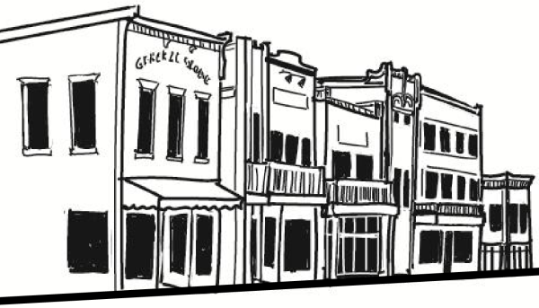 | 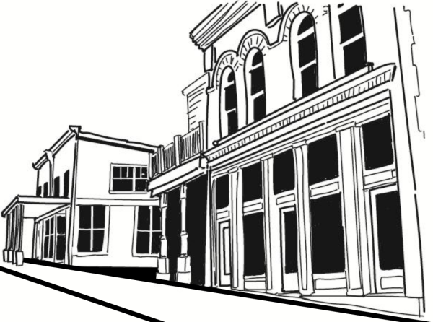
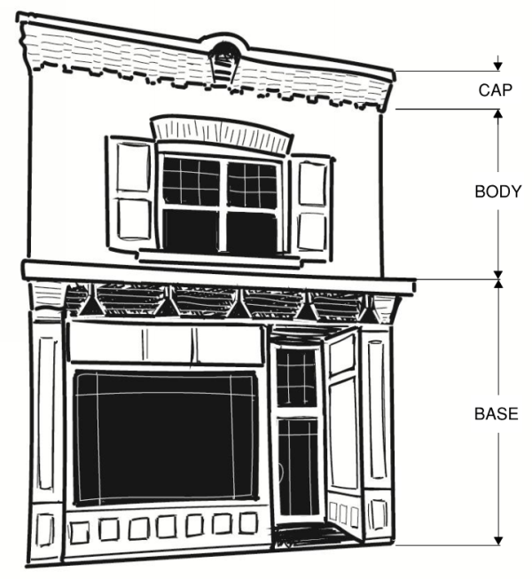 | 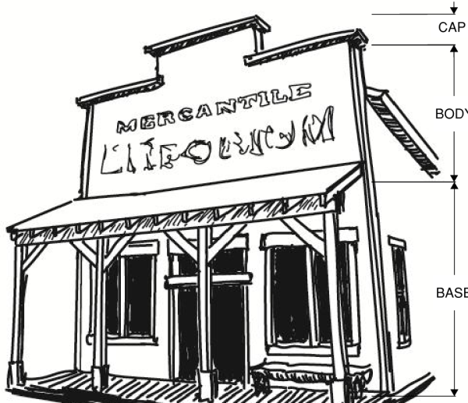
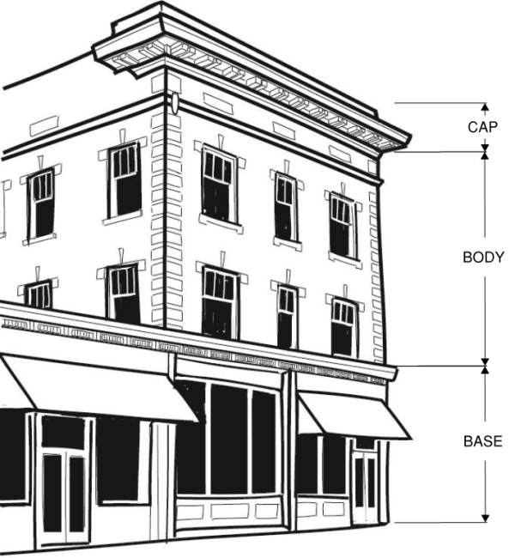 | 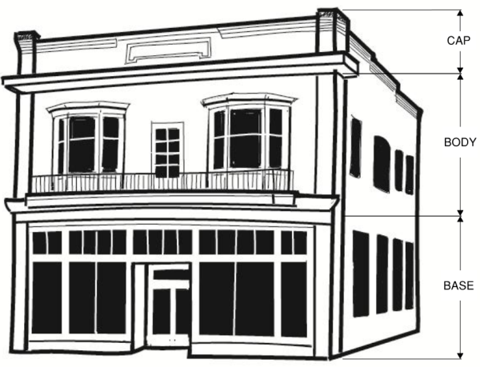
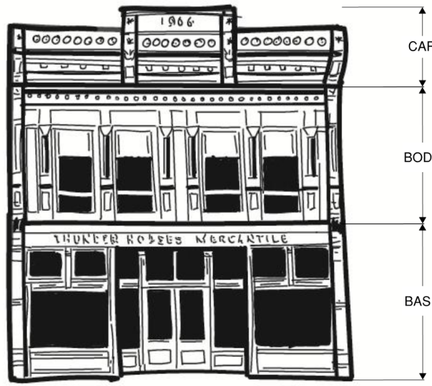

- New Town Eden Village Area building design standards. In addition to applicable standards in this chapter, the following standards apply to all buildings in the New Town Eden Village Area, except buildings on a lot that contains one or two single-family dwellings:
  - Design theme. All buildings shall have architectural styling and materials that implement agrarian-style architecture. Agrarian-style architecture shall incorporate at least two of the following four options:
    - Either a gable roof at a 6/12 or greater slope, a gambrel roof, or a monitor roof.
    - An attached shed-roof at a 4/12 or greater slope that is not attached to the main roof structure.
    - A clerestory or cupola.
    - Gable-style dormer windows.
  - Rooflines. Rooflines shall be broken every 50 feet, with no less than a 12 inch shift between adjacent rooflines.
  - Building massing. The wall massing of building facades shall be broken at least every 40 feet with no less than a six inch shift in the plain of adjacent walls. Each street-facing façade shall be designed and constructed to have a building base, building body, and varying building roofline, each having varying building materials or design techniques.
  - Building material. Building façade walls shall be finished with no less than two diverse types of material. The primary building material shall be wood siding or similar appearing siding.
    - Brick or stone may be used in place of wood if approved by the Land Use Authority.
    - Metal siding may be used on the building's body, as long as the building's base is made of brick or stone, and as long as the metal siding is broken horizontally by brick or stone every twenty feet, and is treated to create a natural-appearing aged patina.
  - Colors. Muted earth-tone colors are required. No more than 70 percent of a building's facade shall be white.
  - Examples. Examples of generally acceptable architectural features are depicted in the following images. Any conflict between details in the images and regulations in this chapter shall be interpreted in favor of the regulations in the chapter.
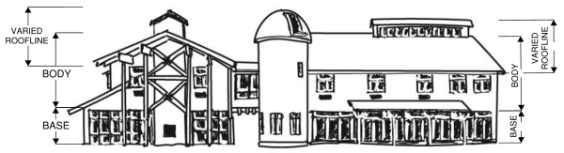
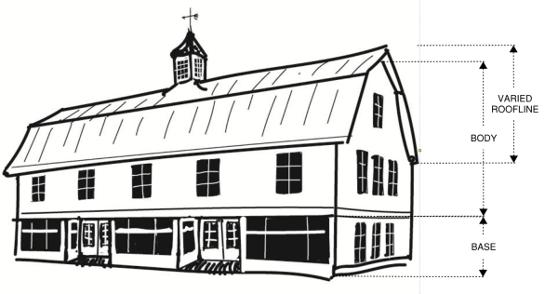 | 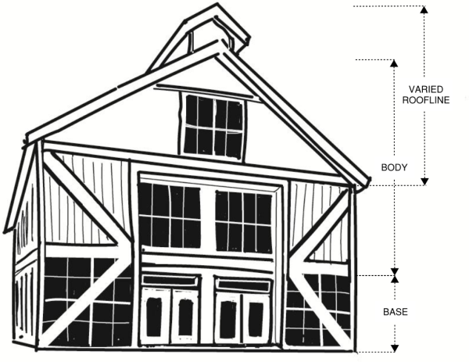
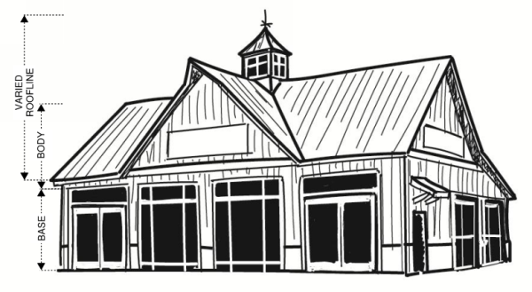 | 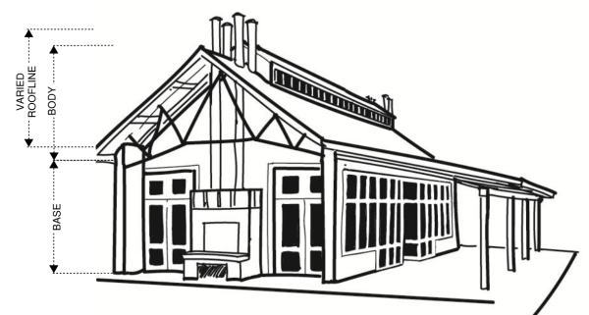
- Nordic Valley Village Area building design standards. In addition to applicable standards in this chapter, the following standards apply to all buildings in the Nordic Village Area, except buildings on a lot that contains a one or two single-family dwelling:
  - Design theme. All buildings shall have architectural styling and materials that implement a modern interpretation of alpine design. A modern interpretation of alpine design includes a balance between modern alpine and classical alpine design features. The following design features are intended to provide minimum stylistic requirements to implement this design theme.
  - Rooflines. Buildings shall have varying rooflines of predominantly gabled roofs. Rooflines shall be broken every 100 feet, with no less than a 12 inch shift between adjacent rooflines that are on the same plain.
  - Building massing. The wall massing of building facades shall be broken at least every 50 feet with no less than a six inch shift in the plain of adjacent walls. Each street-facing façade shall be designed and constructed to have a building base, building body, and a varying building roofline.
  - Building material. Building façade walls shall be finished with no less than two primary and one secondary type of building material. The primary building materials shall be real cut stone, glass, or wood siding or similar appearing siding with a natural wood finish. The secondary building materials include metal, wood, large-cut timbers, metal beams and columns, or concrete or other flat-surface building material which may be colored as allowed herein.
    - Each building shall have at least 60 percent primary building material.
    - The base of the building shall be at least 60 percent stone, except those areas occupied by transparent fenestration.
    - Use of metal shall be limited to trim, balconies, railing, exposed structural components, and roofs.
    - No more than ten percent of any building façade shall be exposed concrete.
  - Colors. Muted earth-tone colors are required. No more than 30 percent of a building's facade shall be white.
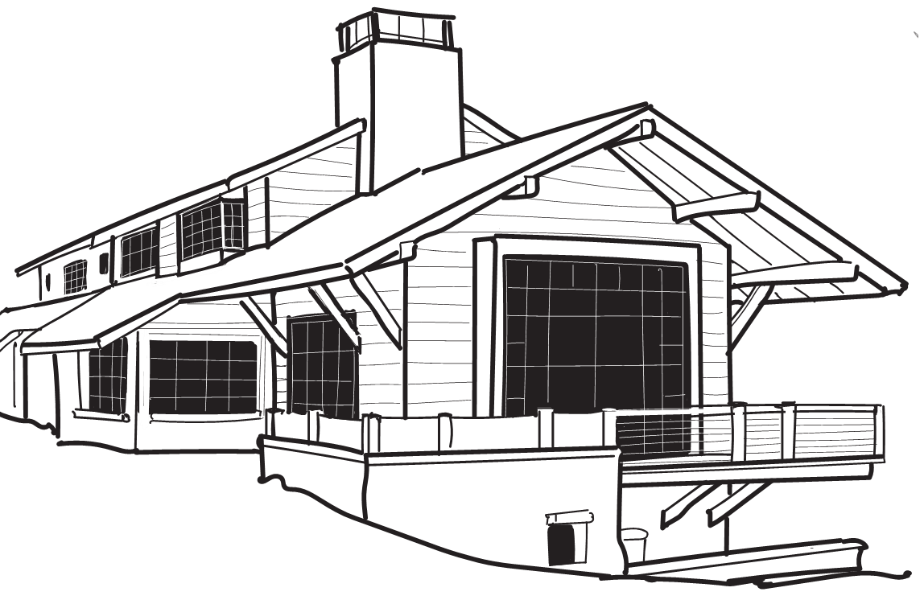
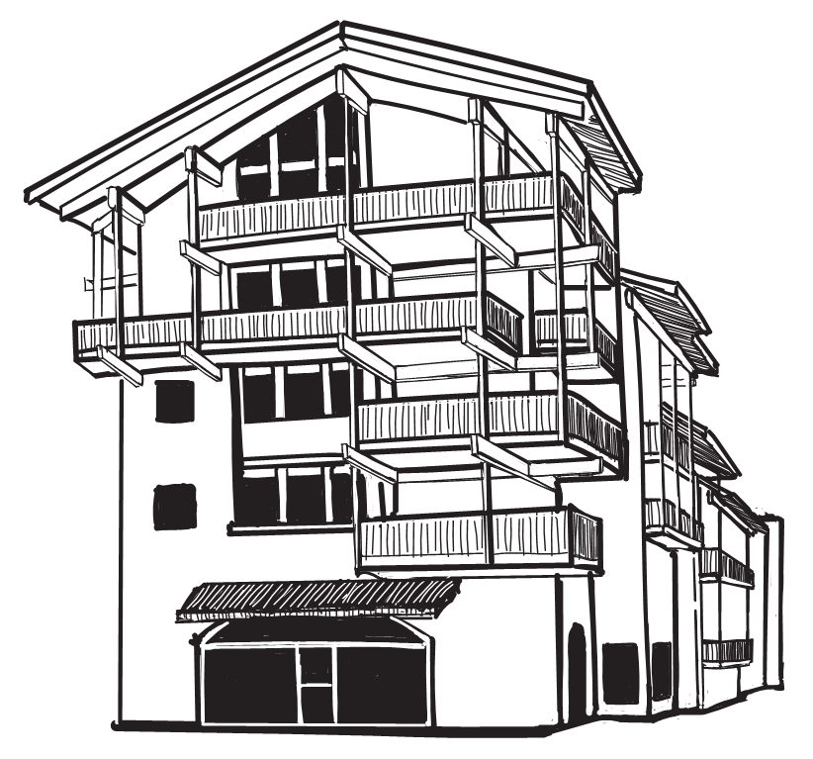
  - Examples. Examples of generally acceptable architectural features are depicted in the following images. Any conflict between details in the images and regulations in this chapter shall be interpreted in favor of the regulations in the chapter.

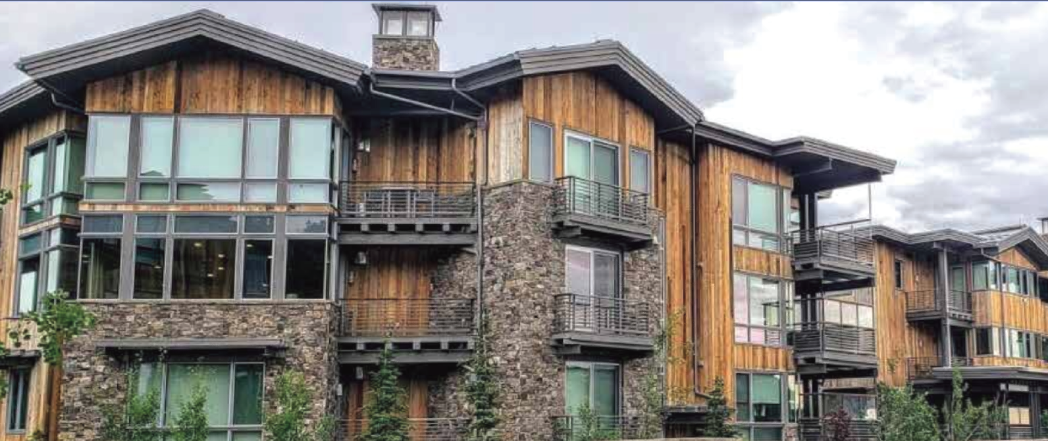
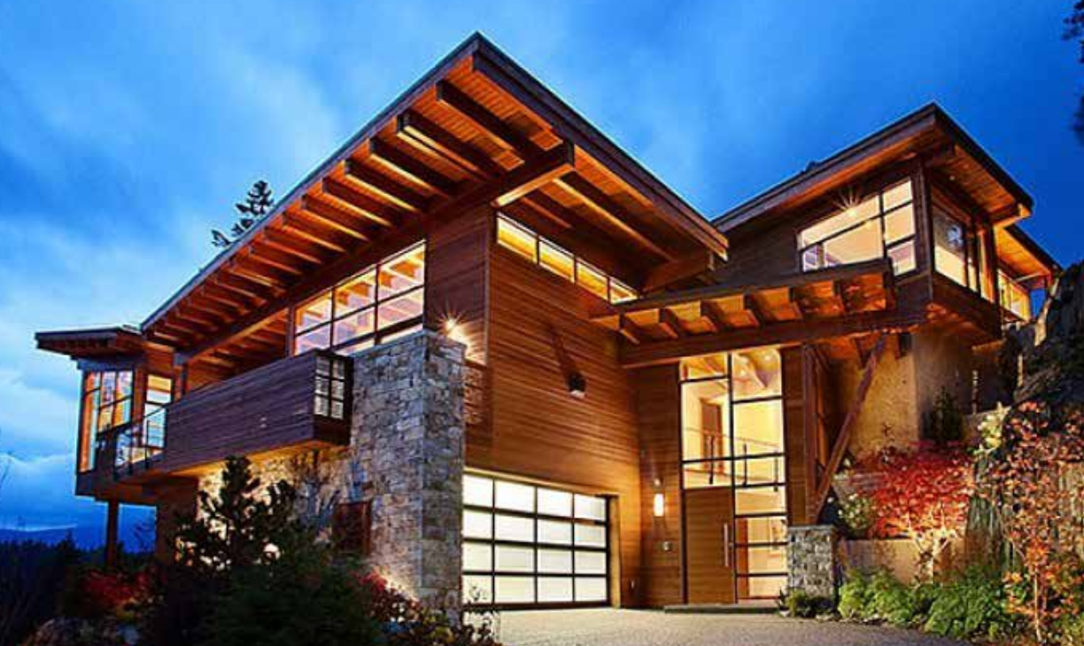
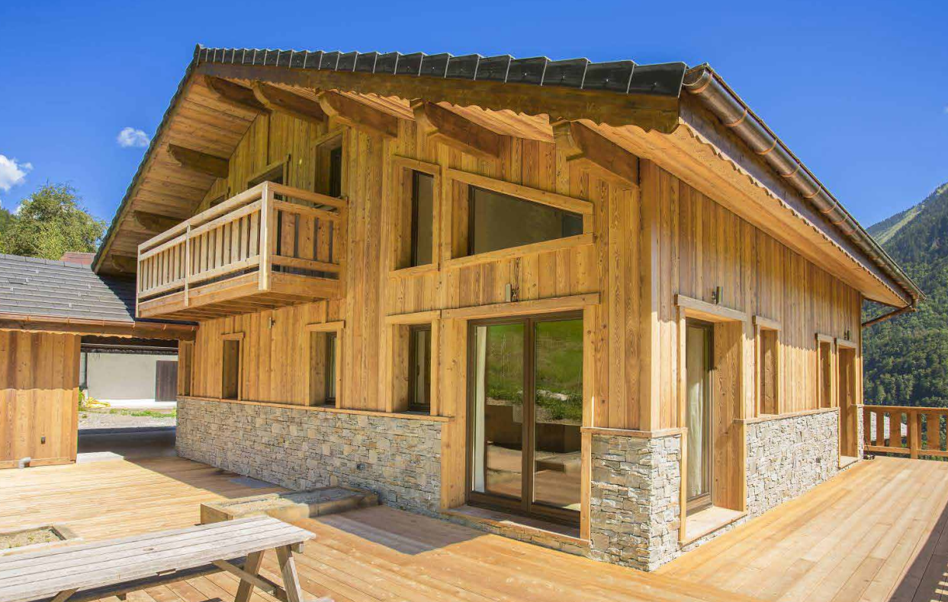
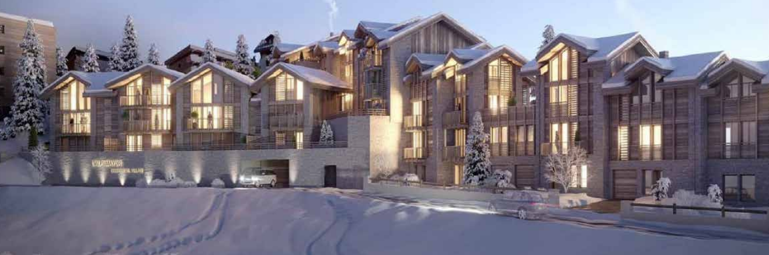
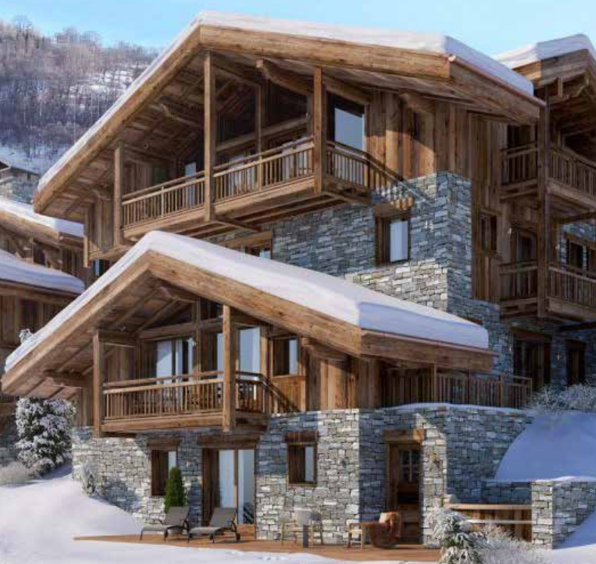
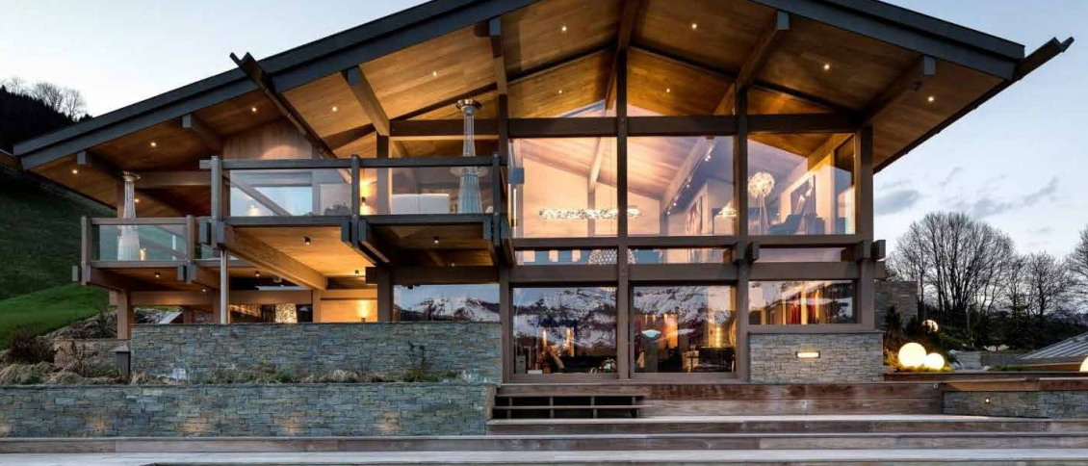
HISTORY
Adopted by Ord. 2022-04 on 1/18/2022

Sec 104-22-7 Street Types And Street Design
Sec 104-22-7.1 Street Types And Right-Of-Way Cross Sections Sec 104-22-7.2 Street Design Standards
HISTORY
Adopted by Ord. 2022-04 on 1/18/2022

Sec 104-22-7.1 Street Types And Right-Of-Way Cross Sections

- Right-of-way dedication. As development occurs on each lot or parcel, the owner shall dedicate area for public right-of-way with a width as depicted in the table below or as otherwise adopted, to form a block pattern as depicted in the applicable street regulating plan.
- Drawings required. Each application for development shall provide engineered construction drawings of the street improvements required herein.

Street type, description, and purpose.
  - Government/institutional street.
A government/institutional street or alley has street-front buildings that are intended to serve the traveling public. The primary purpose of the street is for the siting of government or public-service oriented buildings fronting the street. Public-service oriented buildings may include any governmental, nonprofit, or for-profit school as long as the school provides the same K-12 educational courses required by the State of Utah, or a school that is an accredited institution of higher education. Hospitals or other medical services buildings, including medical, dental, or mental-health offices, laboratories, or similar public-health related offices, a public transportation facility or a multimodal transportation hub are also intended to be street-adjacent. Except for a public transportation facility, pickup and drop off areas shall be located to the rear of the building.

Vehicle-oriented commercial street.
A vehicle-oriented commercial street or alley has street-front buildings that are intended to serve the traveling public, such as a large grocery store, drive-through or drive-up window service of varying kinds, and gas station. Street-front buildings that are not vehicle oriented are also allowed. Multi-family residential uses are allowed only if located above first-floor street-level commercial space.

Mixed-use commercial street.
A mixed-use commercial street has street-front buildings that are oriented toward pedestrian traffic. At the street-level, these buildings shall be exclusively used or reserved for commercial retail Multi-family residential uses are allowed if located above first-floor street-level commercial space.

Multi-family residential street.
A multi-family residential street has street-front buildings that are used for multi- family dwellings, and are setback from the street enough to provide a stoop or door yard between the facade and the street's sidewalk. First-floor building space intended for residential uses shall be offset by half a story from the plane of the street's sidewalk. First-floor street-level commercial area is permitted, but not required. Commercial uses are not permitted above the first-floor street-level.

Mid-block alley.
Each street type may have an associated mid-block alley, where shown on the applicable street regulating plan. As development occurs, sufficient area shall be preserved and constructed to provide the mid-block alley to provide access to parking areas, garages, and other uses or buildings that are located in the middle of the block. The location of an alley shall be in the locations depicted by the applicable street regulating plan, and designed at a minimum in accordance with the graphic to the right, and at a maximum to the standards applicable for a public street. Some mid-block alleys connect to adjoining residential streets. Where they connect, the applicable standards shall change to residential street standards. Snow removal for an alley is the responsibility of all landowners, collectively, or an HOA, that have a parking area that has an access from the alley.

Small-lot residential street.
A small-lot residential street has street-front buildings that may be setback more than multi-family residential street facades, but are less likely to have a noticeable front yard area.

Medium-lot residential street.
A medium-lot residential street has street-front buildings that are setback further than multi-family residential street facades to provide a small front yard area.

Large-lot residential street.
A large-lot residential street has street-front buildings that are setback enough to create a sizeable front yard on a lot that is large.

Rural residential street.
A rural residential street has street-front buildings that are setback enough to create a sizeable front yard on a lot that is at least an acre large.

Estate lot residential street.
An estate lot residential street has street-front buildings that are setback enough to create a sizeable front yard a lot that contains multiple acres.

General open space street.
A general open space street has very limited buildings adjacent to the street, and only those that are incidental and accessory to the open space.

Street right-of-way design.
  - Commercial street design. The design for a governmental and institutional street, vehicle-oriented commercial street, mixed-use commercial street, and multi-family residential street is as follows:
2’
16’
58’

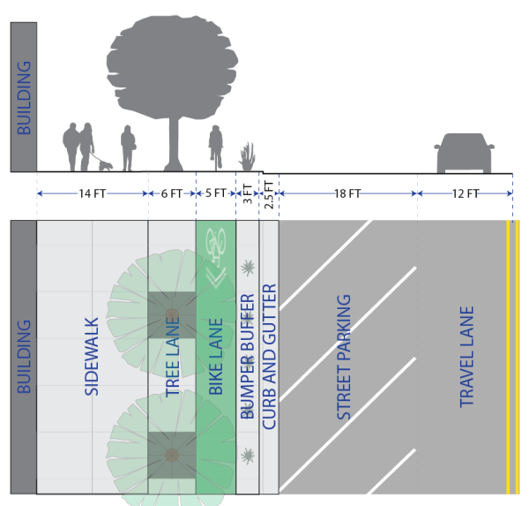

  - Commercial alley design. The design for a governmental and institutional alley, vehicle- oriented commercial alley, mixed-use commercial alley, and multi-family residential alley is as follows: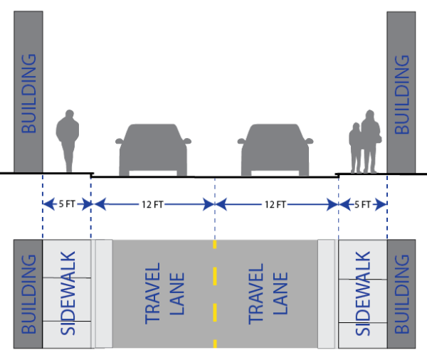
  - Residential street design. The design for all non-multi-family residential streets is as follows: See Section 106-4-5.

Editors note: The color adjacent to each street type corresponds with the street colors on the street regulating plan map(s). The color codes for each are as follows:
RGB | G&I | VOC | MUC | MFR | SLR | MLR | LLR | RR | ELR | OS
R | 25 | 176 | 204 | 255 | 255 | 255 | 255 | 138 | 83 | 75
G | 151 | 33 | 51 | 120 | 170 | 210 | 255 | 153 | 128 | 191
B | 156 | 157 | 0 | 0 | 0 | 0 | 0 | 66 | 69 | 96

HISTORY
Adopted by Ord. 2022-04 on 1/18/2022

Sec 104-22-7.2 Street Design Standards

For all mixed-use commercial, vehicle oriented commercial, multi-family residential, and government/institutional street types, the following provisions shall apply. Other streets shall follow adopted residential street design standards.

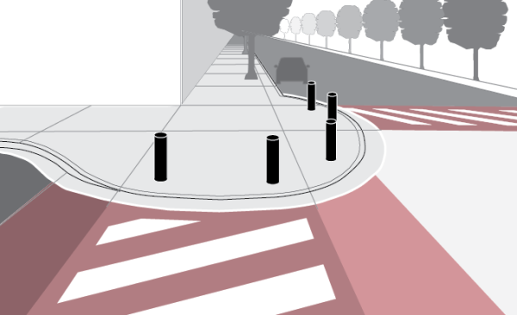
- Pedestrian priority design. The street shall be designed to prioritize pedestrian use. At primary points of conflict between pedestrian uses and vehicle uses, the street facility shall be designed and constructed to promote pedestrian safety, comfort, and efficiency.

  - Raised crosswalks. Where a pedestrian-way intersects with a vehicle-way, the pedestrian-way shall be raised at least six inches above the grade of the vehicle-way, or to the level of the adjoining pedestrian-ways, whichever is higher. This shall include but is not limited to the installation of crosswalks and intersections that are raised to the same plane as the sidewalk or adjoining pathways.
  - Curb extension bulb-outs. In order to provide traffic calming and pedestrian safety, street improvements at intersections, pedestrian crossings, and mid-block alleys, if different, shall be constructed with curb extensions that bulb-out directly adjacent to the lane of travel. Bike lane widths shall not be obstructed or made narrower at any point along a curb extension bulb-out. Bulb-outs shall be designed to the specifications of this ordinance and the County Engineer, or as otherwise adopted. Where a bulb-out provides access to a raised pedestrian crosswalk, bollards shall be installed along the curve of the bulb-out to keep vehicles from entering the pedestrian-way. Examples of bulb-outs are depicted in the images above.
  - Crosswalk contrast. For enhanced noticeability, in addition to white retroreflective striping, crosswalks shall be constructed of stamped and colored concrete to provide clear contrast between the street and crosswalk.
  - Mid-block crosswalk. Each block shall be provided with a mid-block crosswalk. Solar powered user-activated rapid flashing beacons shall be installed on midblock crosswalk signage.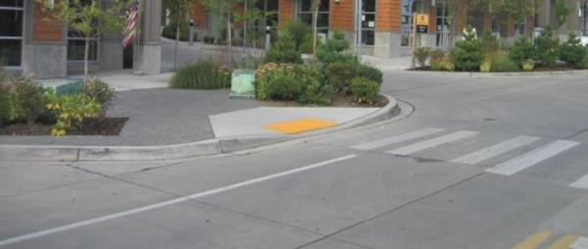

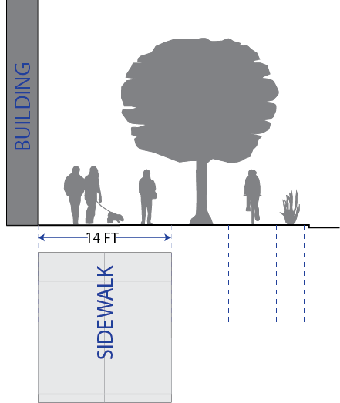
- Sidewalk required. As part of the required street improvements within the FBV zone, a sidewalk shall be installed in the designated sidewalk area, as depicted in Section 104-22-7.1, on the side of the street of the development and for the entire length of the development lot's street frontage.

  - Paved pathway alternative. A 10-foot wide paved pathway may be installed in lieu of the required sidewalk along any street designated as residential except the multi-family residential street

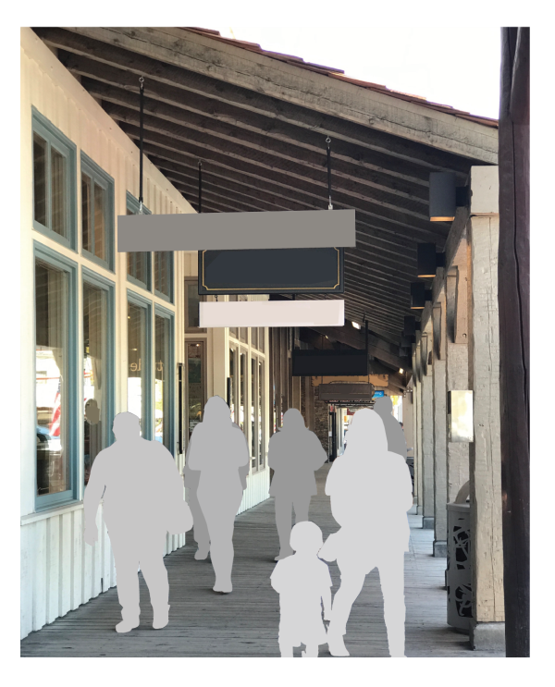
  - Covered boardwalk alternative. The County Commission may, but is not obligated to, approve the encroachment of a covered boardwalk, or similar, by legislative approval of an encroachment and maintenance contract. The adjoining landowners shall bear full responsibility for the operations and maintenance of the boardwalk. The covered boardwalk shall comply with the overhead projections standards of this chapter.

- Street trees required. As part of the required street improvements within this zone, street trees shall be installed in the designated tree lane, as depicted in Section 104-22-7.1, on the same side of the street as the development and for the entire length of the development lot's street frontage. Tree species shall be approved by the Planning Director and County Engineer as part of the review of the development. A street tree plan shall be submitted as part of a development application and shall be accompanied by a letter from a certified arborist or landscape architect, certifying that the proposed tree type is suitable considering site conditions and local climate. The plan shall include planting methods that are specific to the site conditions. Planting methods shall provide means of protecting the longevity of the tree and the street infrastructure. Street trees shall be provided with a permanent watering method with irrigation infrastructure installed underground.
  - Tree planting. No street tree shall be planted within the clear view triangle as provided in Section 108-7-7, Section 106-4-5, or the American Association of State Highway and Transportation Officials (AASHTO) standards. To provide continuous shade of the pedestrian areas, spacing between tree trunks shall equal the average diameter of the specific tree species' canopy at maturity. However, in the Nordic Valley Village area, each block shall have the same number of trees that is equal to one tree per every 50 linear feet of street on both sides of the street, and the trees may be grouped in clusters of no greater than ten trees, rather than equally spaced along the right of way.
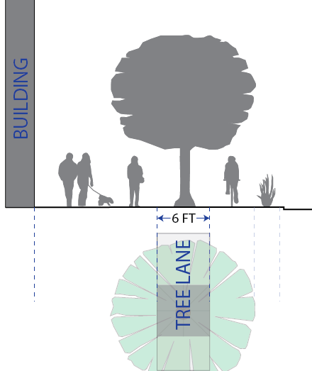

  - Tree maintenance. Unless an association, district, or other collective funding and maintenance entity is approved by the County to provide tree maintenance, a street tree shall be maintained by the owner or proprietor of the property that is immediately adjacent to the street right-of-way where the tree is located. A tree maintenance plan shall be submitted as part of the development review for new development. Trees shall be pruned in a manner that gives at least a seven foot clearance above the sidewalk and a 12 foot clearance above a bike lane or parking area, as depicted by the following graphic:

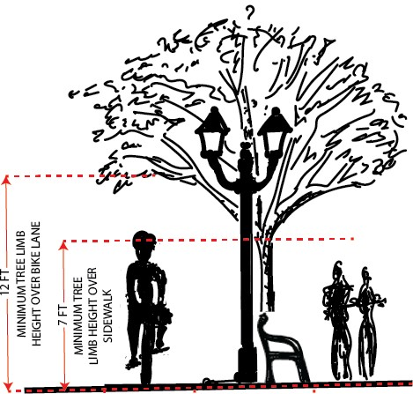

Bike facilities required.
  - Separated bike lane. A concrete bike lane that is five feet in width shall be installed as part of the required street improvements. The bike lane shall be on the same plane as the sidewalk, and shall be separated from the pedestrian walkway by the tree lane.
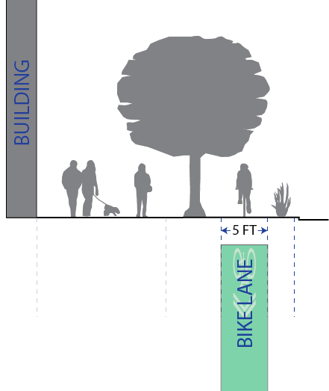
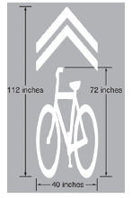
  - Bike lane alternative. When topography results in the inability to safely create sufficient street right-of-way width, the County Engineer has discretion to allow a bike lane to occupy the street's vehicle travel lane. In these cases, a five-foot wide retroreflective green bike lane shall be applied to the center of the lane, and marked with retroreflective sharrows as depicted by the following graphic:

Street parking required.
  - 45-degree angle parking. Each street shall be designed and constructed to provide 45- degree angled parking.
  - Street parking alternative. When topography results in the inability to safely create sufficient street right-of-way width, the County Engineer has discretion to allow a parallel street-parking design instead.

  - Parking bumper buffer. A three-foot parking buffer shall be provided between the bike lane and the curb for vehicle bumper overhang. Vegetation may be in this buffer.
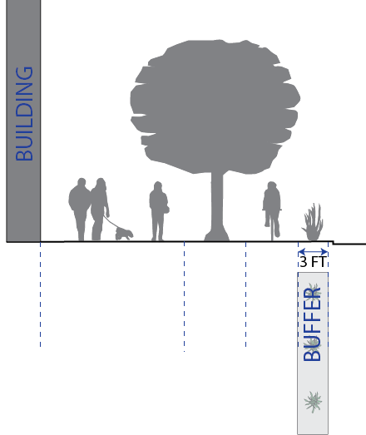

- Curb, gutter, and drainage facilities. Curb, gutter, and drainage facilities shall be installed along each street and internal alleyway in accordance with the County's standard curb and gutter cross sections and in a manner that accommodates the street designs herein.

Items in public right-of-way.
  - Overhead projections. Overhead building projections such as but not limited to awnings, canopies, balconies, and cantilevers, are permitted within the public right-of- way, provided that they leave a vertical clearance over the sidewalk or walkway of no less than nine feet, and shall not project more than eight feet into the public right-of-way. Any support post beneath the building projection shall be no greater than seven feet from the building façade, be designed to offer minimal disruption to sidewalk traffic, and meet all ADA clearance requirements.
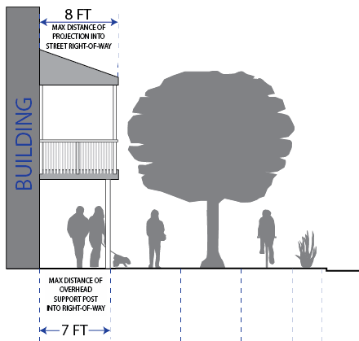
  - Amenities and furniture. Non-permanent street amenities such as street furniture for outside dining, benches, bike racks, planters, and street sales and displays are permitted between street trees and along sidewalks as long as they do not cause any hazard to the use of the bike lane; and they are located in a manner that leaves a continuous seven- foot wide pedestrian walkway.
  - Street Lighting. Street lighting shall be installed as part of the required street improvements within this zone. Street lighting shall compliment the architectural design theme of the area.
  - Overhead utilities. All new development shall move all existing overhead utilities underground, and install all new utilities underground as well.

- Round-a-bout. A round circle along any street intersection on the street regulation plan indicates a planned round-a-bout. As development occurs, street right-of-way shall be dedicated to the County to accommodate at least a 110-foot diameter round-a-bout. Round-a-bout improvements shall be installed if required by the County Engineer. Otherwise, all improvements installed shall be installed in a manner that does not create an undue burden on the construction of a future round-a-bout.
HISTORY
Adopted by Ord. 2022-04 on 1/18/2022

Sec 104-22-8 Street Regulating Plans

The following maps depict the adopted Street Regulating Plans for their respective areas. The plans illustrate the intended street layout of the area and the designated street types. The plan is intended to be a guide for the placement of streets and mid-block alleys, and is not designed to survey-level accuracy. A mid-block alley shall be as close to the middle of the block as is practicable, and the street placement shall be within 200 feet of the location depicted on these maps. A land owner proposing development in an area that a street or alley is planned shall be responsible for dedicating the land and constructing the street or alley improvements.

Old Town Eden Street Regulating Plan Map.

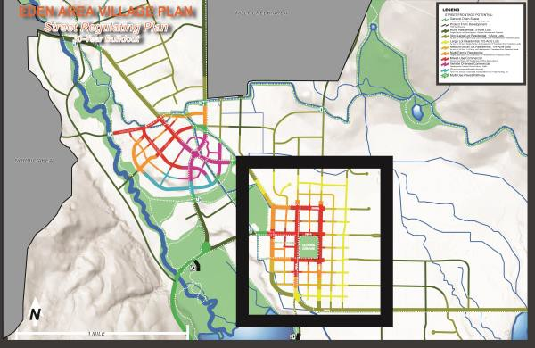

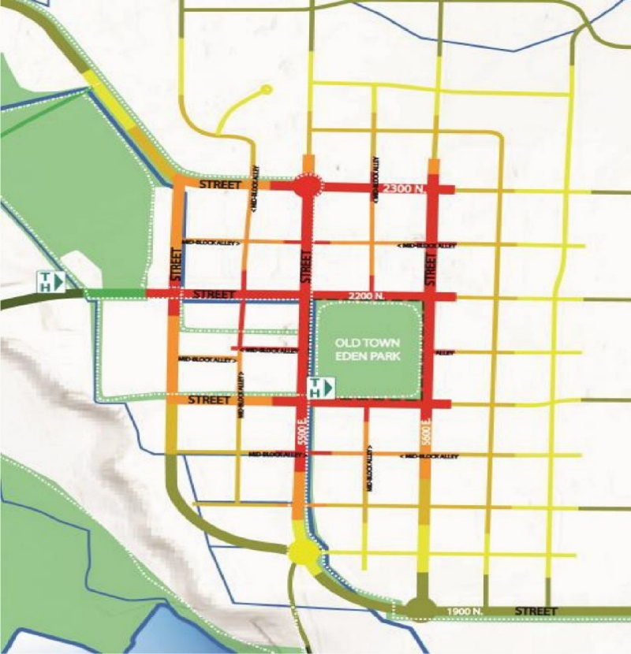
0

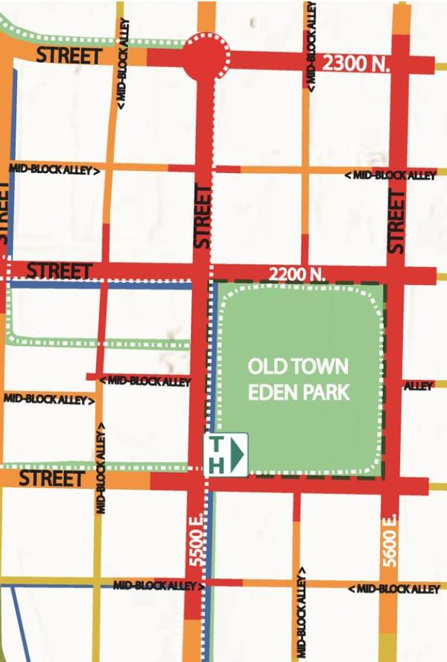

- New Town Eden Street Regulating Plan Map.
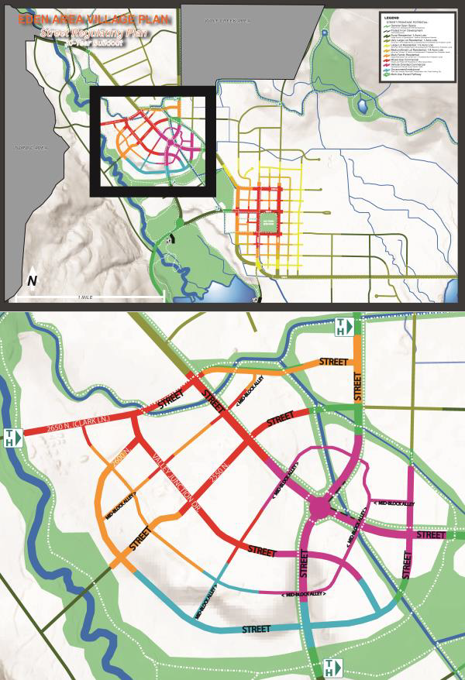

- Nordic Valley Village Area Street Regulating Plan Map.
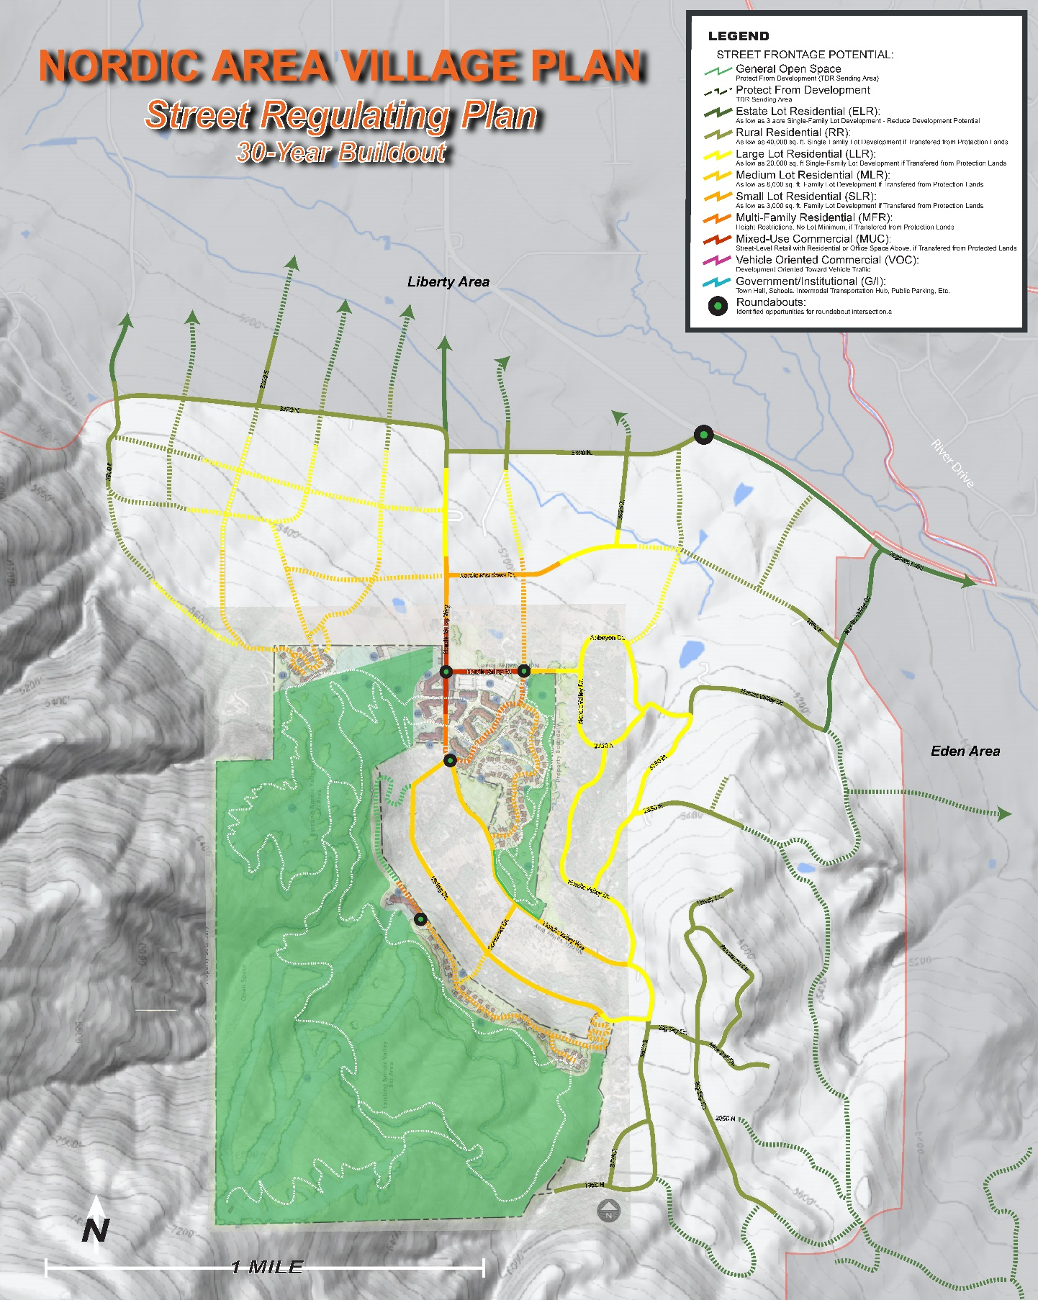
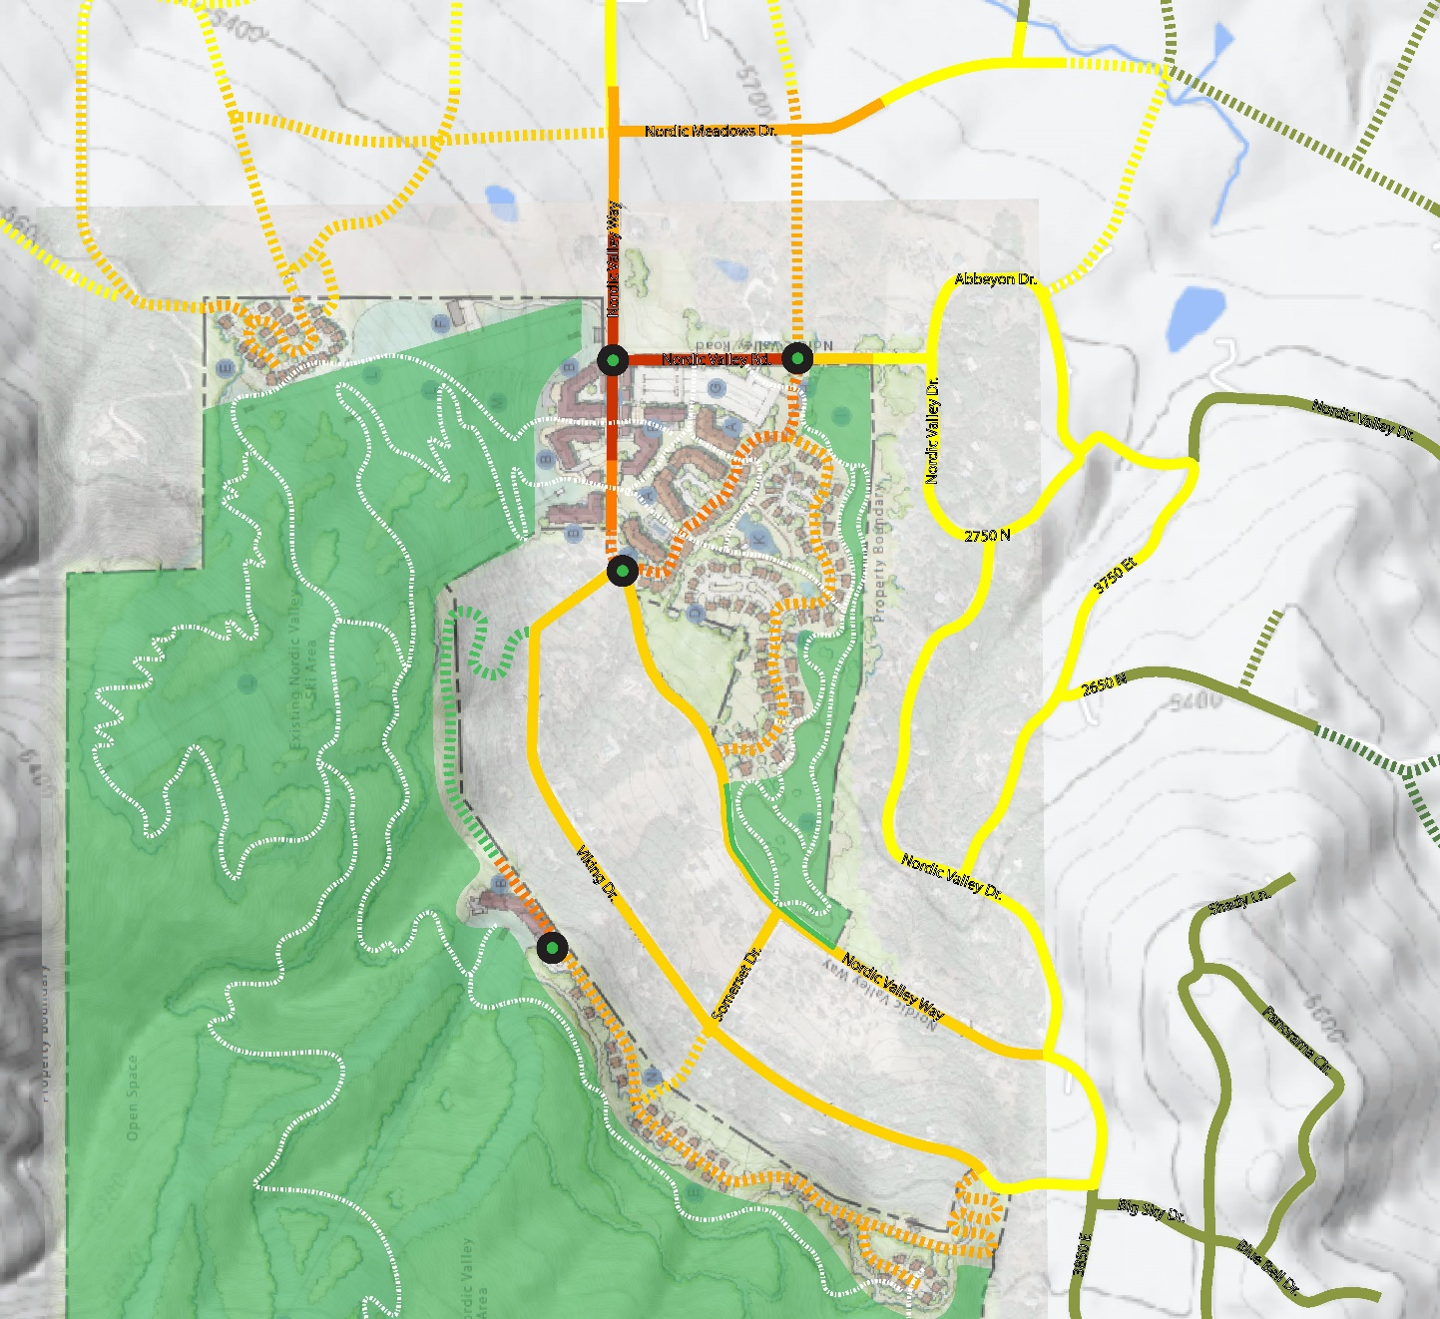
HISTORY
Adopted by Ord. 2022-04 on 1/18/2022

Sec 104-22-9 Parking and Internal Block Access.

- Each application for development shall include a parking plan that demonstrates that sufficient parking will be provided by the street parking adjacent to the building or an off-street parking lot within 1000 feet of the building. With exception to seasonal day-skiing parking lots, all parking lots shall be hard-surface asphalt or concrete. Street parking not adjacent to the lot's street-frontage shall not be counted in determining that sufficient parking has been provided.
- Except for residential uses, the Land Use Authority may reduce the minimum parking spaces required if sufficient evidence suggests that the required number of spaces is excessive for the building and proposed use or uses therein. If a change of use occurs, more parking may be required if the new use merits it, as determined by the Land Use Authority. The applicant proposing to change the use shall be required to provide the additional off-street parking within 1000 feet of the use.
- The minimum required parking for a residential use shall be located off-street within the same block as the residential use.
- A surface parking lot shall have one tree for each four parking spaces, and a five-foot wide landscape planting area that runs the depth of the parking row shall be located at each end of a parking row.
- When located adjacent to a vehicle-oriented commercial, mixed use commercial, or multi-family commercial street, a parking structure shall have first-floor street-level commercial space along the street’s frontage. However, for a corner lot, this requirement applies to the façade that is adjacent to the more prominent street, as determined by the land use authority; the other façade shall have the same for no less than fifty percent of that façade’s street frontage. The other fifty percent, and the area of the parking structure above the street level commercial space, shall have a street-facing facade that disguises the parking structure to generally look like other buildings in the area.

- Cross-access and cross-access easement. For all parcels or lots along a governmental or institutional, vehicle-oriented commercial, mixed-use commercial, or multi-family residential street, providing access to adjacent existing or future development without the need to access the public right-of-way is required. This access shall be provided by a mid-block alley, where shown on a street regulating plan, or other alley or shared driveway as may be deemed necessary by the land use authority. When no new alley access is deemed necessary because an alley access or street access is already provided to the lot or parcel through another lot or parcel, then a cross-access easement shall be provided along adjoining lot lines, as follows:
  - A cross access easement shall provide an easement to all landowners in the block that develop along a governmental or institutional, vehicle-oriented commercial, mixed-use commercial, or multi-family residential street that is framing the block. The easement shall allow ingress and egress to these other lots or parcels, including ingress and egress infrastructure.
  - At a minimum, each developed lot or parcel shall have two points of ingress and egress, at least one of which shall be stubbed to adjacent property where practicable. Except that a parking area is allowed to only provide a single access as long as it does not block the accessibility to other areas within the block that is or could be used for public parking.
  - Each parking area that is located within the block and that will be open to the public for public parking shall be designed to extend to the parcel boundary and shall provide a cross access easement along all sides of the parking area abutting the adjacent lot(s) or parcel(s) in a manner that allows the adjoining lot or parcel owner to extend that public parking area seamlessly into their parcel.
  - When locating a cross-access easement or designing the cross-access infrastructure, good faith efforts shall be made to coordinate the location and design with the adjoining land owner.
  - The Planning Director may require the cross-access to be located in a manner that optimizes internal block traffic circulation.
  - Construction of the cross-access infrastructure shall be completed prior to the issuance of a certificate of occupancy for any structure on the lot or parcel, or a completion bond may substitute for completion if allowed by the County Engineer.
  - When a lot or parcel is being developed that abuts an existing cross-access easement or existing cross-access infrastructure, a reciprocal cross-access easement shall be provided on the same lot line or parcel line in the same location and of equal width. The reciprocal cross-access infrastructure shall be constructed to the same standard as, or better than, the existing cross-access infrastructure on the adjacent parcel. A cross-access easement shall be recorded on the title of all affected properties, along with a perpetual operation and maintenance agreement between the property owners that specifies, at a minimum, that the infrastructure will be operated and maintained by the property owners in a manner that is safe and usable for two-way vehicle traffic.
  - If property owners fail to operate or maintain cross-access infrastructure that was required by the County under this section, the County may pursue enforcement measures as provided in this Land Use Code.
HISTORY
Adopted by Ord. 2022-04 on 1/18/2022

Sec 104-22-10 Signage

In addition to the signage regulations in this Land Use Code, no signage shall be affixed to a building higher than the top of the second story.

HISTORY
Adopted by Ord. 2022-04 on 1/18/2022

Sec 104-22-11 FBV Transferable development rights
- Density allowance and transferable development rights. As provided in the Ogden Valley General Plan, the creation of dwelling units in the FBV zone shall not create any new density in the Ogden Valley Planning Area unless otherwise provided in this Land Use Code. To establish the residential dwelling unit rights that exist on a lot or parcel in the FBV zone, or to increase or decrease residential dwelling unit rights on a lot or parcel in the FBV zone, the following apply:
- For a lot or parcel rezoned to the Form-Based Village Zone from a zone that allows residential dwelling units, the base density, as defined in Title 101, Chapter 2, shall be the same as the density that was allowed in the prior zone. This shall be documented by recording a covenant to the lot or parcel that provides a calculation of the base density. The covenant shall run with land, and be between the owner and the County.
- Additional residential dwelling units are permitted on any lot that has street frontage on, or gains primary access from, any street type in the street regulating plan except a rural residential street and a general open space street. However, no new density is allowed unless the landowner has successfully negotiated the reallocation of an equal number of dwelling unit rights from another lot or parcel that has an available dwelling unit right as determined by the lot or parcel's base density and adjusted for any previous dwelling unit right reduction or addition. The reallocation shall be made by recording a covenant to each affected lot or parcel. Each covenant shall run with the land and be between the owner and the County. Each covenant shall document the applicable lot or parcel's calculated base density; the number of dwelling units already developed on the lot or parcel; the number of dwelling unit rights subtracted from, or added to, the base density by any means; and the number of dwelling unit rights remaining for the lot or parcel.
- Residential dwelling unit rights may be transferred to a lot or parcel in a FBV zone from any lot or parcel in the following zones within the Ogden Valley Planning Area: RE-15, RE-20, AV-3, F-5, FV-3, S-1, FR-1, FR-3, RMH-1-6, CVR-1, and FBV.
- Regardless of number of residential dwelling unit rights transferred to a lot or parcel in the FBV zone, the number of dwelling units actually constructed shall be limited by what can be constructed given compliance with the standards of this chapter.
- A dwelling or dwelling unit specifically devoted to the housing of employees working in the local service-industry and earning less than 80 percent of the county’s median household income, does not count toward density allowances and are not required to be established through transferable development rights.

