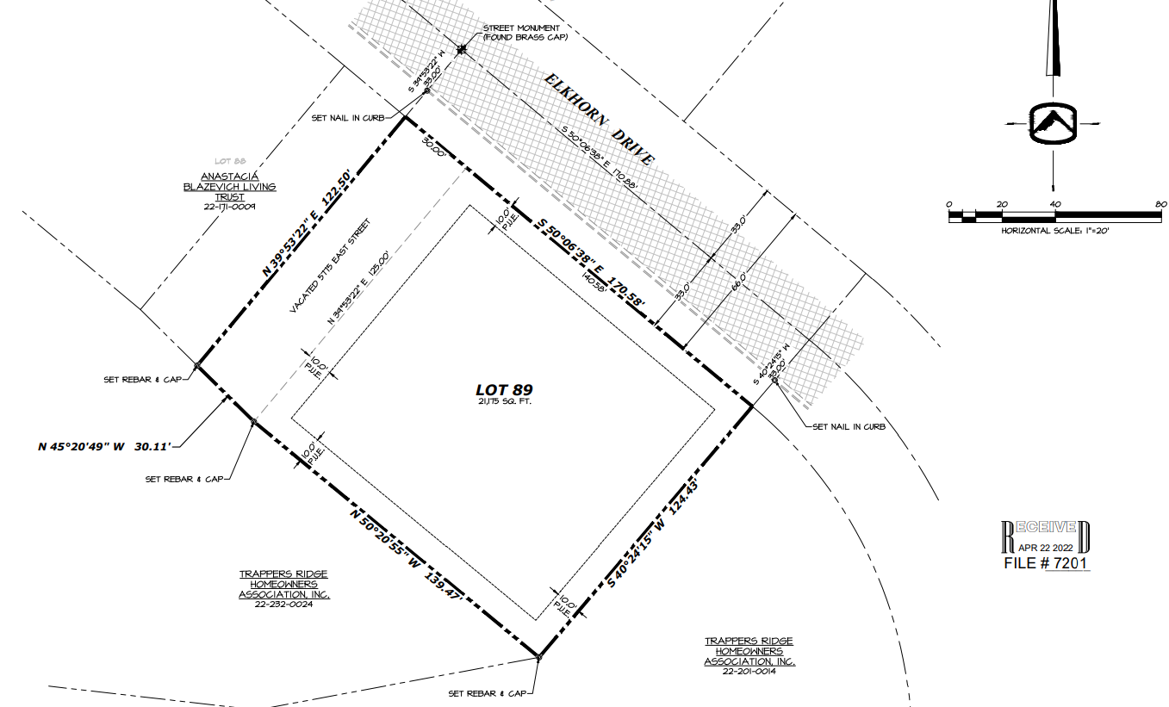

Proposed new P.U.E (10’ wide from adjacent property lines)

Easement to be vacated