|  |  |
| --- | --- |
| **WC Logo.emf** | **Staff Report for Administrative Approval**  *Weber County Planning Division* |
|  | |

****Synopsis****

****Application Information****

**Application Request:** Consideration and action request for final approval of Rocky Rhodes Subdivision 1st Amendment.

**Agenda Date: Wednesday, November 16, 2022**

**Applicant:** Gwen Rhodes

**Representative: Paul Beus**

**File Number:** UVR081022

****Property Information****

**Approximate Address:** 3822 N 3500 E, Eden

**Project Area:** 3.0 acres

**Zoning:** AV-3

**Existing Land Use:** Residential

**Proposed Land Use:** Agriculture Valley

**Parcel ID:** 22-177-0002

**Township, Range, Section:** T7N, R1E, Section 20

****Adjacent Land Use****

**North:** Agriculture Valley **South:** Agriculture Valley

**East:** Agriculture Valley **West:** Agriculture Valley

****Staff Information****

**Report Presenter: Marta Borchert**

mborchert@webercountyutah.gov

**801-399-8761**

**Report Reviewer:**

Applicable Ordinances

* Title 101, Chapter 1, General Provisions, Section 7, Definitions
* Title 104, Chapter 2, Agriculture Valley Zone
* Title 104, Zones, Chapter 28, Ogden Valley Sensitive Lands Overlay Districts
* Title 106, Subdivisions, Chapter 1-8 as applicable

Background and Summary

This is a proposal to change the boundary line between parcel number 221770002 and 220130014 to obtain more room for drive way and shift the pickle ball court and greenhouses to lot 2 on the northern border.

The Weber County Land Use Code (LUC) §101-1-7 identifies a subdivision amendment of five or fewer lots as a “Small Subdivision” which can be administratively approved by the Planning Director. The proposed subdivision amendment and lot configuration are in conformance with the current zoning as well as the applicable subdivision requirements as required in the LUC.

Analysis

*General Plan:* The proposal conforms to the Ogden Valley General Plan by maintaining the existing density provided by the current zoning and existing approvals (2016 Ogden Valley General Plan, Land Use Principle 1.1).

*Zoning:* The subject property is located in the Agricultural Valley (AV-3) Zone. The purpose and intent of the AV-3 zone is identified in the LUC §104-4-1 as:

*The purpose of the Agricultural Valley Zone, AV-3 is to provide area for residential development in a forest setting at a low density, as well as to protect as much as possible the naturalistic environment of the development.*

*Review Agencies:* The Weber County Engineering Division and Weber Fire District have granted conditional approval The Surveyor’s office will review the final plat once administrative approval of the subdivision is granted. Final subdivision approval will be granted from Planning, Engineering, and Surveying after all conditions have been met.

Staff Recommendation

Staff recommends final approval of Rocky Rhodes 1st Amendment. This recommendation for approval is subject to all applicable review agency requirements. This recommendation is based on the following conditions:

1. There will need to be a deferral for curb, gutter and sidewalk.

This recommendation is based on the following findings:

1. The proposed subdivision amendment conforms to the Ogden Valley General Plan.
2. The proposed subdivision complies with applicable County ordinances.

Administrative Approval

Administrative final approval of UVG021921 is hereby granted based upon its compliance with the Weber County Land Use Code. This approval is subject to the requirements of applicable review agencies and the conditions of approval listed in this staff report.

Date of Administrative Approval: _______________________________

____________________________________

Weber County Planning Director

Exhibits

1. Proposed amended plat

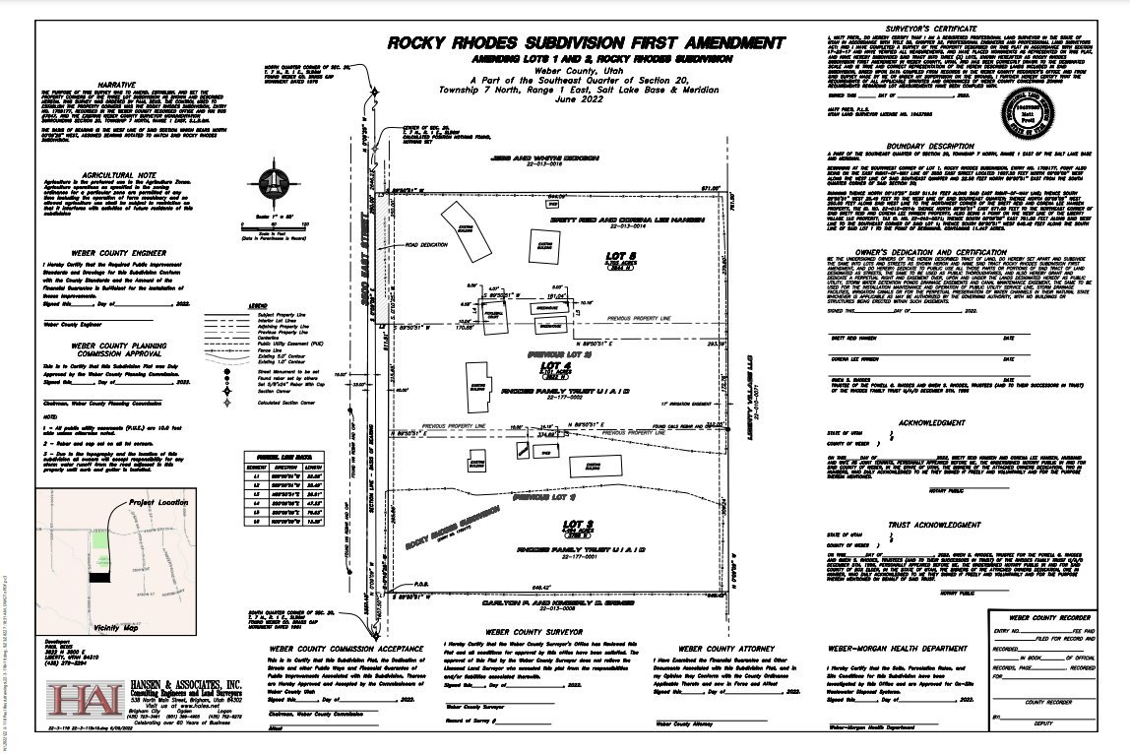

Location Map 1

