|  |  |
| --- | --- |
| **WC Logo.emf** | **Staff Report to the Weber County Planning Division**  *Weber County Planning Division* |
|  | |

****Synopsis****

****Application Information****

**Application Request:** Consideration and action on a request for approval of Charlesworth Estates Subdivision, a proposal to create a one-acre residential lot.

**Agenda Date: Wednesday, December 12, 2018**

**Applicant:** Jeff Hales, Authorized Representative

**File Number:** LVC 111318

****Property Information****

**Approximate Address:** 4187 West 4000 North

**Project Area:** 1.03 Acres

**Zoning:** Agricultural (A-2)

**Existing Land Use:** Vacant

**Proposed Land Use:** Residential

**Parcel ID:** 19-009-0061

**Township, Range, Section:** T7N, R2W, Section 21

****Adjacent Land Use****

**North:** Residential/Agricultural **South:** Residential/Agricultural

**East:** Residential/Agricultural **West:** Residential/Agricultural

****Staff Information****

**Report Presenter:** Felix Lleverino

flleverino@co.weber.ut.us

801-399-8767

**Report Reviewer: RG**

Applicable Land Use Codes

* Title 101 (General Provisions) Chapter 1 (Definitions)
* Title 104 (Zones) Chapter 7 (Agricultural A-2)
* Title 106 (Subdivisions) Chapter 1 (General Provisions) Section 8 (Final Plat Requirements)

Development History

This parcel was created February 29th, 2000 and is now required to undergo the official platting process in order to establish a buildable lot.

Background and Summary

The applicant is requesting approval of a .95 acre (41,667 sq. ft.) residential lot. Access to the property will be from a public right-of-way called 4000 North Street.

As part of the approval process, the proposal has been reviewed against the current Weber County Land Use Code (LUC), and the standards of the A-2 Zone found in LUC §104-7. The following section is a brief analysis of this project against current land use regulations.

Analysis

*General Plan*: This proposal conforms to the Western Weber General Plan by encouraging one-acre residential properties that may pursue agriculturally related uses.

*Zoning*: The property is located in the A-2 Zone. The purpose of this zone is stated in the LUC §104-7-1.

*“The purpose of the A-2 Zone is to designate farming areas where agricultural pursuits and the rural environment should be promoted and preserved.”*

*Site Development Standards*: Lots created in the A-1 Zone are required to comply with site development standards for the A-1 Zone. This proposal exceeds the minimum standards with regard to lot area and width.

*Small Subdivision*: “The Planning Director is delegated administrative authority to approve small subdivisions if in his discretion there are no conditions which warrant its submittal to the planning commission LUC §106-1-8 (f)).” This proposal qualifies as a small subdivision consisting of three or fewer lots for which no new streets are being created or realigned.

*Road Dedication*: Following approval from the Planning Director, this proposal will be presented before the County Commission for approval of the area being dedicated to the public right-of-way 4000 North Street.

*Flood Zone*: This parcel is within an area of minimal flood hazard and determined to be outside the 500-year flood level.

*Culinary Water*: Bona Vista Water Improvement District has provided a letter stating that it will serve the needs for domestic use only and that proof of secondary water must be provided prior to applying for a residential connection.

*Sewer Services*: Weber-Morgan Health Department has provided a letter stating that water table monitoring and soil evaluations have been completed.

*Review Agencies*: The Weber County Fire District has approved this proposal. Weber County Planning, Engineering, and Surveying have submitted comments that have been addressed by a revised subdivision plat.

*Public Notice*: Noticing was provided to all property owners of record within 500 feet of the subject property.

Staff Recommendation

Staff recommends final plat approval of Charlesworth Estates Subdivision, a proposal to create a 41,667 sq. ft. residential lot. This recommendation is based on the following conditions:

1. The area dedicated to the public right of way shall be approved by the County Commission.
2. The final Mylar must be signed by the County Commission prior to recording.
3. A deferral agreement must be entered into by the owner and the agreement shall be recorded with the final Mylar.

This recommendation is based on the following findings:

1. The proposed subdivision conforms to the Western Weber General Plan.
2. The proposed subdivision complies with the applicable County codes.

Administrative Approval

Administrative final approval of Charlesworth Estates Subdivision, a proposal to create a 41,667 sq. ft. residential lot is hereby granted based upon its compliance with the Weber County Land Use Code. This approval is subject to the requirements of applicable review agencies and the conditions of approval listed in this staff report.

Date of Administrative Approval:

________________________________________

Rick Grover

Weber County Planning Director

Exhibits

1. Charlesworth Estates Subdivision
2. Current Recorders Plat
3. Bona Vista Will-serve Letter
4. Health Department Feasibility Letters

Area Map

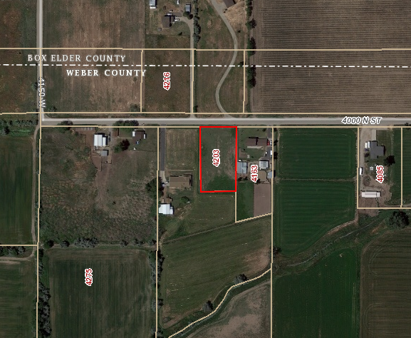

**Subject Properties**

Exhibit A

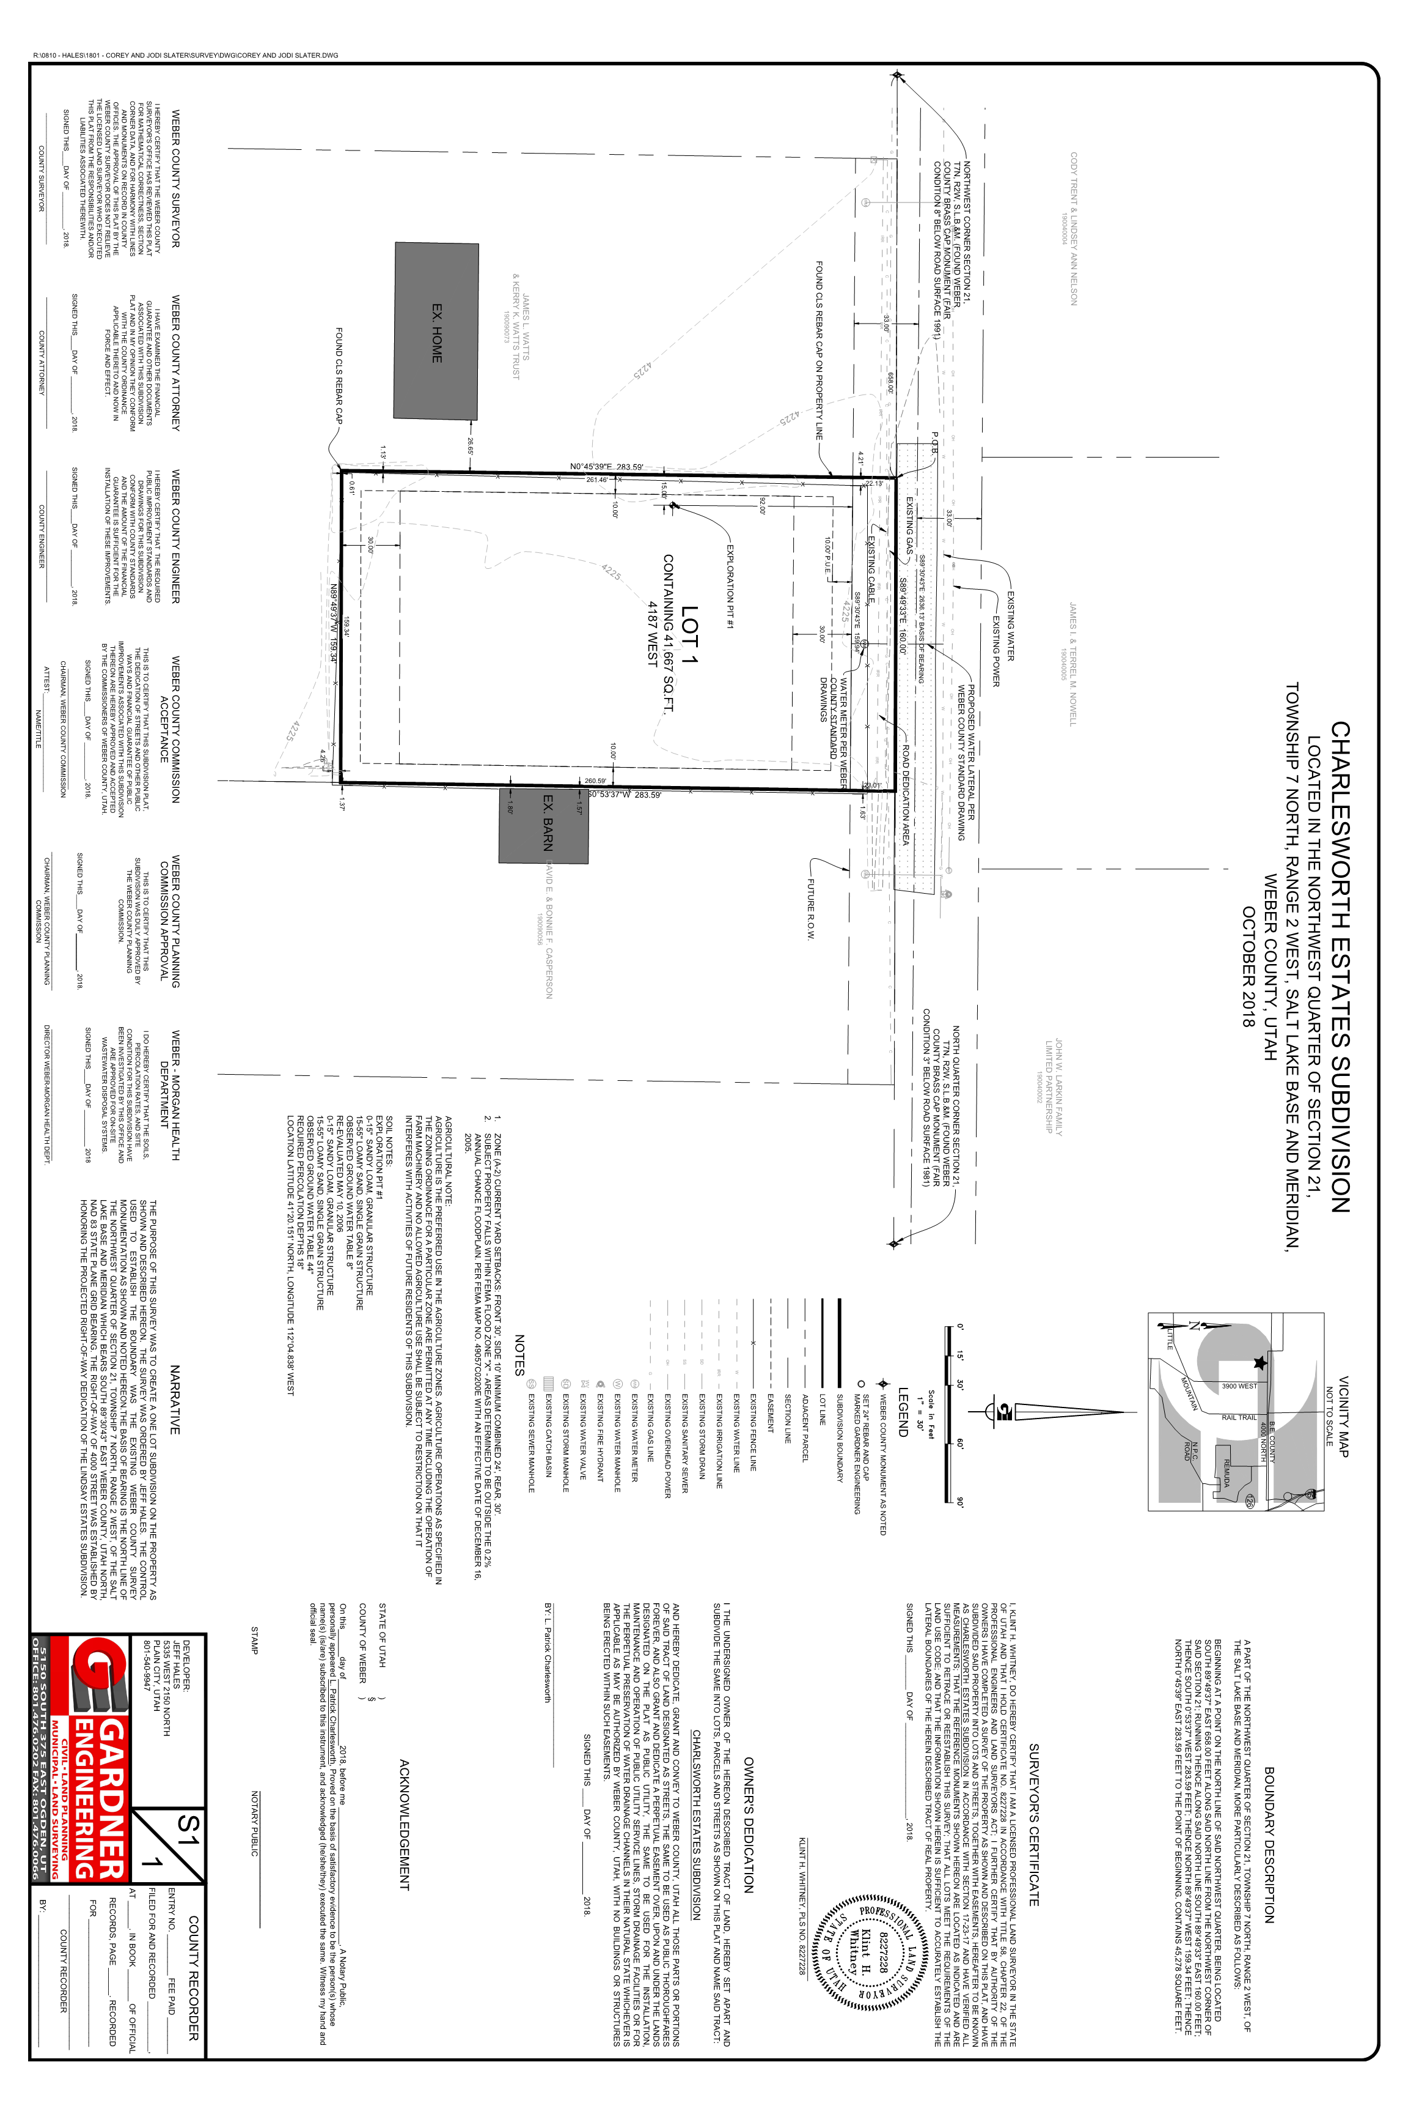

Exhibit B

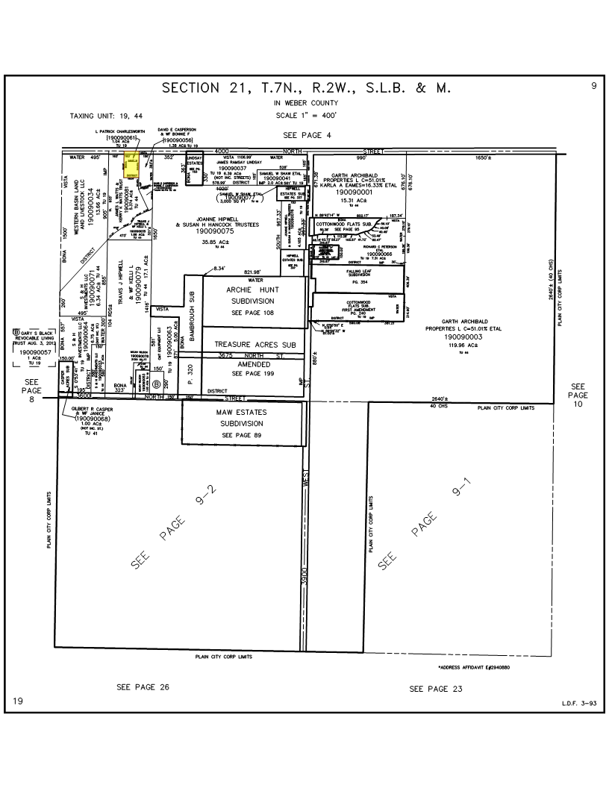

Exhibit C

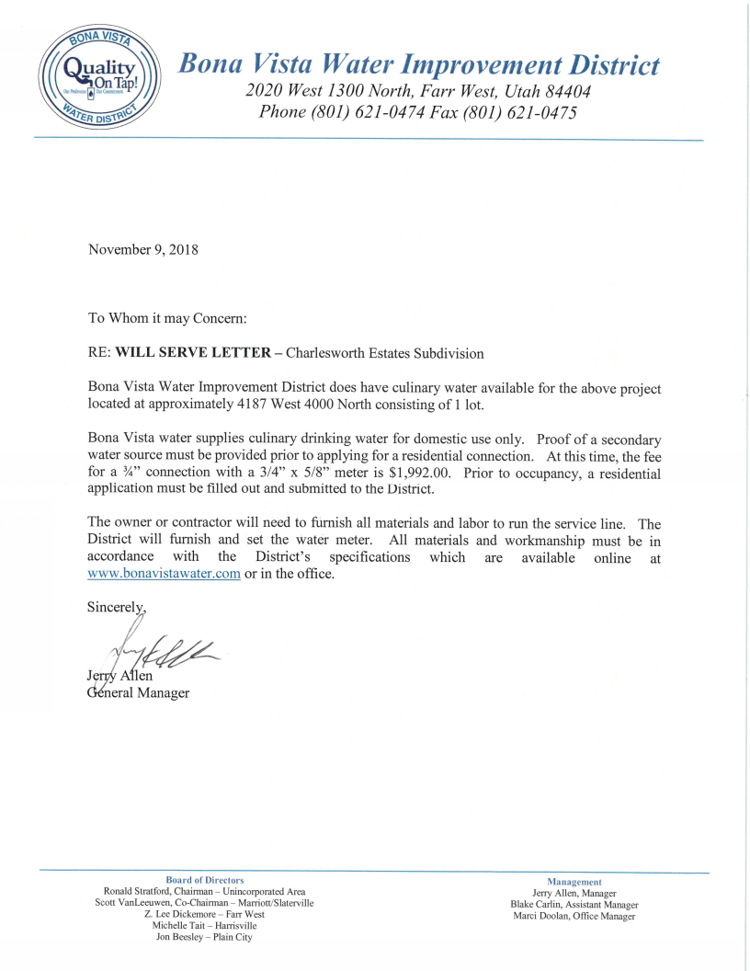

Exhibit D

