|  |  |
| --- | --- |
| **WC Logo.emf** | **Staff Report to the Western Weber Planning Commission**  *Weber County Planning Division* |
|  | |

****Synopsis****

****Application Information****

**Application Request:** Consideration and action for a conditional use request for Winston Park, a Planned Residential Unit Development consisting of 54 residential units, and two open space parcels, totaling approximately 17 acres, not including roads.

**Type of Decision: Administrative**

**Applicant: Wade Rumsey**

**Agenda Date: December 8, 2020**

**Approximate Address:** 3701 West 1800 South

**Project Area:** 40.259 Acres

**Zoning:** A-1

**Existing Land Use:** Residential/Agricultural

**Proposed Land Use:** Residential

**Parcel ID:** 15-078-0002

**Township, Range, Section:** T6N, R2W, Section 28 NE

****Adjacent Land Use****

**North:** 1800 South St. **South:** Agricultural

**East:** Agricultural **West:** Agricultural/Residential

****Staff Information****

**Report Presenter: Tammy Aydelotte**

[taydelotte@co.weber.ut.us](mailto:taydelotte@co.weber.ut.us)

**801-399-8794**

**Report Reviewer: SB**

Applicable Ordinances

* Title 101, Chapter 1 General Provisions, Section 7, Definitions
* Title 104, Zones, Chapter 5 Agricultural A-1 Zone
* Title 108, Chapter 1 Design Review
* Title 108, Chapter 4 Conditional Uses
* Title 108, Chapter 5 Planned Residential Unit Development
* Title 108, Chapter 8 Parking and Loading Space, Vehicle Traffic and Access Regulations

Summary and Background

This application is a conditional use permit request for a Planned Residential Unit Development. Receiving a recommendation for approval from the Planning Commission is the first step in the PRUD process. If the conditional use permit is approved by the Commission then the applicant will be allowed to begin the subdivision process. Winston Park PRUD includes 54 lots, ranging in size from 12,000-13,000 square foot lots. The open space will consist of two parcels totaling approximately 17 acres.

**This is not a cluster subdivision application, therefore the requirements for a cluster subdivision do not apply to this request for approval. There are no requirements regarding the suitability of soil conditions for open space dedication. An HOA will be created and tasked with maintenance of any proposed open space.**

Under the PRUD ordinance, a development is able to receive additional lots than what the zone normally allows. The extra density is called Bonus Density. **The applicant is eligible to receive a 30 percent bonus density based on the preservation of 30% of the adjusted gross acreage as open space, as defined in 101-1-7**. **However, if the applicant preserves open space area above 30 percent, the county may grant a bonus density of up to 50 percent.** Applicant is proposing to dedicate 40% of gross adjusted acreage as open space, and is therefore requesting 40% bonus density. Under the PRUD ordinance the applicant has chosen to do the following to warrant the requested additional density:

“The county may award bonus densities based on an accumulation of any combination of the following:

1. (a) If a PRUD provides and implements an approved roadway landscape and design plan that includes, but is not necessarily limited to, vehicle and pedestrian circulation, lighting, and street trees of an appropriate species, size of at least a two-inch caliper, and quantity of not less than eight trees for every 100 feet of road length, **up to 20 percent bonus density may be granted.**

…..

2. (d) If a PRUD provides a common area that offers easily accessible amenities such as trails, parks, or community gardens, that are open for use by the general public, **up to a 15 percent bonus density may be granted**.

There will be walking paths/sidewalks throughout the PRUD that will connect to sidewalk along 1800 South Street.

1. (g) 1. For a parcel containing at least ten acres but fewer than 20 acres, **up to a 15 percent bonus density may be granted.** The larger open space parcel contains over 15 acres, thus satisfying this requirement.

2. (i) If a PRUD provides for the development of excess sewage treatment capacity, up to a **five percent bonus density may be granted.**

With the combination of the above bonus density options, the applicant is able to receive up to **40 percent bonus density**.

**\*\***This item was presented in the December 8, 2020 meeting and a decision was tabled pending the applicant approaching the local parks district to investigate the possibility of donating the proposed open space. The applicant and the park district were unable to reach an agreement that benefitted both sides, so the applicant is continuing his request for open space.

Analysis

*General Plan:* The proposal conforms to the West Central Weber County General Plan by supporting agriculture and encouraging residential cluster style development with a minimum 30% open space.

*Zoning:* The subject property is located in the Agricultural A-1 Zone.

The purpose and intent of the A-1 zone is identified in the LUC §104-5-1 as:

*“The purpose of the A-1 Zone is to designate farm areas, which are likely to undergo a more intensive urban development, to set up guidelines to continue agricultural pursuits, including the keeping of farm animals, and to direct orderly low-density residential development in a continuing rural environment.”*

*Lot area, frontage/width and yard regulations*: The purpose and intent of a Planned Residential Unit Development (PRUD) is intended to *“allow for diversification in the relationship of various uses and structures to their sites and to permit more flexibility of such sites and to encourage new and imaginative concepts in the design of neighborhood and housing projects in urbanizing areas.”* The proposed PRUD utilizes the allowed flexibility to create neighborhoods with lots ranging in size from 0.23 acre lots to .99 acre lots and sized to accommodate single family homes.

The proposal includes the following minimum single family development standards:

* Yard development standards:

Front Yard: 20 feet

Side Yard: 6 feet

Rear Yard: 20 feet

* Maximum Building Height:
  + Single Family: 35’ (average building height)

Based on the allowed flexibility of a PRUD, the proposed layout, lot configurations and lot sizes are acceptable. In order to provide clear site standards at intersecting streets throughout the development, staff recommends adding to the minimum setback standards on the preliminary and final subdivision plats a setback for “Side, facing street corner lot”. This setback should be a minimum of 15 feet. A condition of approval has been added to staff’s recommendation to ensure the additional “Side, facing street corner lot: 15 feet” setback standard is added to the preliminary and final subdivision plats for review and approval as required per LUC §104-5-7.

During each individual phase, the County review agencies will be able to more thoroughly vet the preliminary and final development details to ensure that all conditions of approval and the applicable subdivision standards are met. Applicant is planning one phase for this development.

*Conditional Use Review:* The proposed PRUD is conditionally allowed in the A-1 zone. A review process has been outlined in LUC §108-4-3 to ensure compliance with the applicable ordinances and to mitigate anticipated detrimental effects. The standards for consideration for conditional use permits include:

* + Standards relating to safety for persons and property
  + Standards relating to infrastructure, amenities, and services
  + Standards relating to the environment
  + Standards relating to the current qualities and characteristics of the surrounding area and compliance with the intent of the general plan
  + Standards relating to performance
  + Standards generally
  + Voluntary contributions providing satisfactory compliance with applicable standards

These standards have been combined with the design review standards in this report. As a requirement of the conditional use permit, the applicant has provided a “Will-Serve Letter” from Taylor West Weber Water Improvement District and is working with Weber County Engineering regarding additional infrastructure for Central Weber Sewer District for culinary and waste water services. If the applicant has not already annexed into the Central Weber Sewer District, it must be completed prior to final approval of the subdivision within this proposed PRUD. The applicant, during the subdivision phase, will be required to provide proof of secondary water availability. The applicant has provided the required material to facilitate a thorough review of the proposed project including the project narrative, vicinity map, conceptual layout, and proposed landscaping for the development.

The general requirements for consideration by the County Commission for the proposed planned residential unit development include items such as the architectural design of buildings and their relationship on the site and development beyond the boundaries of the proposal; which streets shall be public and which shall be private; the entrances and exits to the development and the provisions for internal and external traffic circulation and off-street parking; the landscaping and screening as related to the proposed uses within the development and as a means of its integration into its surroundings; lighting and the size, location, design, and quality of signs if any; the residential density of the proposed development and its distribution as compared with the residential density of the surrounding lands, either existing or as indicated on the zoning map or general plan proposals of the county as being a desirable future residential density.

*Bonus Density Request:* The County may grant a bonus density of up to 30 percent if the applicant preserves open space area equal to or greater than 30 percent of the PRUD's adjusted gross acreage per LUC §108-5-5(c)(2). The proposal meets this bonus density requirement. If the applicant preserves open space area above 30 percent, the county may grant a bonus density of up to 50 percent; however, overall bonus density potential shall be no greater than a percentage equal to the percentage of the PRUD's total area preserved as open space. The proposal dedicates 16.320 acres of open space which is **46%** of the adjusted gross acreage (40.259 total area-4.873 acres of roads = 35.386 acres developable area); therefore qualifying for up to the 46 percent bonus density.

With the requested **42** percent bonus density, the applicant will be able to add an additional **16** units to the **38** base units for an overall density of **54** residential units.

*Design Review:* The proposed conditional use mandates a design review as outlined in the LUC §108-1 to ensure that the general layout and appearance of the development shall not impair the orderly and harmonious development of the neighborhood nor impair investment in and occupation of the neighborhood. As part of this review, the County Commission shall consider the relevant standards for the proposed conditional use and impose conditions to mitigate deficiencies where the plan is found deficient. The standards for consideration are as follows:

1. *Considerations relating to traffic safety and traffic congestion.* The proposal includes access from the existing County road identified as 1800 South. Along with the creation of 5 additional county roads, a sidewalk or pathway will be installed, and curb and gutter will wither be installed or deferred along 1800 South St, per County Engineering. Within the PRUD, sidewalk and park strips will be located on both sides of the roadway within the subdivision.
2. *Considerations relating to landscaping, screening and buffering.* The applicant has, on a conceptual level, addressed the areas in the development that will be landscaped. Staff feels that the landscaping, screening and buffering requirements of the Design Review as outlined in LUC §108-1-4(3) are met with the submitted landscape plan. Additional landscaping plans will be included in the preliminary and final subdivision design for the open space area and will be guaranteed with a financial guarantee upon recordation of the final subdivision plat.

Sidewalk along 1800 South Street shall be required, with a possible deferral for curb and gutter (Engineering requirements).

3) *Considerations relating to buildings and site layout.* The applicant has provided a concept plan showing the buildings and site layout (See Exhibit B). In reviewing the proposed layout, additional conditions, aside from those proposed in this staff report, are not required at this time.

*Common Area/Open Space:* The general requirements for a PRUD identify the need to preserve common open space. The applicant is proposing to preserve approximately 17 acres of agricultural property. The applicant has indicated, through a submitted narrative that the open space will be dedicated to wither grazing or farming, involving agreements with local residents who wish to utilize the open space for these purposes. The proposed layout identifies the agricultural parcel, and is labeled as such.

5) *Considerations relating to utility easements, drainage, and other engineering questions.* During the preliminary and final subdivision process, the applicant will be required to provide civil engineered drawings that identify the existing and proposed topography, contour lines, utilities, easements and drainages. The conceptual plans appear to provide adequate setbacks for the yard; however further evaluation will take place during the preliminary plan review. The applicant will need to adhere to all conditions of the Engineering Division including but not limited to easements and utilities to and through the property, site improvements and storm water drainage.

6) *Considerations relating to prior development concept plan approval associated with any rezoning agreement, planned commercial or manufacturing rezoning, or planned residential unit development approval.* The proposed site does not have any type of development agreement associated with the property; therefore considerations pertaining to this portion of the code are not applicable at this time.

*Review Agencies:* Due to the conceptual nature of the proposal, the Weber County Surveyor’s Office has not reviewed the proposal. The Weber Fire District has reviewed this project, requesting additional information. The Engineering Division has not yet reviewed the proposal. A condition of approval has been made part of the Planning Staff’s recommendations to ensure that any conditions of the applicable reviewing agencies are strictly adhered to.

*Public Notice:* Public notice is not required for conditional use applications.

Summary of County Commission Considerations

* Does this proposal comply with the applicable PRUD ordinance?
* In considering the proposed planned residential unit development, the County Commission shall review and consider the following, as applicable:
  + *The architectural concept of buildings and their relationship on the site and development beyond the boundaries of the proposal.*
  + *Which streets shall be public and which shall be private; the entrances and exits to the development and the provisions for internal and external traffic circulation and off-street parking.*
  + *The landscaping and screening as related to the proposed uses within the development and their integration into the surrounding area.*
  + *The residential density of the proposed development and its distribution as compared with the residential density of the surrounding lands, either existing or as indicated on the zoning map or general plan proposals of the county as being a desirable future residential density.*

Staff Recommendation

Staff recommends approval of the request for a conditional use request for Winston Park, a Planned Residential Unit Development consisting of 54 residential units, and two open space parcels (1.275 acres and 15.046 acres) used for agricultural purposes.

1. The following setback standard shall be added to the final subdivision plats for review and approval: Front – 20’, side – 6’, rear – 20’, corner lot with a side facing a street – 15’.
2. Street light design shall be approved by Planning Department prior to issuance of a conditional use permit.
3. Sidewalk, curb and gutter will be installed along the applicant’s frontage of 1800 South as well as along the roads within the subdivision.

This recommendation is based on the following findings:

1. The proposed PRUD conforms to the West Central Weber County General Plan.
2. The PRUD is intended to allow for more flexibility of residential building sites.
3. The building uses, locations, lot area, width, yard, height and coverage regulations proposed are acceptable as shown on the conceptual drawings.
4. Up to a 50 percent bonus density may be granted based on the following:
5. If the applicant preserves open space area above 30 percent, the county may grant a bonus density of up to 50 percent; however, overall bonus density potential shall be no greater than a percentage equal to the percentage of the PRUD's total area preserved as open space. The proposal dedicates approximately 17 acres of open space (two parcels) which is 50% of the adjusted gross acreage; therefore qualifying for up to the 50 percent bonus density.
6. The proposal will not be detrimental to the public health, safety, or welfare.
7. The proposal will not deteriorate the environment of the general area so as to negatively impact surrounding properties and uses.

Exhibits

1. Project Narrative and Bonus Density Calculations
2. Winston Park PRUD Conceptual Plan
3. Proposed Lot Layout
4. Culinary Water Preliminary Approval Letter

Location Map

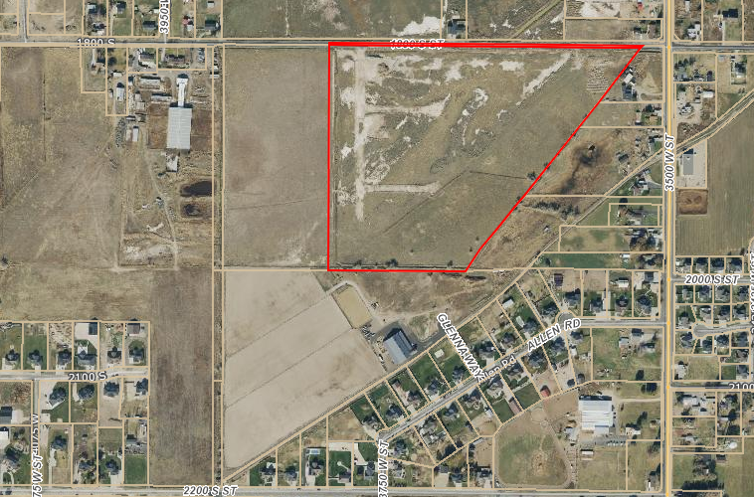

Subject Property

Exhibit A-Project Narrative and Bonus Density Calculations

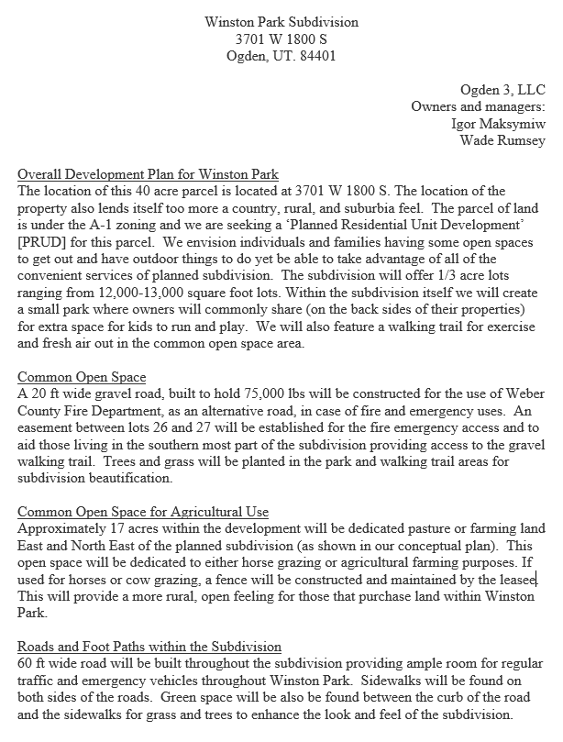

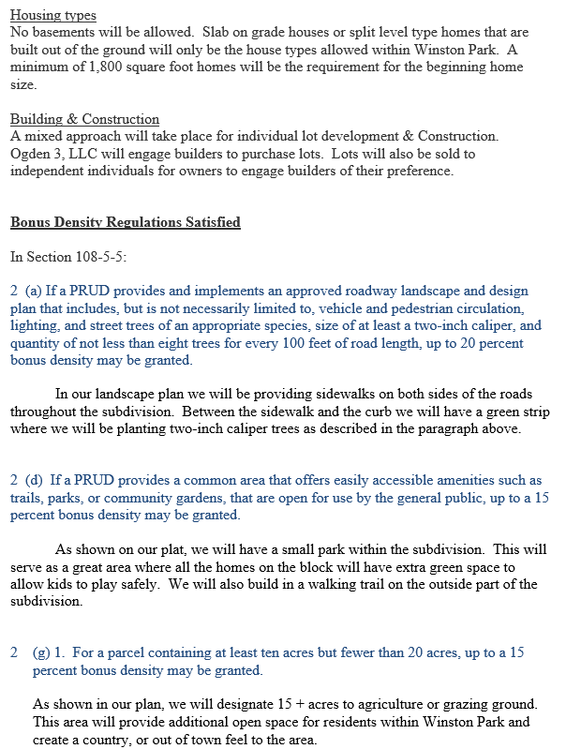

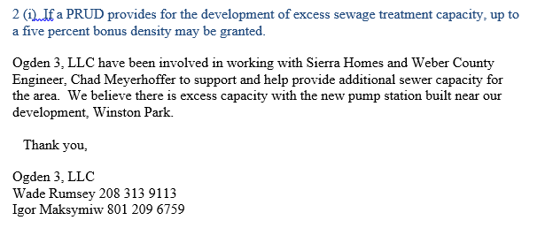

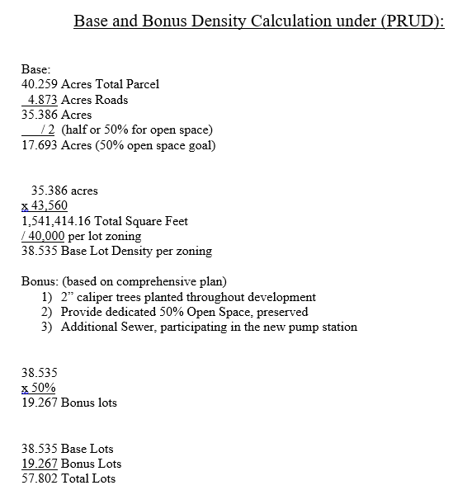

Exhibit B-Winston PRUD Landscaping Plans

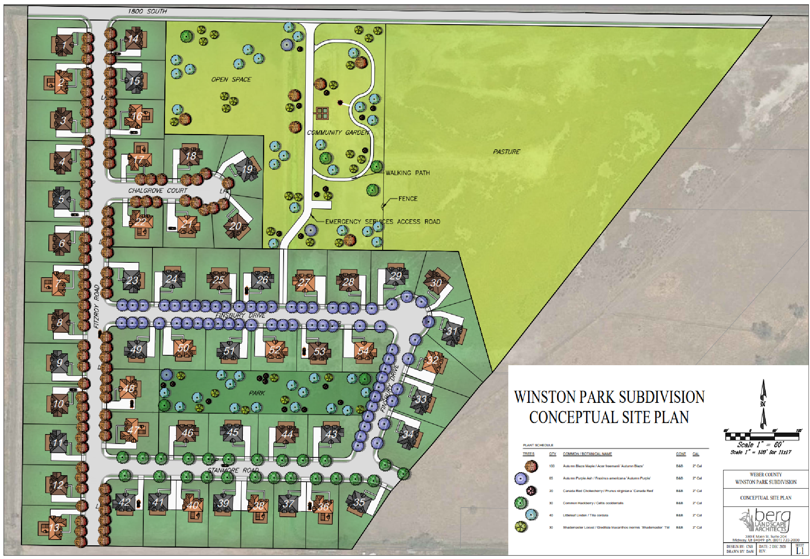

Exhibit C-Proposed Lot Layout

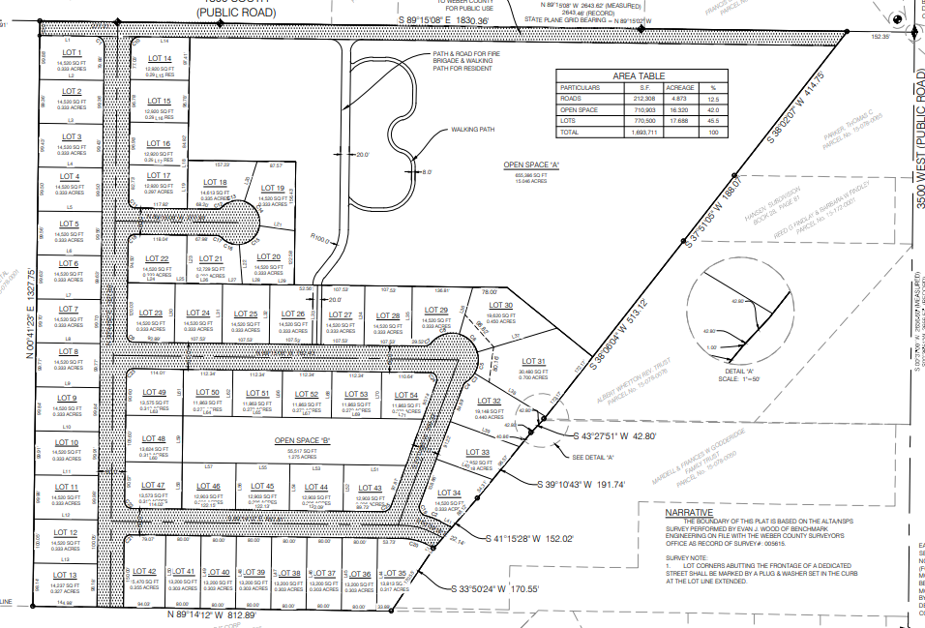

Exhibit D-Culinary Water Preliminary Approval

