PINEAE GREENHOUSES, INC.
BUILDING ELEVATION PHOTOS

S-3 and S-4 GREENHOUSES – OUTSIDE FRONT VIEWS

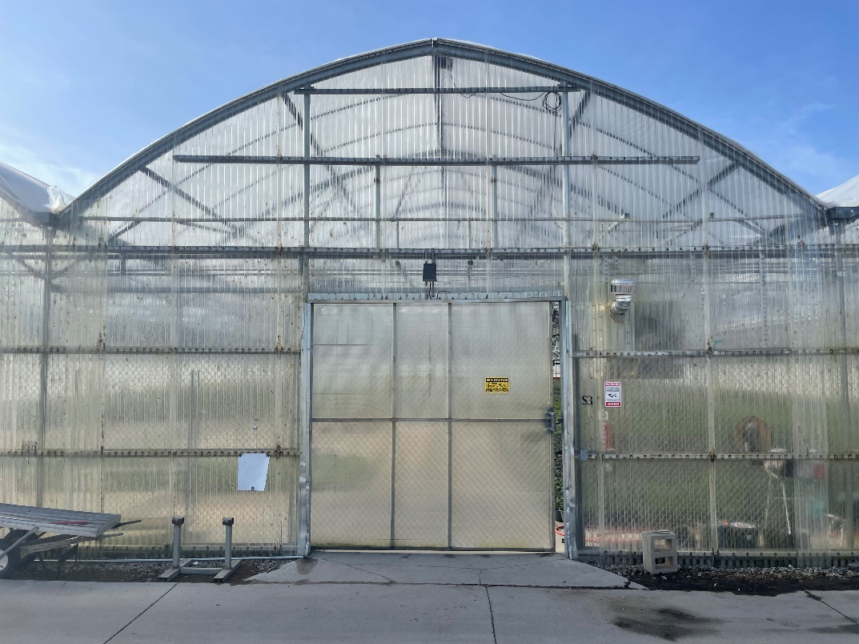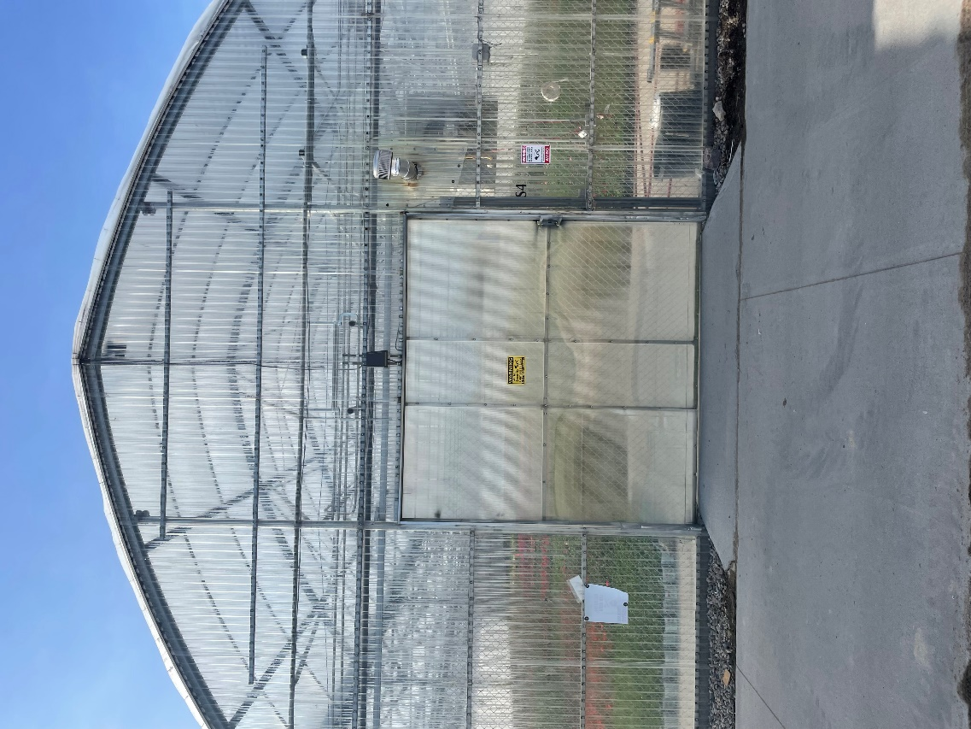
S-3 and S-4 GREENHOUSES – OUTSIDE SIDE VIEWS

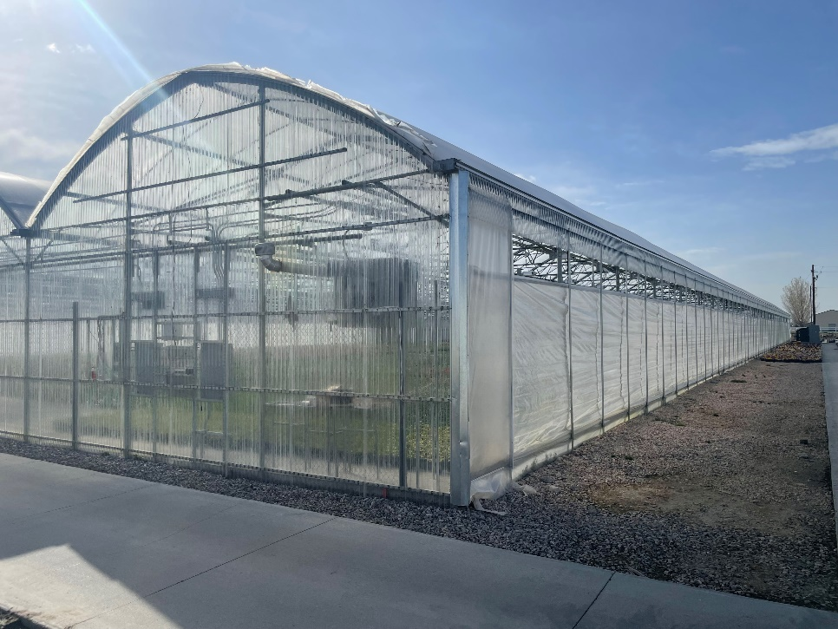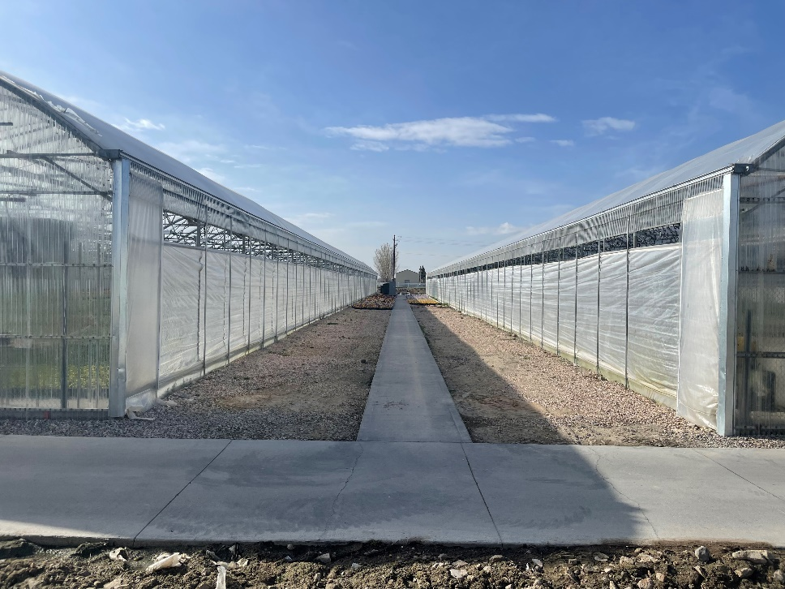

S-4 EXTENTION GREENHOUSE – OUTSIDE FRONT/SIDE/BACK VIEWS AND CONNECTED TO S-4 GREENHOUSE

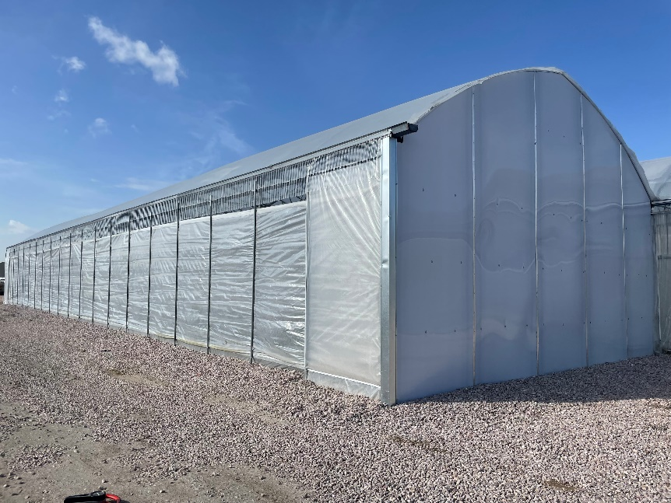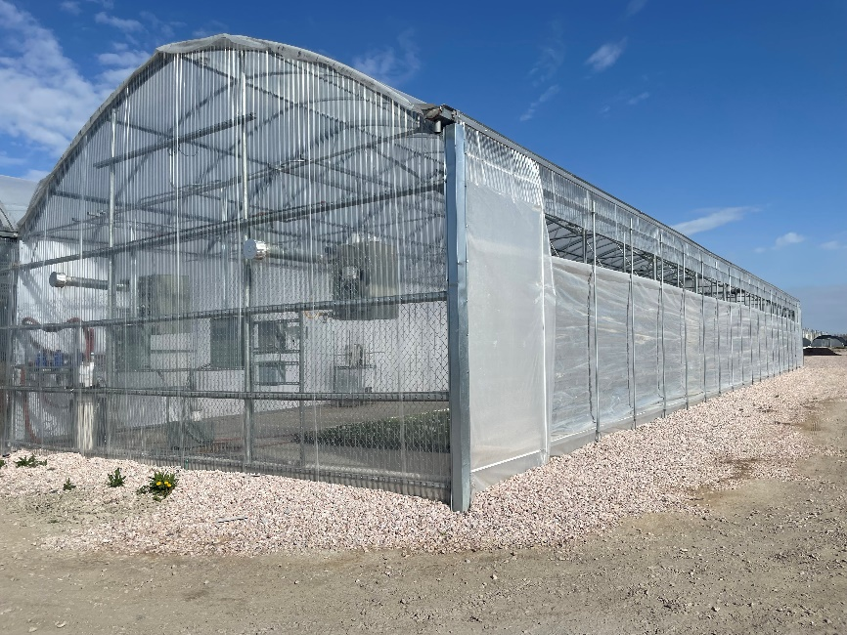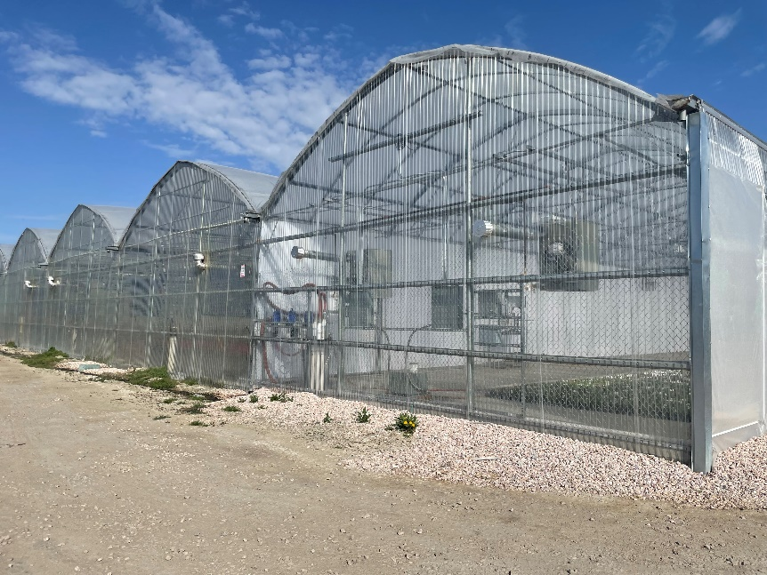

S-3, S-4, and S-4 EXTENTION GREENHOUSES PHOTO

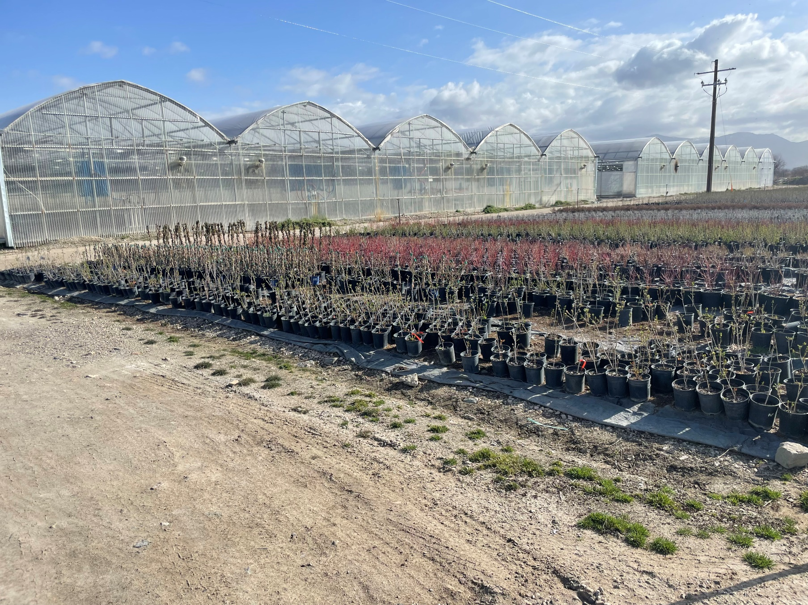
S-3 and S-4 GREENHOUSES – INSIDE VIEWS

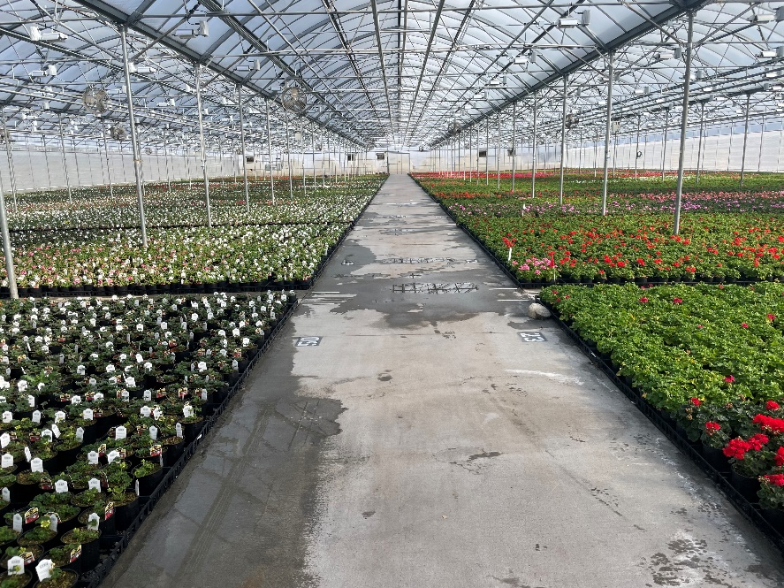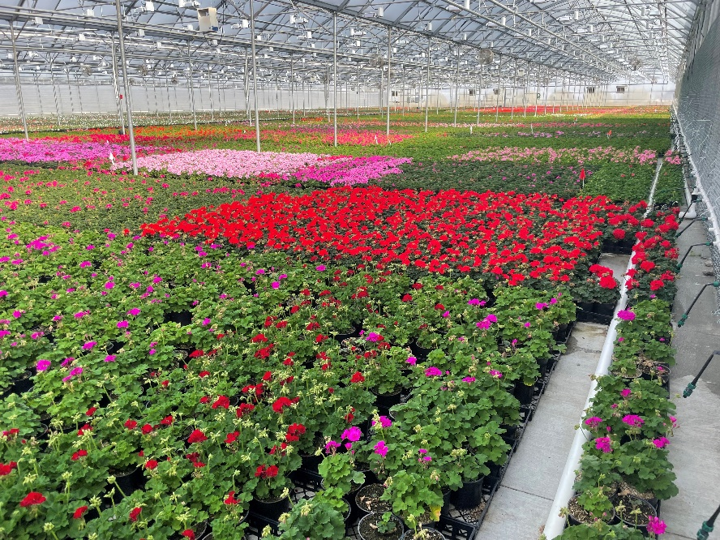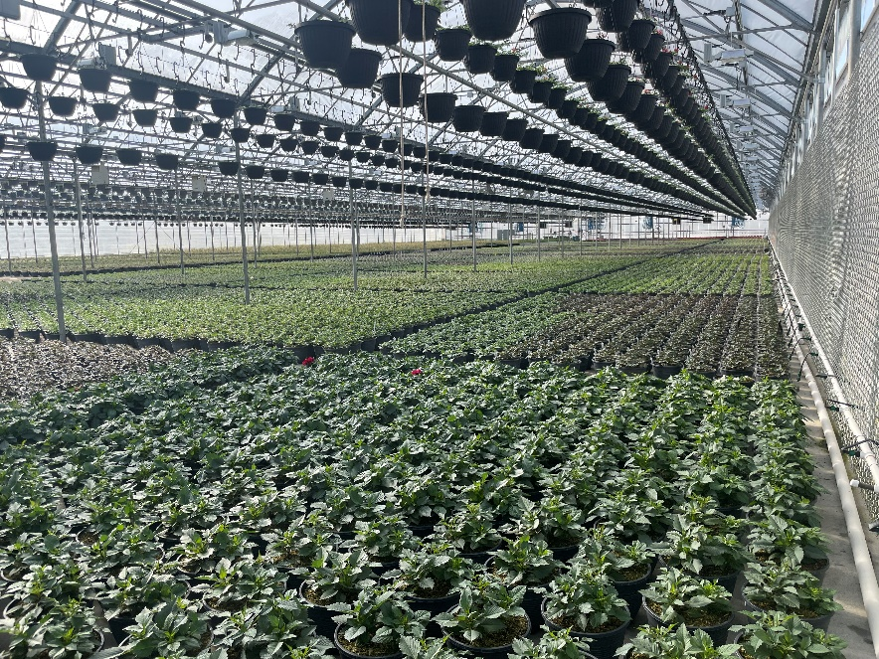
S-4 EXTENTION GREENHOUSE – INSIDE VIEWS

