|  |  |
| --- | --- |
| **WC Logo.emf** | **Staff Report to the Weber County Commission**  *Weber County Planning Division* |
|  | |

**Synopsis**

**Application Information**

**Application Request:** To hold a public hearing to consider and take action on a request to amend the Weber County Zone Map by realigning the O-1 and RE-15 boundary along the western edge of The Highlands at Wolf Creek Phases one and five, and to approve a rezoning ordinance.

**Agenda Date:** Tuesday, February 12, 2019

**Initiated by:** Weber County Planning Staff

**File Number:** ZMA 2018-08

**Property Information**

**Approximate Address:** 5500 East Aspen Glow Street (Eden, Unincorporated Weber County)

**Zoning:** Areas currently zoned O-1 and RE-15

**Existing Land Use:** Residential

**Proposed Land Use:** Residential Estates (RE-15) and Open Space Zone (0-1)

**Township, Range, Section:** T7N, R1E, Section 23

**Adjacent Land Use**

**North:** Open Space **South:** Residential

**East:** Open Space **West:** Open Space

**Staff Information**

**Report Presenter:** Felix Lleverino

flleverino@webercountyutah.gov

801-399-8767

**Report Reviewer:** CE

**Applicable Ordinances**

§102-5: Rezoning Procedures

**Summary**

This application is a staff-driven request to amend the Weber County zone map by realigning the O-1 and RE-15 boundary along the western edge of The Highlands at Wolf Creek Phases one and five. The RE-15 zone is intended for medium density residential and agricultural uses, with a minimum lot size of 15,000 square feet. The O-1 zone is intended to preserve open space where plants and animals can be studied and where residential dwellings are not allowed.

Weber County Surveying has provided descriptions for the areas incidental to this zoning map amendment proposal that is included with the ordinance (see Figure 1).

Page 16 of the general plan indicates that open space in the Ogden Valley is for the preservation of areas that may be used for and continued agricultural operations and low intensity uses. This zoning boundary re-alignment would create a defined line between residential uses and open space that follows the subdivision boundary of the Highlands at Wolf Creek Phases one and five.

The Ogden Valley Planning Commission has forwarded a decision with a unanimous positive recommendation to the County Commission. Staff is offering a positive recommendation for the zoning boundary re-alignment based on its compliance with the general plan.

**ORDINANCE NUMBER** 2019-

**An ordinance amending the Weber County Zoning Map to realign a zoning boundary on the west side of The Highlands at Wolf Creek Phases one and five.**

**WHEREAS,** the Weber County Board of Commissioners have adopted a zoning map amendment for the unincorporated areas of Weber County; and

**WHEREAS,** the Weber County Board of Commissioners have received an application to amend the adopted zoning map for a parcel of land located on the western boundary of The Highlands at Wolf Creek Phases one and five; and

**WHEREAS,** after a duly noticed public hearing, the Ogden Valley Planning Commission has given a recommendation on the map amendment to the Weber County Board of Commissioners; and

**WHEREAS,** after a duly noticed public hearing, the Weber County Board of Commissioners have determined that the zoning map amendment complies with the intent of the Ogden Valley General Plan; and

**WHEREAS,** the Board of Weber County Commissioners have also determined that the proposed zoning map amendment is not detrimental to the health, safety, and general welfare of the area; and

**WHEREAS,** the Board of Weber County Commissioners have determined the proposed zoning map amendment will promote a more aesthetic and uniform zoning map that will follow the boundary of the respective subdivision boundary; and

**WHEREAS,** as part of their consideration, the Weber County Board of Commissioners have determined that the surrounding land uses do not pose a conflict with the proposed zoning map amendment;

**NOW, THEREFORE,** the Weber County Board of Commissioners ordains an amendment to the Weber County Zoning Map to realign a zoning boundary on the west side of The Highlands at Wolf Creek Phases one and five. The graphic representation of the rezone is included and incorporated herein as Exhibit A. A written description of the rezone is included as Exhibit B through E. In the event, there is a conflict between the two, the graphic representation shall prevail.

This ordinance shall become effective fifteen (15) days after publication.

Passed, adopted, and ordered published this day of , 2019, by the Weber County Board of Commissioners.

BOARD OF COUNTY COMMISSIONERS OF WEBER COUNTY

By_____________________________,

Scott K Jenkins, Chair

Commissioner Jenkins voted ______

Commissioner Harvey voted ______

Commissioner Froerer voted ______

ATTEST:

________________________________________

Ricky Hatch, CPA

Weber County Clerk/Auditor

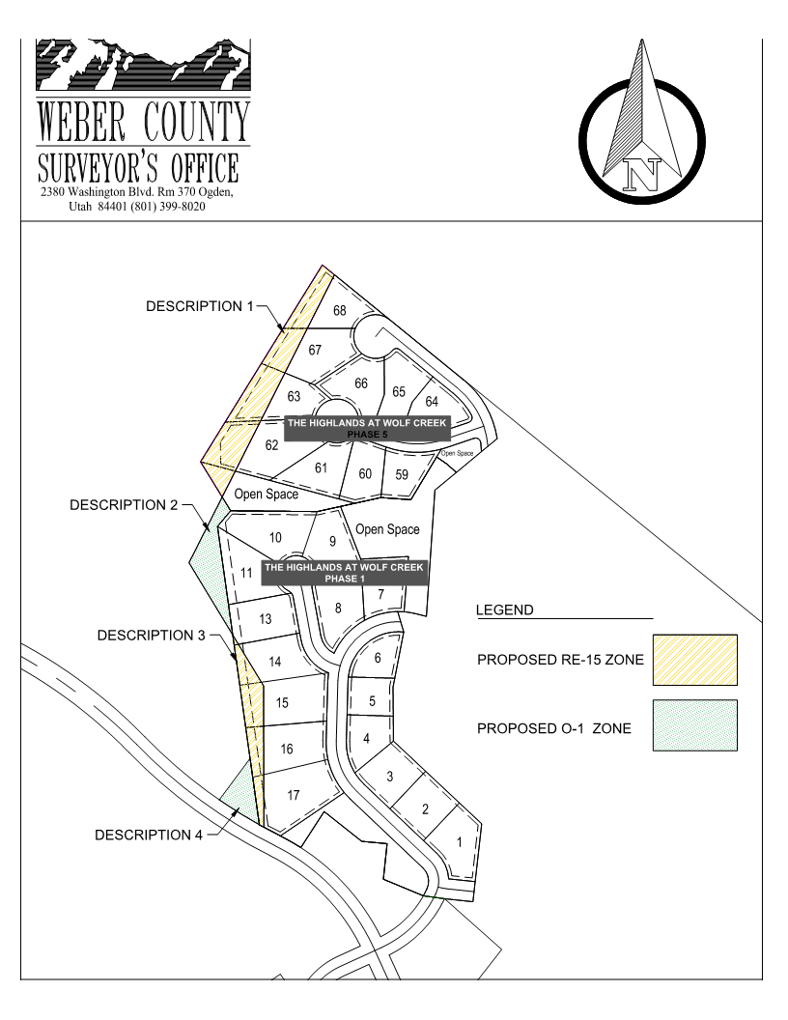

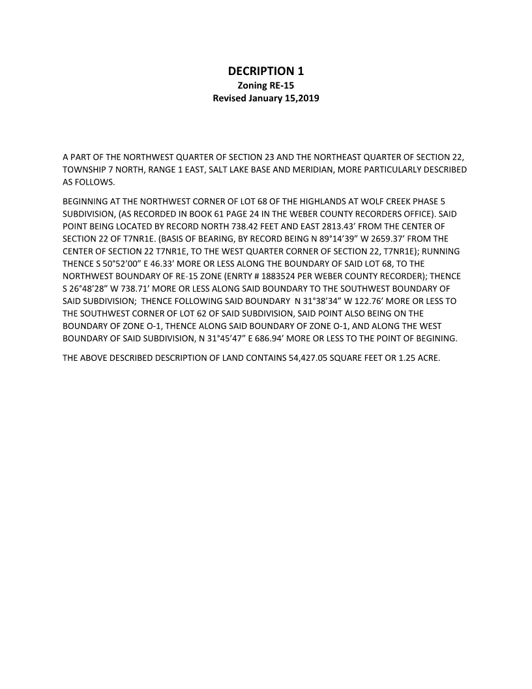

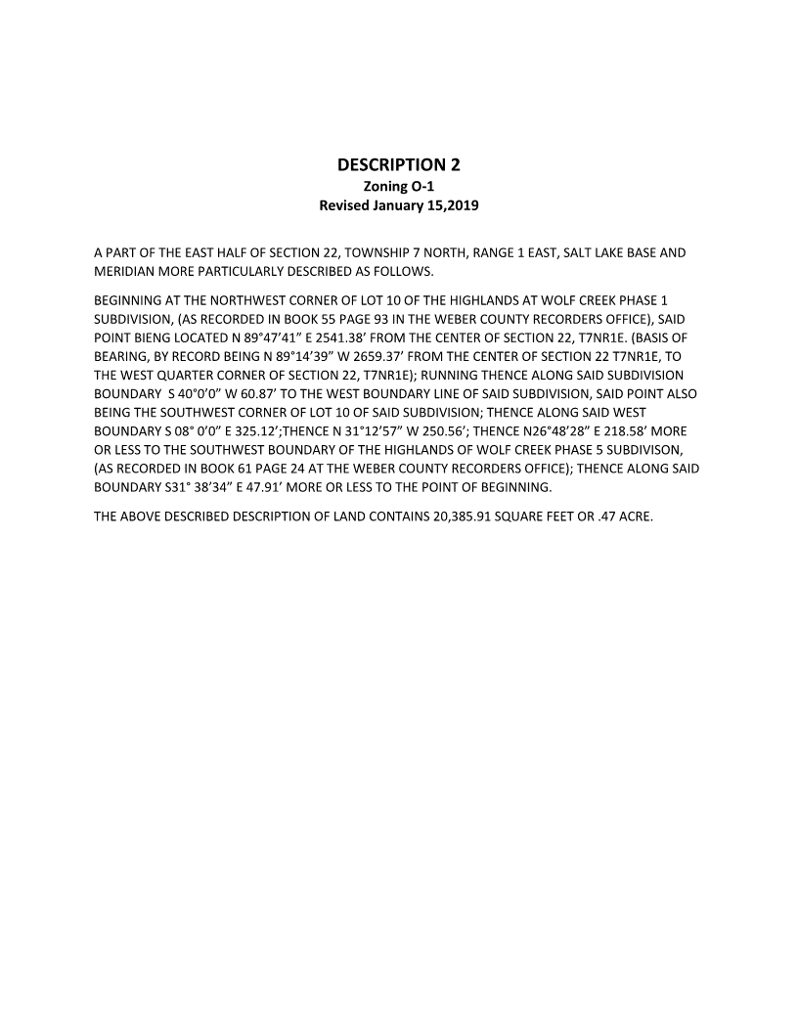

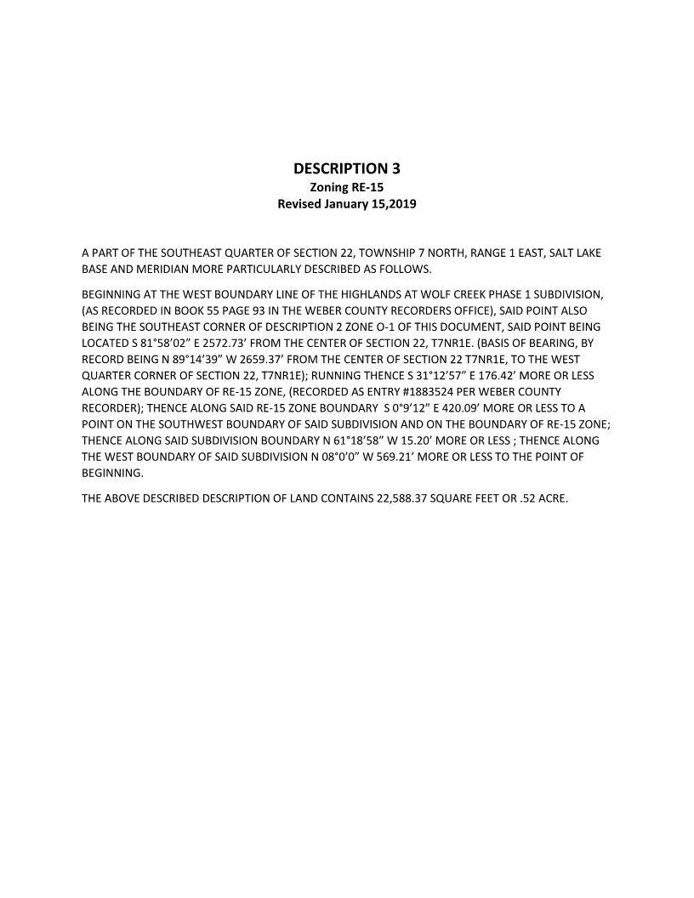

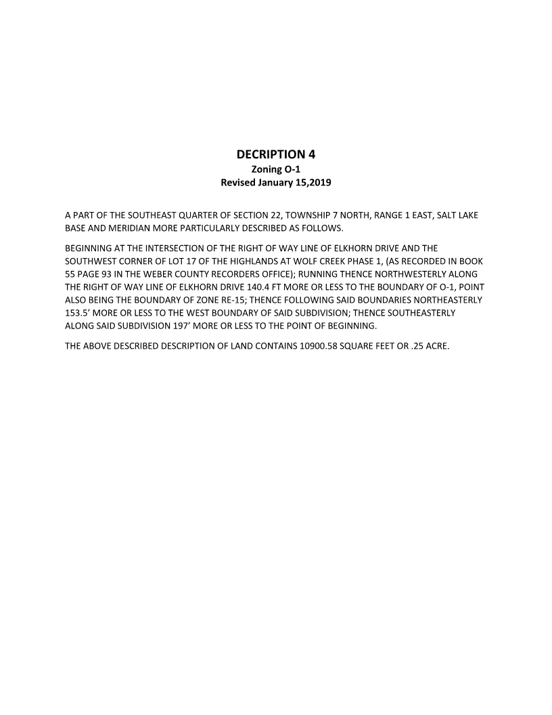

|  |  |
| --- | --- |
| **WC Logo.emf** | **Staff Report to the Ogden Valley Planning Commission**  *Weber County Planning Division* |
|  | |

**Synopsis**

**Application Information**

**Application Request:** To consider and take action on a request to amend the Weber County zone map by realigning the O-1 and RE-15 boundary along the western edge of The Highlands at Wolf Creek Phases one and five.

**Agenda Date:** Tuesday, January 22, 2019

**Initiated by:** Weber County Planning Staff

**File Number:** ZMA 2018-08

**Property Information**

**Approximate Address:** 5500 East Aspen Glow Street (Eden, Unincorporated Weber County)

**Zoning:** Areas currently zoned O-1 and RE-15

**Existing Land Use:** Residential

**Proposed Land Use:** Residential Estates (RE-15) and Open Space Zone (0-1)

**Township, Range, Section:** T7N, R1E, Section 23

**Adjacent Land Use**

**North:** Open Space **South:** Residential

**East:** Open Space **West:** Open Space

**Staff Information**

**Report Presenter:** Felix Lleverino

flleverino@webercountyutah.gov

801-399-8767

**Report Reviewer:** CE

**Applicable Ordinances**

§102-5: Rezoning Procedures

**Legislative Decisions**

When the Planning Commission is acting as a recommending body to the County Commission, it is acting in a legislative capacity and has wide discretion. Examples of legislative actions are general plan, zoning map, and land use code amendments. Legislative actions require that the Planning Commission give a recommendation to the County Commission. For this circumstance, criteria for recommendations in a legislative matter require compatibility with the general plan and existing ordinances.

**Summary**

This application is a staff-driven request to amend the Weber County zone map by realigning the O-1 and RE-15 boundary along the western edge of The Highlands at Wolf Creek Phases one and five. The RE-15 zone is intended for medium density residential and agricultural uses, with a minimum lot size of 15,000 square feet. The O-1 zone is intended to preserve open space where plants and animals can be studied and where residential dwellings are not allowed.

Weber County Surveying has provided descriptions for the three areas incidental to this zoning map amendment proposal that will be included with the ordinance.

Page 16 of the general plan indicates that open space in the Ogden Valley is for the preservation of areas that may be used for and continued agricultural operations and low intensity uses. This zoning boundary re-alignment would create a defined line between residential uses and open space that follows the subdivision boundary of the Highlands at Wolf Creek Phases one and five.

Staff is offering a positive recommendation for the zoning boundary re-alignment based on its compliance with the general plan.

**Policy Analysis**

The Weber County Land Use Code has a chapter that governs application-driven rezones. Even though this is a staff-driven application many of the procedures are applicable. The following is a policy analysis of the staff recommended zoning boundary re-alignment based on the Land Use Code and best planning practices.

*Zoning.* The current zones of the subject areas are RE-15 and O-1. Figures 1-4 display current zoning and the parcels affected by the proposed zoning boundary realignment. The RE-15 zone is intended for medium density residential and agricultural uses, with a minimum lot size of 15,000 square feet.

Weber County Code § 104-3-1 says the purpose of the RE-15 zone is:

*“to provide and protect residential development at a low density in a semi-agricultural or rural environment. It is also to provide for certain rural amenities on larger minimum lots, in conjunction with the primary residential nature of the zone.”*

Weber County Code § 104-26-1 says the purpose of the O-1 zone is:

*“The open space zone is specifically intended to encourage the preservation of a natural environment in an otherwise urban setting; to hold for future generations open space in which plants and animals can be protected and studied; to inhibit erection of unnecessary buildings on a floodplain, on areas of severe slope, areas of fault line and rock slides; to provide suitable areas for recreation and relaxation, and to alleviate stream pollution.”*

On March 17, 2005, The Highlands at Wolf Creek was recorded with the zoning lines in place as is shown on the subdivision plat (see Exhibit B).

*General plan.* Weber County Code § 102-5-2 specifies that rezoning should be in compliance with the general plan. This zoning map re-alignment does not conflict with Ogden Valley General Plan and is part of an overall zoning map maintenance measure that will result in a more accurate and aesthetic map. **Figure 5** shows the Ogden Valley General Plan Current Zoning Map that will not require an amendment due to the minute nature of the boundary re-alignment and the small scale of the Current Zoning Map.

*Rezoning.* Weber County Code § 102-5-3 sets forth approval criteria when considering a rezone. Because a rezone is legislative, this criterion allows broad deference to the County Commission’s legislative decision-make authority. The criterion is twofold:

*(a) To promote compatibility and stability in zoning and appropriate development of property within the county, no application for rezoning shall be approved unless it is demonstrated that the proposed rezoning promotes the health, safety, and welfare of the county and the purposes of this chapter.*

*(b) The planning commission and the county commission will consider whether the application should be approved or disapproved based upon the merits and compatibility of the proposed project with the general plan, surrounding land uses, and impacts on the surrounding area. The commissions will consider whether the proposed development and in turn the application for rezoning, is needed to provide a service or convenience brought about by changing conditions and which therefore promotes the public welfare. The county commission may require changes in the concept plan in order to achieve compatibility and may impose any conditions to lessen or eliminate adverse impacts.*

**Staff Recommendation**

Staff recommends that the Planning Commission forward a positive recommendation to the County Commission regarding File #ZMA 2018-08, a proposal to consider and take action on a request to amend the Weber County zone map by realigning the O-1 and RE-15 boundary along the western edge of The Highlands at Wolf Creek Phases one and five. This recommendation comes with the following findings:

1. The Ogden Valley General Plan does not conflict with this proposal.
2. The proposed zoning map amendment will promote a more aesthetic and uniform zoning map that will follow the boundary of the respective subdivision boundary.
3. The surrounding land uses do not pose a conflict with the proposed zoning map amendment.

**Exhibits**

A: The Highlands at Wolf Creek Phase 1

B: The Highlands at Wolf Creek Phase 5

C: The Highlands at Wolf Creek Zoning Boundary Re-Alignment Map

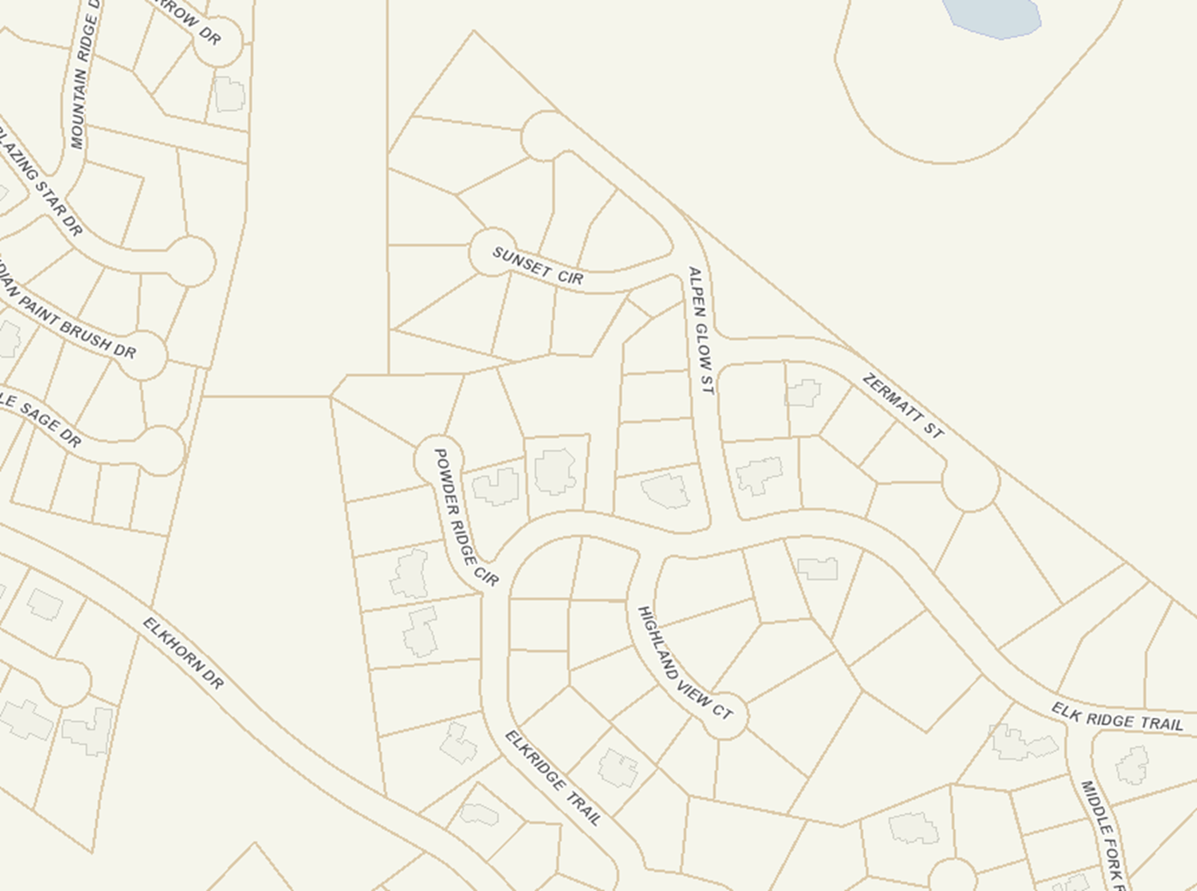

HIGHLANDS HOA

WCU LLC DBA WOLF CREEK UTAH LLC

ADAMS FAMILY TRUST

ZIMMER

BUDGEE TRUST

MENSIES

WILKERSON

LEDENE

PETRIE

LABAN

NTC & CO LLP TRUSTEE

Phase 1

Phase 5

**Figure 1: Current Zoning Map and the Subject Parcels**

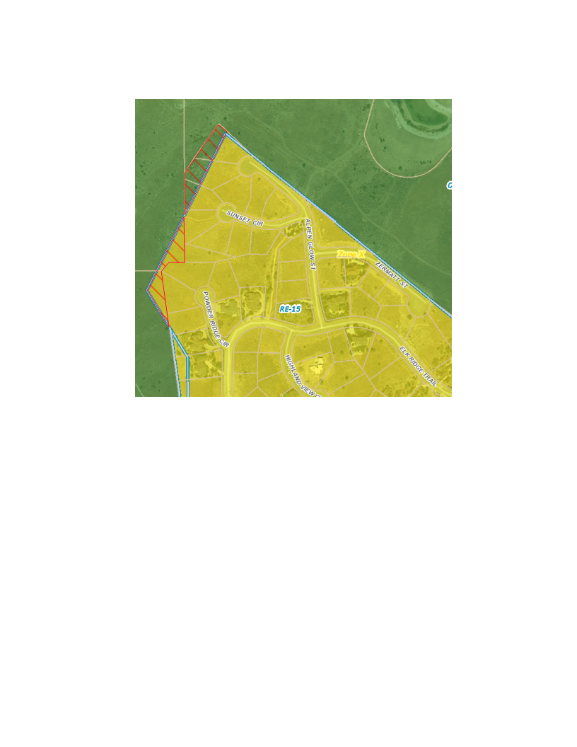

**Figure 2: Proposed Zoning Map and the Subject Parcels**

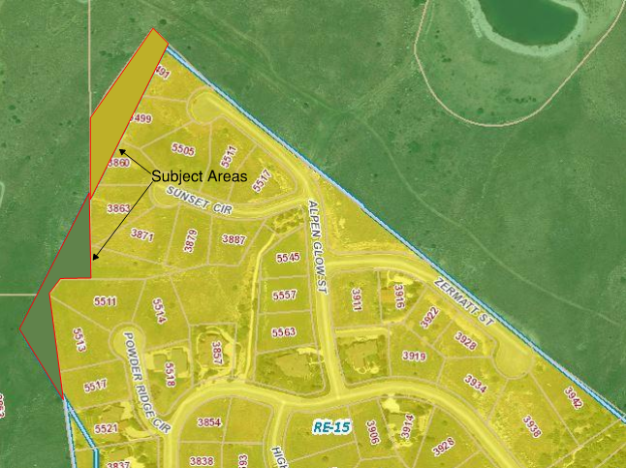

**Figure 3: Current Zoning Map and Subject Parcel**

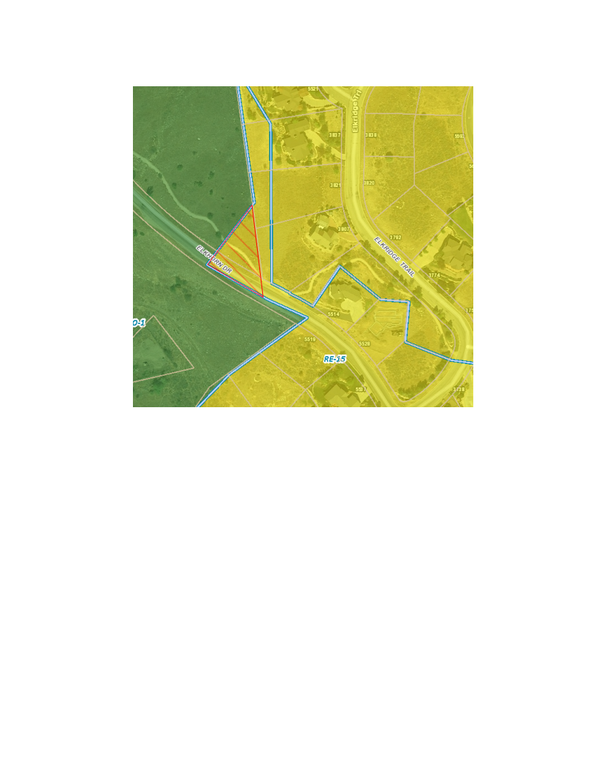

**Figure 4: Proposed Zoning Map and the Subject Parcel**

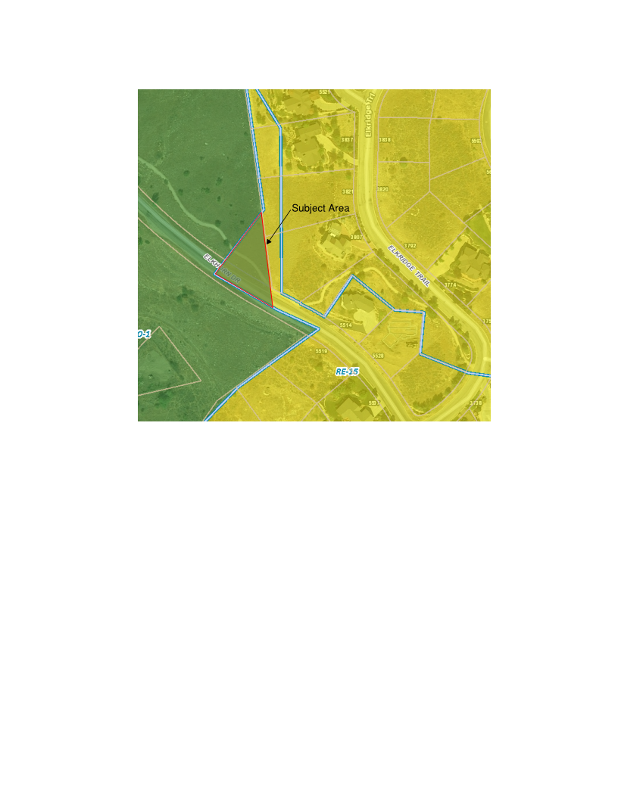

**Figure 5: Current Zoning Map of the Ogden Valley’s General Plan.**

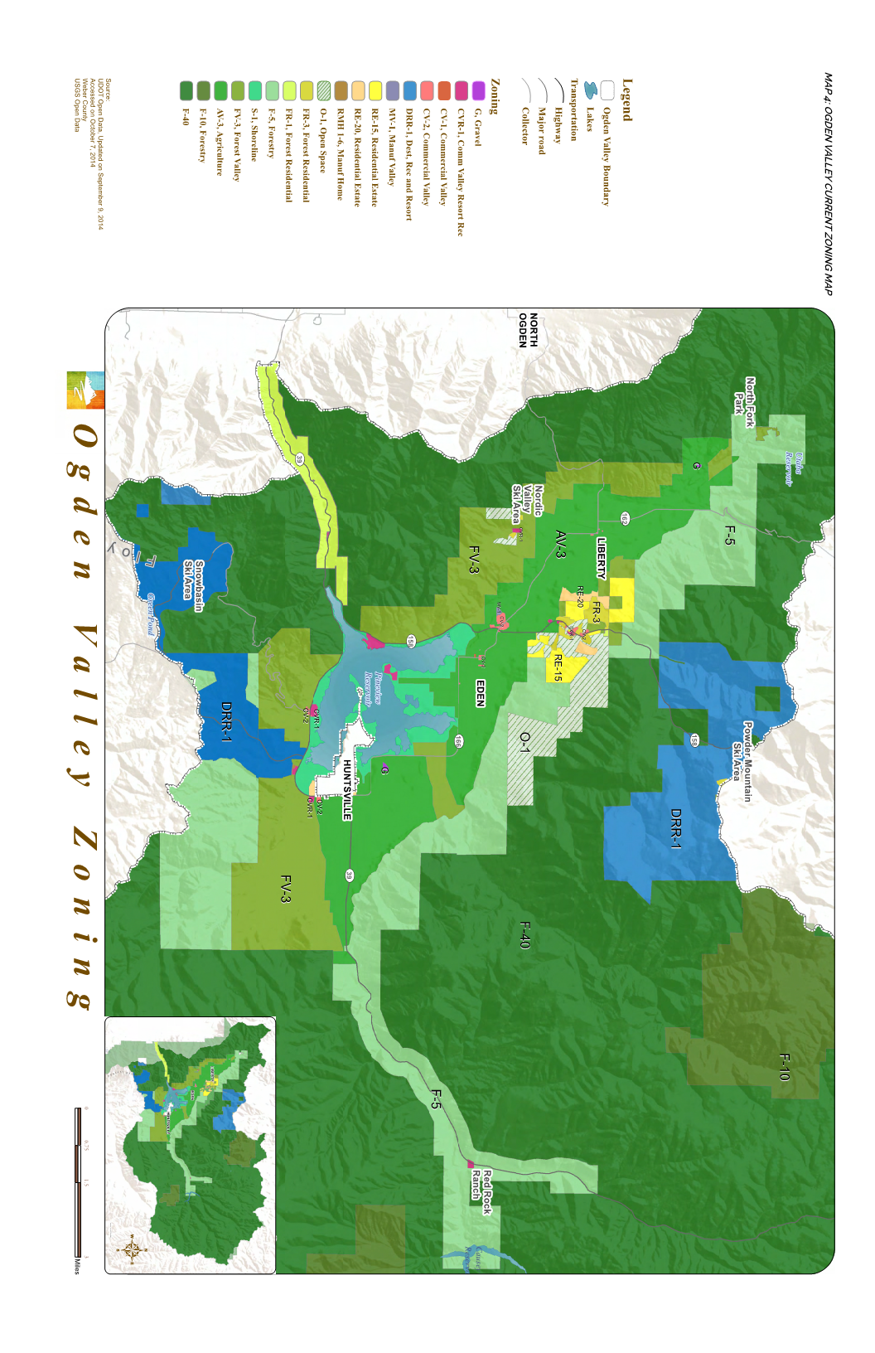

**Exhibit A**

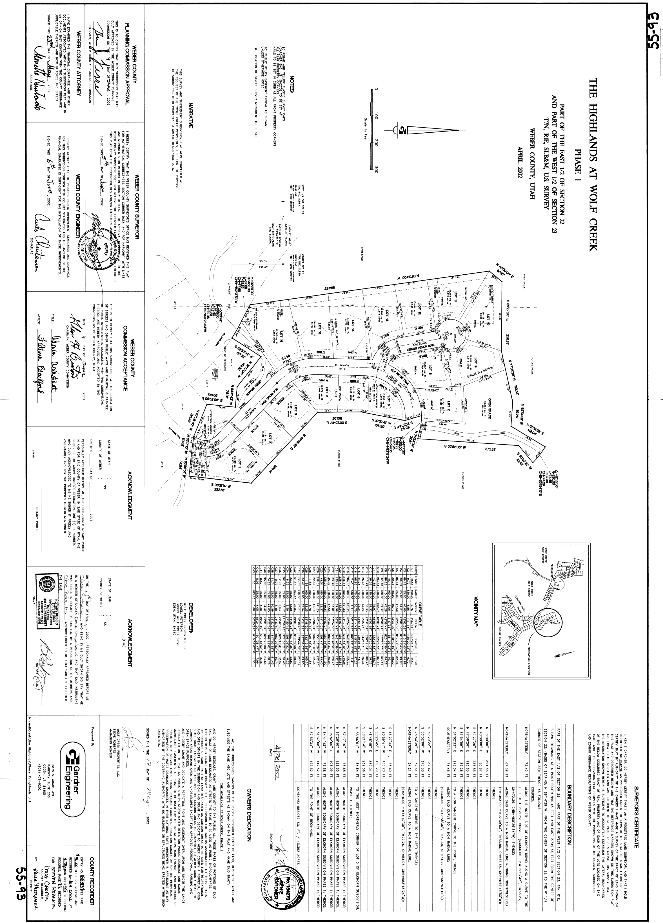

**Exhibit B**

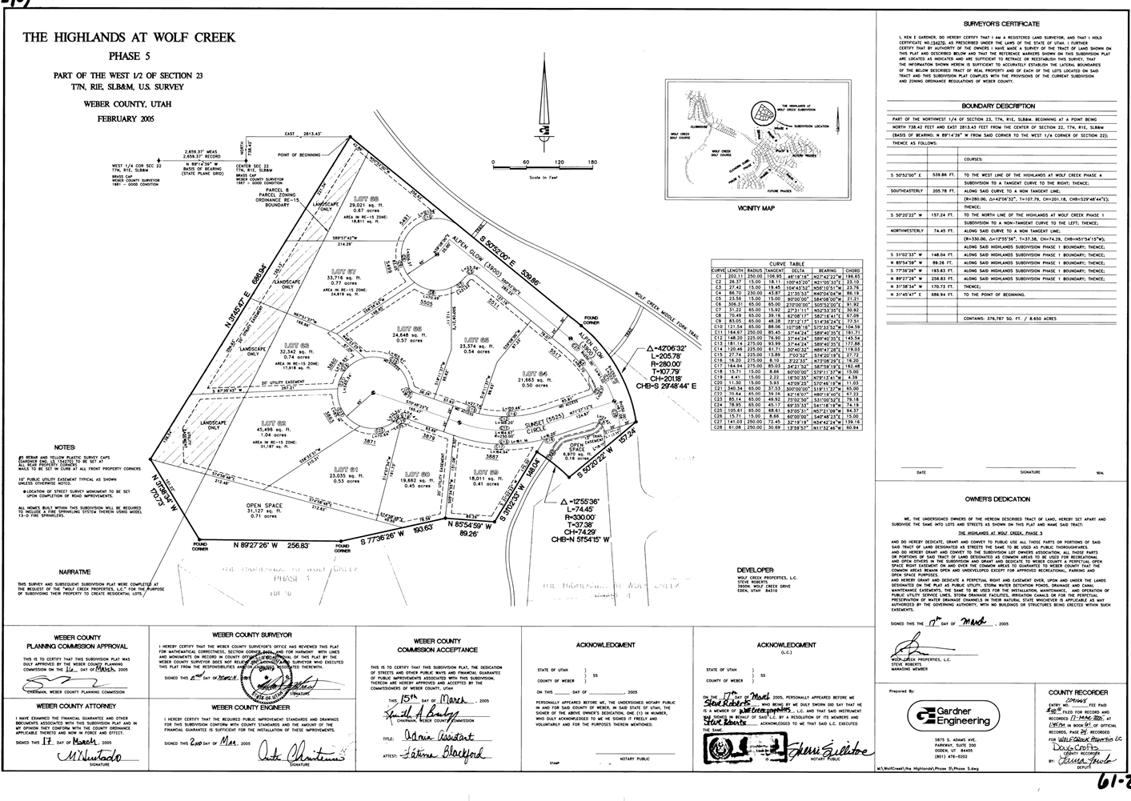

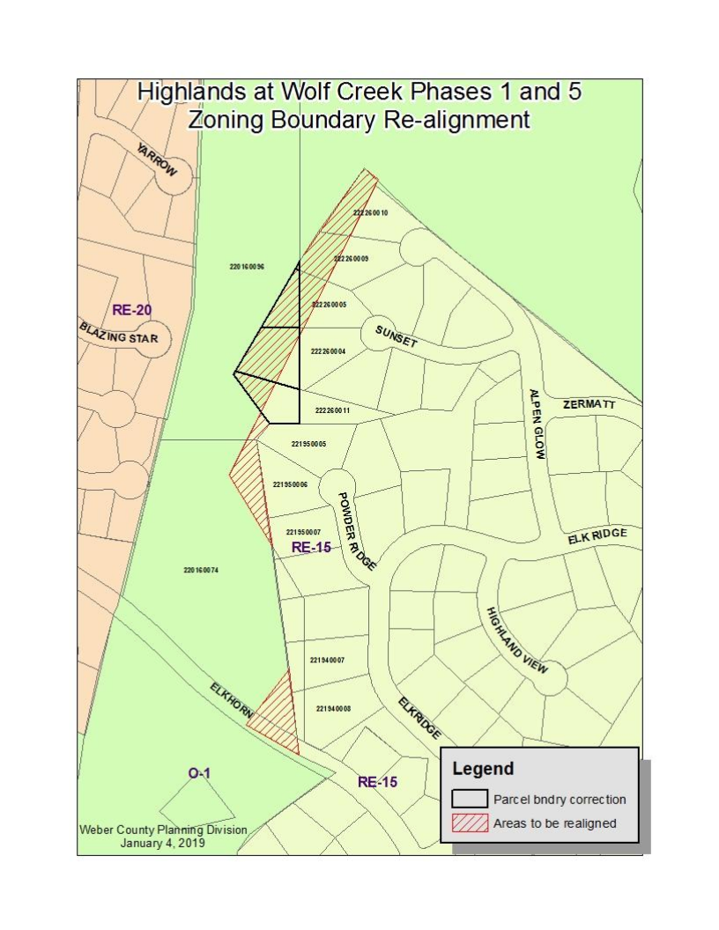**Exhibit B**