|  |  |
| --- | --- |
| **WC Logo.emf** | **Staff Report to the Weber County Planning Commission**  *Weber County Planning Division* |
|  | |

****Synopsis****

****Application Information****

**Application Request:** A request for design review approval to construct a new greenhouse that will be added to a large scale growing operation named Pineae Greenhouses.

**Type of Decision: Administrative**

**Agenda Date: February 12, 2019**

**Applicant:** Pineae Greenhouses

**Authorized Agent:** Brian Gold

**File Number:** DR# 2019-01

****Property Information****

**Approximate Address:** 1901 S 5100 W, Taylor

**Project Area:** 75 Acres

**Zoning:** Agricultural (A-2) Zone

**Existing Land Use:** Plant and tree nursery

**Proposed Land Use:** Plant and tree nursery

**Parcel ID:** 15-081-0031

**Township, Range, Section:** Township 6 North, Range 2 West, Section 30

****Adjacent Land Use****

**North:** Agricultural **South:** Agricultural/Residential

**East:** Agricultural **West:** Agricultural

****Staff Information****

**Report Presenter:** Felix Lleverino

flleverino@webercountyutah.gov

801-399-8767

**Report Reviewer:** RK

Applicable Ordinances

* Weber County LUC Title 104, Chapter Agricultural (A-2) Zone
* Weber County LUC Title 108, Chapter 1 - Design Review

Development History

The Pineae Greenhouse site plan was approved by the planning commission on April 12th, 2005.

A site-plan amendment to move a 7,000 sq. ft. office from within a greenhouse to a stand-alone location due to the high humidity was approved by the Planning Commission on July 12th 2005.

On November 1, 2006, the Planning Commission approved a design review amendment that was approved to leave the drive-way unpaved. The request to omit perimeter fencing surrounding the detention pond was denied.

Design Review Amendment 2013-11 was approved on November 12th 2013 to construct four 48,000 square foot greenhouses (see Exhibit B, site plan buildings six through nine).

Summary and Background

The applicant is requesting design review approval to amend the approved site-plan by constructing a 68,000 sq. ft. greenhouse that will be used to grow potted plants. This operation has been in operation in the unincorporated Weber County since 2005. This proposal is before the Planning Commission as a Design Review because of the scale of the addition and that the agricultural greenhouse is considered a wholesale commercial operation. The staff has determined that a greenhouse and nursery limited to the sale of materials produced on premises and with no retail shop operation is a permitted use in the A-2 Zone.

Analysis

*Design Review:* LUC §108-1-2 requires a design review for a business, and commercial structures and uses to ensure that the general design, layout, and appearance of the site is orderly and harmonious with the surrounding neighborhood.

As part of the design review, the Planning Commission shall consider applicable codes and impose conditions that mitigate deficiencies if necessary. Consideration is given to the following:

* *Traffic safety and traffic congestion*:
  + The dead-end public right-of-way called 5100 West Street leads to the entrance of Pineae Greenhouses. The parking area occupies a space that measures roughly 21,000 sq. ft. and is capable of providing parking for 95 vehicles.
* *Outdoor advertising:*
  + This design review amendment does not include any outdoor advertising.
* *Landscaping:*
  + A greenhouse operation is considered an agricultural operation, which is exempt from the landscaping requirement as outlined in LUC §108-1-3.
* *Building and site layout:*
  + The greenhouse location will exceed the minimum setback of 20 feet regulated within the site development standards for the A-2 Zone. The site-plan submitted indicates a 118-foot setback from the south property line.
  + The proposed hours of operation are from 7:30 AM to 4:30 PM, Monday through Friday.
* *Utility easements, drainage, and other engineering questions:*
  + The proposal must meet all review agency requirements, including the requirements outlined in the Engineering Division's review.

Conformance to the General Plan

The proposal conforms to the West Central Weber General Plan by allowing owners to pursue agricultural related activities associated within agricultural zones.

Staff Recommendation

The Planning Division recommends approval of file# DR 2019-01, subject to all review agency requirements and with the following conditions:

1. The Pineae Greenhouse operation will comply with all requirements from Weber County Engineering as a means to manage all stormwater and effluent from business operations.
2. A land use permit must be issued for the new greenhouse.
3. A building permit must be issued for gas and electrical lines.

The recommendation based on the following findings:

1. The proposed project complies with applicable County codes.
2. The proposed project conforms to the West Central Weber General Plan.
3. The proposed project will not negatively affect public health, safety, or welfare.
4. The proposed project will not deteriorate the environment of the general area so as to negatively impact surrounding properties and uses.

Exhibits

1. Design review application and narrative
2. Site Plan

Vicinity Map

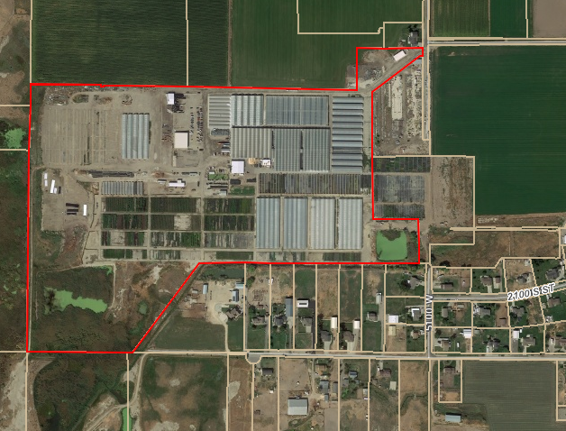

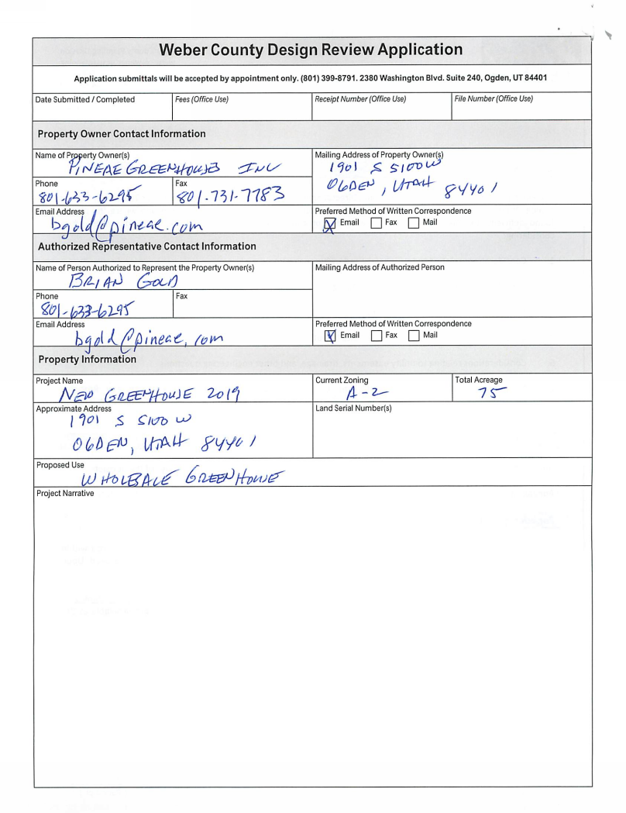Exhibit A

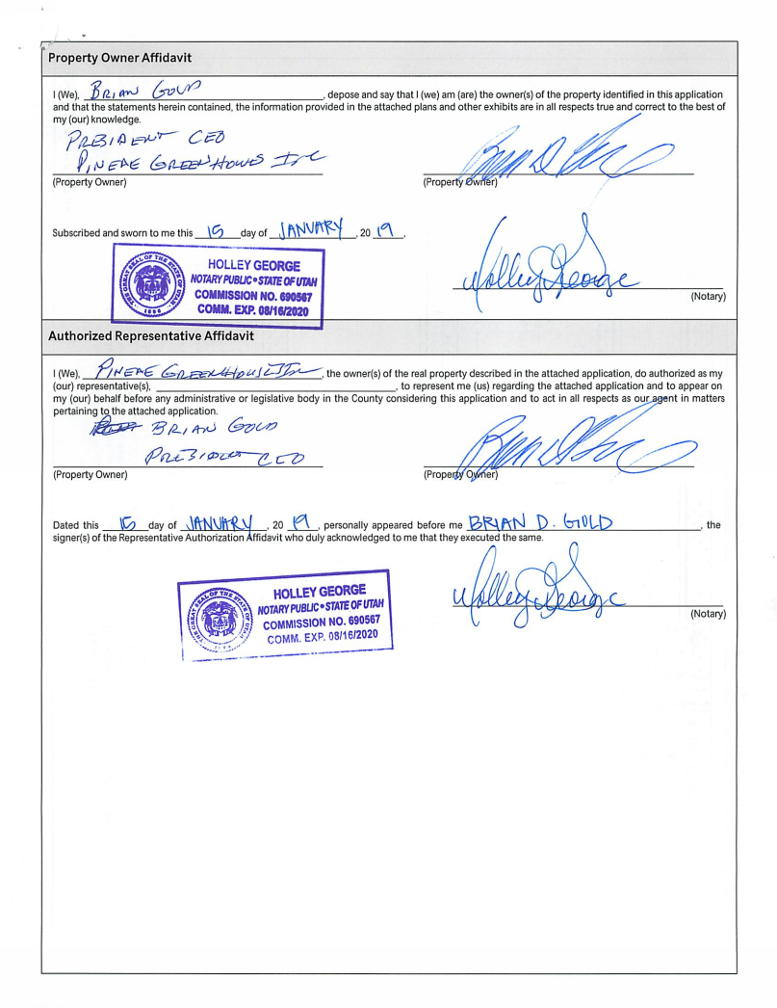

Exhibit B

