|  |  |
| --- | --- |
| **WC Logo.emf** | **Staff Report for Administrative Subdivision Approval**  *Weber County Planning Division* |
|  | |

****Synopsis****

****Application Information****

**Application Request:** Consideration and action on an administrative application for final approval of the Paul Gibson Subdivision, a one lot subdivision with access by a private right of way.

**Type of Decision: Administrative**

**Agenda Date: Wednesday, July 13, 2016**

**Applicant:** Paul Gibson, owner

**File Number:** LVF 061716 & AE 0516

****Property Information****

**Approximate Address:** 2742 South 4700 West, Taylor UT

**Project Area:** 5.26 acres

**Zoning:** Agriculture (A-1) Zone

**Existing Land Use:** Agriculture

**Proposed Land Use:** Residential, Agriculture

**Parcel ID: 15-083-0034**

**Township, Range, Section:** T6N, R2W, Section 32

****Adjacent Land Use****

**North:** Agriculture **South:** Residential

**East:** Agriculture **West:** Residential

****Staff Information****

**Report Presenter:** Felix Lleverino

flleverino@co.weber.ut.us

801-399-8767

**Report Reviewer:** RK

Applicable Ordinances

* Weber County Land Use Code Title 101 (General Provisions) Section 7
* Weber County Land Use Code Title 104 (Zones) Chapter 5 (A-1 Zone)
* Weber County Land Use Code Title 106 (Subdivisions)
* Weber County Land Use Code Title 108 (Flag lot access strip, private right-of-way, and access easement standards), (Access to a lot/parcel using a private right-of-way of access easement), (Access to a lot/parcel at a location other than across the front lot line)

Background and Summary

The applicant is requesting approval of the Paul Gibson Subdivision, a one lot subdivision located at approximately 2742 South 4700 West in the A-1 Zone. The proposed 5.261 acre subdivision does not qualify as a flag lot because the access strip exceeds 30’. However, this lot does possess access by private right-of-way pursuant of section 108-7-31.

The purpose of this subdivision is for the owner, Paul Gibson, to build a single family home. The access to this parcel will be from 4700 West Street via a private right of way. The consideration to utilize the existing 60 ft access and utility easement that was required during the approval process for the Gibson Hill Subdivision in 2006 for a possible future public road connecting 4550 West to 4700 West has been denied by the owner of Gibson Hill Subdivision (see Exhibit B). After being denied access through Gibson Hill subdivision, Paul has opted to utilize the alternate route which connects to 4700 W via an access through a private right of way that Paul Gibson will maintain.

Culinary water will be provided by Taylor West Weber Water Improvement District and wastewater will be controlled by individual septic systems. Electrical and gas utilities have been installed through the Gibson Hill Subdivision PUE running from the cult de sac that provides access to the Gibson Hill Subdivision. Prior to Paul Gibson Subdivision being approved and recorded, all review agency requirements must be addressed and completed.

Analysis

General Plan: The proposal conforms to the Western Weber General Plan by creating large lots to maintain the country feel with land that has agricultural and livestock uses.

*Zoning*: The subject property is located in an Agricultural Zone A-1 zone. That land use requirements for this zone are stated in the LUC§ 104-5 as follows:

*The purpose of the A-1 Zone is to designate farm areas, which are likely to undergo a more intensive urban development, to set up guidelines to continue agricultural pursuits, including the keeping of farm animals, and to direct orderly low-density residential development in a continuing rural environment.*

As part of the subdivision process, the proposal has been reviewed against the current subdivision ordinance in LUC 106 chapter 1, and the standards in A-1 zone LUC 104-5-7. Small Subdivisions, as defined in LUC 101-7, can be administratively approved per LUC 106-1-5(b)(1) The proposed subdivision will not create any new public streets.

As stated in the land use code in relation safety standards LUC 108-7-29 2(a) “The lot address shall be displayed in a prominently visible location at the street entrance to the flag lot access strip, private right-of-way, or access easement”.

*Lot area, frontage/width and yard regulations*: In the LUC §104-7-6, the A-1 zone requires a minimum lot area of 40,000 sq. ft. and a minimum lot width of 150’. The proposed subdivision is a one lot subdivision that fronts a county road identified as 3600 West. This subdivision is considered an “Agricultural Parcel” with 5.26 acres as defined in the General Provisions of the LUC§101-7.

Currently there is a small shed located on the lot. The applicant will build the single family dwelling in front of the existing shed. It appears that both structures will conform to the minimum yard setback regulations of the A-1 zone as found in LUC §104-5-7.

*Culinary water and sanitary sewage disposal:* Will serve and feasibility letters have been provided for the culinary water and the sanitary sewer for the proposed subdivision. The culinary water for the proposed subdivision will be provided by Taylor West Weber Improvement District. The Weber-Morgan Health Department has performed a percolation test and has granted approval for a septic system to be installed for the Paul Gibson Subdivision.

*Review Agencies*: The proposed subdivision has been reviewed and approved with conditions by the Weber Fire District. The Weber County Engineering and Surveying Divisions have not reviewed the proposal to date. The applicant will need to ensure that prior to recording the final Mylar, all conditions of approval must be met.

*Public Notice*: A notice has been mailed not less than seven calendar days before final approval to all property owners of record within 500 feet of the subject property regarding the proposed small subdivision per noticing requirements outlined in LUC §26-1-7.

Staff Recommendations

Staff recommends final approval of the Paul Gibson Subdivision, a one lot subdivision with access by a private right of way. This recommendation is subject to all review agency requirements and based on the following condition:

1. The lot address shall be displayed in a prominently visible location at the street entrance to the flag lot access strip, private right-of-way, or access easement

This recommendation is based on the following findings:

1. The proposed subdivision conforms to the Western Weber General Plan.
2. With the recommended conditions, the proposed subdivision complies with applicable county ordinances.
3. The proposed subdivision will not be detrimental to public health, safety, or welfare.
4. The proposed subdivision will not deteriorate the environment of the general area so as to negatively impact surrounding properties and uses.

Administrative Approval

Administrative final approval of Paul Gibson Subdivision is hereby granted based upon its compliance with the Weber County Land Use Code. This approval is subject to the requirements of applicable review agencies and the conditions of approval listed in this staff report.

Date of Administrative Approval: Wednesday, July 13, 2016.

________________________________________

Rick Grover

Weber County Planning Director

Exhibits

1. Paul Gibson Subdivision Plat
2. Gibson Hill Subdivision Plat showing 60’ access and utility easement

Map 1

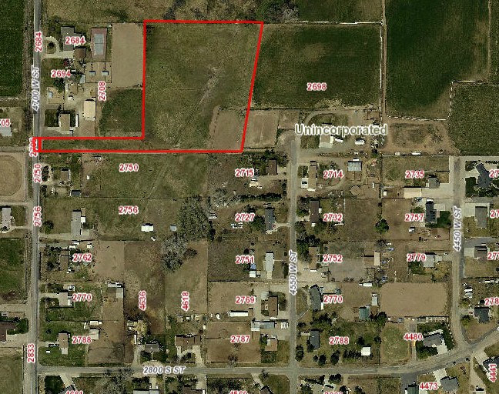

Exhibit A

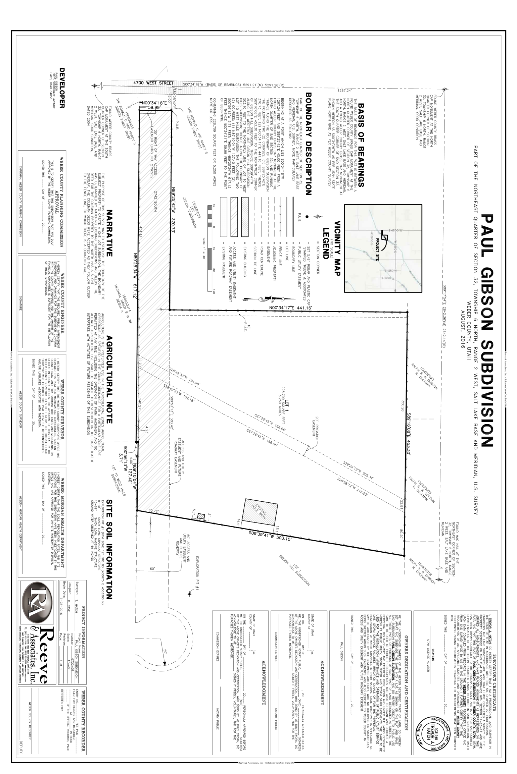

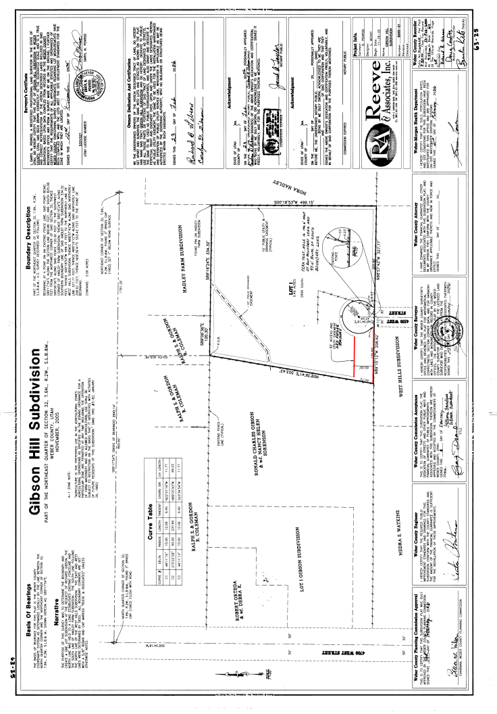Exhibit B