|  |  |
| --- | --- |
| **WC Logo.emf** | **Staff Report to the Ogden Valley Planning Commission**  *Weber County Planning Division* |
|  | |

****Synopsis****

****Application Information****

**Application Request:** Consideration and action on a conditional use permit application for a public utility substation (water storage tank) for Liberty Pipeline Company.

**Type of Decision: Administrative**

**Agenda Date: Tuesday, January 03, 2017**

**Applicant:** Liberty Pipeline Company c/o Pen Hollist, Director

**Authorized Agent:** Mike Durtschi, project engineer (Gardner Engineering)

**File Number:** CUP# 2016-20

****Property Information****

**Approximate Address:** 6970 N. Durfee Way, Liberty, UT

**Project Area:** 0.95 acres

**Zoning:** Forest Zone (F-5)

**Existing Land Use:** Water Storage Tank

**Proposed Land Use:** Water Storage Tank and Distribution Line

**Parcel ID:** 17-135-0002

**Township, Range, Section:** Township 8 North, Range 1 West, Section 36

****Adjacent Land Use****

**North:** Forest **South:** Forest Residential

**East:** Forest **West:** Forest

****Staff Information****

**Report Presenter: Steve Burton**

sburton@co.weber.ut.us

801-399-8766

**Report Reviewer:** RK

Applicable Ordinances

* Title 101, Chapter 1, General Provisions, Section 7, Definitions
* Title 104, Chapter 9 Forest Zones (F-5)
* Title 108, Chapter 1 Design Review
* Title 108, Chapter 4 Conditional Uses
* Title 108, Chapter 10 Public Buildings and Public Utility Substations and Structures

Summary and Background

Liberty Pipeline Company is requesting approval of a conditional use permit to construct a 250,000 gallon water storage tank and install approximately 1,100 linear feet of distribution piping. These improvements will provide emergency storage to the entire system and will increase Liberty Pipeline Company's upper area storage and flow capacity needed to meet State requirements for fire events. The proposed tank will be located approximately 60 feet from an existing 90,000 gallon tank. The proposed tank's diameter is 53 feet and the tank depth is 16 feet. The tank will be buried with 6 inches of top soil placed on top of the tank. The property lies in the Forest 5 Zone (F-5) which allows “Water pumping plants and reservoirs” as well as “Public utility substations and transmission lines” only when authorized by a conditional use permit.

The project area is located within "Common Area A" of Durfee Creek Estates No. 1. A proposed easement of approximately 4.2 acres will surround the project area of 0.95 acres. Liberty Pipeline Company will need to secure this easement from the property owner.

Conditional use permits should be approved as long as any harmful impact is mitigated. The Uniform Land Use Code of Weber County, Utah (LUC) already specifies certain standards necessary for mitigation of harmful impact to which the proposal must adhere. The proposed application appears to meet these standards. The following is staff’s evaluation of the request.

Analysis

*General Plan:* The Ogden Valley General Plan identifies the need for additional culinary water and new water infrastructure based on projected growth. *(see the 2016 Ogden Valley General Plan Chapter 7: Utilities and Public Services)*. The proposed use conforms to the Ogden Valley General Plan by providing additional water sources to meet the demands of the Valley's existing water systems throughout developing areas.

*Zoning:* The subject property is located within the F-5 Zone which is categorized as a “Forest Zone”. The intent of the forest zones can be further described per LUC §104-9-1 as follows:

*a. The intent of the forest zones is to protect and preserve the natural environment of those areas of the county that are characterized by mountainous, forest or naturalistic land, and to permit development compatible to the preservation of these areas.*

*b. The objectives in establishing the forest zones are:*

*1. To promote the use of the land for forest, fish and wildlife and to facilitate the conservation of the natural resources, vegetation and attractions;*

*2. To reduce the hazards of flood and fire;*

*3. To prevent sanitation and pollution problems and protect the watershed;*

*4. To provide areas for private and public recreation and recreation resorts; and*

*5. To provide areas for homes, summer homes, and summer camp sites.*

The F-5 Zone has specific standards identified in the LUC §104-9-4 that shall be met as part of the development process. The applicable standards are as follows:

* Minimum yard setbacks:
* Front: 30’
* Side: 20’
* Rear: 30’
* Minimum lot area: 5 acres
* Minimum lot width: 300’
* Main Building height:
* Maximum: 35’
  + Accessory building height:
    - Maximum: 25’, unless meeting requirements of LUC §108-7-16, Large accessory buildings

The proposed use is conditionally allowed in the F-5 zone and has been reviewed as a “Water pumping plants and reservoirs” as well as “Public utility substations and transmission lines”. The location and arrangement of public utility substations and structures must be in accordance with construction plans submitted to and approved by the planning commission. The minimum lot area for all public utility substations per LUC §108-10-2 is waived and the rear yard requirements may be reduced in the Forest Zones to 20’ per LUC §108-10-3.

*Conditional Use Review:* A review process has been outlined in LUC §108-4-3 to ensure compliance with the applicable ordinances and to mitigate anticipated detrimental effects. The property is currently owned by the Durfee Creek Estates Home and Owners Association. A draft of the necessary easements has been provided to the Planning Division; however, a final signed copy of all easements and/or lease agreement for the access, location and affiliated construction for the proposed tank will need to be provided to the Planning Division prior to the issuance of the conditional use permit.

A notice of intent has been filed with the State of Utah Water Resources Control Board by the Owner so that the project may be covered under the state general permit. Prior to commencing work, Liberty Pipeline Company will need to receive approval from the applicable agencies for the new tank. A condition has been made part of the Planning Division’s recommendations to ensure that this standard is met.

*Design Review:* The forest zone and the proposed conditional use, mandate a design review as outlined in LUC §108-1 to ensure that the general design, layout and appearance of the building remains orderly and harmonious with the surrounding neighborhood. Certain areas of the design review are only applicable due to the nature of the request. As part of this review, the Planning Commission shall consider the applicable matters based on the proposed conditional use and impose conditions to mitigate deficiencies where the plan is found deficient. The matters for consideration are as follows:

* *Considerations relating to traffic safety and traffic congestion.* As part of this consideration, the applicant has provided detailed a site plan (see Exhibit B). The proposal is not considered large scale construction; therefore considerable traffic congestion or delay is not anticipated. Per the County Engineering Division, the contractor will be responsible to guarantee site materials are not tracked onto the County roadways. A condition of approval has been added to the Planning Division’s recommendation to ensure the contractor cleans all equipment prior to exiting the site and sweeps the County roadway as needed, removing any material tracked from the site onto the asphalt, in order to provide safe vehicular traffic along County roads.
* *Considerations relating to landscaping.* The applicant has outlined the following considerations to landscaping in the SWPPP: 1. Exposed stockpiles of soils, construction, and landscaping material will be covered with heavy plastic sheathing; 2. In landscaping areas where the vegetation has not established growth and taken hold, sandbag or dirt berms will be constructed around their perimeter to ensure that water will be contained inside the landscaping area and that it will not be conveyed to a storm drain inlet; 3. Areas where landscaping has died or not taken hold will be re-vegetated; 4. Storm water runoff will be diverted around disturbed soils with berms or dirt swales.
* *Considerations relating to buildings and site layout.* The proposed water tank will not require a new pump house or other new buildings. The buried water tank has a diameter of 53 feet and a depth of 16 feet.
* *Considerations relating to utility easements, drainage, and other engineering questions.* The applicant will need to adhere to all conditions of the Engineering Division including but not limited to storm water and surface water drainage, retention facilities, and site clean-up of the property. A condition has been made part of the Planning Division’s recommendations to ensure that this standard is met.
* *Considerations relating to prior development concept plan approval associated with any rezoning agreement, planned commercial or manufacturing rezoning, or planned residential unit development approval.* The proposed site does not have any type of development agreement associated with the property; therefore considerations pertaining to this portion of the code are not applicable at this time.

*Review Agencies:* Prior to the commencement of work, the applicant will need to receive the approval from all applicable agencies for the water system improvements. A condition has been made part of the Planning Division’s recommendations to ensure that all conditions of the review agencies will be met.

Summary of Planning Commission Considerations

In order for a conditional use to be approved it must meet the requirements of applicable ordinances listed in this staff report, which include the requirements listed in LUC §108-4-4, under “Criteria for Issuance of Conditional Use Permit”, which states:

*a) A conditional use shall be approved if reasonable conditions are proposed, or can be imposed, to substantially mitigate the reasonably anticipated detrimental effects of the proposed use in accordance with the standards of this chapter, or relevant standards or requirements of any other chapter of this Land Use Code. When considering any of the standards, the land use authority shall consider the reasonably anticipated detrimental effects of the proposed use in the context of current conditions and, to the extent supported by law, the policy recommendations of the applicable general plan.*

*b) If the reasonably anticipated detrimental effects of a proposed conditional use cannot be substantially mitigated by the proposal or the imposition of reasonable conditions to achieve compliance with applicable standards, the conditional use may be denied.*

The Planning Commission will need to determine if the request for a water storage tank and distribution line has met the requirements of the applicable Uniform Land Use Code of Weber County. The Planning Commission may impose additional conditions in order to ensure full compliance with the required standards. In making a decision, the Planning Commission should consider the following questions:

* Does the submittal meet the Uniform Land Use Code of Weber County? If no, then what conditions could be added in order to comply?
* Have the "Decision Requirements” and other applicable ordinances been met?

Staff Recommendation

The Planning Division recommends approval of file# CUP 2016-20, a conditional use permit for Liberty Pipeline Company's water storage tank to be located at approximately 6970 N. Durfee Way, Liberty, UT. This recommendation for approval is subject to all review agency requirements and with the following conditions:

1. Prior to the issuance of the conditional use permit, a final signed copy of all easements and/or lease agreement for the access, location and affiliated construction for the proposed water storage tank will need to be provided to the Planning Division.
2. Prior to commencing work, Liberty Pipeline Company will need to receive the approval from the applicable agencies for the new water storage tank and distribution line, including all permits outlined in the Engineering Division's review.
3. All equipment leaving the site will be cleaned prior to entering the County right-of-way and the contractor will be responsible for sweeping the County roadway, as needed, removing any material tracked from the site onto the asphalt, in order to provide safe vehicular traffic along the County right-of-way.

This recommendation is based on the following findings:

1. The proposed use conforms to the Ogden Valley General Plan.
2. The proposed use will provide the needed water sources to meet the demands the Ogden Valley.
3. The proposed use, if conditions are imposed, will not be detrimental to the public health, safety, or welfare.
4. The proposed use, if conditions are imposed, will comply with applicable County ordinances.
5. The proposed use will not deteriorate the environment of the general area so as to negatively impact surrounding properties and uses.

Exhibits

1. Application
2. Site Plan
3. Building & Landscape Plan

Map 1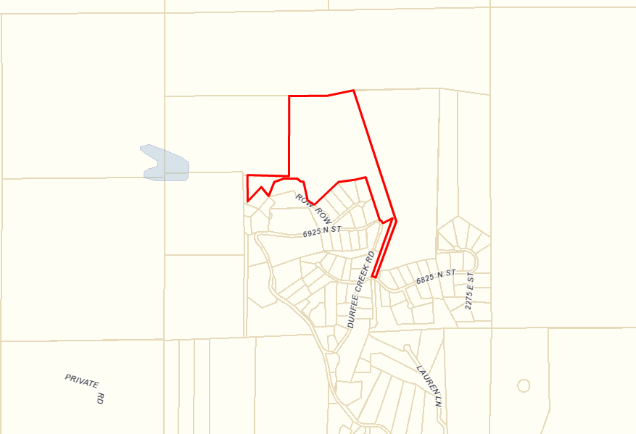

Subject Property

Map 2

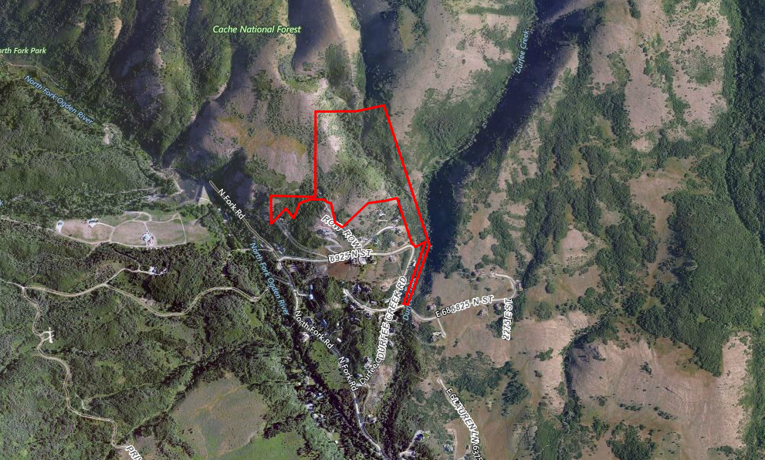

Subject Property