|  |  |
| --- | --- |
| **WC Logo.emf** | **Staff Report for Administrative Subdivision Approval**  *Weber County Planning Division* |
|  | |

****Synopsis****

****Application Information****

**Application Request:** Consideration and action on an amendment to the Robins Roost Subdivision to execute a lot line adjustment between the original Lot 5 and Lot 8

**Type of Decision: Administrative**

**Agenda Date:**

**Applicant: James Swearingen, Thomas Halliday – Owners, and**

**M. Darin Hammond – Authorized Representative**

**File Number:** UVR060517

****Property Information****

**Approximate Address:** 5185 East 2275 North, Eden, UT, 84310

**Project Area:** 1.107 and .959 Acres

**Zoning:** AV-3 Zone

**Existing Land Use:** Residential

**Proposed Land Use:** Residential

**Parcel ID:** 22-075-0006, 22-075-0008

**Township, Range, Section:** Township 7 North, Range 1 East, Section 34

****Adjacent Land Use****

**North:** 2275 N **South:** Residential

**East:** Residential **West:** Residential

****Staff Information****

**Report Presenter: Tammy Aydelotte**

**taydelotte@co.weber.ut.us**

801-399-8794

**Report Reviewer: RK**

Applicable Ordinances

* Title 106, Chapter 2, Subdivision Standards.
* Title 106, Subdivisions, Chapter 1-8 as applicable

Development History

* 11/8/1977: Received application for Robins Roost Subdivision Phase 1, creating 12 legal lots.
* 6/5/2017: Received application for Robins Roost Subdivision 1st Amendment, to adjust the lot line between the original lot 5 and Lot 8, in o

Background and Summary

The Planning Division recommends final approval of the Robins Roost Subdivision 1st Amendment, a small subdivision consisting of two residential lots (see Exhibit A). The proposed subdivision is located at approximately 5185 East 2275 North, Eden, and is in the AV-3 zone.

The proposed amendment will consist of 2.09 acres. The proposed subdivision amendment is the result of a more recent survey. The subdivision and lot configurations were established at a time that the zoning in the Ogden Valley was a minimum of 40,000 square feet for a residential lot; consequently, the lots are considered legal nonconforming lots. The proposed subdivision meets all other applicable subdivision requirements as required in the Uniform Land Use Code of Weber County, Utah (LUC).

Analysis

*General Plan:* The proposal conforms to the Ogden Valley General Plan by encouraging development within the existing residential areas.

*Zoning:* The subject property is located in the Ogden Valley Agricultural Valley Zone more particularly described as the AV-3 zone. The purpose and intent of the AV-3 zone is identified in the LUC §104-6-1 as:

*“The purpose of the AV-3 Zone is to designate farm areas, which are likely to undergo a more intensive urban development, to set up guidelines to continue agricultural pursuits, including the keeping of farm animals, and to direct orderly low-density residential development in a continuing rural environment.”*

As part of the subdivision process, the proposal has been reviewed against the current subdivision ordinance in LUC Title 106, and the standards in the AV-3 zone in LUC Title 104 Chapter 6. Small subdivisions as defined in LUC §101-7 can be administratively approved per LUC §106-1-5(b)(1). The proposal has been reviewed against the adopted zoning and subdivision ordinances to ensure that the regulations and standards have been adhered to. The proposed subdivision is in conformance with county code. The following is a brief synopsis of the review criteria and conformance with the LUC.

*Lot area, frontage/width and yard regulations*: The AV-3 Zone has a minimum lot area or a minimum lot width requirement per LUC §104-6-6(h) for a single family residential dwelling. Both lots have an existing residential dwelling, therefore the following development standards will be reviewed upon submittal for a building permit (accessory use – small accessory buildings):

* Front yard setback: 30 feet
* Side yard setback: 10 feet except 1 foot if located at least 6 feet in rear of main building
* Rear yard setback: 1 ft. except 10 ft. where accessory building on a corner lot rears on side yard of an adjacent lot
* Accessory building height: 25 feet

The proposed lot configuration meets the width standards in the AV-3 Zone. The lots do not have adequate area for the AV-3 zone; however, per LUC §108-12-11(2):

*“Any lot legally platted within the bounds of a subdivision that was created pursuant to the standards of the zoning code and subdivision code in effect at the time of its creation, but no longer complies due to subsequent changes to these codes, may be amended pursuant to the minimum standards in effect at the time of its creation. The amendment shall not create any new lots. An amended plat shall be required.”*

The proposed lots meet this requirement and are considered and are considered legal nonconforming lots.

*Review Agencies:* The Weber Fire District and Weber County Engineering Division have reviewed and approved the proposed subdivision amendment. The Weber County Surveyor’s office has reviewed the proposal and provided the applicant with the needed corrections that will be necessary prior to approving the proposal.

*Additional design standards and requirements:* There may be additional site preparation in conjunction with an approved building permit. The proposed subdivision does not require the realignment of or the creation of a new street system. With the exception of the recommended conditions identified in this staff report additional standards and requirements are unnecessary at this time.

*Tax clearance:* The 2016 property taxes have been paid in full. The 2017 property taxes will be due in full on November 30, 2017.

*Public Notice:* The required noticing for the final subdivision plat approval has been mailed to all property owners of record within 500 feet of the subject property regarding the proposed small subdivision per noticing requirements outlined in LUC §106-1-6(c).

Staff Recommendation

Staff recommends final plat approval of Robins Roost Amendment #1, adjusting the lot line between the existing lots 13 and 14. This recommendation for approval is subject to all applicable review agency requirements and is based on the following conditions:

1. A Deferral Agreement will be recorded with the final Mylar.

This recommendation is based on the following findings:

1. The proposed subdivision conforms to the Ogden Valley General Plan.
2. With the recommended conditions, the proposed subdivision complies with applicable county ordinances.

Administrative Approval

Administrative final plat approval of Robins Roost Amendment #1, adjusting the lot line between the existing lots 13 and 14, Robins Roost Subdivision Amendment #1, is hereby granted based upon its compliance with the Weber County Land Use Code. This approval is subject to the requirements of applicable review agencies and is based on the findings listed in this staff report.

Date of Administrative Approval: ___________________________

________________________________________

Rick Grover

Weber County Planning Director

Exhibits

1. Original Subdivision Plat
2. Proposed Subdivision Plat

Map 1

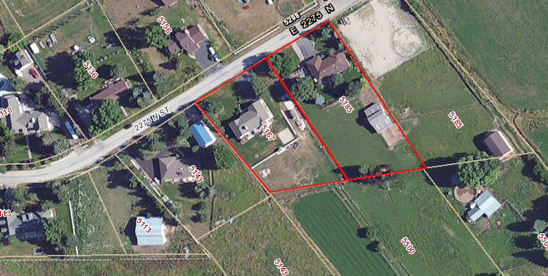

Subject Property

Exhibit A: Plat of Original Subdivision

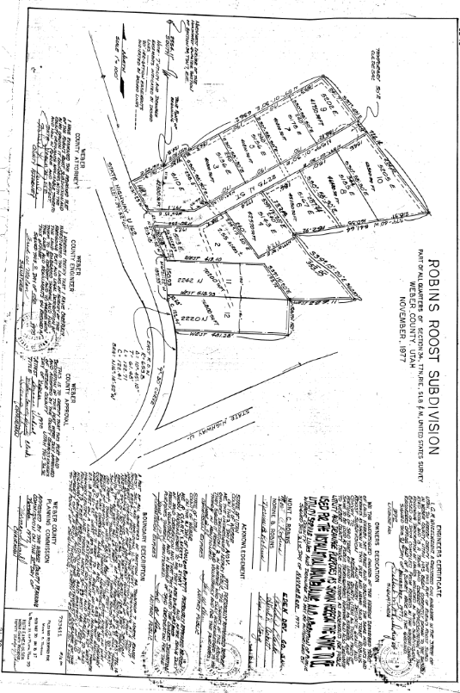

Exhibit B: Plat of Proposed Subdivision

