|  |  |
| --- | --- |
| **WC Logo.emf** | **Staff Report for Weber County Commission**  *Weber County Planning Division* |
|  | |

****Synopsis****

****Application Information****

**Application Request:** Consideration and action on a request for final approval of the Ella O Fowles Subdivision.

**Type of Decision Administrative**

**Agenda Date: Tuesday, February 05, 2019**

**Applicant:** Rondell B Hanson

**File Number:** UVL 101816

****Property Information****

**Approximate Address:** 148 N 10630 E Huntsville, Utah

**Project Area:** 2.03 acres

**Zoning:** Forest (F-5) Zone

**Existing Land Use:** Residential

**Proposed Land Use:** Residential

**Parcel ID:** 21-019-0001, 21-019-0002, 21-019-0003, 21-019-0004, 21-019-0005, 21-019-0006

**Township, Range, Section:** Township 6N Range 2E Section 14

****Adjacent Land Use****

**North:** Forest/Residential **South:** Forest

**East:** Forest/Residential **West:** Forest/Residential

****Staff Information****

**Report Presenter:** Felix Lleverino

flleverino@co.weber.ut.us

801-399-8767

**Report Reviewer:** SB

Applicable Ordinances

* Title 101 (General Provisions) Section 7 (Definitions)
* Title 104 (Zones) Chapter 9 (F-5 Zone)
* Title 106 (Subdivisions)
* Title 108 (Standards) Chapter 7 (Supplementary and Qualifying Regulations) Section 23 (River and stream corridor setbacks)
* Title 108 (Standards) Chapter 12 (Non-Conforming lots) Section 11 (Subdivision plat requirements for nonconforming lots; exemptions)
* Title 108 (Standards) Chapter 18 (Drinking Water Source Protection) Section 6 (Prohibited uses)
* Title 108 (Standards) Chapter 22 (Natural Hazard Areas)

Development History

* Ogden Valley Planning Commission granted preliminary approval for Ella O Fowles subdivision on January 24, 2017. It was then granted final approval on August 22nd, 2017.
* Due to the complexity entailed in gathering consensus from all landowners, receiving approval from the Eagles membership board, and obtaining re-build letters from the Planning Division, the 1-year time limitation period for final approval had lapsed. The applicant re-submitted a petition for approval to the Ogden Valley Planning Commission on January 22, 2019, at which time the proposal was granted preliminary and final approval with a positive recommendation to the County Commission.

Background and Summary

The applicant is requesting final approval of a six-lot subdivision that is located adjacent to the south fork of the Weber River (see the Area Map). The six lots within this subdivision have the combined acreage of 2.03 acres. Lots 1 through 6 of Ella O Fowles Subdivision have existed in their current configuration prior to 1966, the year zoning was enacted in the upper valley, and are considered “Lots of Record” that are nonconforming to current zoning standards.

This subdivision plat has been created as a means to legitimize the boundary description to reflect the longstanding physical property boundaries.

The proposed application has been reviewed against standards in the Uniform Land Use Code of Weber County, Utah (LUC). The section below is the staff’s evaluation of the request.

Analysis

*General Plan*: The proposal conforms to the Ogden Valley General Plan by maintaining the existing density provided by the current zoning and existing approvals (2016 Ogden Valley General Plan, Land Use Principle 1.1).

*Zoning*: The property is located in the F-5 Zone. The purpose of this zone, as described in LUC §104-9-1, is stated below:

*“The intent of the forest zones is to protect and preserve the natural environment of those areas of the county that are characterized by mountainous, forest or naturalistic land, and to permit development compatible to the preservation of these areas.”*

*Lot Area, Frontage Width and Yard Regulations*: The area of the lots within this proposal range from 20,089 sq ft to 9,013 sq ft., and the width of each lot range from 73.32 ft to 170.95 ft. Due to Lots 1 through 6 existing in their current configuration prior to zoning being enacted in the upper valley, these lots are considered to be “Lots of Record” as defined in the LUC §101-1-7 which states:

*“A Lot of record is defined by the following statement:*

*(3). A parcel/lot described in a deed, sales contract or survey that was recorded in the office of the Weber County Recorder before January 1, 1966”*

The yard regulations for the F-5 zone are as follows:

Front: 30 feet

Side: 20 feet

Rear: 30 feet

The lot areas and widths do not meet the minimum lot area of 5 acres for the F-5 Zone and the minimum width of 300 ft. Based on LUC §108-12-13, non-conforming lots may be allowed reduced side-yard setbacks. The reduced side-yard setbacks are established using the following equation:

*1) A nonconforming lot's actual width (v) may be divided by the current required frontage/width (w) in order to formulate a ratio or proportional relation (x). (Formula: "v" divided by "w" equals "x".)*

*(2) The ratio may then be multiplied by the current zone's side-yard setback requirement (y) in order to establish a reduced setback (z). (Formula: "x" multiplied by "y" equals "z".)*

*(3) The reduced side-yard setback is subject to the conditions listed below.*

*a. Under no circumstances shall an interior lot be allowed to reduce the side-yard setback requirement below five feet on one side and eight feet on the other.*

*b. Under no circumstances shall a corner lot be allowed to reduce the side-yard requirement below 10 feet when the side yard fronts on a street.*

*Stream Corridor Setbacks*: The required minimum building setbacks are 100 feet on both sides of the south fork of the Weber River measured from the high water mark. Any additional improvements on these lots will need to adhere to the adopted stream corridor requirements.

*Culinary Water and Sanitary System*: Each lot within this subdivision uses a shared septic system and culinary water well.

*Natural Hazards*: Being that these lots are in close proximity to the Weber River, and lie within the flood zone AE, it is recommended by FEMA that flood insurance is purchased for federally insured loans.

*Review Agencies*: Weber County Health Department has provided information confirming that the culinary and septic facilities are suitable. Weber County Planning, Surveying, Engineering, and the Fire Marshal have posted reviews and marked the proposed subdivision as approved.

*Tax Clearance*: There is no record of past delinquent tax history and no outstanding tax bills on these parcels.

Planning Commission Recommendations

The Ogden Valley Planning Commission recommends final approval of the Ella O Fowles Subdivision, consisting of six lots. This recommendation is based on the following conditions:

1. All county reviewing agency requirements shall be met prior to recording the final Mylar.

The recommendation for approval is based on the following findings:

1. The proposed subdivision conforms to the Ogden Valley General Plan.
2. The proposed subdivision complies with the applicable County codes.

Exhibits

1. Ella O Fowles Subdivision Plat
2. 1966 Recorder’s Plat
3. Subdivision application

Area Map

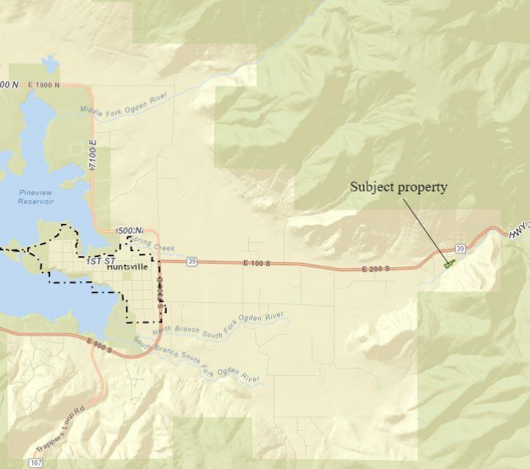

Exhibit A

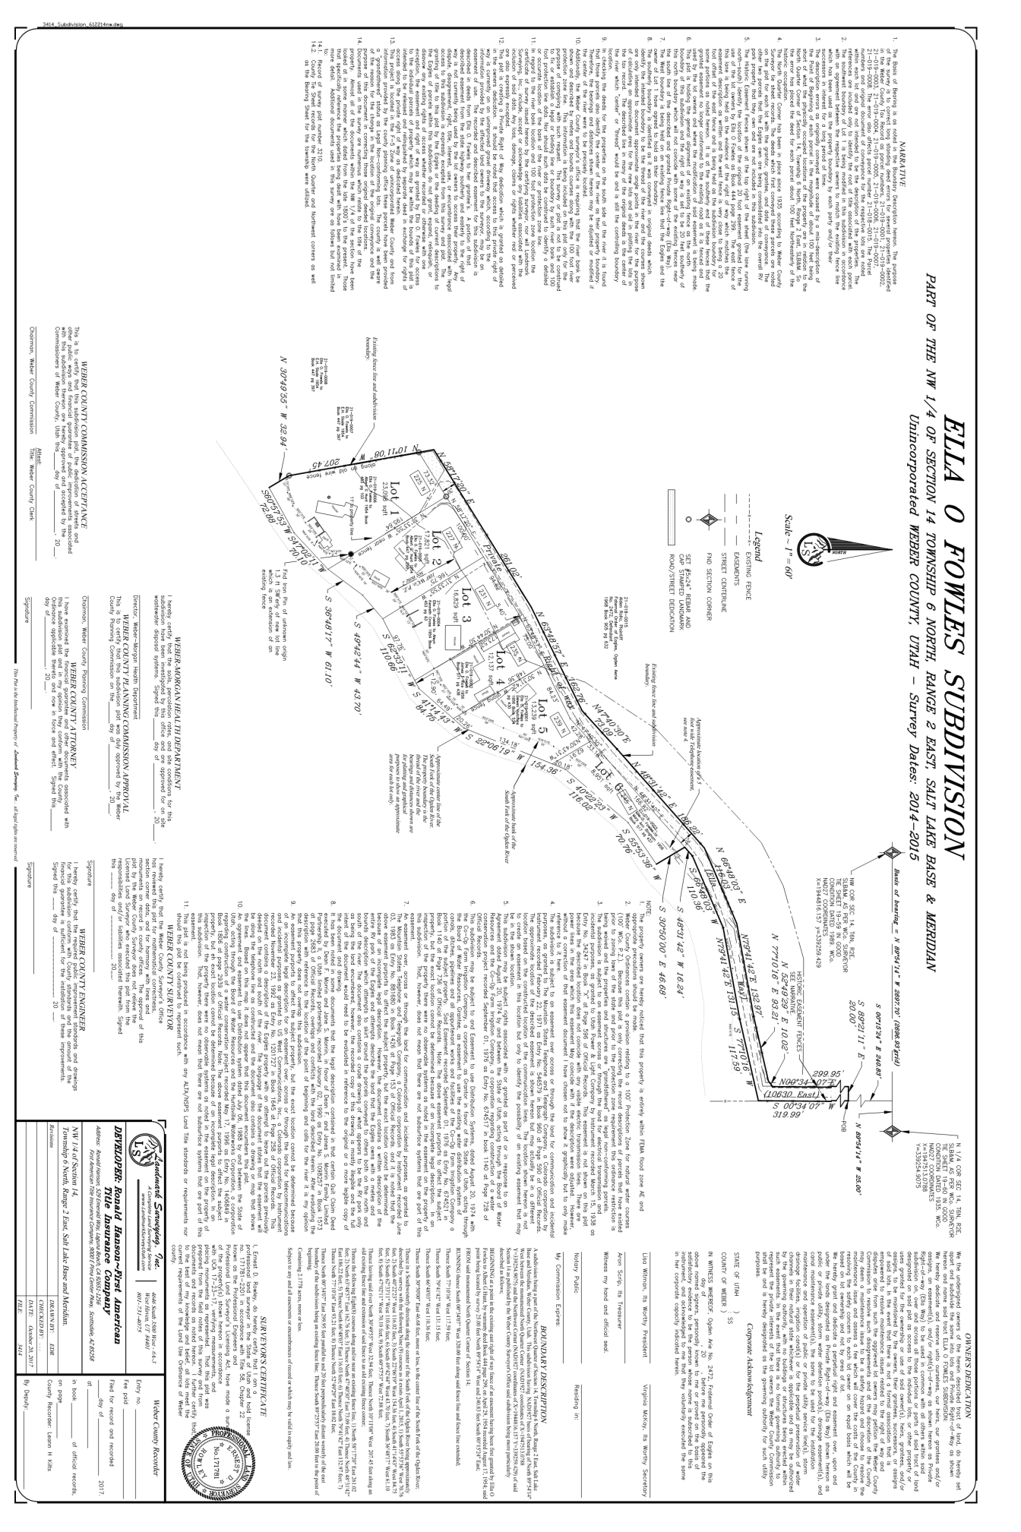

Exhibit B

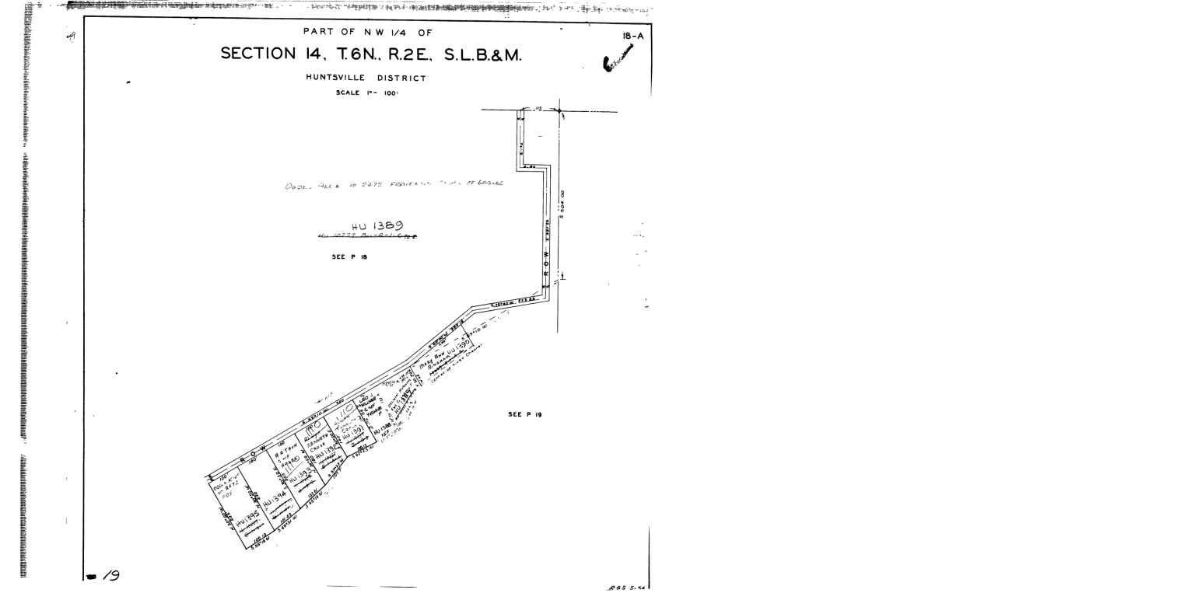

Exhibit C

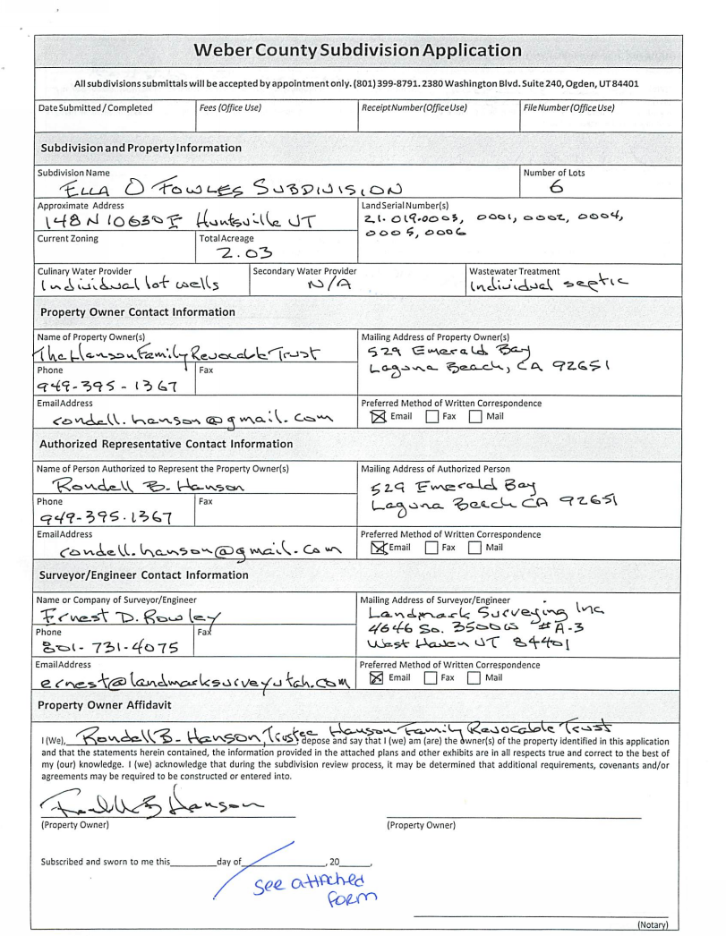

Exhibit C-2

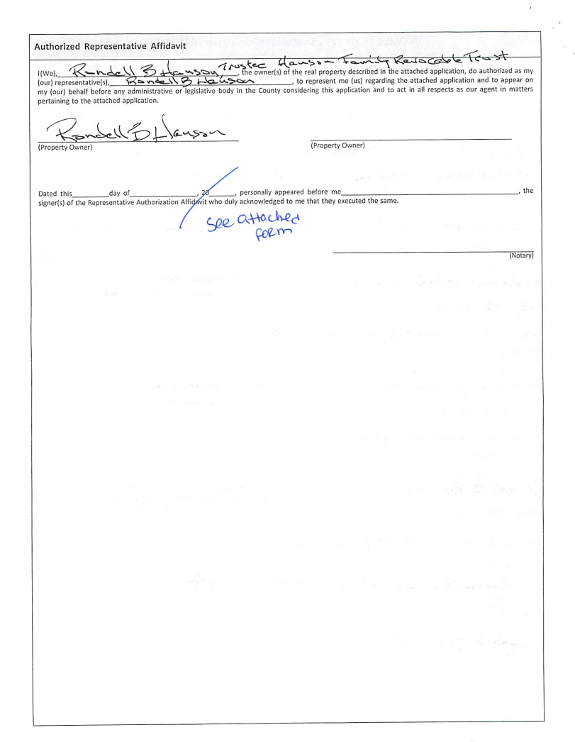

Exhibit C-3

