|  |  |
| --- | --- |
| **WC Logo.emf** | **Staff Report to the Western Weber Planning Commission**  *Weber County Planning Division* |
|  | |

****Synopsis****

****Application Information****

**Application Request:** Consideration and action on ZTA 2018-01, a request to amend the General Plan Zoning Map, Future Land Use Map, M-1 Zone text amendment to remove single-family dwellings from the list of permitted uses, and to amend pages 2-2, 2-6, and 2-15 of the General Plan.  
  
Consideration and action on ZTA 2018-02 a request to change the zoning in areas along 900 South at 7500 West to 8300 West from M-1 to A-2, and to rezone a 15.75 acres parcel from A-3 to A-2 Zoning

**Agenda Date: Tuesday, June 12, 2018**

**Applicant:** John Price

**File Number:** ZTA 2018-01, ZTA 2018-02

****Property Information****

**Approximate Address:** 7900 West 900 South

**Project Area:** 356.83 Acres

**Zoning:** The area is currently Manufacturing (M-1) and the proposed area will become Agricultural (A-2) Zoning. Including an area that is currently A-3 that is proposed to become A-2 zoning.

**Existing Land Use:** Agricultural/Residential

**Proposed Land Use:** Agricultural/Residential

**Parcel ID:** 10-037-0009, 10-037-0010, 10-037-0032, 10-037-0037, 10-037-0041, 10-037-0042, 10-043-0010, 10-066-0001. 10-048-0027, 10-048-0029.

**Township, Range, Section:** T6N, R3W, Sections 15, 22

****Adjacent Land Use****

**North:** Residential/Agricultural **South:** Residential/Agricultural

**East:** Residential/Agricultural **West:** Residential/Agricultural

****Staff Information****

**Report Presenter:** Felix Lleverino

flleverino@co.weber.ut.us

801-399-8767

**Report Reviewer:** CE

Applicable Ordinances

1. Title 102, Chapter 5 (Rezone Procedures)
2. Title 104, Chapter 7 (Agricultural A-2)
3. Title 104, Chapter 8 (Agricultural A-3)
4. Title 104, Chapter 22 (Manufacturing M-1)

Proposal History

This proposal was presented before the Western Weber Planning Commission as a Work Session Item on the evening of Tuesday, May 8, 2018. In that meeting, it was stated by a member of the commission to include a 56.89-acre parcel that is on the south side of 900 South Street with this proposal to prevent negative effects that may impact residential uses.

Legislative Decisions

When the Planning Commission is acting as a recommending body to the County Commission, it is acting in a legislative capacity and has wide discretion. Examples of legislative actions are general plan, zoning map, and land use code amendments. Legislative actions require that the Planning Commission give a recommendation to the County Commission. For this circumstance, criteria for recommendations in a legislative matter require compatibility with the general plan and existing ordinances.

Background

The applicant is requesting approval to rezone property located at approximately 7900 West 900 South (In West Warren Area) from its existing Manufacturing (M-1) Zone to the Agricultural (A-2) Zone. This proposal also includes a proposal to amend the Weber Central Weber General Plan Map (see exhibits B and C). The landowners in the area have expressed agreement with the rezone for circumstances that include the desire to create a zoning area that is representative of the current land uses and the future land uses that the owners wish to pursue.

The Weber County Planning Division recommends text amendments to pages 2-2, 2-6, and 2-15 of the General plan regarding the total acreage of M-1 area, and the verbiage related to allowing residential uses within the M-1 Zone. Further, the planning staff recommends a text amendment to the Uniform Land Use Code of Weber County, Utah (LUC) LUC §104-22-2 (47) to remove single-family dwelling as a permitted use within M-1 Zone as currently recommended by the general plan

The current land area that is designated as M-1 zoning amounts to 1103.24 acres. The area that is proposed to be rezoned amounts to 356.83 acres. Thereby reducing M-1 total area to 746.41 acres.

This application also includes a proposal to rezone a 15.75-acre parcel from A-3 to A-2 (see the Area Map and Exhibit C). The applicant is requesting this rezone for the purpose of providing an area that will be developed as part of a future cluster subdivision.

The current land area that is designated as A-3 zoning amounts to 12,382.05 acres. The area that is proposed to be rezoned amounts to 15.75 acres. Thereby reducing A-3’s total area to 12.366.3 acres.

Summary of Planning Commission Considerations

Section 102-5-3 (Approval criteria) of the Weber County Land Use Code states:

*“To promote compatibility and stability in zoning and appropriate development of property within Weber County, no application for rezoning shall be approved unless it is demonstrated that the proposed rezoning promotes the health, safety, and welfare of Weber County and the purposes of this Ordinance. The Planning Commission and the County Commission will consider whether the application should be approved or disapproved based upon the merits and compatibility of the proposed project with the General Plan, surrounding land uses, and impacts on the surrounding area. The Commissions will consider whether the proposed development and in turn the application for rezoning, is needed to provide a service or convenience brought about by changing conditions and which therefore promotes the public welfare.”*

In order to explain how the proposal meets these criteria, the County’s Land Use Code requires that the applicant provide answers to the following questions in addition to a narrative that explains the project vision:

1. *How is the change in compliance with the General Plan?*
2. *Why should the present zoning be changed to allow this proposal?*
3. *How is the change in the public interest?*
4. *What conditions and circumstances have taken place in the general area since the General Plan was adopted to warrant such a change?*
5. *How does this proposal promote the health, safety, and welfare of the inhabitants of Weber County?*

The applicant has provided a brief narrative describing the project vision and answers addressing these five questions (See Exhibit A for Narrative and information related to the above questions). The planning staff has visited the site and reviewed the application in order to determine whether or not this rezone request meets the criteria. The following determinations have been made:

1. **How is the change in compliance with the General Plan?**

This proposal will not change the current development plan for this area, as the current residents in the area have plans to develop the land in a manner is more consistent with A-2 zoning.

1. **Why should the present zoning be changed to allow this proposal?**

The uses in this area have remained consistently residential and agricultural since M-1 Zoning was enacted.

1. **How is the change in the public interest?**

The planning staff has determined that the rezone request is in the public interest for the following reasons:

* Current uses within this area are more consistent with A-2 zoning.
* Following approval of a text amendment to the General Plan and the Land Use Code to remove single-family dwelling as a permitted use within the M-1 zone and to avoid non-conforming uses within the M-1 zone, this rezone is in the public interest.

1. **What conditions and circumstances have taken place in the general area since the General Plan was adopted to warrant such a change?**

Since the West Central Weber General Plan was adopted the uses have remained residential and agricultural. The landowners are not interested in pursuing manufacturing-related activities.

1. **How does this proposal promote the health, safety, and welfare of the inhabitants of Weber County?**

The planning staff has determined that this rezone request promotes the health, safety, and welfare of the inhabitants of Weber County in the following ways:

* Rezoning of this area will remove the possibility of light manufacturing being pursued in close proximity to agricultural and residential uses.
* A rezone would allow for residential uses to be enhanced and give the owners an opportunity to expand residential uses.
* The rezone would protect residents from nuisances that could result from manufacturing uses.

Staff Recommendation

Staff recommends approval of ZTA 2018-01, a request to amend the General Plan Zoning Map, Future Land Use Map, M-1 Zone text amendment to remove single-family dwellings from the list of permitted uses, and to amend pages 2-2, 2-6, and 2-15 of the General Plan.  
  
Staff recommends approval of ZTA 2018-02, a request to change the zoning in areas along 900 South at 7500 West to 8300 West from M-1 to A-2, and to rezone a 15.75 acres parcel from A-3 to A-2 Zoning. This recommendation is based on the following conditions:

1. The legal description of the rezone areas must be provided.

Exhibits

1. Application and project narrative
2. General Plan Zoning Map
3. General Plan Zoning Map Amendment
4. Future Land Use Map
5. Future Land Use Map Amendment
6. General Plan Text Amendments
7. Land Use Code Text Amendment

Map 1

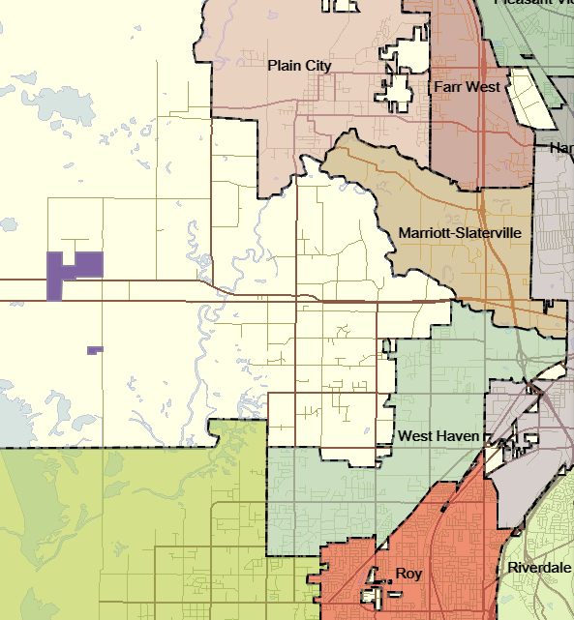

A-3 to A-2

M-1 to A2

Rezone Areas

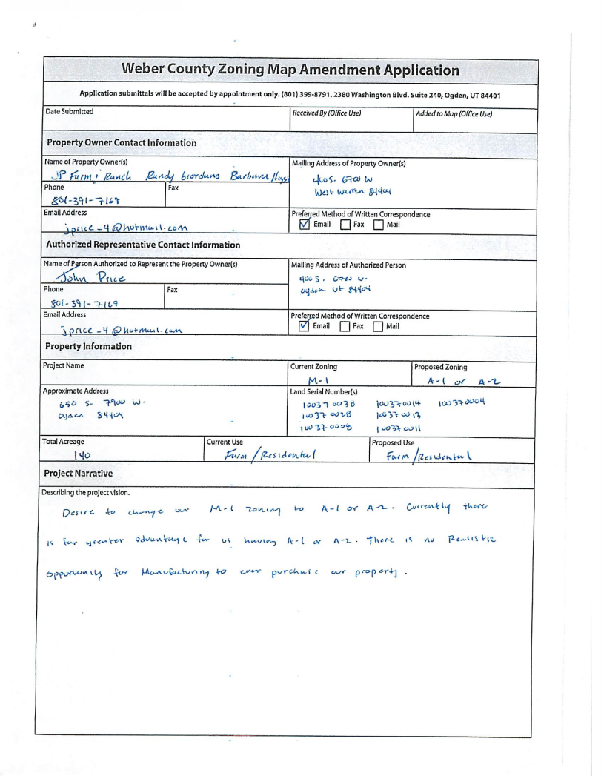Exhibit A

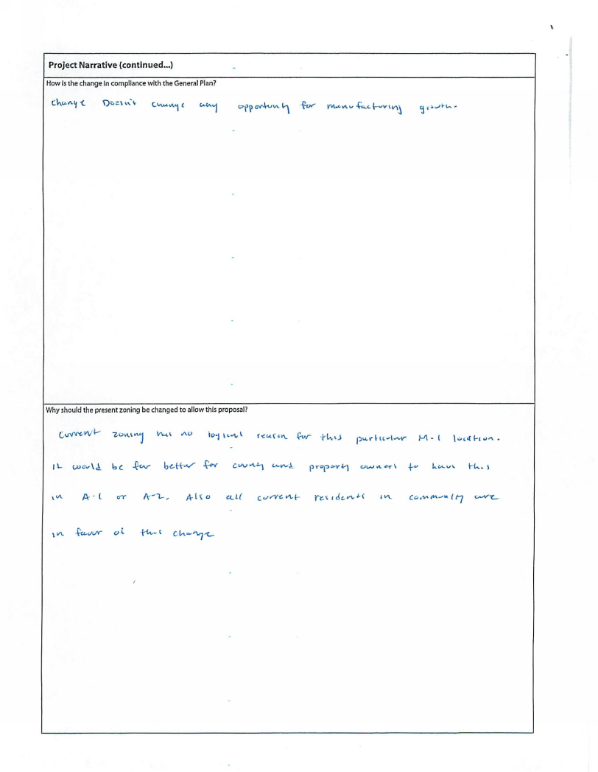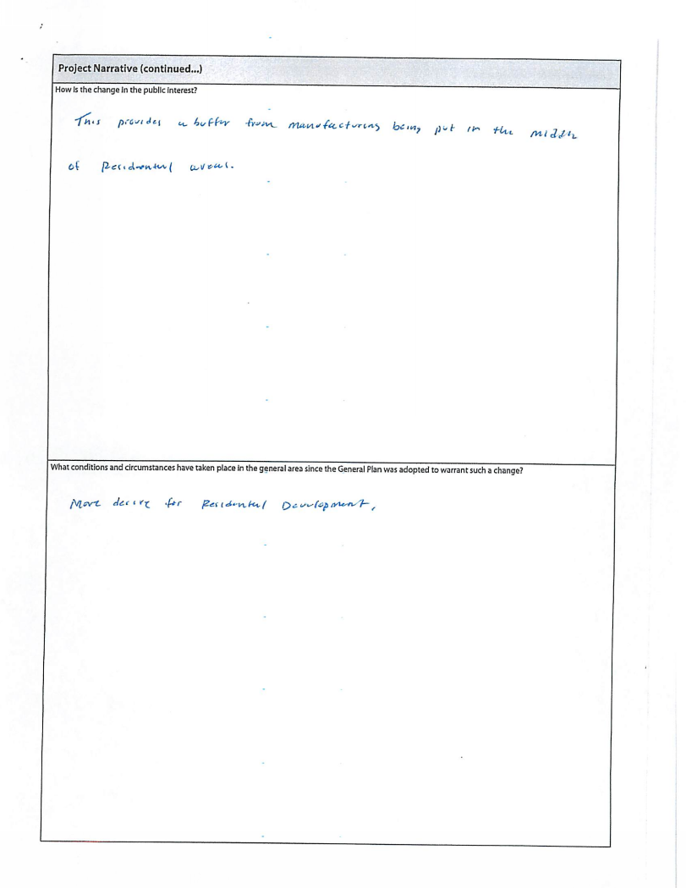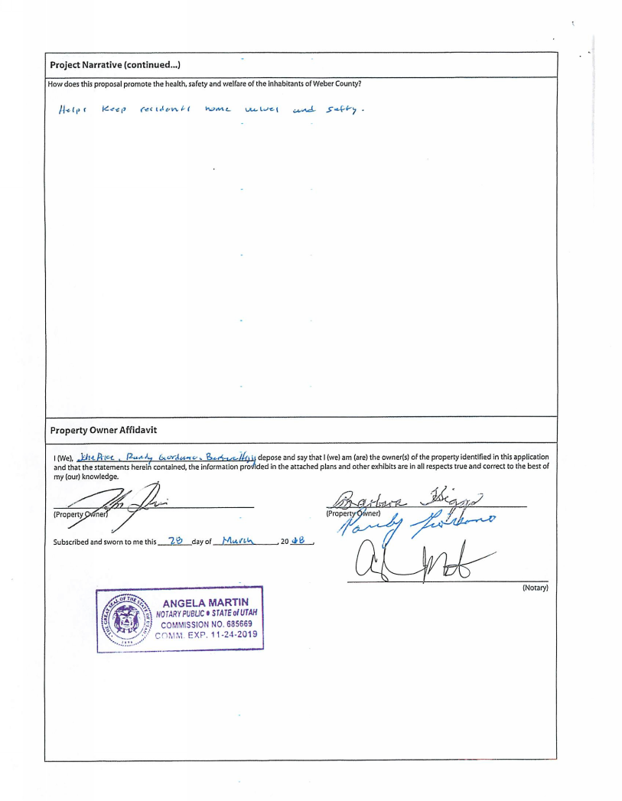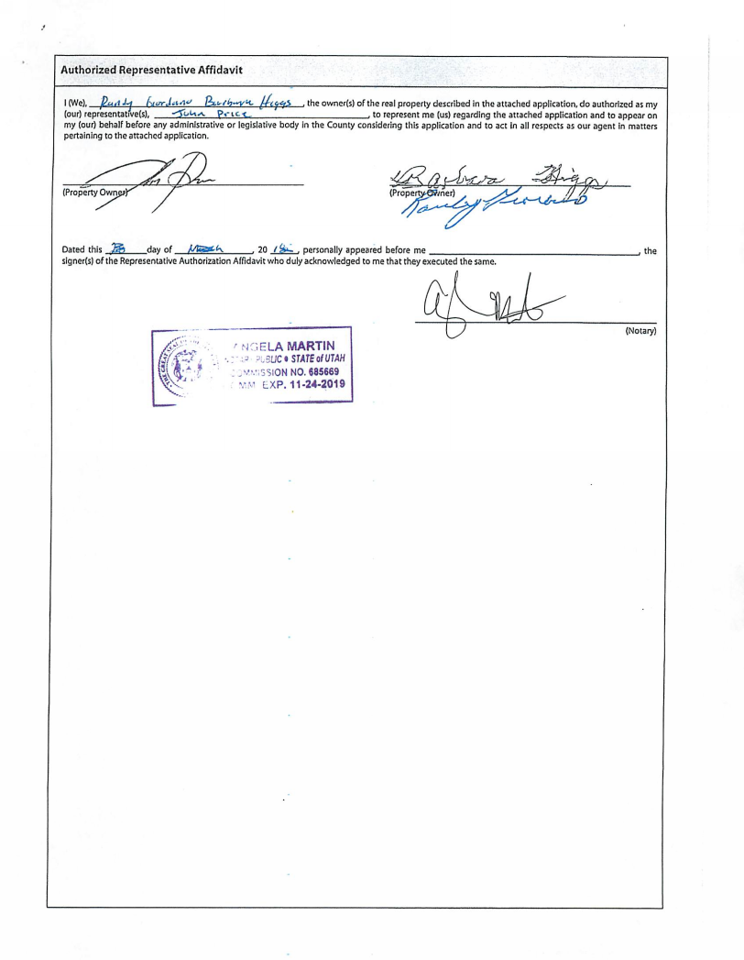

Exhibit B

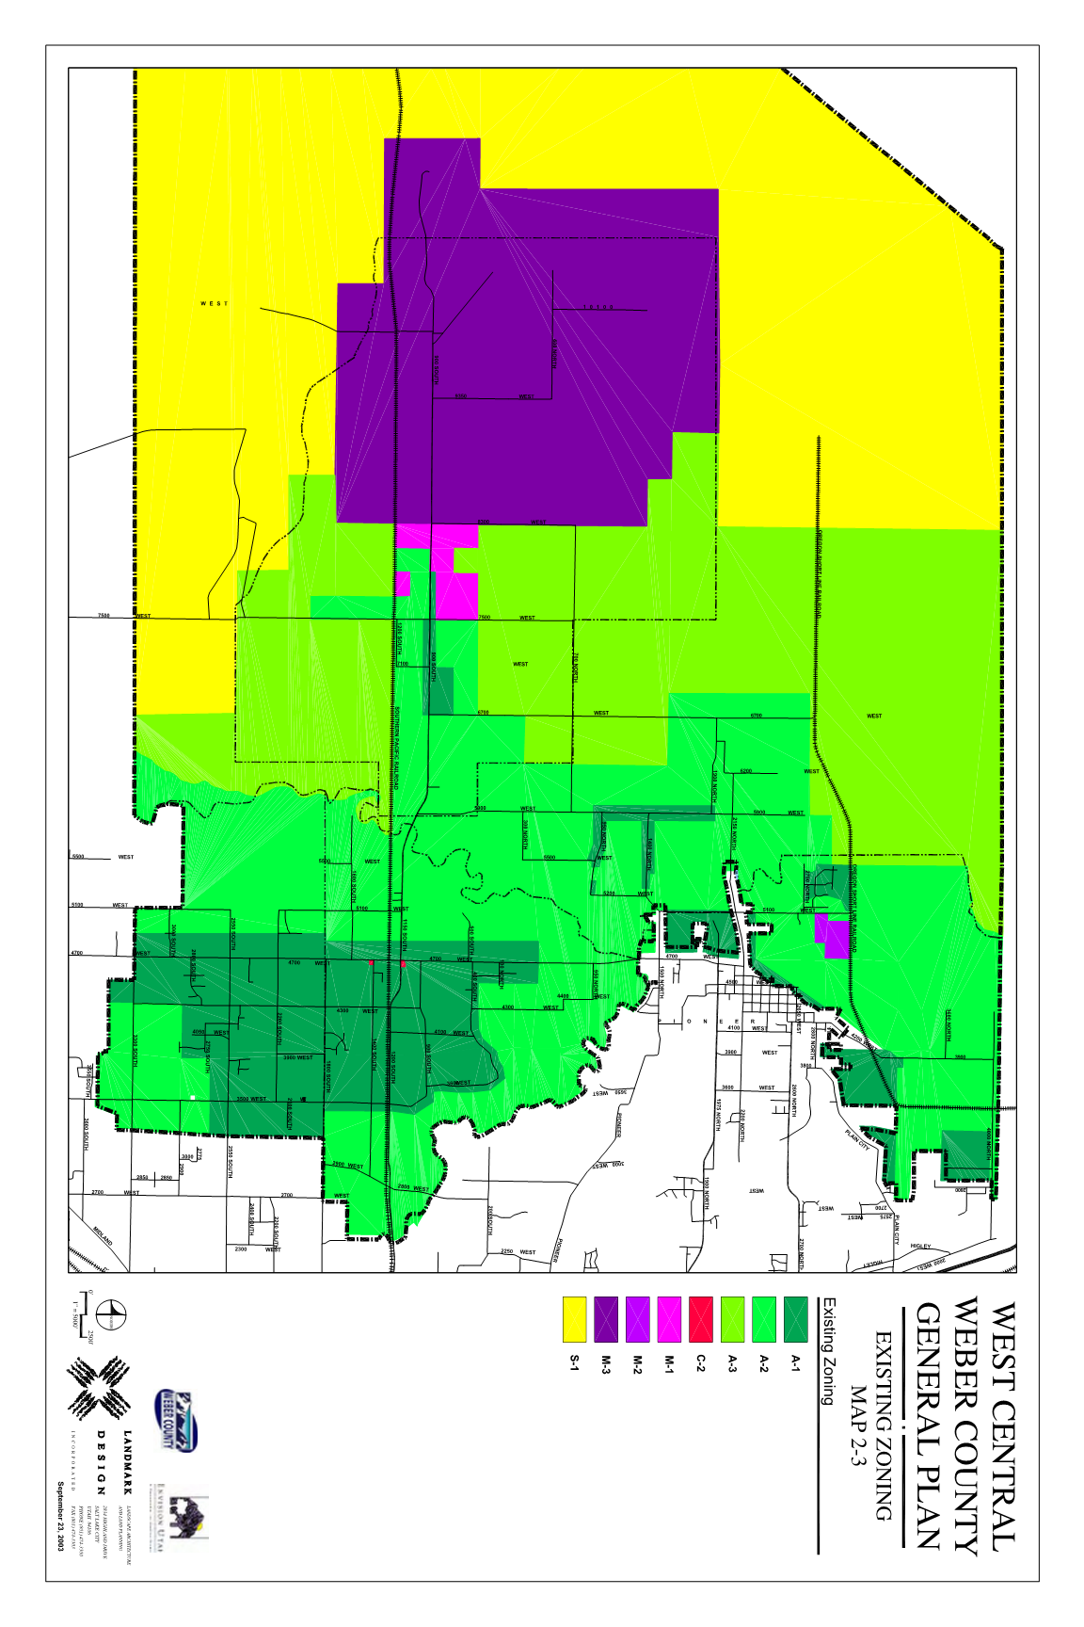

Exhibit C

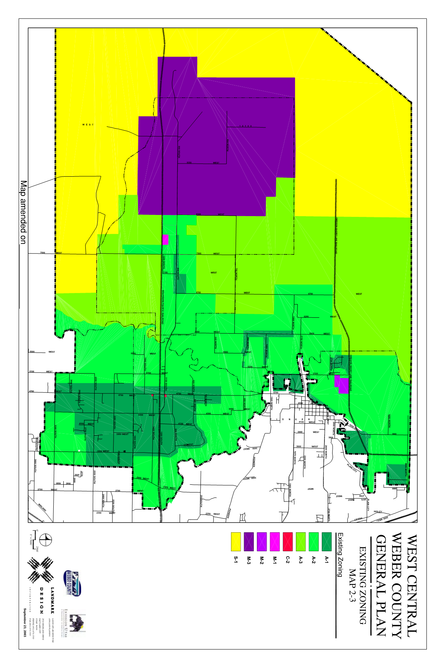

Exhibit D

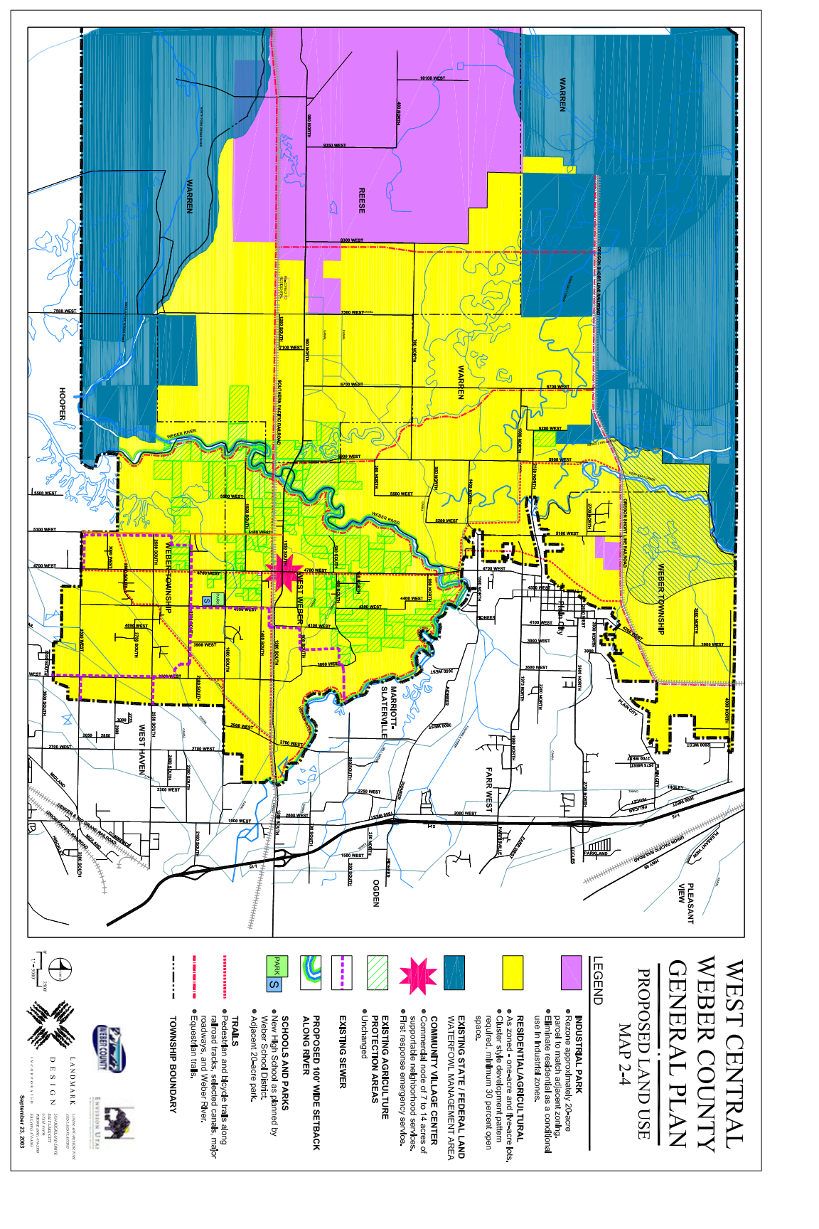

Exhibit E

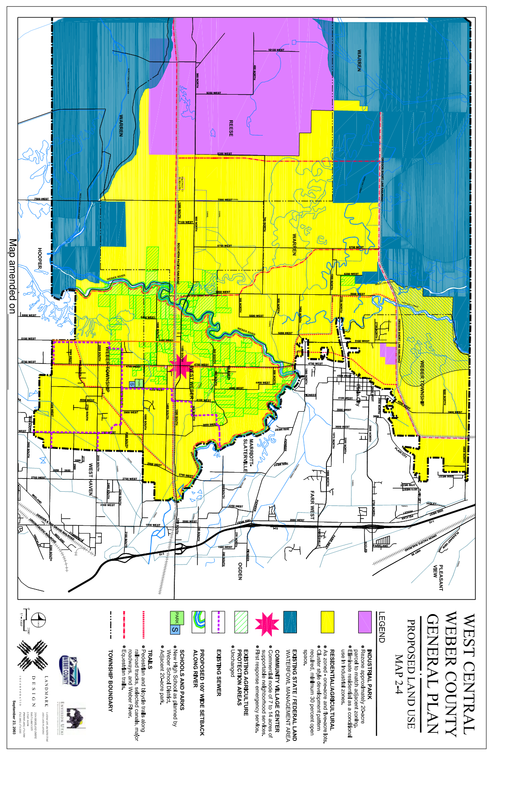

Exhibit F

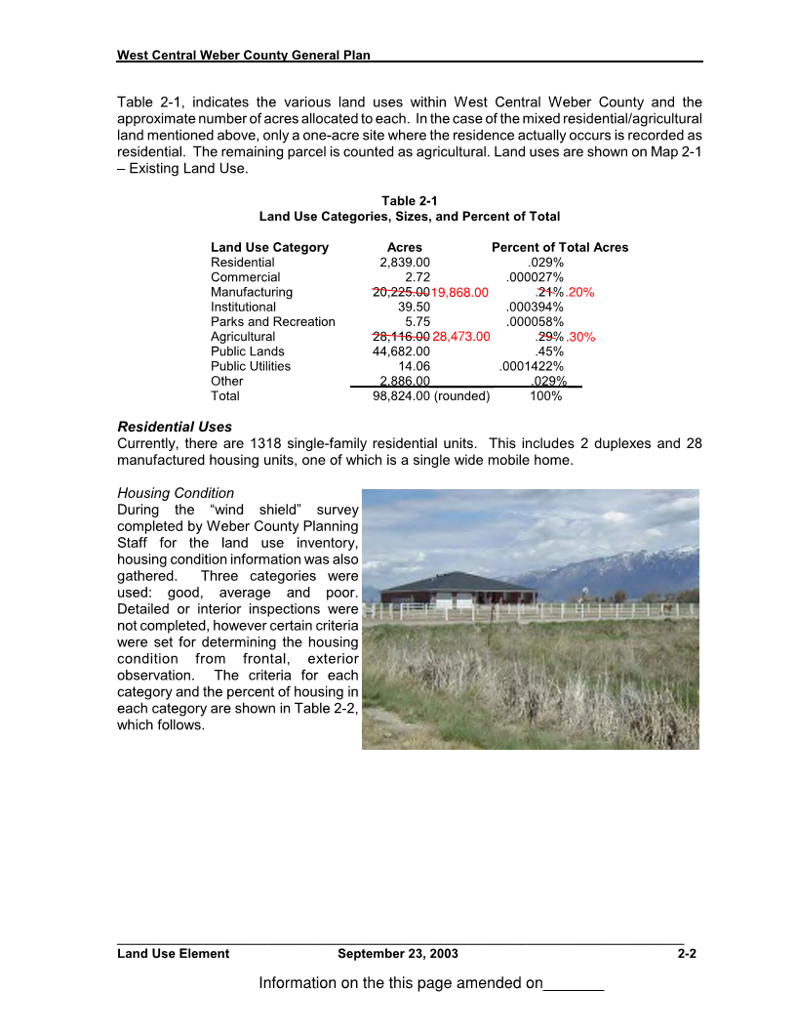

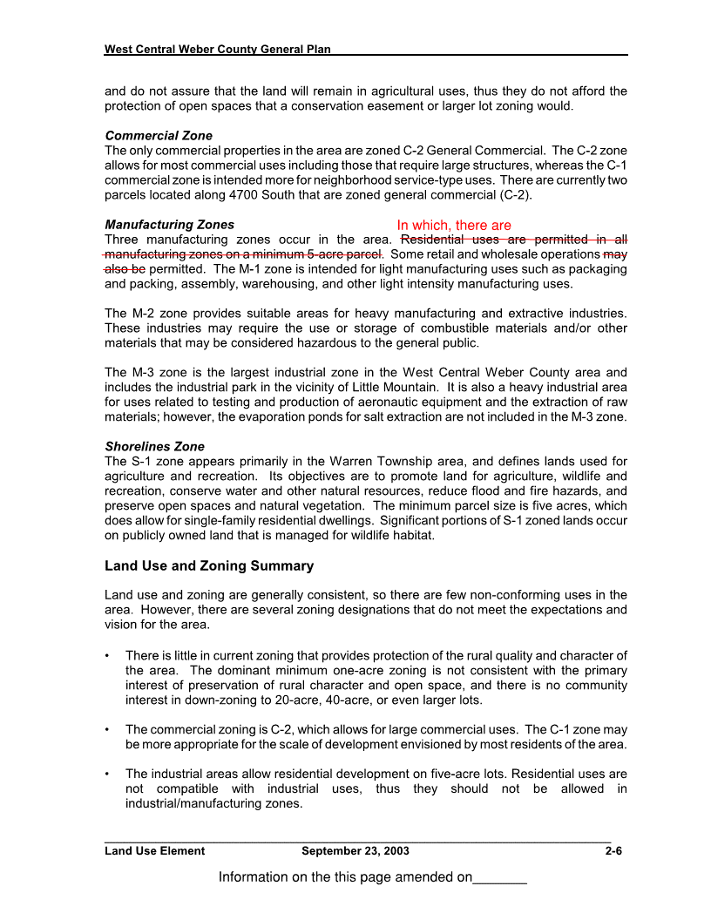 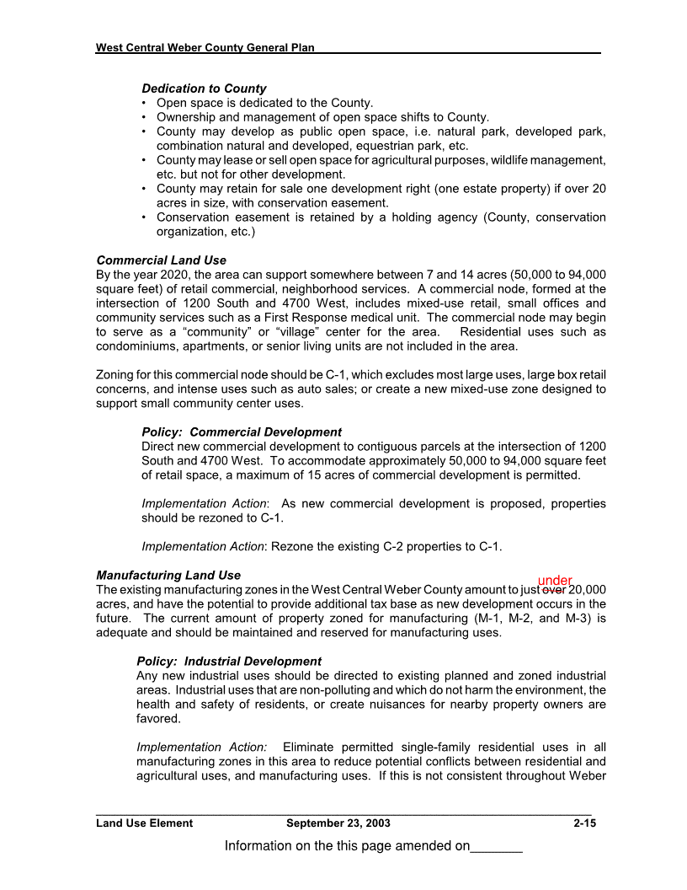 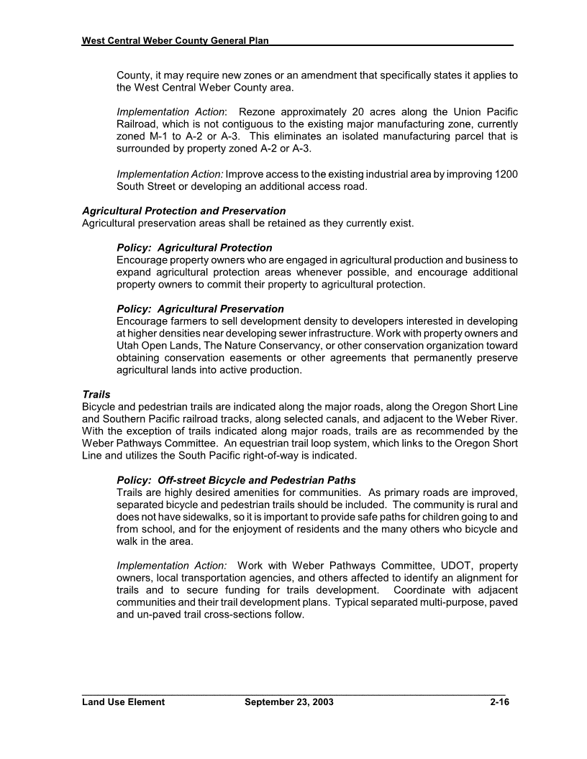

Exhibit E

