**Engineering Review**

The Conclusions and Recommendations from the September 5th 2007 Geologic Hazards Reconnaissance Report identified: “potential risks from earthquake shaking, surface fault rupture, liquefaction and landslides. Sheet and rill flow may also pose a seasonal concern' with the following recommendations:

1. The 'proposed home should be designed and constructed with to current seismic standards to reduce potential ground shaking hazard.'

**The Structural Design Calculations present a level E consideration for seismic loadings.**

**“Level E Seismic Category: Structures of ordinary occupancy located within a few kilometers of major active faults capable of producing MMI IX or more intense shaking.”**

***This seems to address the need to design per the current seismic standards identified in the 2007 report.***

2. 'A design-level geotechnical engineering study should be conducted prior to construction to:

         1) Address soil conditions at the site for use in foundation design, site grading, and drainage;

         2) Provide recommendations regarding building design to reduce risk from seismic acceleration;

         3) Evaluate and provide recommendations regarding liquefaction and, if needed, shallow groundwater; and

         4) Evaluated stability of slopes at the site, including providing recommendations such as setbacks and/or engineered mitigation measures to reduce the landslide risk if the factors of safety are deemed unsuitable.”

**The Section of the Price Engineering Design Calculation entitled Soil Design Properties Indicate that *no Geotechnical Study or Investigation was made available to them requiring them to assume stable soils characteristics*. Their designs were based on the unified soil classification of soil types GW, GP, SW, SP. The Soil Type found or identified in the reconnaissance report indicate a soils type of:**



**Looking at the Unified Soil Classification chart below the described soils would appear to be classified as an SM silty sand or an SC clayey sand outside of the range of the soil classification assumed in the structural design calculations prepared by the structural engineer.**

**______.**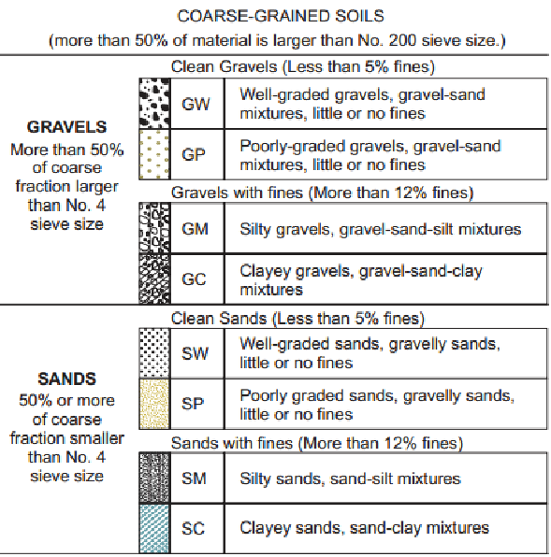

**It is my recommendation that a *design level geologic study* be performed as recommended in the September 5th , 2007 Geologic Hazards Reconnaissance report and the current Structural Calculations be reviewed by the Geotechnical Engineer to see if they adequately address the soil conditions found at the site.**

3.  Site hydrology and runoff should be addressed in the civil engineering design for the development to reduce the risk of localized sheet and rill flow.

**It is further noted that the soils are lacking significant cohesion characteristics making them sensitive to ground water and surface erosion and that an engineered grading plan should be provided to intercept and safely conduct surface waters around the building site to prevent soil saturation and or erosion that could potentially weaken or undercut the soils supporting the structure. *Please add an engineered grading plan to the design drawings.***

**I have tried to address all the concerns regarding the project with the information provided to me. This does not however assure that other site conditions or factors may be identified in the Site Geotechnical Study or during the actual excavations for the building foundations as well as during construction that may be of additional concern that will have to be addressed in addition to this review.**

**Please contact me if needed with questions regarding this review at 801 399-8054.**

**Blane W. Frandsen PE**