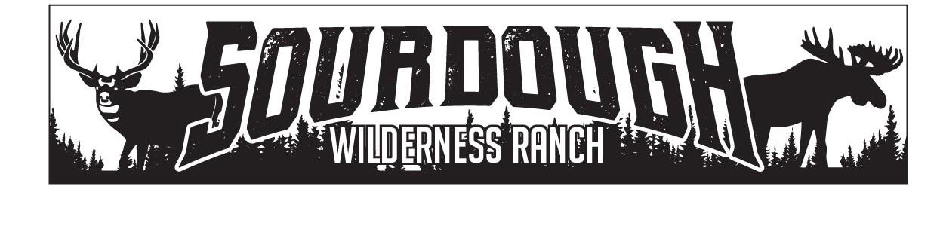
1150 N. Hwy 89 Suite B
Harrisville, UT 84404
801-773-3348
Sourdoughranch@gmail.com

Weber County
2380 Washington Blvd. Suite 240
Ogden, Utah 84401

Matt Bailey
RE: Lake East 18-Shed Approval
July 13th, 2023
Matt Has been approved by the board of trustees to place a shed up to 100 sq ft in size on Lake East Lot#18 by the board of trustees of Sourdough Wilderness Ranch.

Sincerely,

Shawna Lee

Shawna Lee
Office Manager
Board Secretary/Treasurer

