**Common Plan SWPPP for**

**Hill Single Family Home**

**5519 E Buckhorn Drive**

Eden, UT 84310

Kevin Hill

Owner Street Address

Owner City, State, Zip

Same as Above

Contractor Street Address

Contractor City, State, Zip

03/22/2018

SWPPP Preparation Date



# 1. Project Information

|  |  |  |
| --- | --- | --- |
| **Project Name:** Hill Residence | | |
| **Address:** 5519 E Buckhorn Drive | | |
| **City:** Eden | **State:** UT | **Zip:** 84310 |
| **Latitude:** Degrees, Decimal Minutes | | |
| **Longitude:** Degrees, Decimal Minutes | | |
| **UPDES Permit Tracking Number:** UTRH85473 | | |

|  |  |  |
| --- | --- | --- |
| **Owner:** Kevin Hill | | |
| **Contact Person:** Owner | | |
| **Address:** PO Box 751 | | |
| **City:** Eden | **State:** UT | **Zip:** 84310 |
| **Telephone Number:** (801) 430-8998 | | |
| **Email Address:** khill22x22@gmail.com | | |

|  |  |  |
| --- | --- | --- |
| **General Contractor:** Owner | | |
| **Contact Person:** Click here to enter text. | | |
| **Address:** Click here to enter text. | | |
| **City:** Click here to enter text. | **State:** State | **Zip:** Zip Code |
| **Telephone Number:** Contact Person Phone | | |
| **Email Address:** Contact Person Email | | |

**1.5**

**Unknown Features (although this may be a law under another program, it’s not a permit requirement). Discovery of Historical, Archaeological or Paleontological Objects, Features, Sites, or Human Remains**

A. Immediately suspend construction operations in the vicinity(100 foot minimum buffer) of the discovery.

B. Verbally notify the Public Works Department and provide them the exact location.

C. Protect the discovery and provide written confirmation of the discovery to the City and State Historic Departments within two calendar days.

D. Contractor and City follow State mitigation laws.

**2. Best Management Practices**

**2.1 SWPPP Sign**(see permit part 1.10, 4.2.11)

No sign will be provided

**2.2 Sensitive Features Control** (see permit part 2.2)

**2.2.1 Wetlands**

There are no wetlands within or near the proposed site.

**2.2.2 Water Bodies within or 30’ from Disturbance Boundary** (see permit part 2.3.5)

There are no wetlands within or near the proposed site.

**2.3 Sediment Control** (see permit part 2.1.2, 2.1.3 & 2.3)

**2.3.1** **Trap/Filter Sediment at Property Boundary**(see permit part 2.1.2)

Silt Fence (See Appendix B – SWPPP Site Map).

**2.4.1 Inlet Protection**(see permit part 2.1.3 & 2.3)

Storm Drain Inlet Protection (See Appendix B – SWPPP Site Map).

**2.4.2 Steep Slopes** (see permit part 2.3.2)

Straw Wattles (See Appendix B – SWPPP Site Map).

**2.4.x Street Maintenance**(see permit part 3.2.2)

Manual Sweeping

**2.4 Top Soil Preservation**(see permit part 2.5)

Preserve as much existing vegetation as possible

**2.5 Dust Control**(see permit part)

**2.5.1**

Selective operation during low wind conditions.

**2.6 Egress Control**(see permit part 2.4)

**2.6.1 Track Out**(see permit part 2.4.1)

Gravel at egress area (See Appendix B – SWPPP Site Map).

**2.7 Waste Management Control**(see permit part 4.2.6)

**2.7.1 Solid Waste**(see permit part 2.4.3)

A roll-off dumpster will be provided on site.

**2.7.2 Construction Spoil**(see permit part 2.1.1)

Stabilized construction entrance.

**2.7.3 Sanitary Waste**(see permit part 2.4.4)

Portable toilets.

**2.7.4 Cement Product Operations**(see permit part 2.4.5, 2.9.2)

Concrete waste management (See Appendix B – SWPPP Site Map)

**2.7.5 Concrete Cutting Operations**(see permit part 2.9.2)

Concrete waste management (See Appendix B – SWPPP Site Map)

**2.7.6 Non Aqueous Waste**(see permit part 2.8.2)

Material delivery, storage and containment.

***2.7.7 Construction Wastewater****(see permit part 2.7, 2.9, 2.9.4)*

N/A – no wastewater will be generated

***2.8 Management of Construction Materials Control***

***2.8.1 Storage of Construction Materials****(see permit part 2.8.2)*

No construction materials will be stored where pavement is directly connected to waterways.

***2.8.2 Construction Staging(backfill)****(see permit part 2.1.1)*

No construction materials (backfill) will be stored where pavement is directly connected to waterways.

***2.8.3 Construction Staging(Landscaping)****(see permit part 2.1.1)*

No construction materials (landscaping ) will be stored where pavement is directly connected to waterways.

***2.9 Final Stabilization****(see permit part 2.6)*

***2.9.1 Landscaping Plan***

No landscape plan is proposed at this time.

***2.9.x2 Temporary Containment of Sediment***

Silt Fence (See Appendix B – SWPPP Site Map).

# 3. Spill Prevention and Response Plan(see permit part 2.8.3, 2.9.3)

Onsite containment BMP’s (See Appendix B – SWPPP Site Map).

**Any discharges in 24 hours equal to or in excess of the reportable quantities listed in 40 CFR 117, 40 CFR 110, and 40 CFR 302 will be reported to the National Response Center and the Division of Water Quality (DWQ) as soon as practical after knowledge of the spill is known to the permittee.** The permittee shall submit within 14 calendar days of knowledge of the release a written description of: the release (including the type and estimate of the amount of material released), the date that such release occurred, the circumstances leading to the release, and measures taken and/or planned to be taken to the Division of Water Quality (DWQ), 288 North 1460 West, P.O. Box 144870, Salt Lake City, Utah 84114-4870. The Storm Water Pollution Prevention Plan must be modified within14 calendar days of knowledge of the release to provide a description of the release, the circumstances leading to the release, and the date of the release. In addition, the plan must be reviewed to identify measures to prevent the reoccurrence of such releases and to respond to such releases, and the plan must be modified where appropriate.

|  |  |
| --- | --- |
| **Agency** | **Phone Number** |
| National Response Center | (800) 424-8802 |
| Division of Water Quality ( DWQ) 24-Hr Reporting | (801) 538-6146; (801) 536-4123 |
| Utah Department of Health Emergency Response | (801) 580-6681 |
| Weber Fire Department | (801)745-9277 or (801)782-3580 |

Minimum spill quantities requiring reporting:

|  |  |  |
| --- | --- | --- |
| **Material** | **Media Released To** | **Reportable Quantity** |
| Engine oil, fuel, hydraulic & brake fluid | Land | 25 gallons |
| Paints, solvents, thinners | Land | 100 lbs (13 gallons) |
| Engine oil, fuel, hydraulic & brake fluid | Water | Visible Sheen |
| Refrigerant | Air | 1 lb |
| Antifreeze, battery acid, gasoline, engine degreasers | Air, Land, Water | 100 lbs (13 gallons) |

Emphasis to:

1st Priority: Protect all people (including onsite staff)

2nd Priority: Protect equipment and property

3rd Priority: Protect the environment

1. Make sure the spill area is safe to enter and that it does not pose an immediate threat to health or safety of any person.
2. Check for hazards (flammable material, noxious fumes, cause of spill) – if flammable liquid, turn off engines and nearby electrical equipment. If serious hazards are present leave area and call 911. LARGE SPILLS ARE LIKELY TO PRESENT A HAZARD.
3. Stop the spill source and contain flowing spills immediately with spill kits, dirt or other material that will achieve containment.
4. Call co-workers and supervisor for assistance and to make them aware of the spill and potential dangers
5. If spilled material has entered a storm sewer, regardless of containment; contact the Municipal Storm Water Division.
6. Cleanup all spills (flowing or non-flowing) immediately following containment. Clean up spilled material according to manufacturer specifications, for liquid spills use absorbent materials and do not flush area with water.
7. Properly dispose of cleaning materials and used absorbent material according to manufacturer specifications.
8. Report the reportable quantity to the Weber Morgan Health Department.

**Emergency Numbers**

Utah Hazmat Response Officer 24 hrs (801)-538-3745

Weber County Sheriff Department (801)-778-6600)

Weber County Engineering Division (801)-399-8374

# *4. Site Map(s) (see permit part 4.2.3)*

*The SWPPP site maps are filed in Appendix B*

*{Maps shall include all structural BMPs, and all site components necessary to demonstrate pollution containment. Multiple SWPPP site map sheets may be necessary to clearly show how and when BMPs are to be employed relative to the construction phases}*

*The SWPPP site maps shall include but not limited to:*

1. *boundaries of project/property*
2. *boundaries of disturbance (including areas outside of property boundaries)*
3. *show slopes on site*
4. *location of structures/facilities*
5. *locations of :*
   1. *stockpiles for soils and materials*
   2. *construction supplies*
   3. *portable toilets*
   4. *garbage/trash containers*
   5. *egress points/track out pads*
   6. *concrete washout pits or containers*
6. *water bodies, wetlands, natural vegetative buffers*
7. *placement of all BMPs, perimeter, erosion control, sediment control, inlet, etc.*
8. *storm water inlets and storm water discharge points (where storm water drains off the site)*
9. *areas that will be temporarily or permanently stabilized on the site*

*{Refer to the regulation for specific requirements}*

# 5. Record Keeping

See the appendices in Appendix A-K.

# SWPPP Inspections-Maintenance-Correction Report (permit part 3.2.1, 3.2.2, 3.3, 3.4, 4.2.12)

Inspections are required every 7 calendar days

Repair or replace BMPs prior to need or by end of week whichever comes first. Update the Inspection-Maintenance-Correction Report weekly.

Section 3.2.2 requires daily maintenance of pavements and site grounds.

See the Inspection-Maintenance-Correction Reports in Appendix E

# Changes to the SWPPP(see permit part 4.2.12, 4.2.13)

See the Amendment Log in Appendix F.

# Training(see permit part 4.2.7)

Training Logs and Documents are filed in Appendix H.

Owner has completed a certified SWPPP course.

# 6. Discharge Information

**Receiving Waters (look up** [**http://wq.deq.utah.gov**](http://wq.deq.utah.gov) **to identify your receiving water body)**

|  |  |
| --- | --- |
| **1.** | **Pineview Resevoir** |

**Impaired Waters (refer to** [**http://wq.deq.utah.gov**](http://wq.deq.utah.gov) **in the left hand column to determine status of receiving water body).**

|  |  |  |  |  |
| --- | --- | --- | --- | --- |
| **Impaired Surface Water** | **Is this surface water impaired?** | **Pollutant(s) causing the impairment** | **Has a TMDL been completed?** | **Pollutant(s) for which there is a TMDL** |
| Pineview Resevoir | ☐ Yes ☐ No | Dissolved oxygen | ☐ Yes ☐ No | Dissolved oxygen |

# 7. Certification, Notification and Delegation(see permit part 4.2.9)

|  |
| --- |
| **Owner Certification:** See documents filed in Appendix G.  **Operator Certification:** Owner and Operator are the same.  **Delegation of Authority:** See documents filed in Appendix G.  **Subcontractor Certification:** See documents filed in Appendix G  **Notice of Permit Transfer Requirements:** See documents filed in Appendix G |
|  |

# SWPPP Appendices

**Appendix A: General Location Map**

**Appendix B: SWPPP Site Maps**

**Appendix C: UPDES Permit(UTRH00000)**

**Appendix D: Permits; NOI, MS4**

**Appendix E: Inspection-Maintenance-Correction Report**

**Appendix F: SWPPP Amendment Log**

**Appendix G: Certifications, Agreements, Delegation of Authority**

**Appendix H: Training Log**

**Appendix I: Construction Plans**

**Appendix J: Additional Information**

**Appendix K: BMP Specifications and Details**

**APPENDIX A: General Location Map**

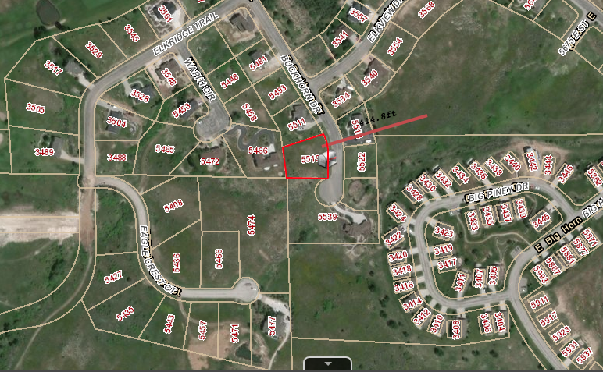

**APPENDIX B: SWPPP Site Map**

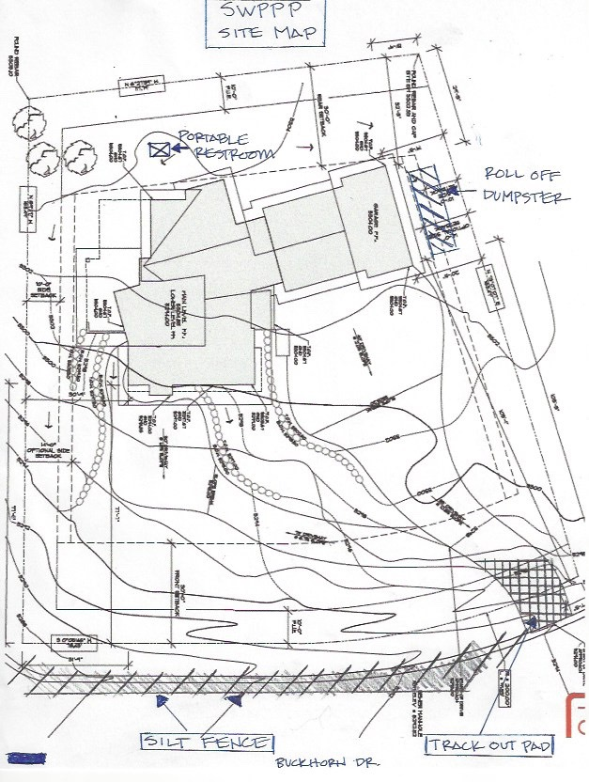

**APPENDIX C: UPDES Permit (UTRH85473)**

**APPENDIX D: Permits, NOI, MS4**

**APPENDIX E: Inspection-Maintenance-Correction Report**



**APPENDIX F: SWPPP Amendment Log**



**APPENDIX G: Certificates, Agreements, Delegation of Authority**

***OWNER CERTIFICATION***

I certify under penalty of law that this document and all attachments were prepared under my direction or supervision in accordance with a system designed to assure that qualified personnel properly gathered and evaluated the information submitted. Based on my inquiry of the person or persons who manage the system, or those persons directly responsible for gathering the information, the information submitted is, to the best of my knowledge and belief, true, accurate, and complete. I am aware that there are significant penalties for submitting false information, including the possibility of fine and imprisonment for knowing violations.

|  |  |  |  |  |  |  |
| --- | --- | --- | --- | --- | --- | --- |
| Name: |  | | Title: |  | | |
| Signature: | |  | | | Date: |  |

|  |  |
| --- | --- |
| Company: |  |

|  |  |
| --- | --- |
| Project: |  |

***OPERATOR CERTIFICATION***

I certify under penalty of law that this document and all attachments were prepared under my direction or supervision in accordance with a system designed to assure that qualified personnel properly gathered and evaluated the information submitted. Based on my inquiry of the person or persons who manage the system, or those persons directly responsible for gathering the information, the information submitted is, to the best of my knowledge and belief, true, accurate, and complete. I am aware that there are significant penalties for submitting false information, including the possibility of fine and imprisonment for knowing violations.

|  |  |  |  |  |  |  |
| --- | --- | --- | --- | --- | --- | --- |
| Name: |  | | Title: |  | | |
| Signature: | |  | | | Date: |  |

|  |  |
| --- | --- |
| Company: |  |

|  |  |
| --- | --- |
| Project: |  |

SUBCONTRACTOR CERTIFICATION

STORMWATER POLLUTION PREVENTION PLAN

Project Number: ­­

Project Title:

Operator(s):

As a subcontractor, you are required to comply with the Stormwater Pollution Prevention Plan (SWPPP) for any work that you perform on-site. Any person or group who violates any condition of the SWPPP may be subject to substantial penalties or loss of contract. You are encouraged to advise each of your employees working on this project of the requirements of the SWPPP. A copy of the SWPPP is available for your review at the office trailer.

Each subcontractor engaged in activities at the construction site that could impact stormwater must be identified and sign the following certification statement:

**I certify under the penalty of law that I have read and understand the terms and conditions of the SWPPP for the above designated project and agree to follow the BMPs and practices described in the SWPPP.**

This certification is hereby signed in reference to the above named project:

Company:

Address:

Telephone Number:

Type of construction service to be provided:

Signature:

Title:

Date:

Delegation of Authority Form

Delegation of Authority

I, _______________________ (name), hereby designate the person or specifically described position below to be a duly authorized representative for the purpose of overseeing compliance with environmental requirements, including the Construction General Permit, at the ____________________________________ construction site. The designee is authorized to sign any reports, stormwater pollution prevention plans and all other documents required by the permit.

________________________________________ (name of person or position)

________________________________________ (company)

________________________________________ (address)

________________________________________ (city, state, zip)

________________________________________ (phone)

By signing this authorization, I confirm that I meet the requirements to make such a designation as set forth in ____________________________________ (Reference State Permit), and that the designee above meets the definition of a “duly authorized representative” as set forth in ____________________________________ (Reference State Permit).

I certify under penalty of law that this document and all attachments were prepared under my direction or supervision in accordance with a system designed to assure that qualified personnel properly gathered and evaluated the information submitted. Based on my inquiry of the person or persons who manage the system, or those persons directly responsible for gathering the information, the information submitted is, to the best of my knowledge and belief, true, accurate, and complete. I am aware that there are significant penalties for submitting false information, including the possibility of fine and imprisonment for knowing violations.

**Name:**

**Company:**

**Title:**

**Signature:**

**Date:**

**Notice of Permit Transfer Requirements**

Upon transfer of ownership or control of the subject property under this Permit (see section 8.2.2.a.) coverage under the UPDES CGP must continue until stabilization requirements are satisfied according to permit requirements. This requirement may be met by either of the following transfer options:

1. Obtaining coverage under a new and independent Notice of Intent (NOI – the application process to procure coverage under the UPDES CGP). This results in a new permit coverage number.

2. Coordinating with the previous owners and the State of Utah, Department of Environmental Quality, Division of Water Quality where ownership, other information, and signatures (including electronic certifications) contained in the NOI that is current for the property is changed to reflect the change in ownership and responsible parties for conducting construction activities (general contractor). For this step you would assume the responsibilities of the original CGP coverage. This continues the original permit coverage number.

_____________________________________ ____________________________

Name of Previous Owner Telephone Number

________________________________________________________________________

Address of Previous Owner City State Zip

______________________________________________ ____________________

Signature of Previous Owner Date

_____________________________________ ____________________________

Name of New Owner Telephone Number

________________________________________________________________________

Address of New Owner City State Zip

______________________________________________ ____________________

Signature of New Owner Date

**PROJECT NAME AND LOCATION**

______________________ ___________________________________________

Previous Permit Number Name of Project

________________________________________________________________________

Address of Project City State Zip

________________________________________________________________________

Longitude Latitude

**WHAT KIND OF TRANSFER: PARTIAL OR TOTAL?**

Is this a transfer of ownership of partial or total of the permitted area? Partial □

Total □

If this is a transfer of part of the permitted area to a new owner, describe what part:

________________________________________________________________________

________________________________________________________________________

________________________________________________________________________

Will there be a new SWPPP prepared? YES □ NO □

Please update the General Contractor Information (see transfer options 1 or 2, first page). If this is a partial transfer the only option is 1.

This form must be submitted to the Municipality of Jurisdiction and DWQ

To submit to DWQ either email to the construction storm water coordinator or,

FAX to 801-535-4301

Or mail to DWQ

PO Box 144870

**APPENDIX H: Training Log**



**APPENDIX I: Construction Plans**

**APPENDIX J: Additional Information**

**APPENDIX K: BMP Specifications and Details (label BMPs to match the sections identified in this document.)**

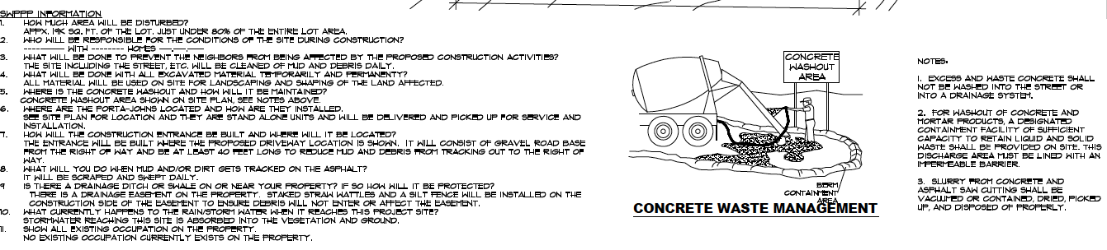

**See Appendix B for Other SWPPP BMP’s**