On Tue, Dec 26, 2023 at 10:00 AM Cameron Draney <cdraney@utah.gov> wrote:
To whom it may concern

The Division of Drinking Water (the Division) understands that The Ruby water system (System #29131) that will serve this development will construct a new water system, including a new culinary well, storage tank, and all necessary appurtenances to provide safe drinking water to the patrons of the development. The existing problematic spring source and storage system will be entirely physically disconnected from the culinary system. Although this is not a formal approval of the new system, the Division has no concerns with the proposed plan as presented and supports the replacement of the existing problematic drinking water system.

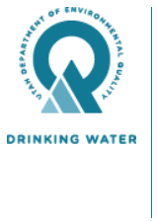 | Cameron Draney, P.E.  Environmental Engineer III | Division of Drinking Water  M: (385) 271-7039  drinkingwater.utah.gov

