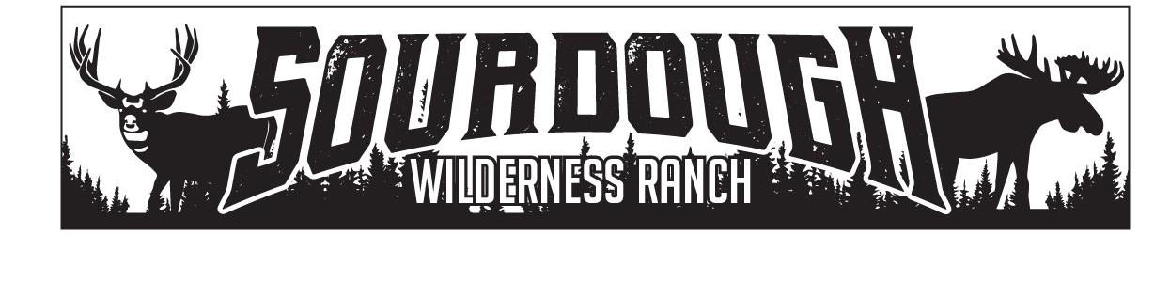
1150 N. Hwy 89 Suite B
Harrisville, UT 84404
801-773-3348
Sourdoughranch@gmail.com

Weber County
2380 Washington Blvd. Suite 240
Ogden, Utah 84401

JOHN HIRSBRUNNER
RE:Pole Line 2 Shed Approval
June 12th, 2023
John Hirsbrunner has been approved by the board of trustees to place a shed up to 100 sq ft in size on Pole Line Lot #2 by the board of trustees of Sourdough Wilderness Ranch.

Sincerely,

Shawna Lee

Shawna Lee
Office Manager
Board Secretary/Treasurer

