Memo
Bright Acres Subdivision alternative access
Date: August 12, 2021
Regarding: Request for the previously approved alternative access for the proposed Bright Acres Subdivision to provide access to a second Lot based on a property boundary realignment requested by the Weber Morgan Health Department
Applicant: Scott and Rachel Hale, 983 E Bella Vista Dr Fruit Heights, Utah 84307, 801-792-4065, Scottchale@gmail.com
To: Weber County Planning Department, 2380 Washington Boulevard, Suite 240, Ogden Utah, 84410
Request
Mr. and Mrs. Hale would like approval from Weber County for a private driveway access to two residential lots in a proposed four residential lot subdivision on an approximately 14 acre parcel at approximately 5638 N 3100 E Liberty, Utah 84310. The original design of the subdivision required alternative access via a private driveway for one of the four lots (lot 2), which alternative access was approved by the county. Below is an image of original plan for lots 2, 3 and 4, showing the approved alternative access for lot 2 and the originally proposed property boundaries between these lots.
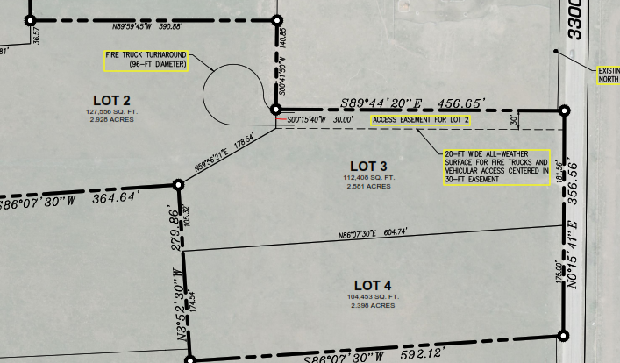

When the Weber Morgan Health Department reviewed the originally proposed subdivision, they requested that we rearrange the property boundaries between lots 3 and 4 for the following reason. The water for lots 2, 3, and 4 will be provided via a private shared well that has been drilled on lot 2. Water for these lots will be provided by a private well as the local water utility, Liberty Pipe, limits the number of new connections to five per year and sold all available connections in the first half of 2021. Weber Morgan Health department requires that all lots on a subdivision that obtain water from a private well have space for a 200’ diameter well protection zone, even though the well is physically located on only one of the lots. Lots 3 and 4 were less than 200’ wide at their widest point and therefore didn’t meet this requirement, which is why the health department asked for the boundaries between these lots to be reconfigured. The updated subdivision plan changed the boundaries between lots 3 and 4 to run North and South rather than East and West, creating the need for lot 3 to obtain access to 3300 East via the same alternative private driveway approved for lot 2. As noted in the original alternative access application, the private access is planned to be a 15 to 20 ft wide all weather surface driveway for fire truck (up to 75,000 pounds) and vehicular access, centered in a 20 to 30 ft easement, with an emergency pull out at the mid point, terminating in a fire truck turnaround. Below is an image from the updated subdivision map that shows the proposed property boundaries for lots 3 and 4 and the private drive providing access for lots 2 and 3.
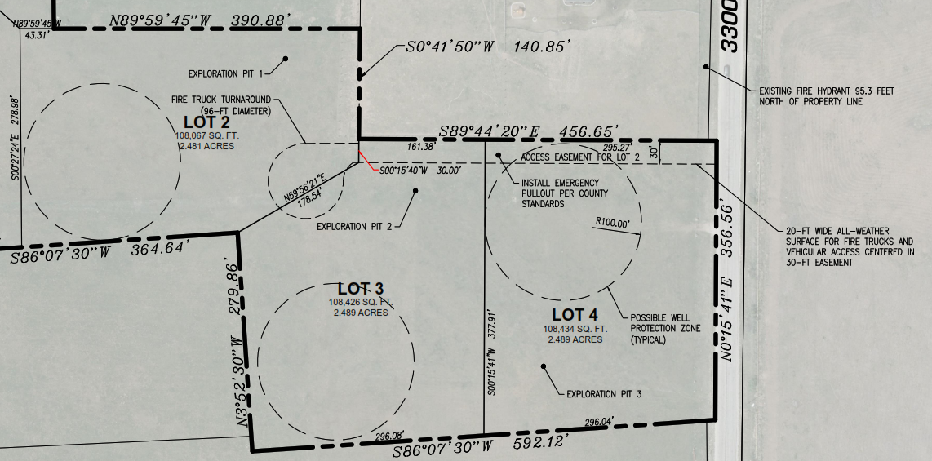

Reason for the Request
Sec §108-7-31 of the Weber County Code notes that lots/parcels which do not have frontage on a street, but which have access by a private right-of-way or access easement may, under certain circumstances, use a private right-of-way or access easement as the primary access, subject to approval based on certain conditions being met including:

(a)(3) Based on substantial evidence, it shall be shown that it is unfeasible or impractical to extend a street to serve such lot/parcel. Financial adversity shall not be considered; however, circumstances that may support an approval of a private right-of-way/access easement as access to a lot/parcel may include but not be limited to unusual soil, topographic, or property boundary conditions.

As also outlined in the original alternative access application, the property boundary conditions around the proposed lots we are seeking alternative access make it impractical to extend a street to serve these lots. The lots sit in the middle of a triangle of land between 5750 N to the North, 3300 E to the East, and North Fork Road to the West. There does not appear to be a path for a new road through this triangle of land that would not cut through a developed property enroute to another connecting road and/or that would be beneficial for providing convenient access to owners of surrounding properties.

We own the property on which the proposed private drive access to 3300 E will be built and therefore have the ability to provide the access easement needed for the private drive. Refer to the updated concept plan map that shows the access easement and private drive has been designed to provide safe and consistent access to these lots in accordance with the requirements of Sec 108-7-29.

