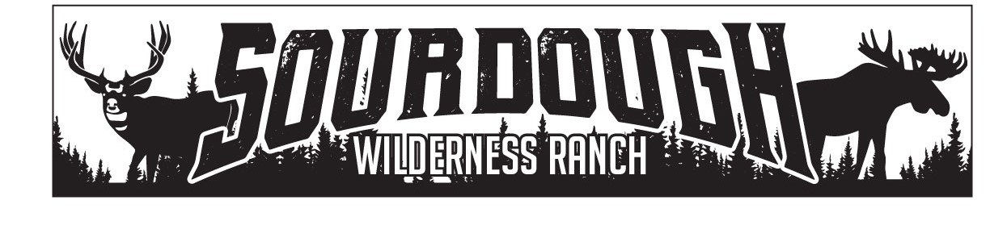
1150 N. Hwy 89 Suite B
Harrisville, UT 84404
801-773-3348
Sourdoughranch@gmail.com

Weber County
2380 Washington Blvd., Suite 240
Ogden, Utah 84401

RE: BRANDON WESSMAN: HEARTACHE 18
SHED APPROVAL
June 19, 2021
Brandon Wessman has been approved to place a shed up to 100sq ft in size on Heartache 18, by the board of trustees of Sourdough Wilderness Ranch.

Sincerely,

Shawna Lee

Shawna Lee
Office Manager
Board Secretary/Treasurer

