Ordinance No.
An ordinance of Weber County vacating a portion of
a Public utility easement in the Mountain View Estates No. 5

WHEREAS, the Owner has filed a petition to vacate two feet from a ten-foot public utility easement along the rear property line of lot 32, Mountain View Estates, as depicted in Exhibit A of this ordinance; and
WHEREAS, after providing proper public notice, a public hearing was held before the Weber County Commission on November 30, 2021, regarding the reduction of the public utility easement; and
WHEREAS, Weber County’s Engineering Department has been notified and has provided written approval of the public utility easement width reduction; and
WHEREAS, the Commission finds that good cause exists to reduce the width of the public utility easement, and that it will not substantially affect the Ogden Valley General Plan, and that neither the public interest nor any person will be materially injured;
NOW THEREFORE, the Board of County Commissioners of Weber County ordains as follows: two feet are hereby vacated from a ten-foot public utility easement along the rear property line of lot 32, Mountain View Estates No. 5, as depicted in Exhibit A of this ordinance.
This Ordinance shall be effective 15 days after publication in the Standard Examiner.
Adopted and ordered published this 30th day of November, 2021.

Weber County Commission
By_________________________________
James H. Harvey, Chair

Commissioner Harvey Voted
Commissioner Froerer Voted
Commissioner Jenkins Voted

ATTEST:
_________________________________
Ricky Hatch, CPA
Weber County Clerk

Exhibit A
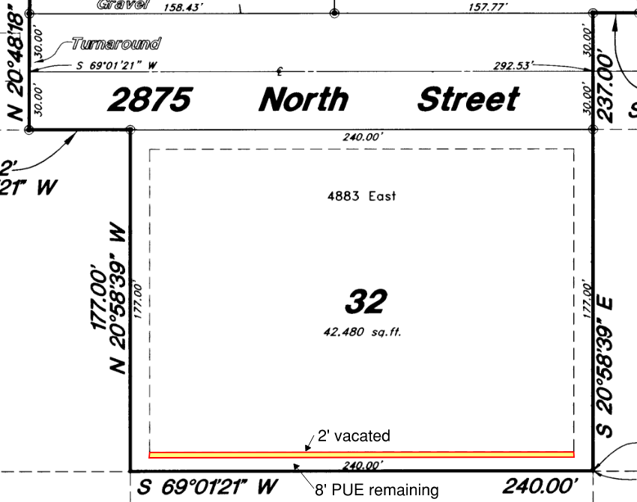
Dedication Plat 54-098

