ATTACHMENT TO DESIGN REVIEW APPLICATION

EDEN HERITAGE MONUMENT PROJECT
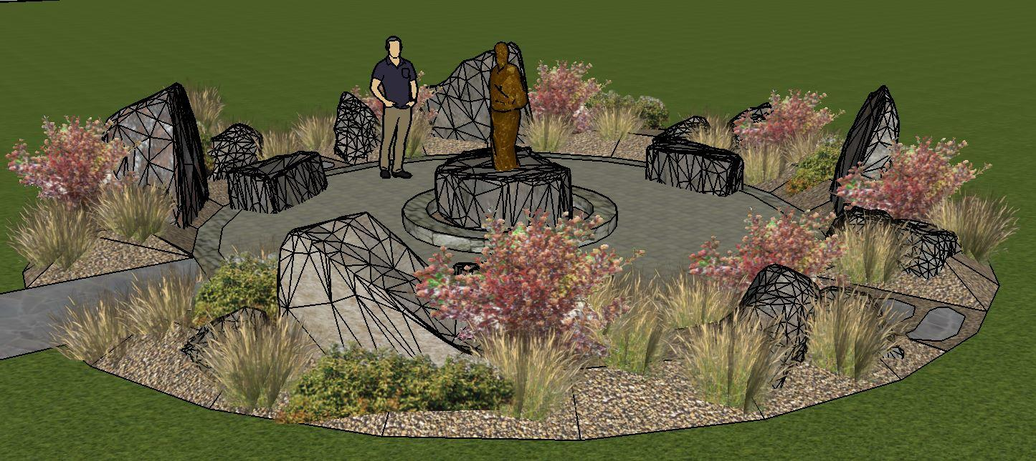

To honor those who founded this beautiful settlement of Eden, Utah prior to 1900, a volunteer committee of Eden residents is committed to raising donated funds and constructing a monument to be located in the southwest corner of Eden Park. This monument project is sponsored by Sons of the Utah Pioneers (SUP) and supported by the local Ogden Valley Chapter. The monument has been designated as SUP Historical Site #229. It is anticipated this project will be completed by Summer 2022.

The names of Eden’s founders who pioneered this settlement before the year 1900 will be engraved on bronze plaques mounted on flat boulders surrounding a center located 5 ft. high bronze statue of a typical young boy in Eden, Utah from the late 1800’s. This statue will be mounted on a flat boulder approximately five feet in diameter and three feet high. The flat boulder supporting the bronze statue will be supported by a five foot diameter concrete footing, approximately three feet deep. A paver or stamped concrete patio will surround the center located bronze statue. The patio will be a circular shape with a diameter of 20 feet.

Landscaping will surround the outer perimeter of the patio extending an additional five feet beyond the patio area. Five to six large boulders, with flat face cuts for mounting the bronze plaques, will be placed in the landscaping area. The engraved bronze plaques will include founding family names and Eden historical narratives.

A five foot wide concrete walkway will be laid from the south parking lot to the entrance of the monument.

Landscaping and Irrigation Plan - Xeroscaping landscaping will be used. Appropriate drought resistant plants will be planted and a drip irrigation system will be installed tapping into the existing Eden Park sprinkler irrigation system. Crushed rock or mulch will be used to fill in the landscaping area.

Lighting Plan – Only appropriate solar lighting, controlled with automatic timers, will be used.

Waiver of Application Fee – This is to request that the Design Review Application fee of $500 be waived because this project is to be a historical monument to be enjoyed by all Eden residents and is 1) headed by a volunteer committee of six people who do not get paid, 2) all funds and most of the labor and equipment for the monument are donated by supporting businesses and 3) the Sons of Utah Pioneers is the non-profit sponsor.

NOTE: With acceptance of this Application by Weber County Planning Department, the Eden Monument committee intends to coordinate with the Eden Park Board to complete the project.

Site and Monument Plot Plan

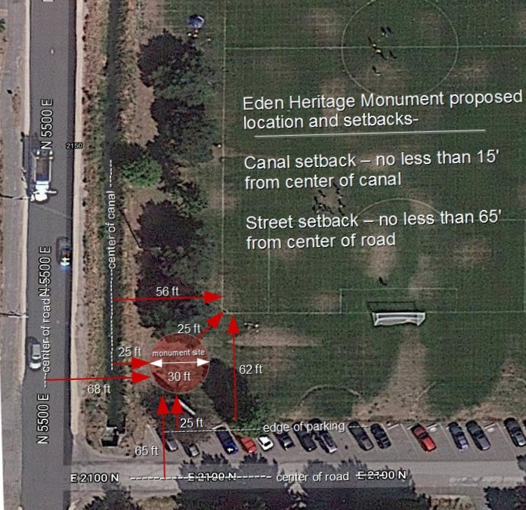

Monument Location and Setback at Eden Park
(See 30 ft. diameter brown circle)

Letter from Eden Park Board

Eden Founding Families Heritage Monument at Eden Park

Original authorization by the Eden Park Board (EPB) given to the Eden Heritage Committee to locate monument at the west side of the bowery situated between the backstop, bowery, and playground was given January 12, 2019.

The following amendment PROPOSAL was presented to the EPB on July 19, 2021 was voted on and approved.

Eden Park Board agreement and authorization for relocation of the monument

Location of monument to be the SW corner of park between canal/tree line, soccer field and Coke scoreboard.

Monument Committee will comply with the following:

Set backs - Monument construction will comply with all set backs from road and canal.

Building permit - will be acquired from Weber County planning and zoning.

Monument elements

- to include a statuary and other bronze work (stories representing the time period and people being memorialized) applicable to honoring Eden Founding Families, including bronze placards listing names of Eden Settlers between 1860 and 1900. Final content to be reviewed by the EPB for final approval.

- containing physical elements of pavers, boulders, benches, non-maintenance xeriscape, drip irrigation, solar lighting, security final approval of permanent design and features needs to be approved by the EPB.

Removal of the Coke scoreboard sign - Eden Park and the Eden Heritage Committee to split the cost of removal - $250.00 each.

Eden Park to maintain an ongoing minimum 20 ft buffer between soccer field boundary lines and the monument. (existing buffer is between 20-25 ft)

***Monument Committee will work with the EPB to obtain final signoff along the way on all aspects of this project including but not limited to all bronze work design and stories, all physical elements of pavers, boulders, benches, non-maintenance xeriscape, drip irrigation, solar lighting, security.

Eden Park will be responsible for ongoing oversight of Eden Heritage Monument beginning at monument completion/dedication,

NOTES:

Setbacks – monument will comply to the following setbacks

16' from canal center to any structure

65' from center of road to any building (monument might have a reduced setback distance since it is not a building and existing Coke scoreboard is at 50' from road center.)

Current west sideline of soccer field is 56 ft from canal center. Current soccer field end line is 62 ft from parking area

An overall monument footprint with a maximum 30' diameter will have a minimum 25' foot set back from the center of the canal and a 25' setback from the sideline and end line corner of the soccer field and a 25' distance from the street-side parking area

Eden Park Board

___________________________________ Date _ 09/30/2021_____________
Nicholas Froerer
Board Member

NOTE: Original signed by Nicholas Froerer

Map reference below:

