Sunnyfield, LLC has been dedicated to the preservation of agriculture and agricultural land here in the Ogden Valley. As part of that Sunnyfield has worked diligently and spent a lot of resources to restore existing structures at Sunnyfield Farm including the restoration of the farm shop (old milk barn) and the continued restoration of the large barns. Sunnyfield has devoted 36 developable acres to agricultural uses. Sunnyfield continues to work along side of a 5th generation local farmer to help facilitate the operation of a working farm that is becoming a destination and also a source of local farm raised product for the families within the Ogden Valley. The dream of Sunnyfield LLC is to continue to re-invigorate a long-standing working farm that had been a part of the community since 1868 so it can be here for the community to enjoy for many generations to come.
Sunnyfield requests to transfer 8 development rights from 2103 N. 5500 E. area as described in the attached legal description. This would leave a remaining 3 development rights on that described property.
The 8 development rights are to be transferred to Weber County Parcel # 220500017 which is approx. 22.94 acres. Under current land use code the 22.94 acres would allow 7 current development rights. The 8 TDR’s along with the existing 7 development rights would then allow for 15 development rights on Weber County Parcel #220500017.
This TDR will help Sunnyfield to continue using its current land for agricultural uses. Additionally removing density in this area provides an excellent agricultural gateway into the Old Town Eden village node and moves the density into an area that is already developed on all sides including an existing subdivision (Eden Acres) which consists of higher density 1 acre lots.
Sec 104-22-11 Form-Based Zone Transferrable Development Rights discusses the ability to transfer development rights as provided in the Ogden Valley General Plan. The 9 TDRs would be transferring within the village node to an area that is designated for higher density and would be contiguous with and connected to an existing subdivision (Eden Acres) that consists of 1 acre lots. See map illustration below taken from the Land Use Code Sec 104-22-8.

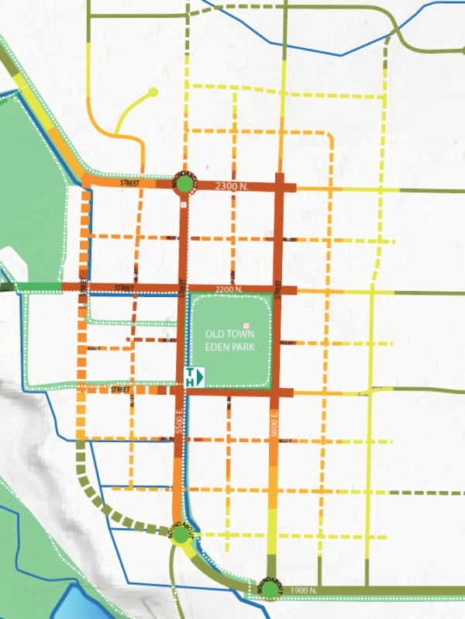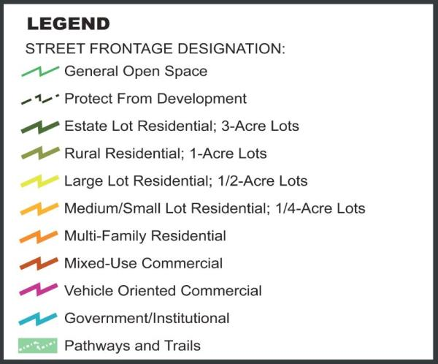

Land Use Principle 1.4 in the general plan states the general plan should “Employ mechanisms such as TDRs to reallocate existing authorized development units from less suitable to more suitable locations”. This TDR accomplishes that as it takes density out of the gateway into Old Town Eden additionally preserving viewsheds of Pineview Reservoir and transfers that density to be contiguous with an established 1-acre subdivision (Eden Acres).
The Ogden Valley General plan discusses Gateways and Viewsheds as follows: “Ogden Valley’s natural setting provides opportunities for spectacular views of local agriculture, the mountains, Pineview Reservoir, and the stars in the night sky. The visual values of the Valley are most evident at major entry points, or gateways, and from roadways extending through the community. Residents feel that an important aspect of preserving the Valley’s rural character includes maintaining the sense of arrival at Ogden Valley gateways and preserving open view corridors at key points within the Valley. Residents do not want development to be obtrusive or to unduly compromise these views.” The plan goes on to state that “integral elements of the character of the Ogden Valley plan area are the open farm fields, grasslands and pastures of the Ogden Valley. In much of the rural west, agriculture areas provide for well-managed open spaces that are enjoyed by residents and visitors to the area. The presence of livestock, farm machinery and isolated farm houses contribute to the rural character of Ogden Valley.”
Additionally, Land Use Goal 2 in the general plan states that “a goal of Weber County is to support continued agricultural operations in Ogden Valley”.
The transfer of TDRs is not adding any overall density to the village node. Rather it transfers existing development rights to an already established higher density area, preserves open agricultural open space in the gateway to Old Town Eden and helps support the viability of keeping an agricultural farm in the Ogden Valley. The transfer of TDR’s fits within the guidelines and goals of the Ogden Valley General plan and would be beneficial to the community
Sunnyfield believes that the Ogden Valley General Plan supports Sunnyfield’s transfer of TDR’s and the plan supports the goals of the Ogden Valley General plan. Keeping Sunnyfield a farm is a huge benefit to the community. Farming is difficult both physically and financially, however, this TDR will go a long way in helping the farm to stay a farm.

A narrative explaining the planned or potential future access to culinary and secondary water facilities, and wastewater disposal facilities.
Culinary water at the property is to be provided by Eden Waterworks company and the property has 40-acre feet of water allotted to parcel #22-050-0017. Wastewater will be disposed by septic tank and a storm water plan will be developed by an engineer and presented at the time of a subdivision application.

