WEBER COUNTY PLANNING DIVISION

Administrative Review Meeting Agenda

March 06, 2019

4:00 to 5:00 p.m.

- UVJ012419: Consideration and action on the application for final plat approval of the John and Vicki Subdivision, located at 4146 N 3800 W, Liberty UT in the AV-3 Zone. (John W McFarland Revocable Trust, Applicant; Brett McFarland/Cecil Satterthwaite, Agents) Ronda Kippen, Presenter

- Adjournment

The meeting will be held in the Weber County, Breakout Room, in the Weber Center, 1st Floor, 2380 Washington Blvd., Ogden, Utah unless otherwise posted

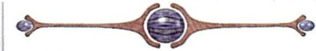

In compliance with the American with Disabilities Act, persons needing auxiliary services for these meetings should call the Weber County Planning ·Commission at 801-399-8791

