Ordinance No.
An ordinance of Weber County vacating the side Public utility easements within lots 119, 120, 121, 122, of the evergreen park subdivision no. 1

WHEREAS, the owner has filed a petition to vacate the side public utility easements within lots 119, 120, 121, 122, of the Evergreen Park Subdivision No. 1, as depicted in Exhibit A of this ordinance; and
WHEREAS, after providing proper public notice, a public hearing was held before the Weber County Commission on July 19, 2022, regarding the vacation of the public utility easements; and
WHEREAS, Weber County’s Engineering Department has been notified and has provided written approval of the public utility easement vacation; and
WHEREAS, the Commission finds that good cause exists to vacate the public utility easement, and that it will not substantially affect the Ogden Valley General Plan, and that neither the public interest nor any person will be materially injured;
NOW THEREFORE, the Board of County Commissioners of Weber County ordains as follows: the side public utility easements within lots 119, 120, 121, 122, of the Evergreen Park Subdivision No. 1 are hereby vacated, as depicted in Exhibit A of this ordinance.
This Ordinance shall be effective 15 days after publication in the Standard Examiner.
Adopted and ordered published this 19th day of July 2022.

Weber County Commission
By_________________________________
Scott Jenkins, Chair

Commissioner Jenkins Voted
Commissioner Harvey Voted
Commissioner Froerer Voted
ATTEST:
_________________________________
Ricky Hatch, CPA
Weber County Clerk

Exhibit A
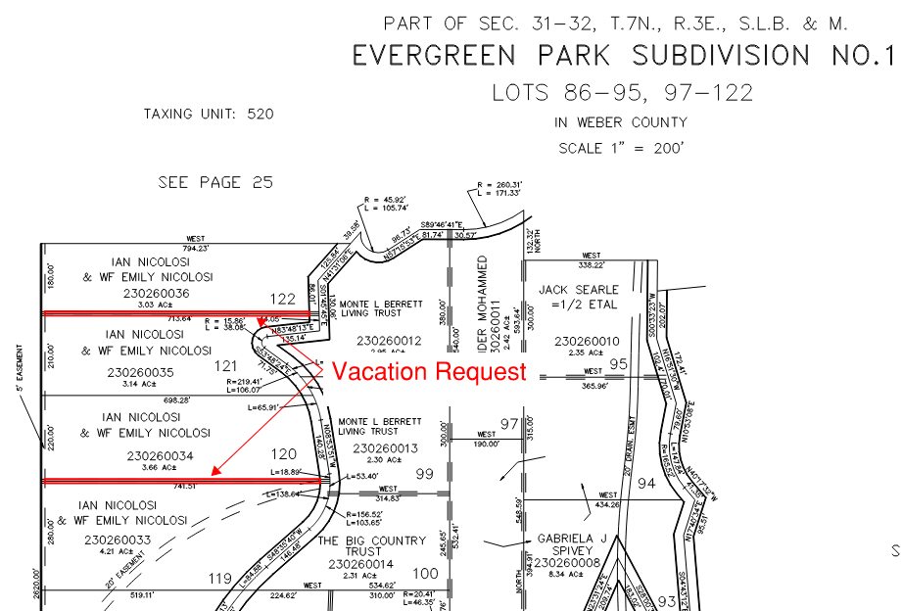
Recorder’s plat 23-026

