Welcome to Fairway Oaks  neighborhood | Home Owners Association  - •  - Est. 1998
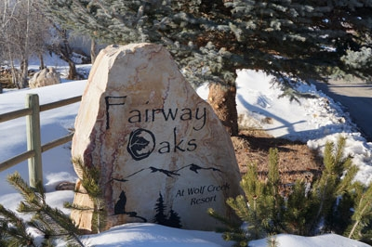  Neighborhood Rules  - No trespassing on other’s property  - Honor quiet hours of 10 PM- 7 AM  - No trailer parking in streets or on driveways, except for loading/unloading (includes boat, utility, ATV, and camping trailers and motorhomes)  - According to the Night Sky Initiative, turn off exterior lights by 11 PM.  - Park in the home’s garage or driveway. If additional parking is needed, one vehicle may be parked on the street in designated areas with the parking tag provided.  - Garbage day is MONDAY. If you are staying in the home over a Sunday night, please place all trash inside the green cans and place them at the curb by early Monday morning. Please return them promptly to the garage when they have been emptied. | 95% of the homes in our neighborhood are owner-occupied.  We are honored to have you as a guest here. Please remember to be respectful of the other residents and their property and keep our neighborhood beautiful.

