(This SWPPP Template is for the Common Plan Permit Only, and
does NOT address SWPPP requirements found in the CGP.)

Common Plan SWPPP for
White Residence
2148 E 6825 N
Liberty, UT 84310

Richard White
Owner Street Address
Owner City, State, Zip

Peterson Builders Inc
4794 E 2600 N
Eden, UT 84310

7/12/2019
SWPPP Preparation Date

1. Project Information
Project Name: White Residence
Address: 2148 E 6825 N
City: Liberty | State: UT | Zip: 84310
Latitude: 41.382728
Longitude: -111.895451
UPDES Permit Tracking Number: UTRH94901

Owner: Richard White
Contact Person: Richard White
Address: PO Box 807
City: Dillon | State: CO | Zip: 80435
Telephone Number: 970-409-9234
Email Address: bergziege08@gmail.com

General Contractor: Peterson Builders Inc
Contact Person: Chad Ferguson
Address: 4794 E 2600 N
City: Eden | State: UT | Zip: 84310
Telephone Number: 385-238-6593
Email Address: chadfurg.pbi@gmail.com

Answering “no” to the two questions below means the project is not eligible for this permit.
Is the project in Indian Country? | Yes ☐ | No ☒
Is the project a residential building on a single lot and disturbing one acre or less? | Yes ☒ | No ☐

2. Pollution Sources/Best Management Practices
 | Answer yes or no whether the following features are located at your site. If yes, select the BMP(s) that will be used to protect each feature. If no, continue to the next question. Attach necessary illustrated details for proper installation in Appendix G, and show locations of all controls on Site Map in Appendix A.
2.1 |  | Is there a SWPPP sign on site? (see permit part 1.10) | Yes ☒ | Required
 |  | The sign must include the UPDES tracking number, the owner or general contractor name, phone number and email, and if the SWPPP is on-line, instructions on how to view it. The size requirement is to be readable from a publicly accessible point.

2.2 | Will there be construction dewatering on the site? (see permit part 2.7) |  | Yes ☐ | No ☒
 | BMP(s): | ☐ Dewatering of the construction area is needed and a separate dewatering permit  has been obtained to treat and discharge water. Construction Dewatering (if discharged offsite) must be covered by UPDES Permit UTG070000.
 |  | ☐ Water from the dewatering of the construction area will be infiltrated on site.

2.3 | Will there be non-storm water discharges on the site? (see permit part 1.3) |  | Yes ☐ | No ☒
 | Allowable discharges include: Flushing of drinking water or irrigation water (not including wash or cleaning waters), water used for dust control, spring water or groundwater not exposed to construction activities, water from emergency fire-fighting activities, and water from foot drains not exposed to construction activities. (see permit part 2.4.5 & 2.9).
 | Please list all anticipated non-storm water discharges: Click here to enter text.
 | What will you do to manage the non-storm water discharges? Please list direct discharges, contained non-storm water discharges, and discharges that are treated separately.
 | BMP(s): | ☐ All non-storm water discharges are listed as allowable per permit part 1.3 and discharged
 |  | ☐ All non-storm water discharges that are not allowed are properly contained (see questions 2.12 and 2.16)
 |  | ☐ All non-storm water discharges that are contaminated with sediment only (free of chemicals, oils, etc.) will be treated in a sediment basin or equivalent (see permit part 2.8.1).
 |  | ☐ Other: Click here to enter text.

2.4 | Is it possible for the total area of disturbance to be phased, minimizing the total exposure of disturbed soil at one time? (see permit part 2.3.1) | Yes ☐ | No ☒
 | If disturbance can be minimized please show the locations on the site map and summarize (here) where disturbances will be delayed for some of the disturbed area: Click here to enter text.

2.5 | What perimeter controls will be used to prevent sediment from leaving the site? (permit part 2.1.2 & 2.3)
 | BMP(s): | ☒ Silt Fence | ☐ Berms
 |  | ☒ Vegetative Buffer | ☐ Cut-Back-Curb
 |  | ☐ Staked straw Wattles (Fiber Rolls) | ☐ Weighted Wattles
 |  | ☐ Other: Click here to enter text.

2.6 | Are surface waters located within 30 feet of your project’s earth disturbances? |  |  |  | Yes ☐ | No ☒
 | Note: A 30’ natural vegetative buffer MUST be maintained by water bodies. If a buffer less than 30’ is used, you must demonstrate that the additional controls offer the same protection as a 30’ natural vegetative buffer, and select the reason for exemption below. (see permit part 2.3.5)
 | BMP(s): | ☐ 30’ Natural Vegetative Buffer
 |  | If less than 30’ Natural Vegetative Buffer select additional Controls:
 |  |  | ☐ 2 Silt Fence Barrier | ☐ 2 Straw Wattle Barriers (Fiber Roll)
 |  |  | ☐ Other: Click here to enter text.

2.7 | Are there critical or sensitive areas (such as preservation of the drip lines around trees, wetlands, buffer zones by water bodies, etc.) located on or adjacent to the site? (see permit part 2.2) |  | Yes ☐ | No ☒
 | BMP(s): | ☐ Separate and isolate with environmental fencing
 |  | ☐ Other: Click here to enter text.

2.8 | What track out control will be used to prevent dirt from being tracked on streets as vehicles leave the site? (see permit part 2.4.1)
 | BMP(s): | ☐ Track Out Pad | ☒ Cobble | ☐ Gravel
 |  | ☐ Rumble Strips | ☐ Wash Down Pad | ☐ Delivery Pad
 |  | ☒ Restricted Site Access | ☐ Selective Access During Dry Weather (Dry soil)
 |  | ☐ Other: Click here to enter text.

2.9 | Do you have storm drain inlets on or down gradient of this site? (see permit part 2.1.3)  Protection must address the curb inlet opening (throat) as well as the grate. |  |  | Yes ☐ | No ☒
 | Where is/are the nearest downstream inlet(s) and how will you protect them: Click here to enter text.
 | BMP(s): | ☐ Rock/Sand-filled Bags | ☐ Drop Inlet Bags
 |  | ☐ Filter Fabric | ☐ Gravel or Sand filled Wattles
 |  | ☐ Proprietary inlet devices
 |  | ☐ Other: Click here to enter text.

2.10 | Will curb ramps be used at the site? (see permit part 2.4.2) |  |  | Yes ☐ | No ☒
 | If curb ramps are used it must be done with material [not dirt] that will not wash away in storm water.
 | BMP(s): | ☐ Crushed Rock | ☐ Wood/Steel Ramps
 |  | ☐ Other: Click here to enter text.

2.11 | Will there be stockpiles or spoil piles on the site? |  |  | Yes ☐ | No ☒
 | Note: Select “Contained by other BMP” if another BMP on your site will contain runoff from the stockpiles. Materials that can be transported with precipitation must not be placed in the street. (see permit part 2.1.1)
 | BMP(s): | ☐ Surrounded by Silt Fence  ☐ Covered with Tarp | ☐ Surrounded by Staked Straw Wattles  ☐ Temporary – Removed same day
 |  | ☐ Contained by other BMP. Explain: Click here to enter text.
 |  | ☐ Other: Click here to enter text.

2.12 | Does the project include installation of concrete, masonry, stucco, and paint (water based) work in this project? (see permit part 2.4.5 & 2.9.1)  Wash water must be contained, the solids dried, and disposed of at a landfill. |  |  | Yes ☒ | No ☐
 | BMP(s): | ☐ Lined Depression | ☒ Steel Dumpster
 |  | ☐ Regional Washout (per development)
 |  | ☐ Other: Click here to enter text.

2.13 | How will solid waste be dealt with on the site? (see permit part 2.4.3)
 | Light trash in uncovered dumpsters can blow out and scatter with wind and rain may fall on uncovered leachable material in the dumpster and leak out the bottom causing pollutants to escape.
 | BMP(s): | ☐ Bag Lightweight Trash | ☒ Leak Proof Dumpsters
 |  | ☐ Receptacles with Lids | ☐ Other: Click here to enter text.

2.14 | Will there be a need to dispose of solvents, oil, fuel, etc. liquid waste? (see permit part 2.9) |  |  | Yes ☐ | No ☐
 | BMP(s): | ☐ Contained and Removed from the site | ☐ Collected for Reuse
 |  | ☐ Other: Click here to enter text.

2.15 | How will sanitary waste be handled on the site? (see permit part 2.4.4)
 | BMP(s): | ☐ Portable Toilet(s) (must be staked down on dirt surface & 10’ from curb)
 |  | ☐ Onsite or Adjacent Indoor Bathrooms
 |  | ☐ Portable Toilet Secondary Containment (secured down with straps to heavy weights)
 |  | ☐ Other: Click here to enter text.

2.16 | How will you minimize the discharge of pollutants from spills and leaks? (see permit part 2.8.3)
 | BMP(s): | ☐ Use of drip pans | ☒ Offsite fueling, and maintenance
 |  | ☒ Spill kit | ☐ Spill response plan.
 |  | ☐ Other: Click here to enter text.

2.17 | Will there be a need to store construction materials on site? (see permit 2.8.2) |  |  |  | Yes ☐ | No ☒
 | Minimize the exposure of materials with a pollution risk (certain building and landscaping materials, fertilizers, pesticides, herbicides, detergents).
 | BMP(s): | ☐ Covering Erodible or Liquid Materials | ☐ Secondary Containment
 |  | ☐ Strategic Storage and Staging | ☐ Stored off-site
 |  | ☐ Enclose them in a weather proof shed.
 |  | ☐ Other: Click here to enter text.

2.18 | Does your site have steep slopes (greater than 70%)? (see permit part 2.3.2) |  |  | Yes ☐ | No ☒
 | BMP(s): | ☐ Erosion Control Blanket  ☐ Seeding | ☐ Avoid Disturbance on slope  ☐ Hydroseed
 |  | ☐ Mulch | ☐ Tackifiers
 |  | ☐ Other: Click here to enter text.

2.19 | Are there site conditions that cause storm water flows with highly erosive velocities? (see permit parts 2.3.3 and 2.3.4) |  |  | Yes ☐ | No ☒
 | Flows must be controlled to minimize sediment transport.
 | BMP(s): | ☐ Gravel Check Dam | ☐ Straw Wattles (Fiber Rolls) Check Dam
 |  | ☐ Divert Flows around the Site | ☐ Armored channel (riprap, geotextile, other)
 |  | ☐ Other: Click here to enter text.

2.20 | How will you reduce storm water volume to minimize sediment transport, channel and stream bank erosion? (see permit parts 2.3.4 and 2.3.3)
 | BMP(s): | ☐ Utilize basin, depression storage of storm water, cut back curb, or other to hold and infiltrate.
 |  | ☐ Prevent heavy equipment (as much as possible) from compacting soil so storm water will infiltrate easier.
 |  | ☐ Rip soil after heavy equipment has caused compaction.
 |  | ☒ Other: N/A

2.21 | Is there a need for dust control on the site (regulatory or for practical reasons)? |  |  | Yes ☐ | No ☒
 | BMP(s): | ☐ Wetting with Water | ☐ Cover dirt piles with a tarp
 |  | ☐ Use Mag chloride, Calcium Chloride or Lignan Sulfonate
 |  | ☐ Stabilize surface with mulch, gravel or other surface cover
 |  | ☐ Other: Click here to enter text.

2.22 | Will there be disturbed areas on the site that will need to be temporarily stabilized before the project is completed? (see permit part 2.6) |  |  |  |  | Yes ☐ | No ☒
 | Places that are disturbed and then left for over 14 days with no activity, must be temporarily or permanently stabilized.
 | BMP(s): | ☐ Bark or other mulch | ☐ Hydro-mulch |  | ☐ Seeding
 |  | ☐ Tackifier |  | ☐ Staked netting with straw mulch
 |  | ☐ Other: Click here to enter text.

2.23 |  | Will the house be sold without any landscaping? |  |  |  | Yes ☒ | No ☐
 |  | If so, how will you leave the site for the new home owner so sediment will be contained on site until the home owner completes landscaping? (the permit can be terminated when the owner occupies the house even though the site is not stabilized).
 |  | BMP(s): | ☐ Mulching/Hydro-mulching | ☐ Swales | ☐ Silt Fence
 |  |  | ☐ Wattles | ☐ Cut-Back-Curb | ☐ Seeding
 |  |  | ☐ Vegetated Buffer | ☐ Grade Front-Yard Lower than Sidewalk
 |  |  | ☐ Other: Click here to enter text.
3. Sequence of Construction Activity
Type of Construction Activity | Approximate Date Range
Start/End of the Project | 7/25/2019 – 7/25/2020
Excavation activities | 7/25/2019 – 7/27/2019
Foundation/Footings | 7/30/2019 – 8/5/2019
Backfill | 8/13/2019 – 8/15/2019
Erection of Building
Utility Lines installed (you may need to separate this into Plumbing lines, electrical lines, gas lines, water lines, Internet lines, etc.) | 8/8/2019 – 10/3/2019
Insert more rows for any stage that should be included
Landscaping (if the house is sold or occupied by owner with landscaping, if not landscaping should not be included) | N/A

4. Site Map
On a blank page (or include a page from the architectural drawings that show site layout and dimensions), please draw a map (and place this map in Appendix A) showing the layout of the site including locations of:
- boundaries of project/property
- boundaries of disturbance (including areas outside of property boundaries)
- show slopes on site (if there are steep areas show steep areas)
- location of structures/facilities
- locations of :
  - stockpiles for soils and materials
  - construction supplies
  - portable toilets
  - garbage/trash containers
  - egress points/track out pads
  - concrete washout pits or containers
- water bodies, wetlands, natural vegetative buffers
- placement of all BMPs, perimeter, erosion control, sediment control, inlet protection, etc.
- storm water inlets and storm water discharge points (where storm water drains off the site)
- areas that will be temporarily or permanently stabilized on the site
- areas where disturbances will be delayed to minimize total exposed surface at one time.
5. Potential Sources of Pollutants
Potential sources of sediment to storm water runoff:
• Clearing and grubbing operations
• Grading and site excavation operations
• Vehicle tracking
• Topsoil stripping and stockpiling
• Landscaping operations
Potential pollutants and sources, other than sediment, to storm water runoff:
• Combined Staging Area—small fueling activities, minor equipment maintenance, sanitary facilities, and hazardous waste storage.
• Materials Storage Area—general building materials, solvents, adhesives, paving materials, paints, aggregates, trash, and so on.
• Construction Activity—paving, curb/gutter installation, concrete pouring/mortar/stucco, and building construction
• Concrete Washout Area
For all potential construction site pollutants, see Table 2 below.
Table 2. Potential construction site pollutants. Circle/highlight all that applies to your site and in the last column identify pollution prevention measures to minimize their discharge.
Material/Chemical | Storm Water Pollutants | Common Location* | Pollution Prevention Methods
Pesticides (insecticides, fungicides, herbicides, rodenticide) | Chlorinated hydrocarbons, organophosphates, carbamates, arsenic | Herbicides used for noxious weed control | N/A
Fertilizer | Nitrogen, phosphorous | Newly seeded areas | N/A
Plaster | Calcium sulphate, calcium carbonate, sulfuric acid | Building construction | N/A
Cleaning solvents | Perchloroethylene, methylene chloride, trichloroethylene, petroleum distillates | No equipment cleaning allowed in project limits | N/A
Asphalt | Oil, petroleum distillates | Streets and roofing | Post asphalt will import and not mix on site
Concrete | Limestone, sand, pH, chromium | Curb and gutter, building construction | Washout dumpster will be provided on site
Glue, adhesives | Polymers, epoxies | Building construction | Small quantities.  Limited to within the footprint
Paints | Metal oxides, Stoddard solvent, talc, calcium carbonate, arsenic | Building construction | Limited to within the footprint
Curing compounds | Naphtha | Curb and gutter | N/A
Wood preservatives | Stoddard solvent, petroleum distillates, arsenic, copper, chromium | Timber pads and building construction | N/A
Hydraulic oil/fluids | Mineral oil | Leaks or broken hoses from equipment | N/A
Gasoline | Benzene, ethyl benzene, toluene, xylene, MTBE | Secondary containment/staging area | N/A
Diesel Fuel | Petroleum distillate, oil & grease, naphthalene, xylenes | Secondary containment/staging area | N/A
Kerosene | Coal oil, petroleum distillates | Secondary containment/staging area | N/A
Antifreeze/coolant | Ethylene glycol, propylene glycol, heavy metals (copper, lead, zinc) | Leaks or broken hoses from equipment | N/A
Sanitary toilets | Bacteria, parasites, and viruses | Staging area | Located near the house at the top of the building lot. It will be staked down to not tip over in a wind storm
*(Area where material/chemical is used on-site)

6. Spill Prevention and Response Plan
Describe the spill prevention and control plan to include ways to reduce the chance of spills, stop the source of spills, contain and cleanup spills, dispose of materials contaminated by spills, and train personnel responsible for spill prevention and control. Additionally, fill in all BLUE fields below.

Spill Plan:
Spills will be immediately addressed and contained and removed from the site.

Any discharges in 24 hours equal to or in excess of the reportable quantities listed in 40 CFR 117, 40 CFR 110, and 40 CFR 302 will be reported to the National Response Center and the Division of Water Quality (DWQ) as soon as practical after knowledge of the spill is known to the permittee. The permittee shall submit within 14 calendar days of knowledge of the release a written description of: the release (including the type and estimate of the amount of material released), the date that such release occurred, the circumstances leading to the release, and measures taken and/or planned to be taken to the Division of Water Quality (DWQ), 288 North 1460 West, P.O. Box 144870, Salt Lake City, Utah 84114-4870. The Storm Water Pollution Prevention Plan must be modified within14 calendar days of knowledge of the release to provide a description of the release, the circumstances leading to the release, and the date of the release. In addition, the plan must be reviewed to identify measures to prevent the reoccurrence of such releases and to respond to such releases, and the plan must be modified where appropriate.

Agency | Phone Number
National Response Center | (800) 424-8802
Division of Water Quality ( DWQ) 24-Hr Reporting | (801) 538-6146; (801) 536-4123
Utah Department of Health Emergency Response | (801) 580-6681
Weber Fire District | (801) 782-3580
Minimum spill quantities requiring reporting:
Material | Media Released To | Reportable Quantity
Engine oil, fuel, hydraulic & brake fluid | Land | 25 gallons
Paints, solvents, thinners | Land | 100 lbs (13 gallons)
Engine oil, fuel, hydraulic & brake fluid | Water | Visible Sheen
Refrigerant | Air | 1 lb
Antifreeze, battery acid, gasoline, engine degreasers | Air, Land, Water | 100 lbs (13 gallons)
Emphasis to:
1st Priority: Protect all people (including onsite staff)
2nd Priority: Protect equipment and property
3rd Priority: Protect the environment

- Make sure the spill area is safe to enter and that it does not pose an immediate threat to health or safety of any person.
- Check for hazards (flammable material, noxious fumes, cause of spill) – if flammable liquid, turn off engines and nearby electrical equipment. If serious hazards are present leave area and call 911. LARGE SPILLS ARE LIKELY TO PRESENT A HAZARD.
- Stop the spill source and contain flowing spills immediately with spill kits, dirt or other material that will achieve containment.
- Call co-workers and supervisor for assistance and to make them aware of the spill and potential dangers
- If spilled material has entered a storm sewer, regardless of containment; contact the City Storm Water Division.
- Cleanup all spills (flowing or non-flowing) immediately following containment. Clean up spilled material according to manufacturer specifications, for liquid spills use absorbent materials and do not flush area with water.
- Properly dispose of cleaning materials and used absorbent material according to manufacturer specifications.
- Report the reportable quantity to the Weber Morgan Health Department (801) 399-7100.

Emergency Numbers
Utah Hazmat Response Officer 24 hrs (801)-538-3745
Weber County Sheriff Department (801)-778-6600
Weber County Engineering Division (801)-399-8374

7. SWPPP, Inspections and Corrective Action Reports
Inspection Schedule and Procedures: The permit requires inspections once a week (see permit Part 3). You must list and provide details of your BMPs in Appendix G. Inspection reports require reporting on BMPs and how effective they are (download inspection reports from the DWQ construction storm water website under the Common Plan Permit). You may be required to maintain, modify, remove, or apply/install more or different BMPs to control pollutants on the site. Please number your BMPs in Appendix G and refer to those numbers on your inspection reports and corrective action reports when you inspect or report on them.

Describe the general procedures for correcting problems when they are identified. Include responsible staff and time frames for making corrections:
Chad Ferguson will be the initial point of contact for corrective actions. He can be reached at 385-238-6593. He will address the issue with the responsible parties/trade contractors. Basic corrective actions should be completed within 5 working days.
Inspections and Corrective Actions: All inspections and corrective actions must be logged using the “Inspection/Correction Action Log” attached in Appendix E. The log should be filled out completely for each BMP.

8. Training of Sub-Contractors
All sub-contractors, installers of utility connections, and others that perform activities that are affected by permit requirements will be informed about permit requirements that pertain to their scope of work.

Sub-Contractors that have been informed:
Contractor | Date | Topic(s) Covered | Initials of Trainer
Excavator
Gas utilities
Plumbing connection
Electrical connection
Concrete foundation walls
Concrete flat work
Landscaper
Other: Click here to enter text.
Other: Click here to enter text.
Other: Click here to enter text.
Other: Click here to enter text.

9. Changes to the SWPPP
All changes to this SWPPP must be redlined, dated, and initialed in the SWPPP document and on the site map.

10. Record Keeping
The following items should be kept at the project site available for inspectors to review:
- A copy of the Common Plan Permit (Appendix B)
- The signed and certified NOI form (Appendix C)
- Inspection reports (Appendix E)

11. Delegation of Authority (if any)
Duly Authorized Representatives or Positions:
Company/Organization: |  |  |  |  | Peterson Builders Inc
Name: |  | Chad Ferguson
Position: |  |  | Superintendent
Address: |  |  | 4797 E 2600 N
City: | Eden |  |  |  |  |  | State: |  | Ut | Zip: | 84310
Telephone: |  |  |  | 385-238-6593 |  | Fax/Email: |  | Chadfurg.pbi@gmail.com

Owner/General Contractor Signature:

Date:_7/12/2019

12. Discharge Information
Does your project/site discharge storm water into a Municipal Separate Storm Sewer System (MS4)?
☐ Yes ☒ No
Municipal Storm Drain System receiving the discharge from the construction project: Click here to enter text.
Receiving Waters (look up http://mapserv.utah.gov/surfacewaterquality/ to identify your receiving water body)
Enter the name(s) of the first surface water(s) that receives storm water directly from your site and/or from the MS4 listed above. Note: multiple rows provided in the case that your site has more than one point of discharge in which each flows to different surface waters.
1. | Pineview Reservoir
2. | Click here to enter name of receiving waters.
3. | Click here to enter name of receiving waters.
4. | Click here to enter name of receiving waters.

Impaired Waters (refer to http://mapserv.utah.gov/surfacewaterquality/ in the left hand column to determine status of receiving water body).
Select any impaired surface water(s) that your site will discharge to, either directly or through the MS4 selected above.
Impaired Surface Water | Is this surface water impaired? | Pollutant(s) causing the impairment | Has a TMDL been completed? | Pollutant(s) for which there is a TMDL
Pineview | ☒ Yes ☐ No | Temperature Dissolved Oxygen | ☒ Yes ☐ No | Temperature Dissolved Oxygen and Total Phosphorus
Click here to enter text. | ☐ Yes ☐ No | Click here to enter text. | ☐ Yes ☐ No | Click here to enter text.

13. Certification and Notification
I, Chad Ferguson, certify under penalty of law that this document and all attachments were prepared under my direction or supervision in accordance with a system designed to assure that qualified personnel properly gathered and evaluated the information submitted. Based on my inquiry of the person or persons who manage the system, or those persons directly responsible for gathering the information, the information submitted is, to the best of my knowledge and belief true, accurate, and complete. I am aware that there are significant penalties for submitting false information, including the possibility of fine and imprisonment for knowing violations.

This SWPPP should be signed and certified by the construction operator(s).

SWPPP Appendices
Ensure the following documentation is attached to the SWPPP:

Appendix A: SWPPP Site Maps
Appendix B: Common Plan Permit
Appendix C: Notice of Intent (NOI), and a copy of the NOT form unless you plan to terminate the permit on-line
Appendix D: Daily Site Check Log
Appendix E: Inspection Reports and Corrective Actions
Appendix F: Additional Information (i.e. permits such as local permits, dewatering, stream alteration, wetland, and out of date SWPPP documents, delegation of authority forms, etc.)
Appendix G: BMP Specifications and Details (label BMPs to match the sections identified in this document.)

APPENDIX A: SWPPP Site Maps
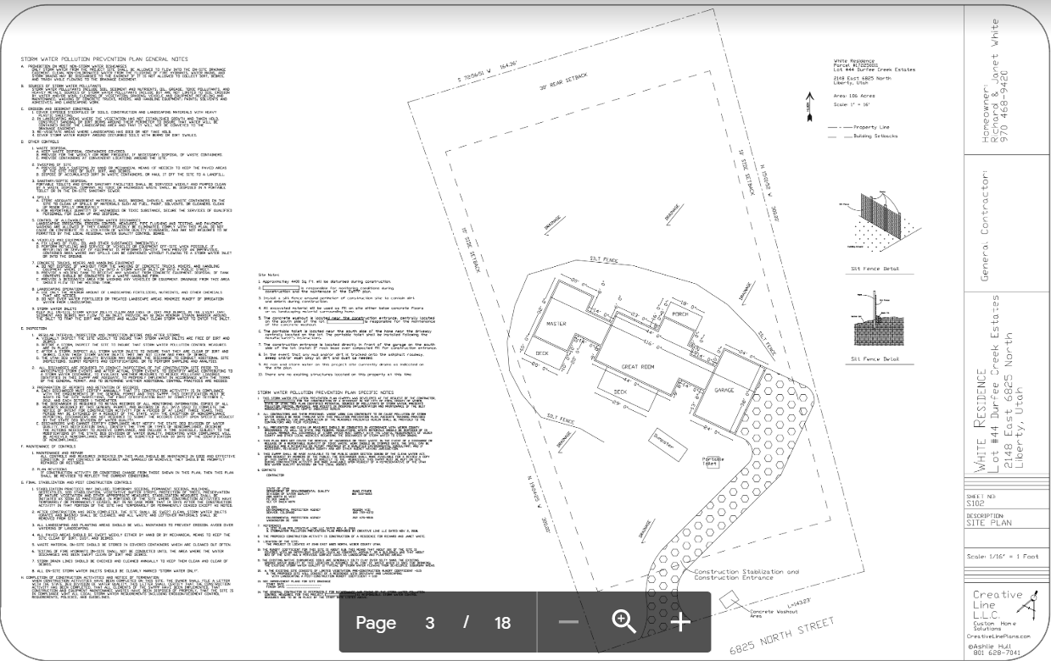

APPENDIX B: Common Plan Permit
Find the permit on https://deq.utah.gov/legacy/permits/water-quality/utah-pollutant-discharge-elimination-system/docs/2016/02feb/updes-common-plan.pdf
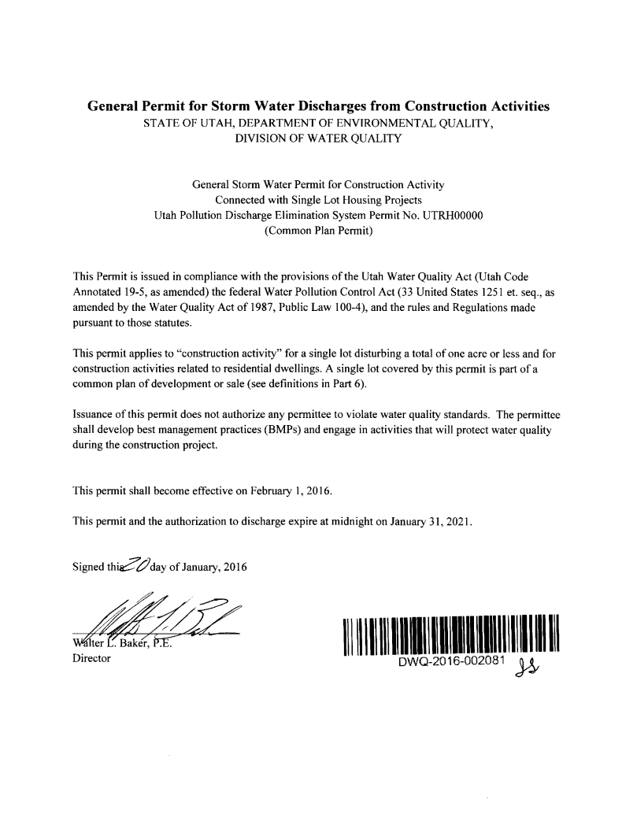

APPENDIX C: Notice of Intent and Termination.
Find the Notice of Termination Form at https://deq.utah.gov/Permits/water/updes/stormwatercon.htm
However, termination of the project can be done on-line at https://secure.utah.gov/stormwater
(You must log in using the same username that you applied for your NOI with. If you completed a paper NOI you must complete a paper NOT.)
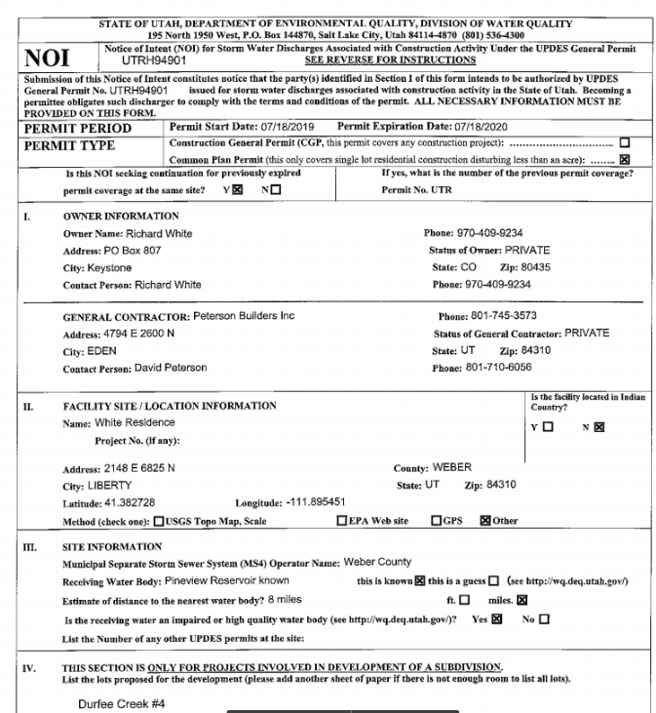
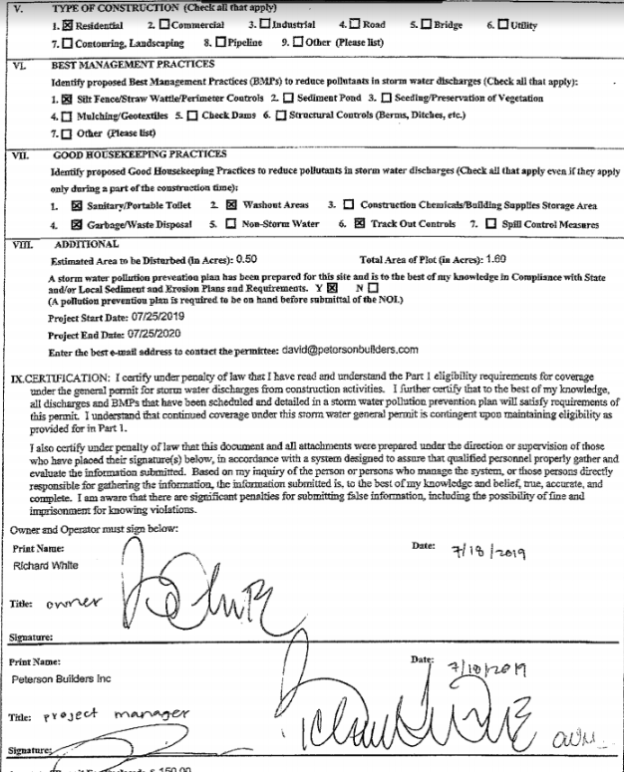

APPENDIX D: Daily Self-Inspection Log (permit part 3.2.2).

Daily Inspection Log
Date | Initials |  | Date | Initials |  | Date | Initials |  | Date | Initials

APPENDIX E: Inspection Reports

Include BMPs inspected even if they are in good condition. Corrections must be completed before the next weekly inspection.
Weekly Inspection/Corrective Action Log
Date & Time of Inspection | Weather | BMP # and Name | Description of BMP Condition or Deficiency | Initial | Correction Date  (MM/DD/YY) | How the BMP was Corrected | SWPPP Changed  (Y/N)

APPENDIX F: Additional Information
For permits such as local permits, dewatering, stream alteration, wetland, and out of date SWPPP documents, delegation of authority forms, etc.

Delegation of Authority

I, David Peterson, hereby designate the person or specifically described position below to be a duly authorized representative for the purpose of overseeing compliance with environmental requirements, including the Common Plan Permit, at the White Residence construction site. The designee is authorized to sign any reports, storm water pollution prevention plans and all other documents required by the permit.

Chad Ferguson (name of person or position)
Peterson Builders Inc (company)
4794 E 2600 N (address)
Eden UT 84310 (city, state, zip)
385-238-6593 (phone)

By signing this authorization, I confirm that I meet the requirements to make such a designation as set forth in ____________________________________ (Reference State Permit), and that the designee above meets the definition of a “duly authorized representative” as set forth in ____________________________________ (Reference State Permit).

I certify under penalty of law that this document and all attachments were prepared under my direction or supervision in accordance with a system designed to assure that qualified personnel properly gathered and evaluated the information submitted. Based on my inquiry of the person or persons who manage the system, or those persons directly responsible for gathering the information, the information submitted is, to the best of my knowledge and belief, true, accurate, and complete. I am aware that there are significant penalties for submitting false information, including the possibility of fine and imprisonment for knowing violations.

Name: David Peterson
Company: Peterson Builders Inc
Title: Project Manager
Signature:
Date: 7/12/2019

APPENDIX G: BMP Specifications and Details
Label BMPs to match the sections identified in this document.
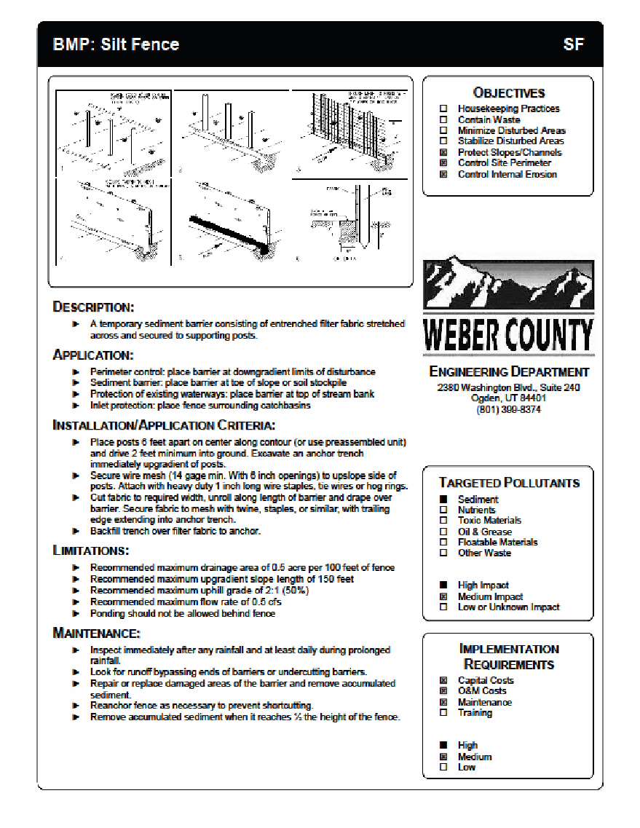
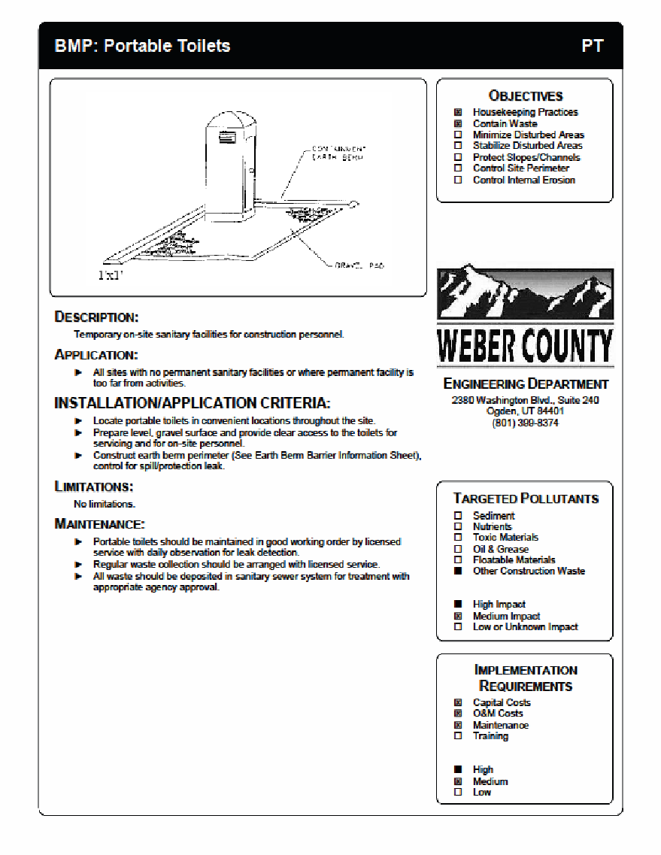
Below are links to various Construction Storm Water BMP Manuals for reference.

Utah Department of Environmental Quality
https://deq.utah.gov/legacy/permits/water-quality/utah-pollutant-discharge-elimination-system/example-appendix-g-bmp.htm
Example Appendix G BMP Specifications and Details Construction Storm Water (UPDES)

Weber County
http://www.webercountyutah.gov/Engineering/swm/construction_bmp.php
Construction Best Management Practices

Salt Lake County
http://slco.org/uploadedFiles/depot/publicWorks/engineering/final_bmp_constructi.pdf
BEST MANAGEMENT PRACTICES FOR CONSTRUCTION ACTIVITIES

Davis County
http://www.daviscountyutah.gov/docs/librariesprovider20/default-document-library/stormwater-best-management-practices.pdf?sfvrsn=c9cd4053_2
A Guide to Storm water Best Management Practices

Nevada DOT
https://www.nevadadot.com/home/showdocument?id=9417
Storm water Quality Manuals: Construction Site Best Management Practices (BMPs) Manual

Caltrans
http://www.dot.ca.gov/hq/construc/stormwater/CSBMP-May-2017-Final.pdf
Construction Site Best Management Practices (BMP) Manual

Oregon
http://www.oregon.gov/deq/FilterPermitsDocs/BMPManual.pdf
Construction Storm water Best Management Practices Manual

Los Angeles
http://dpw.lacounty.gov/cons/specs/BMPManual.pdf
Construction Site Best Management Practices (BMPs) Manual

