When Recorded Return To:
_______________________
_______________________
_______________________
_______________________

EASEMENT DEED

, Grantor, hereby, quit claims, grants, and conveys to the Weber County, his successors, assigns, and agents, (collectively the “County Surveyor”), Grantee, a right to enter on, over, across, or through the property, as described below, for the purpose of accessing a government survey monument or public land survey government corner location that may exist on or near the property as may be required by the County Surveyor to conduct future surveying activities. When accessing the government survey monument or public land survey government corner location the Grantee will make reasonable efforts to minimize the effect of entry upon the property.

Furthermore, the Grantor, hereby, grants and conveys to the County Surveyor a Perpetual Easement to access, inspect, repair, replace, maintain, alter, or adjust a government survey monument or public land survey government corner location that may exist on or near the property as may be required or deemed necessary by the County Surveyor.

Furthermore, this Right of Entry and Perpetual Easement shall run with the land and are binding on the Grantor, his successors, heirs, assigns, and agents, in perpetuity.

LEGAL DESCRIPTION:
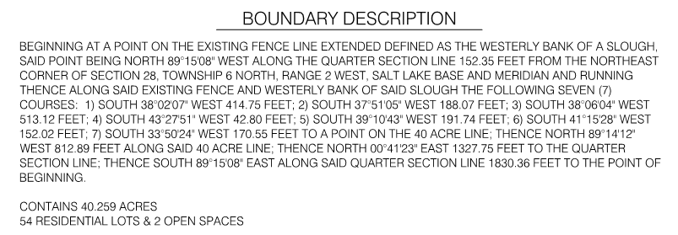

Developer: _____________________________________

INDIVIDUAL ACKNOWLEDGMENT

State of Utah )
ss
County of Weber )

On the _________________ day of __________________ A.D. 20____
personally appeared before me _________________________________________ the signer of the within instrument, who duly acknowledged to me that he/she executed the same.

Notary Public

Residing at:________________, Utah

******************************************************************************

CORPORATE ACKNOWLEDGMENT

State of Utah )
ss
County of Weber )

On the _________________ day of __________________ A.D. 20____
personally appeared before me ____________________________________________________duly sworn, did say that he/she is the of ________ ______________________________, the corporation which executed the foregoing instrument, and that said instrument was signed in behalf of said corporation by authority of a Resolution of its Board of Directors that the said corporation executed the same.

Notary Public

Residing at:________________, Utah

