Rocky Mountain Power – Eden Substation Expansion

Detailed Narrative of the Request:
- Expand the existing Rocky Mountain Power (Utah Power and Light Company) Eden Substation at the corner of 2100 N and 5700 E in Eden, UT. The expansion is required to replace the existing transformers with larger transformers to accommodate the growth in the area. The substation expansion will also allow for the substation to be updated to improve wildfire mitigation standards and provide overall reliability upgrades to the substation.
- Sub Expansion Details
  - Expand yard and fence to the south by 44’-4”
  - Expand yard and fence to the north by 9’-1”
  - Expand yard and fence to the east by 14’-9”
Site Plan
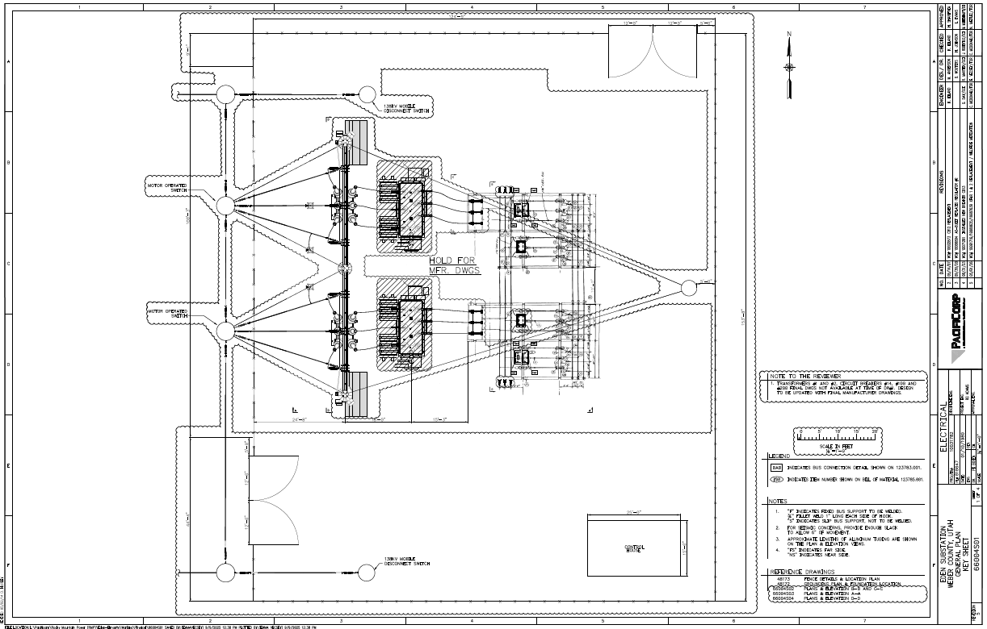

Water and Wastewateer Plan
- No changes to existing plan
Landscape Plan
- Not Applicable
Parking Plan
- Not Applicable

Vicinity Map
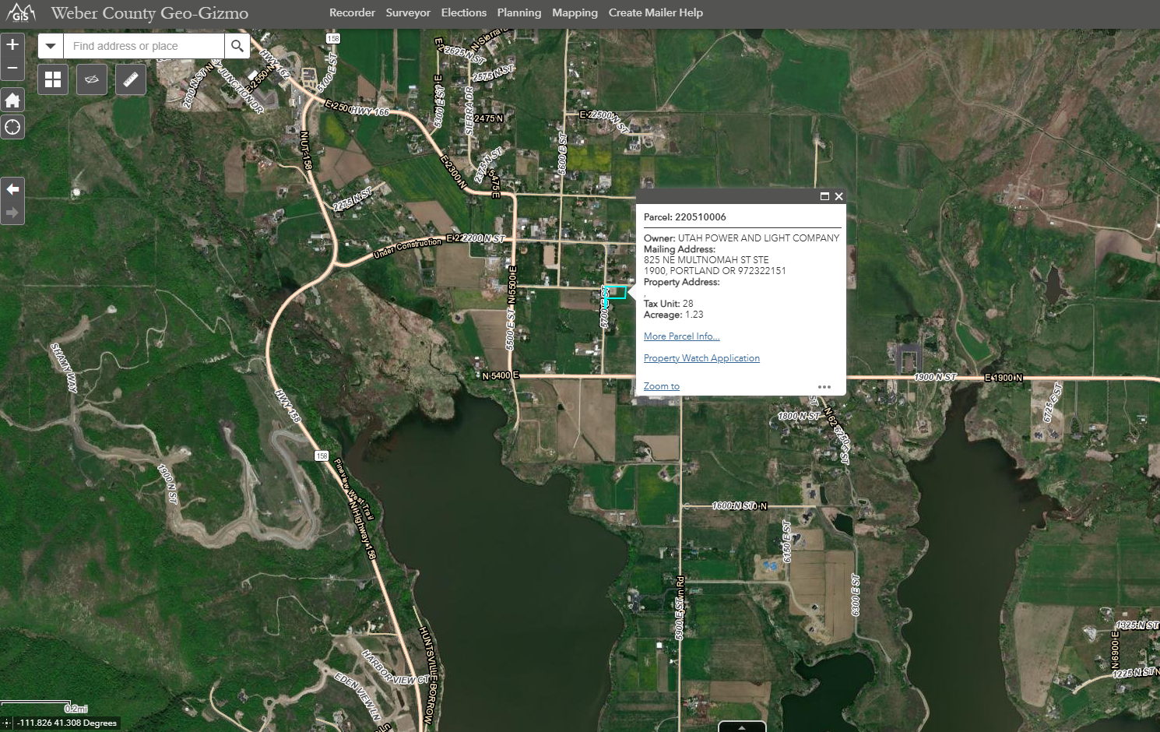

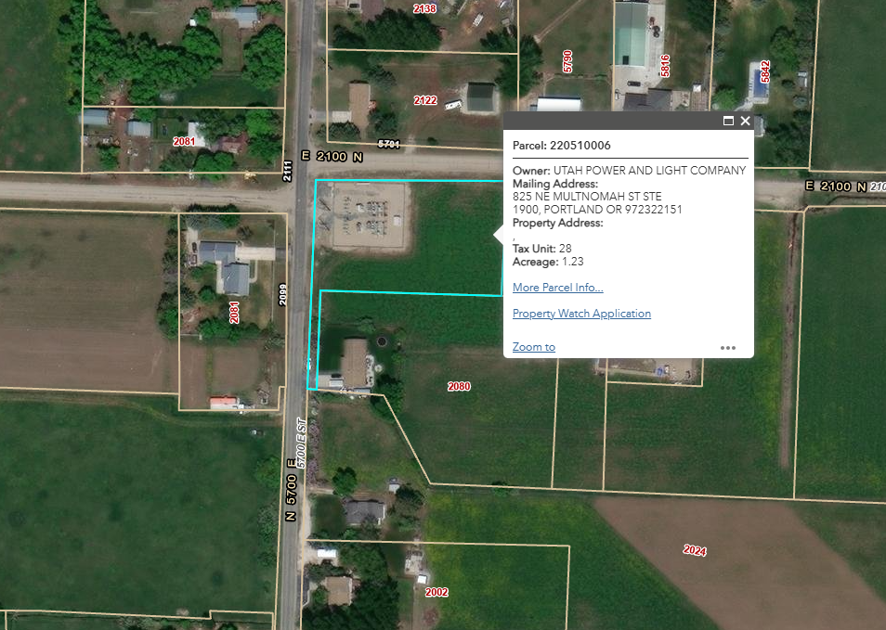
Architectural Renderings and Engineered Plans
- Submitted with Application
Exterior Lighting Plan
- Not Applicable

