|  |  |
| --- | --- |
| **WC Logo.emf** | **Staff Report to the Ogden Valley Planning Commission**  *Weber County Planning Division* |
|  | |

****Synopsis****

****Application Information****

**Application Request:** Consideration and action on a request for final approval of the Fullmer-Roland Subdivision (2 lot) and a recommendation for the vacation of lots 18, 22 and 23 of the Highlands at Wolf Creek Phase 2 Subdivision.

**Agenda Date: Tuesday, March 22, 2011**

**Applicant:** Gary and Janice Fullmer & Peter and Melinda Roland

**File Number:** UVF 022211 and SubVac04-11

****Property Information****

**Approximate Address:** 3729 Red Hawk Circle Eden, Utah

**Project Area:** 1.61 Acres

**Zoning:** Residential Estates (RE-15)

**Existing Land Use:** Residential

**Proposed Land Use:** Residential

**Parcel ID:** 22-206-0002, 22-206-0006 and 22-206-0007

**Township, Range, Section:** T7N, R21, Sections 23

****Adjacent Land Use****

**North:** Residential **South:** Residential

**East:** Residential **West:** Residential

****Staff Information****

**Report Presenter:** Ben Hatfield

bhatfield@co.weber.ut.us

801-399-8766

**Report Reviewer:** SW

Applicable Ordinances

* Weber County Subdivision Ordinance
* Weber County Zoning Ordinance Chapter 3 (RE-15 Zone)

Background

The applicant is requesting final approval of the Fullmer-Roland Subdivision (2 lot) and a recommendation for the vacation of lots 18, 22 and 23 of the Highlands at Wolf Creek Phase 2 Subdivision located approximately at 3729 Red Hawk Circle. The proposed project occupies 1.61 acres and consists of 2 lots. The owners of lots 18 and 23 of the Highlands at Wolf Creek Phase 2 Subdivision desire to divide the vacant lot 22 and reconfigure their lot lines to incorporate the land into their lots. The subdivision lies within the Residential Estates (RE-15) Zone, which requires a minimum area of 15,000 square feet per lot and a minimum lot width of 100 feet.

**Lot Compliance to Applicable Ordinances:**

This subdivision does comply with all requirements of the RE-15 zone by providing an area of more than 15,000 square feet and 100 feet of lot width for each lot. The amended lot 18 will be a double frontage lot. This lot has the required access and frontage on Porcupine Ridge Drive, but will also have 80 feet of frontage on Red Hawk Circle.

**Other Agency Comments and Recommendations:** Culinary Water and Sewer is provided by Wolf Creek Water and Sewer Improvement District.

Summary of Planning Commission Considerations

Does this subdivision meet the applicable county ordinance requirements?

Conformance to the General Plan

The subdivision conforms to the General Plan by meeting the outline of permitted land uses and requirements, and the requirements of the zone in which it is located.

Conditions of Approval

* Requirements of the Weber County Engineering Division
* Requirements of the Weber County Survey Department
* Requirements of the Weber County Health Department
* Requirements of the Weber Fire District
* Vacation of lots 18, 22 and 23 of the Highlands at Wolf Creek Phase 2 Subdivision

Staff Recommendation

Staff recommends final approval of the amended subdivision plat subject to staff and other agency comments and recommendations. Staff also recommends the vacation of lots 18, 22 and 23 of the Highlands at Wolf Creek Phase 2 Subdivision.

Exhibits

1. Original Subdivision plat
2. Amended Subdivision plat

Map 1

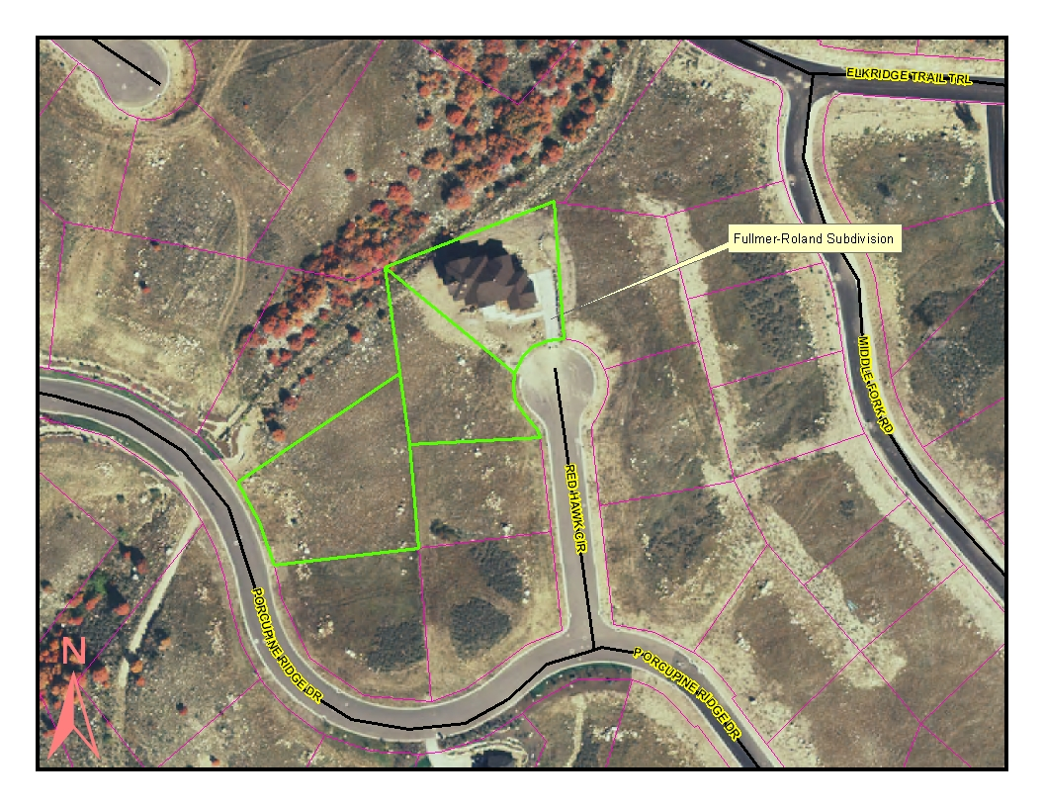

Map 2

