|  |  |
| --- | --- |
| **WC Logo.emf** | **Staff Report to the Weber County Board of Adjustment**  *Weber County Planning Division* |
|  | |

****Synopsis****

****Application Information****

**Application Request:** Consideration and action on a request for a 12 foot variance to the front yard setback in the FR-3 Zone.

**Agenda Date: Thursday, January 12, 2017**

**Applicant:** Jeff Burningham, Owner

**Authorized Representative:** Carson Young

**File Number:** BOA 2016-08

****Property Information****

**Approximate Address:** 6803 East 6675 North, Eden

**Project Area:** 0.28 acres

**Zoning:** Forest Residential Zone (FR-3)

**Existing Land Use:** Vacant

**Proposed Land Use:** Residential

**Parcel ID:** 22-119-0008

**Township, Range, Section:** T7N, R1E, Section 1

****Adjacent Land Use****

**North:** Unimproved road **South:** Vacant Residential

**East:** Residential **West:** Vacant Residential

****Staff Information****

**Report Presenter:** Steve Burton

sburton@co.weber.ut.us

801-399-8766

**Report Reviewer: RK**

Applicable Codes

* Weber County Land Use Code Title 102 (Administration) Chapter 3 (Board of Adjustment)
* Weber County Land Use Code Title 104 (Zones) Chapter 17 (Forest Residential FR-3 Zone)

Background

The applicant is requesting a variance for a reduction to the front yard setback in the Forest Residential FR-3 Zone. The front yard setback for the FR-3 Zone is 25 feet. The applicant is proposing to build a home with the garage 12 feet to the front lot line; this would require an approval of a 13 foot variance to the standard. The application and an explanation of the request have been prepared by the applicant (Exhibit A). A site plan was not submitted with the application.

The subject property is Lot 50-R in the Powder Mountain West Subdivision Phase 3. This lot is in a remote area of the county surrounded by the Powder Mountain Ski Resort. Lot 50-R is at the eastern part of the subdivision where the road (Aspen Drive) straightens out before curving into Powder Mountain West Phase 2. Aspen Drive is an unimproved and unmaintained private road which for many months is snowbound, causing owners to have to ski or snowmobile to their properties from the resort's parking area. Lot 50-R was deemed a “Restricted Lot” during subdivision review due to its slope, and will be required to undergo a Hillside Review.

Lots in the FR-3 Zone are often small in area, having a minimum lot area of 6,000 square feet for a single home. Likely due to the slope and remote location, Lot 50-R has an area of 12,205 square feet. The FR-3 Zone also requires that lots have 40 % of its area left as open green space per The Uniform Land Use Code of Weber County, Utah (LUC) §104-17-5(g). This requirement can impact the potential building envelope on lots.

The property is unique given the slope of the lot. The applicant has stated on the application that the slope of the lot is more steep than others in the area. A topographic map that was provided with the original plat of Powder Mountain West Subdivision Phase 3 does show lot 50-R with a 30% slope, while other lots in the same phase have a 26% to a 28% slope.

The adjacent lot to the East, lot 51-R, received approval of a variance for a 10 foot front yard setback in February 2008. This variance was granted due to the slope of the lot, which on the previously mentioned topographic map had a slope of 28%.

Staff has found some concerns for placing the garage too close to the right of way, some of which are:

* Sight visibility for traffic on 6675 N.
* Sight visibility for traffic pulling out of the garage and onto 6675 N.
* The proximity to other homes nearby.
* The ability for off street parking in the driveway.

No information has been submitted by the applicant addressing these concerns.

Summary of Board of Adjustment Considerations

LUC §102-3 states that one of the duties and powers of the Board of Adjustment is to hear and decide variances from the requirements of the Weber County Land Use Code. In order for a variance to be granted it must be shown that all of the following criteria have been met:

1. *Literal enforcement of the ordinance would cause an unreasonable hardship for the applicant that is not necessary to carry out the general purpose of the Land Use Code.*
2. *In determining whether or not literal enforcement of the land use code would cause unreasonable hardship, the appeal authority may not find an unreasonable hardship unless the alleged hardship is located on or associated with the property for which the variance is sought, and comes from circumstances peculiar to the property, not from conditions that are general to the neighborhood.*
3. *In determining whether or not literal enforcement of the land use code would cause unreasonable hardship, the appeal authority may not find an unreasonable hardship if the hardship is self-imposed or economic.*
4. *There are special circumstances attached to the property that do not generally apply to other properties in the same zone.*
5. *In determining whether or not there are special circumstances attached to the property, the appeal authority may find that special circumstances exist only if the special circumstances relate to the hardship complained of, and deprive the property of privileges granted to other properties in the same zone.*
6. *Granting the variance is essential to the enjoyment of a substantial property right possessed by other property in the same zone.*
7. *The variance will not substantially affect the general plan and will not be contrary to the public interest.*
8. *The spirit of the land use ordinance is observed and substantial justice done.*

Staff’s analysis and findings are discussed below:

1. Literal enforcement of the Land Use Code would require an undesirable result. Because of the slope of the lot, literal enforcement of the 25 foot setback would create a safety concern for the driveway. This request is the best scenario to address the unique circumstances of this lot avoiding impacts to the slope.
2. The special circumstances attached to this property are not self imposed or economic. The steep slope of the lot is the cause of the hardship.
3. Other homes within this Zone and area are not impacted in the same way as Lot 50-R regarding slope. Therefore granting of the variance preserves the rights intended for this property. The additional area requested by the variance fall in line with the building envelopes of similar properties in the subdivision.
4. The General Plan indicates that this area should be developed as is planned and zoned; thereby the variance and development is not contrary to any public interest.
5. This variance request is not an attempt to avoid or circumvent the requirements of the County Land Use Code, but provide justified compensation to the building envelope allowing for the single family dwelling to be built.

Conformance to the General Plan

Single-family dwellings are allowed as a permitted use in the FR-3 Zone and granting this request will not increase the number of existing dwelling units in the area. If the requested variance is granted, it will not have a negative impact on the goals and policies of the Ogden Valley General Plan.

Staff Recommendation

Staff recommends approval of the variance for Lot 50-R in the Powder Mountain West Subdivision Phase 3 for a reduction of 13 feet to the front yard setback. This recommendation is based on compliance with the applicable variance criteria discussed in this staff report and conditioned upon meeting all other applicable review agency requirements.

Exhibits

1. Application

Location Map 1

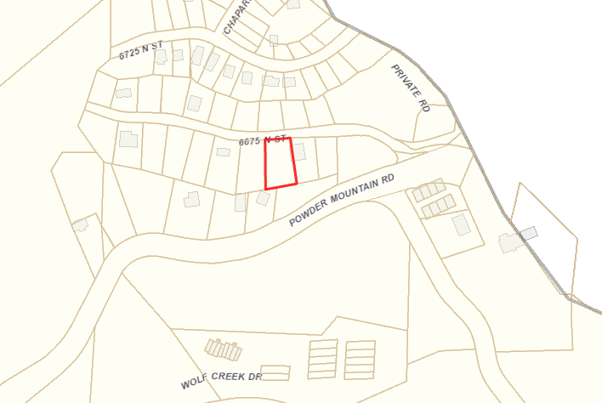

Subject Property

Location Map 2

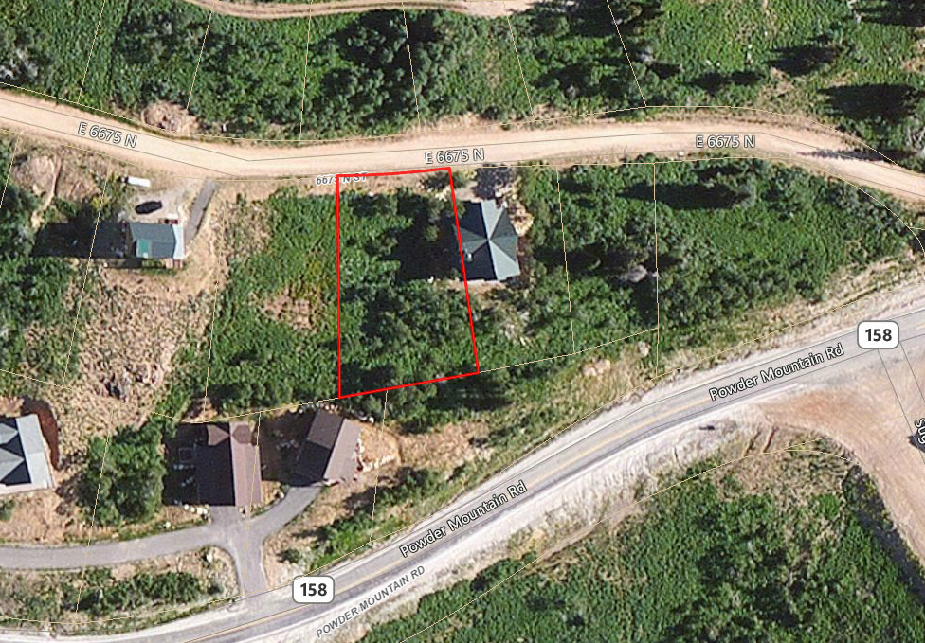

Subject Property