|  |  |
| --- | --- |
| **WC Logo.emf** | **Design Review Staff Report for Administrative Approval**  *Weber County Planning Division* |
|  | |

****Synopsis****

****Application Information****

**Application Request:** Consideration and action for a sign change located at 1770 E 6200 S, Ogden, 84405.

**Type of Decision: Administrative**

**Applicant:** G & H Ben Lomond Properties, LLC, Owner

**Authorized Agent:** Ashley Robison

**File Number:** DR 2019-07

****Property Information****

**Approximate Address:** 1543 W 2700 N, Ogden, UT, 84401

**Project Area:** 300 sq. ft., on the ground, on a 0.77 acre parcel

**Zoning:** Manufacturing (M-1)

**Existing Land Use:** Commercial Development

**Proposed Land Use:** Commercial Development

**Parcel ID:** 19-138-0002

****Adjacent Land Use****

**North:** 2700 North St **South:** Vacant

**East:** Vacant **West:** Vacant Weber Industrial Park

****Staff Information****

**Report Presenter: Tammy Aydelotte**

**taydelotte@co.weber.ut.us**

**Report Reviewer: RG**

Applicable Ordinances

* Title 104, Chapter 22 Manufacturing (M-1) Zone
* Title 108, Chapter 1 Design Review, Application and Review
* Title 108, Chapter 7 Supplementary and Qualifying Regulations
* Title 110, Chapter 1 Signs, Western Weber Signs

Summary and Background

The applicant is requesting final approval of de minimus changes to an existing sign located at 1543 W 2700 N, Ogden, UT. The proposed changes, that require only a de minimus design review, include removal of an existing pole sign, and replacing/relocating with an updated with a 64 square foot single cabinet sign, atop a 12 foot pole, with a 4’ x 8’, double-sided high res LED full color display. There is no adjacent residential development that could be adversely affected by the proposed LED sign. The applicant has submitted that the proposed sign will include a capability to control brightness. The sign will be shut off between the hours of 10pm and 6am. The lighting must be modified, after dusk, to 30% of maximum brightness, to minimize invasive light. The proposed application has been reviewed against certain standards in the Uniform Land Use Code of Weber County, Utah (LUC) and appears to meet these standards. The following is staff’s evaluation of the request.

Analysis

*General Plan:* The proposed use conforms to the Western Weber General Plan by encouraging commercial development within established commercial areas and enforcing the adopted “quality development standards” to ensure compatibility with surrounding development.

*Design Review:* The manufacturing zone mandates a design review as outlined in LUC §108-1 to ensure that the general design, layout and appearance of the building remains orderly and harmonious with the surrounding neighborhood. Certain areas of the design review are only applicable to the current amendment application, such as the signage, landscaping and site layout. As part of this review, consideration has taken into account the applicable matters based on the proposed amendment and impose conditions to mitigate deficiencies where the plan is found deficient. The matters for consideration are as follows:

* *Considerations relating to buildings and site layout.* The proposal includes removal of the existing sign, installation of a new, upgraded sign at a different location on the parcels well as a fresh coat of paint on the pole of an existing sign. The height will remain unchanged, and the lighting conditions are outlined above. The existing sign location meets all setback requirements, including those required for an animated sign (minimum of 75’ from the nearest residential zone).

Staff Recommendation

The Planning Division recommends approval of file# DR2019-07, design review for the sign at Ben Lomond Car Wash, located at 1543 W 2700 N, Ogden, 84401. This recommendation for approval is based on the following findings:

1. The proposed use conforms to the Western Weber General Plan.
2. The proposal, if conditions are imposed, will not be detrimental to the public health, safety, or welfare.
3. The proposal, if conditions are imposed, will comply with applicable County ordinances.
4. The proposed design implements quality development standards and will not deteriorate the environment of the general area so as to negatively impact surrounding properties and uses.

This recommendation for approval is subject to all review agency requirements, and subject to the following conditions:

1. Lighting of the LED cabinet of the sign will occur only between the hours of 6am-10pm. Between the hours of 10pm and 6am, the sign will be shut off, to minimize light pollution in the surrounding areas.
2. The new cabinet will not exceed the current sign area in square footage.
3. The pole will be painted black, with a red vertical strip down the middle, to coordinate with the sign font and design.

Administrative Approval

Administrative Design Review approval of the Ben Lomond Car Wash sign is hereby granted based upon its compliance with the Weber County Land Use Code. This approval is subject to the requirements of applicable review agencies and the conditions of approval listed in this staff report.

Date of Administrative Approval: __________________________

_____________________________________

Rick Grover

Weber County Planning Division Director

Exhibits

1. Design Review Application
2. Site Plan
3. Sign Details

Map 1

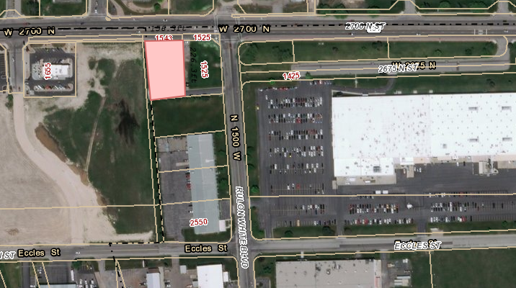

Exhibit A – Design Review Application

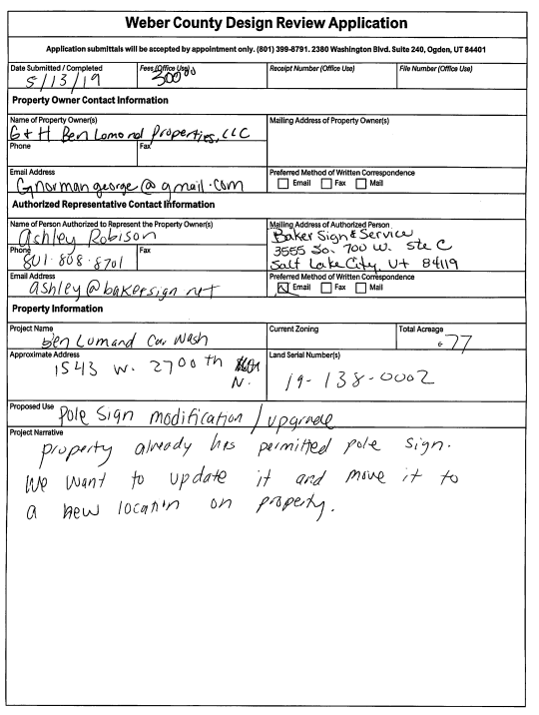

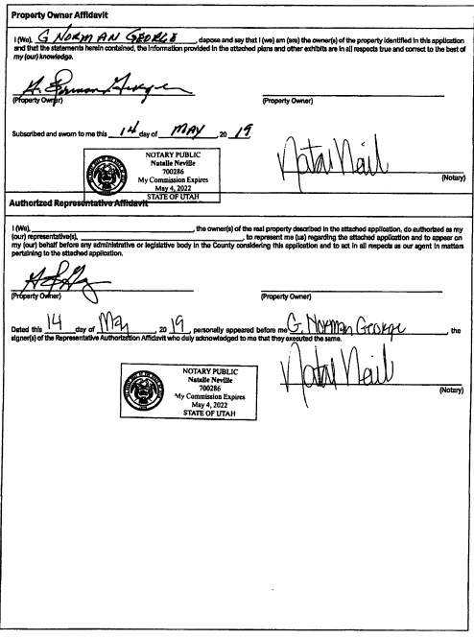

Exhibit B– Site Plan

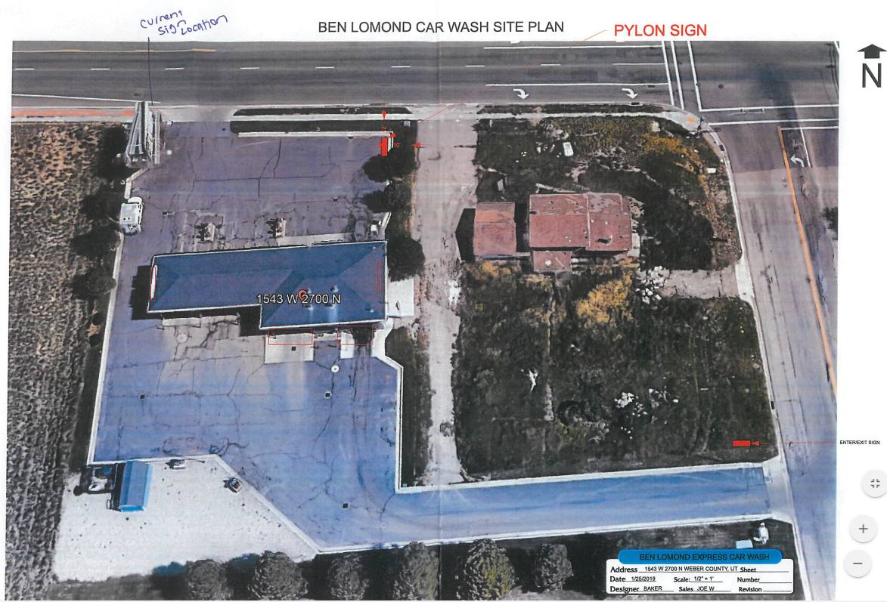

Proposed site for addition

Exhibit C– Sign Details

