|  |  |
| --- | --- |
| **WC Logo.emf** | **Staff Report to the Western Weber Planning Commission**  *Weber County Planning Division* |
|  | |

****Synopsis****

****Application Information****

**Application Request:** Consideration of a request for Final Approval of the Colyn Flinders Subdivision (1 lot).

**Agenda Date: Tuesday, January 11, 2011**

**Applicant:** Colyn Flinders

**File Number:** LVC122110

****Property Information****

**Approximate Address:** 1056 S 3500 W

**Project Area:** 0.92 Acres

**Zoning:** A-1 and A-2

**Existing Land Use:** Residential

**Proposed Land Use:** Residential

**Parcel ID:** 15-060-0132

**Township, Range, Section:** T6N, R2W, Section 22

****Adjacent Land Use****

**North:** Agriculture **South:** Agriculture

**East:** Agriculture **West:** Residential

****Staff Information****

**Report Presenter:** Ben Hatfield

bhatfield@co.weber.ut.us

801-399-8766

**Report Reviewer:** JG

Applicable Ordinances

* Title 26 Weber County Subdivision Ordinance
* Zoning Ordinance Chapter 5 A-1 Zone
* Zoning Ordinance Chapter 6 A-2 Zone

Background

The applicant is requesting final approval of the Colyn Flinders Subdivision located at 1056 South 3500 West. The proposed project occupies 0.92 acres and consists of 1 lot. The subdivision lies within both of the (A-1 and A-2) Agricultural Zones, which both require 40,000 square feet per dwelling and a minimum lot width of 150 feet.

**Lot Compliance to Applicable Ordinances:**

This subdivision does comply with all requirements of the A-1 and A-2 zones by providing 40,044 square feet and 150.7 feet of frontage on a private road (975 South). This lot has a home on it which was built in 1972, but due to previous land divisions was left not conforming to the standards of the subdivision and zoning ordinances. Specifically the parcel lacked the required width and area for this zone. By subdividing this lot it will conform with all Weber County Ordinances. When the private road (975 South) was created many structures along the road had less than the minimum required setback. This home is 24.3 feet from the right of way and will be a noncomplying structure.

The Weber County Engineering Division agrees that there is not a need to install the improvements of curb, gutter, and sidewalk. Due to this being an unimproved private road, a deferral for these improvements is not needed as well.

Summary of Planning Commission Considerations

Does this Subdivision meet the applicable County Ordinance requirements?

Conformance to the General Plan

The subdivision conforms to the General Plan by meeting the outline of permitted land uses and requirements, and the requirements of the Zone in which it is located.

Conditions of Approval

* Requirements of the Weber County Engineering Division
* Requirements of the Weber County Survey Department
* Requirements of the Weber County Health Department
* Requirements of the Weber Fire District

Staff Recommendation

Staff recommends final approval subject to staff and other agency comments and recommendations.

Exhibits

1. Subdivision plat

Map 1

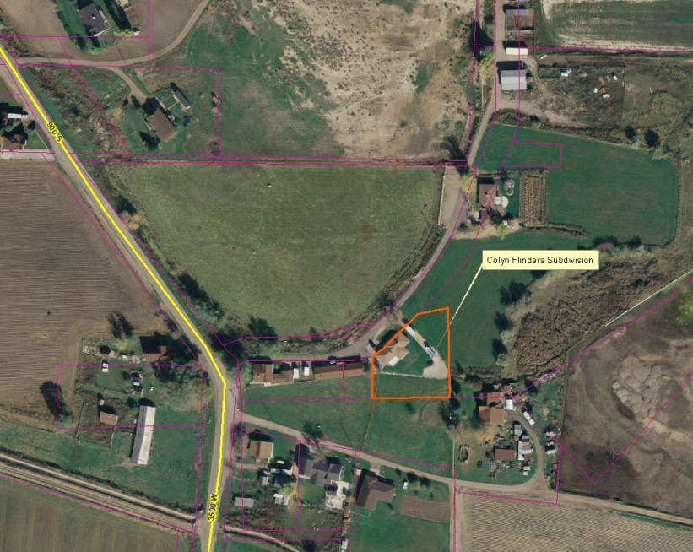

Map 2

