|  |  |
| --- | --- |
| **WC Logo.emf** | **Staff Report to the Weber County Commission**  *Weber County Planning Division* |
|  | |

****Synopsis****

****Application Information****

**Application Request:** Consideration and action on a request for final approval of the Favero’s Legacy Cluster Subdivision Phase 1 with a financial guarantee of 29,471.70.

**Agenda Date: Tuesday, May 09, 2017**

**Applicant: Robert Favero**

**File Number:** LVF051916

****Property Information****

**Approximate Address:** 3750 West 2200 South

**Project Area:** 8.302 Acres

**Zoning:** Agricultural (A-1)

**Existing Land Use:** Residential/ Agricultural

**Proposed Land Use:** Residential

**Parcel ID:** 15-078-0137

**Township, Range, Section:** T6N, R2W, Section 28

****Adjacent Land Use****

**North:** Residential **South:** Agricultural

**East:** Agricultural **West:** Residential

****Staff Information****

**Report Presenter:** Felix Lleverino

**flleverino**@co.weber.ut.us

801-399-8767

**Report Reviewer:** RK

Applicable Ordinances

* Title 101 (General Provisions) Section 7 (Definitions)
* Title 104 (Zones) Chapter 5 (Agricultural (A-1) Zone)
* Title 106 (Subdivisions) Chapters 1, 2, 4, 7, & 8
* Title 108 (Standards) Chapter 3 (Cluster Subdivision)

Development History

* On May 10, 2016, the applicant received unanimous for sketch plan endorsement of Favero’s Legacy Cluster Subdivision.
* On September 13, 2016 the proposed cluster subdivision was granted preliminary approval from the Western Weber Planning Commission (LVF0519-2016).
* On October 4, 2016, the applicant received final approval from the Weber County Commission. It was subsequently revealed that due to a planning oversight this application should have gone before the Planning Commission prior to going before the County Commission.
* On April 26, 2017 the Western Weber Planning Commission forwarded a unanimous approval for final approval of Favero’s Legacy Cluster Subdivision Phase 1.

Background and Summary

The applicant is requesting final approval of the Favero’s Legacy Cluster Subdivision including the acceptance of a financial guaranty in the amount of $29,471.70 for the remaining improvements which include sidewalk, handicap ramp, chip and seal, and signs.

The subject property is zoned A-1 and is currently an 8.302 acre agricultural parcel. The applicant has requested bonus density based on the following qualifying criteria: 10% bonus for meeting the purpose and intent of the cluster subdivision and a 15% bonus density based on providing 4,275 square feet of open space to be used as a community garden in phase 2 (see Exhibit A). Open space parcels A, B and C are one acre each, amounting to 44% of the total developable area reserved as individually owned open space parcels.

Analysis

*General Plan:* The proposal conforms to the Western Weber General Plan by encouraging development in areas of residential growth and preserving agricultural open space to maintain the rural atmosphere of the area.

*Zoning:* The subject property is located in an Agricultural Zone more particularly described as the A-1 zone. The purpose of the Agricultural (A-1) zone is identified in the LUC §104-5-1 as:

*“The purpose of the A-1 Zone is to designate farm areas, which are likely to undergo a more intensive urban development, to set up guidelines to continue agricultural pursuits, including the keeping of farm animals, and to direct orderly low-density residential development in a continuing rural environment.”*

The proposal has been reviewed against the adopted zoning, subdivision and cluster subdivision ordinances to ensure that the regulations and standards have been adhered to. The proposed subdivision, based on the recommended conditions, is in conformance with county code. The following is a brief synopsis of the review criteria and conformance with the LUC.

*Lot area, frontage/width and yard regulations*: The A-1 zone requires a minimum lot area of 40,000 sq ft for a single family dwelling and a minimum lot width of 150 feet. The A-1 zone allows permitted and conditional uses as well as additional permitted uses that require 2 and 5 acres at a minimum. The proposed subdivision will not qualify for any of the permitted uses requiring a 2 or 5 acre minimum due to insufficient lot width for these uses.

The proposed cluster subdivision allows for a reduction in lot width in Agricultural Zones to 60 feet and a reduction in lot area to 15,000 square feet. The lot area can further be reduced to not less than 6,000 square feet if the lot lies within a cluster subdivision that is adjacent to an undeveloped parcel. An undeveloped parcel is considered to be either a parcel of property that does not contain an existing dwelling or contains an existing dwelling that lies further than 150 feet away from all external boundaries of the proposed or subject cluster subdivision. The proposed residential lot sizes are roughly 18,500 square feet and the lot widths are roughly 130 feet. Approximately 1.49 acres will be dedicated to Weber County along 3900 West and 2200 South Street upon recording the final plat to provide the adequate right of way width.

*Common and Open Space:* The proposal includes 3 acres of open space that will be individually owned as one acre parcels by residents within the cluster subdivision and approximately 4,275 square feet of open space to be used as a community garden. The community garden area will be located on Open Space C. The community garden area will have a conservation easement as well as a preservation/maintenance plan for this area approved prior to phase 2 being forwarded for final approval. The applicant will need to provide CC&R’s for review and approval of all areas that will be dedicated for the enjoyment of the public, specifically the community garden, to ensure adequate maintenance and preservation measures will be implemented.

*Bonus Density Criteria Request:* The applicant has been granted a 25% density bonus by the Western Weber Planning Commission. The bonus density request is outlined in the “Open Space Preservation Plan” (see Exhibit D). The bonus density was based on the accumulation of bonus density points outlined in LUC§108-3-8(2):

* *The cluster subdivision meets the purpose and intent of this chapter, a ten percent bonus may be granted.*
* *If a cluster subdivision provides common area that offers easily accessible amenities such as trails, parks, or community gardens, that are open for use by the general public, up to a 15 percent bonus density may be granted.*

*Culinary water and sanitary sewage disposal:* Will serve and feasibility letters have been provided from Taylor West Weber Water for the culinary water and secondary water. Wastewater disposal systems for the proposed subdivision will be served by the Central Weber Sewer Improvement District. After a conversation with Val Surrage who is the manager of the Taylor West Weber Water Improvement district, it has been expressed that the Winslow Farr Subdivision Capacity Assessment will be sufficient to be used for the Favero Legacy Cluster Subdivision. Mr. Surrage has also stated that there is no need for a construction permit because a main line extension is not taking place.

*Additional design standards and requirements:* The applicant has already installed the majority of improvements and has deposited bond money for the remaining improvements that are to be installed in the near future.

*Review Agencies:* This proposal has been reviewed by all County reviewing agencies, and has been approved by Planning, Engineering, the Fire District, and Surveying.

*Tax clearance:* The 2016 property taxes have been paid in full. The 2017 property taxes are due in full as of November 1, 2017.

*Public Notice:* Noticing requirements, according to LUC 106-1-6(c), have been met by mailing notices out to all property owners of record within 500 feet of the subject property.

County Commission Considerations

The Weber County Commission’s consideration will include reviewing phase 1 of this subdivision to determine if it supports the Western Weber General Plan in providing managed growth while preserving pasturelands, farmlands, and open space.

Planning Division Recommendation

The Planning Division recommends approval of the financial guarantee for the remaining improvements for Favero’s Legacy Cluster Subdivision Phase 1, based on the proposed plan adhering to the requirements of the Weber County Land Use Codes including the design standards in the Cluster Subdivision Ordinance. This recommendation for approval is subject to all review agency requirements and based on the following conditions:

1. The Covenants, Conditions and Restrictions (CC&R’s) shall be recorded with the final Mylar.

This recommendation is based on the following findings:

1. The proposed subdivision conforms to the Western Weber General Plan.
2. The proposed subdivision complies with applicable County ordinances.
3. The proposed subdivision will not be detrimental to the public health, safety, or welfare.
4. The proposed subdivision will not deteriorate the environment of the general area so as to negatively impact surrounding properties and uses.

Exhibits

1. Phasing Plan
2. Phase 1
3. Subdivision Improvement Agreement
4. CC&R’s

Location map

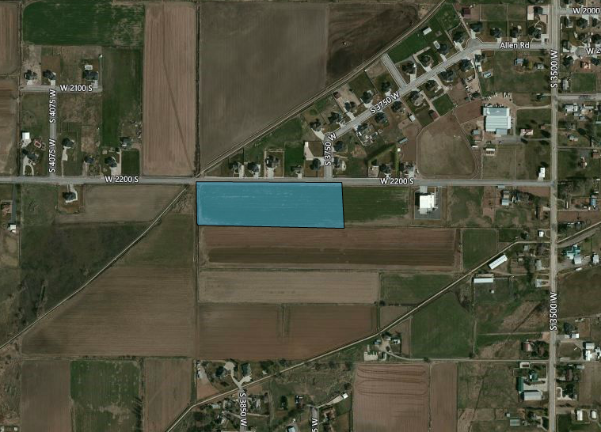

Exhibit A

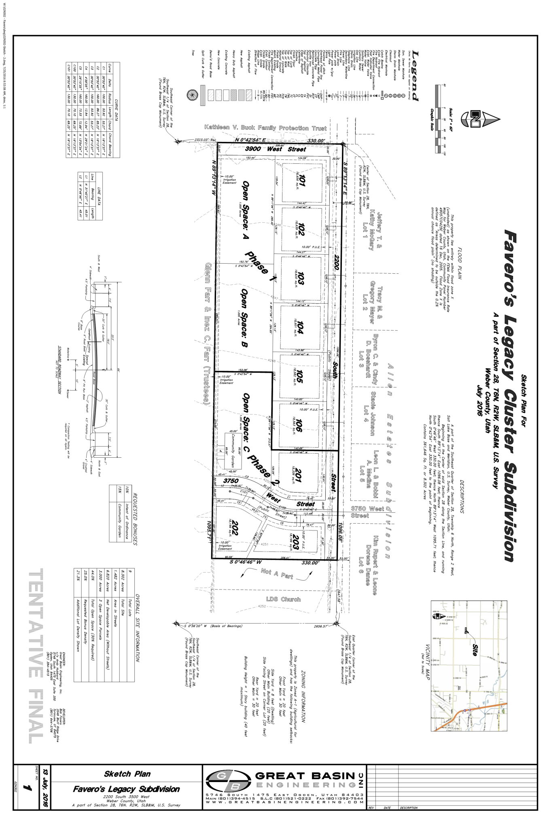

Exhibit B

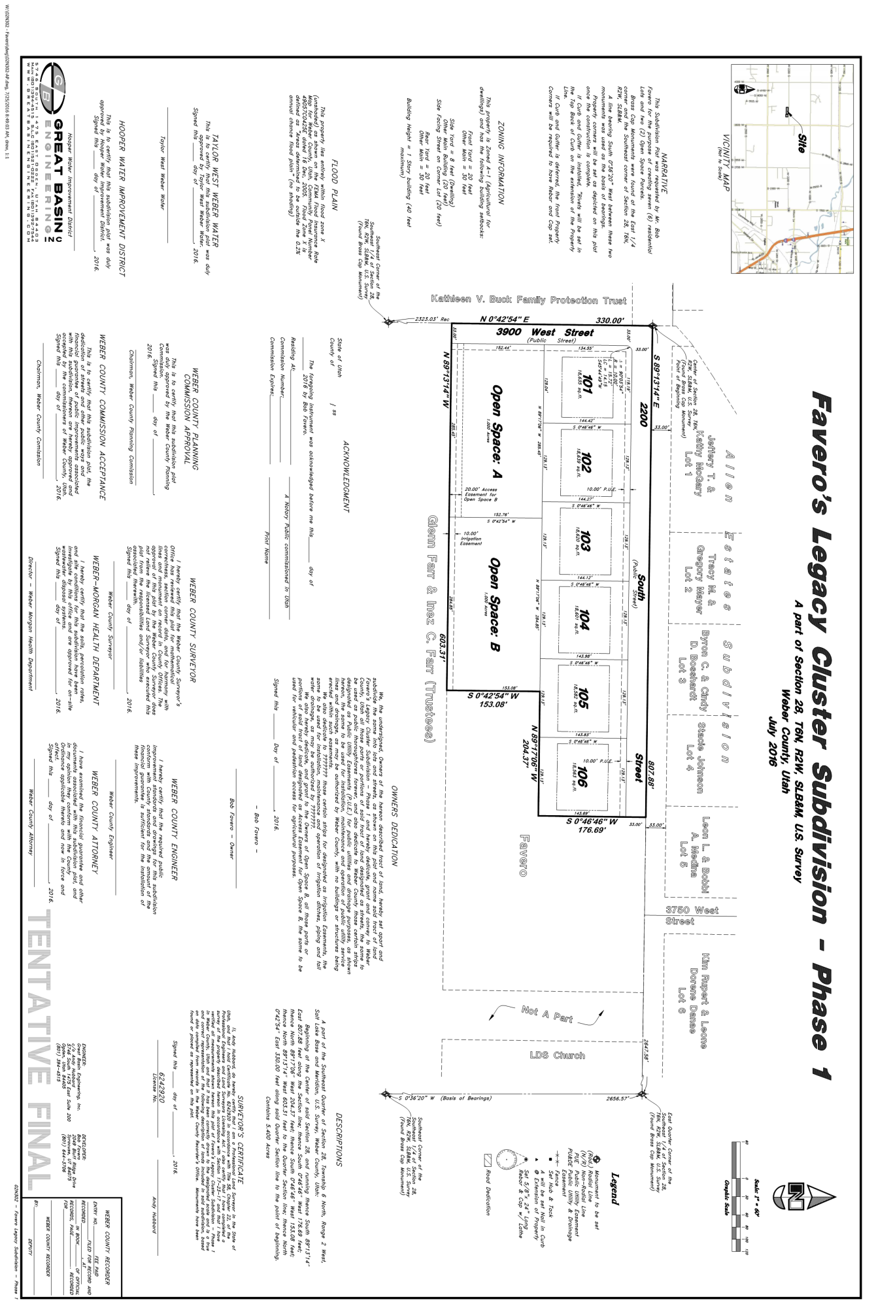

Exhibit C

**WEBER COUNTY**

**SUBDIVISION IMPROVEMENT**

**AGREEMENT**

1. **Parties:** The parties to this Subdivision Improvement Agreement ("the Agreement") are **Robert Favero**

("the Developer") and Weber County Corp. ("the County").

2. **Effective Date:** The Effective Date of this Agreement will be the date that final subdivision plat approval is granted by the County Commission ("the Commission").

RECITALS

WHEREAS, the Developer seeks permission to subdivide property within the unincorporated area of Weber County, to be known as **Favero’s Legacy Subdivision Phase 1**(the "Subdivision"), which property is more particularly described on Exhibit A attached hereto and incorporated herein by this reference (the "Property"); and

WHEREAS, the County seeks to protect the health, safety and general welfare of the residents by requiring the completion of various improvements in the Subdivision and thereby to limit the harmful effects of substandard subdivisions, including premature subdivision which leaves property undeveloped and unproductive; and

WHEREAS, the purpose of this Agreement is to protect the County from the cost of completing subdivision improvements itself and is not executed for the benefit of material, men, laborers, or others providing work, services or material to the Subdivision or for the benefit of lot or home buyers in the Subdivision; and

WHEREAS, the mutual promises, covenants, and obligations contained in this Agreement are authorized by state law and the County's Subdivision Ordinance Title 26-4-1 et seq;

THEREFORE, the Parties hereby agree as follows:

DEVELOPER'S OBLIGATIONS

3. **Improvements:** The Developer will construct and install, at his own expense, those on-site and off-site subdivision improvements listed on Exhibit B attached hereto and incorporated herein by this reference ("the Improvements"). The Developer's obligation to complete the Improvements will arise upon final plat approval by the County, will be independent of any obligations of the County contained herein and will not be conditioned on the commencement of construction in the development or sale of any lots or improvements within the development.

4. **Security:** To secure the performance of his obligations hereunder, the Developer will deposit with the County on or prior to the effective date, an irrevocable deposit in Escrow in the amount of **$**29,471.70.

5. **Standards:** The Developer will construct the Improvements according to the Public Works Standards and Technical Specifications as incorporated herein by this reference.

6. **Warranty:** The Developer warrants that the Improvements, each and every one of them, will be free from defects for a period of one year from the date that the County accepts the improvement when completed by the Developer.

7. **Completion Periods:** The Developer will commence work on the Improvements within one year from the Effective Date of this Agreement (the "Commencement Period") and the Improvements, each and every one of them, will be completed within two years from the Effective Date of this Agreement (the "Completion Period").

8. **Compliance with Law:** The Developer will comply with all relevant laws, ordinances, and regulations in effect at the time of final subdivision plat approval when fulfilling his obligations under this Agreement. When necessary to protect public health, the Developer will be subject to laws, ordinances and regulations that become effective after final plat approval.

9. **Dedication:** The developer will dedicate to the County or other applicable agency as designated by the County the Improvements listed on Exhibit B attached hereto and incorporated herein by this reference pursuant to the procedure described in Paragraph 13 below.

COUNTY'S OBLIGATIONS

10. **Plat Approval:** The County will grant final subdivision plat approval to the Subdivision under the terms and conditions previously agreed to by the Parties if those terms and conditions are consistent with all relevant state laws and local ordinances in effect at the time of final plat approval.

11. **Inspection and Certification:** The County will inspect the Improvements as they are being constructed and, if acceptable to the County Engineer, certify such improvement as being in compliance with the standards and specifications of the County. Such inspection and certification, if appropriate, will occur within 7 days of notice by the Developer that he desires to have the County inspect an improvement. Before obtaining certification of any such improvement, the Developer will present to the County valid lien waivers from all persons providing materials or performing work on the improvement for which certification is sought. Certification by the County Engineer does not constitute a waiver by the County of the right to draw funds under the Escrow on account of defects in or failure of any improvement that is detected or which occurs following such certification.

12. **Notice of Defect:** The County will provide timely notice to the Developer whenever inspection reveals that an improvement does not conform to the standards and specifications shown on the approved subdivision improvement drawings on file in the Weber County Engineering and Surveyor's Office or is otherwise defective. The Developer will have 30 days from the issuance of such notice to cure or substantially cure the defect. The County may not declare a default under this Agreement during the 30 day cure period on account of any such defect unless it is clear that the Developer does not intend to cure the defect. The Developer will have no right to cure defects in or failure of any improvement found to exist or occurring after the County accepts dedication of the improvement(s).

13. **Acceptance of Dedication:** The County or other applicable agency will accept the dedication of any validly certified improvement within 30 days of the Developer's offer to dedicate the improvement. The County's or agency's acceptance of dedication is expressly conditioned on the presentation by the Developer of a policy of title insurance, where appropriate, for the benefit of the County showing that the Developer owns the improvement in fee simple and that there are no liens, encumbrances, or other restrictions on the improvement unacceptable to the County in its reasonable judgment. Acceptance of the dedication of any improvement does not constitute a waiver by the County of the right to draw funds under the Escrow on account of any defect in or failure of the improvement that is detected or which occurs after the acceptance of the dedication. The Improvements must be offered to the County in no more than one dedication per month.

14. **Reduction of Security:** After the acceptance of any improvement, the amount which the County is entitled to draw on the Escrow may be reduced by an amount equal to 90 percent of the estimated cost of the improvement as shown on Exhibit B. At the request of the Developer, the County will execute a certificate of release verifying the acceptance of the improvement and waiving its right to draw on the Escrow to the extent of such amount. A Developer in default under this Agreement will have no right to such a certificate. Upon the acceptance of all of the Improvements, the balance that may be drawn under the Letter of Credit or Escrow will be available to the County for 90 days after expiration of the Warranty Period.

15. **Use of Proceeds:** The County will use funds drawn under the Escrow only for the purposes of completing the Improvements or correcting defects in or failures of the Improvements.

OTHER PROVISION

16. **Events of Default:** The following conditions, occurrences or actions will constitute a default by the Developer during the Construction Period:

a. Developer's failure to commence construction of the Improvements within one year of final subdivision plat approval;

b. Developer's failure to complete construction of the Improvements within two years of final subdivision plat approval;

c. Developer's failure to cure the defective construction of any improvement within the applicable cure period;

d. Developer's insolvency, the appointment of a receiver for the Developer or the filing of a voluntary or involuntary petition in bankruptcy respecting the Developer;

e. Foreclosure of any lien against the Property or a portion of the Property or assignment or conveyance of the Property in lieu of foreclosure.

The County may not declare a default until written notice has been given to the Developer.

17. **Measure of Damages:** The measure of damages for breach of this Agreement will be the reasonable cost of completing the Improvements. For improvements upon which construction has not begun, the estimated cost of the Improvements as shown on Exhibit B will be prima facie evidence of the minimum cost of completion; however, neither that amount or the amount of the Escrow establishes the maximum amount of the developer's liability. The County will be entitled to complete all unfinished improvements at the time of default regardless of the extent to which development has taken place in the Subdivision or whether development ever commenced.

18. **County's Rights Upon Default:** When any event of default occurs, the County may draw on the Escrow to the extent of the face amount of the credit less 90 percent of the estimated cost (as shown on Exhibit B) of all improvements theretofore accepted by the County. The County will have the right to complete improvements itself or contract with a third party for completion, and the Developer hereby grants to the County, its successors, assigns, agents, contractors, and employees, a nonexclusive right and easement to enter the Property for the purposes of constructing, maintaining, and repairing such improvements. Alternatively, the County may assign the proceeds of the Escrow to a subsequent developer (or a lender) who has acquired the Subdivision by purchase, foreclosure or otherwise who will then have the same rights of completion as the County if and only if the subsequent developer (or lender) agrees in writing to complete the unfinished improvements. In addition, the County also may suspend final plat approval during which time the Developer will have no right to sell, transfer, or otherwise convey lots or homes within the Subdivision without the express written approval of the County or until the Improvements are completed and approved by the County. These remedies are cumulative in nature except that during the Warranty Period, the County's only remedy will be to draw funds under the Escrow.

19. **Indemnification:** The Developer hereby expressly agrees to indemnify and hold the County harmless from and against all claims, costs and liability of every kind and nature, for injury or damage received or sustained by any person or entity in connection with, or on account of the performance of work at the development site and elsewhere pursuant to this Agreement. The Developer further agrees to aid and defend the County in the event that the County is named as a defendant in an action concerning the performance of work pursuant to this Agreement except where such suit is brought by the Developer. The Developer is not an agent or employee of the County.

20. **No Waiver:** No waiver of any provision of this Agreement will be deemed or constitute a waiver of any other provision, nor will it be deemed or constitute a continuing waiver unless expressly provided for by a written amendment to this Agreement signed by both County and Developer; nor will the waiver of any default under this Agreement be deemed a waiver of any subsequent default or defaults of the same type. The County's failure to exercise any right under this Agreement will not constitute the approval of any wrongful act by the Developer or the acceptance of any improvement.

21. **Amendment or Modification:** The parties to this Agreement may amend or modify this Agreement only by written instrument executed by the County and by the Developer or his authorized officer. Such amendment or modification will be properly notarized before it may be effective.

22. **Attorney's Fees:** Should either party be required to resort to litigation, arbitration, or mediation to enforce the terms of this Agreement, the prevailing party, plaintiff or defendant, will be entitled to costs, including reasonable attorney's fees and expert witness fees, from the opposing party. If the court, arbitrator, or mediator awards relief to both parties, each will bear its own costs in their entirety.

23. **Vested Rights:** The County does not warrant by this Agreement that the Developer is entitled to any other approval(s) required by the County, if any, before the Developer is entitled to commence development of the Subdivision or to transfer ownership of property in the Subdivision.

24. **Third Party Rights:** No person or entity who or which is not a party to this Agreement will have any right of action under this Agreement, except that if the County does not exercise its rights within 60 days following knowledge of an event of default, a purchaser of a lot or home in the Subdivision may bring an action in mandamus to compel the County to exercise its rights.

25. **Scope:** This Agreement constitutes the entire agreement between the parties and no statement(s), promise(s) or inducement(s) that is/are not contained in this Agreement will be binding on the parties.

26. **Time:** For the purpose of computing the Commencement, Abandonment, and Completion Periods, and time periods for County action, such times in which civil disaster, acts of God, or extreme weather conditions occur or exist will not be included if such times prevent the Developer or County from performing his/its obligations under the Agreement.

27. **Severability:** If any part, term or provision of this Agreement is held by the courts to be illegal or otherwise unenforceable, such illegality or unenforceability will not affect the validity of any other part, term, or provision and the rights of the parties will be construed as if the part, term, or provision was never part of the Agreement.

28. **Benefits:** The benefits of this Agreement to the Developer are personal and may not be assigned without the express written approval of the County. Such approval may not be unreasonable withheld, but any unapproved assignment is void. Notwithstanding the foregoing, the burdens of this Agreement are personal obligations of the Developer and also will be binding on the heirs, successors, and assigns of the Developer. There is no prohibition on the right of the County to assign its rights under this Agreement. The County will release the original developer's Letter of Credit or Escrow if it accepts new security from any developer or lender who obtains the Property. However, no act of the County will constitute a release of the original developer from this liability under this Agreement.

29. **Notice:** Any notice required or permitted by this Agreement will be deemed effective when personally delivered in writing or three (3) days after notice is deposited with the U.S Postal Service, postage prepaid, certified, and return receipt requested, and addressed as follows:

if to Developer (Attn) Robert Favero

(Address) ____2049 Bluff Ridge Drive_

____Syracuse Utah, 84075__

_________________________

if to County: Attn: County Engineer

Weber Center

2380 Washington Blvd. Suite 240

Ogden, UT 84401

30. **Recordation:** Either Developer or County may record a copy of this Agreement in the Clerk and Recorder's Office of Weber County, Utah.

31. **Immunity:** Nothing contained in this Agreement constitutes a waiver of the County's sovereign immunity under any applicable state law.

32. **Personal Jurisdiction and Venue:** Personal jurisdiction and venue for any civil action commenced by either party to this Agreement whether arising out of or relating to the Agreement or Letter of Credit will be deemed to be proper only if such action is commenced in District Court for Weber County. The Developer expressly waives his right to bring such action in or to remove such action to any other court whether state of federal.

Dated this __________ day of ________________, 2017

___________________________________________

Developer

CORPORATE ACKNOWLEDGMENT

State of Utah )

ss

County of Weber )

On the day of A.D. 20 personally appeared before me duly sworn, did say that he/she is the of , the corporation which executed the foregoing instrument, and that said instrument was signed in behalf of said corporation by authority of a Resolution of its Board of Directors that the said corporation executed the same.

_____________________________________________________

Notary Public

Residing at:

APPROVED AS TO FORM:

_____________________________________

Weber County Attorney

_______ ____________________________

Chairperson, Weber County Commission Date

ATTEST:

______________________________________

Weber County Clerk

EXHIBIT A: PROPERTY DESCRIPTION TO BE SUBDIVIDED

PART OF THE SOUTHEAST QUARTER OF SECTION 28, TOWNSHIP 6 NORTH,RANGE 2 WEST, SALT LAKE MERIDIAN, US SURVEY, BEGINNING AT APOINT 1551.42 FEET NORTH 89D09'03" WEST ALONG THE QUARTERSECTION LINE FROM THE NORTHEAST CORNER OF SAID QUARTER SECTIONSAID POINT BEING ON THE NORTHERLY BOUNDARY LINE OF THEPROPERTY DESCRIBED IN THAT CERTAIN WARRANTY DEED RECORDEDAPRIL 5, 1977 AS E#693788 IN BOOK 1170 AT PAGE 576 AND RUNNINGTHENCE NORTH 89D09'03" WEST 1088.58 FEET ALONG SAID NORTHERLYBOUNDARY LINE AND THE QUARTER SECTION LINE, MORE OR LESS, TOTHE NORTHWEST CORNER OF SAID QUARTER SECTION LINE, THENCESOUTH 0D50'57" WEST 330.00 FEET, THENCE SOUTH 89D09'03" EAST1088.58 FEET, MORE OR LESS TO A POINT SOUTH 0D50'57" WEST OFBEGINNING, THECE NORTH 0D50'57" EAST 330.00 FEET TO SAIDNORTHERLY BOUNDARY LINE AND THE POINT OF BEGINNING. CONTAINS359231 SQUARE FEET OR 8.247 ACRES, MORE OR LESS.

EXHIBIT B: REQUIRED ON & OFF SITE SUBDIVISION IMPROVEMENTS

**See Exhibit B**

EXHIBIT C: FINANCIAL GUARANTEE

**See Exhibit C**

**Exhibit B**

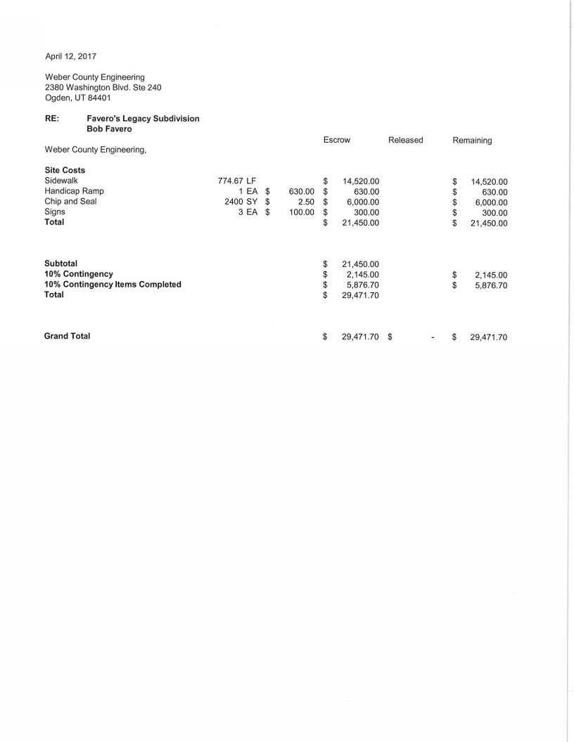

**Exhibit C**

**Escrow Certificate**

To Weber County, Utah:

The undersigned Escrow Agent does hereby certify that it has in its possession and custody, cash in the sum of

$ 29,471.70 which said sum said Escrow Agent is holding in escrow to guarantee the installation and completion, according to Ordinance, of all on and or off-site improvements, as specified in Exhibit "B" on the following described tracts of land in Weber County, Utah to wit:

**LEGAL DESCRIPTION**

ALL OF LOTS 1 THRU 6, AND OPEN SPACES A, AND B, FAVERO’S LEGACY CLUSTER SUBDIVISION PHASE 1, WEBER COUNTY, UTAH, ACCORDING TO THE OFFICIAL PLAT THEREOF.

In the event the funds so provided herein do not pay for and complete in full all of the specified improvements set forth in Exhibit "B" and as contemplated herein, then and in that event, subdivider/developer agrees to forthwith pay to Weber County all additional amounts necessary to so complete such improvements.

Said Escrow Agent hereby covenants and agrees that it will not release said funds to any person, firm or corporation (other than as is hereinafter provided) without the express written consent and direction from said Weber County, Utah, and that if said improvements are not satisfactorily installed and completed according to Ordinance within one month short of two years from the date hereof, that the said Escrow Agent will upon demand deliver said funds to said Weber County, Utah for the sole purpose of making and/or completing all of said improvements, with said County to return to the said Escrow Agent any and all funds which may prove to be in excess of the actual cost to the County to make and/or complete said improvements.

It is understood that the County may, at its sole option, extend said period of two years for such completion of such improvements upon request of the Escrow Agent or the Subdivider/Developer, if the County Commission determines that such extension is proper.

It is further understood and agreed that all matters concerning this agreement shall be subject to the pertinent provisions of the ordinances of Weber County, Utah.

Dated this day of , 20 .

Escrow Agent

Signature

Title

State Of Utah )

ss:

County Of Weber )

On the day of , 20 personally appeared before me and the signers of the within instrument and who duly acknowledged to me that they executed the same.

My Commission Expires:

Notary Public

Approved as to form:

Weber County Attorney Date

Approved:

Chairperson, Weber County Commission Date

Attest:

Weber County Clerk Date

Exhibit D

DECLARATION OF COVENANTS, CONDITIONS AND RESTRICTIONS

Favero Legacy Cluster Subdivision Phase 1

THIS DECLARATION OF COVENANTS, CONDITIONS AND RESTRICTIONS affect that certain real property known as all of Lots in the Favero Legacy Cluster Subdivision Phase 1, County of Weber, State of Utah (hereinafter "the Subdivision"), filed on the _________ day of ___________________ 2017, as Entry No. _________________of the records of Weber County, Utah. The following declarations as to limitations, restrictions, conditions, agreements and covenants to run with the above described land be binding on all present and future owners thereof, for their mutual benefit and protection.

1. Weber County Zoning and Subdivision Ordinances. All lots in the Subdivision shall be subject to requirements of Weber County Zoning and Subdivision Ordinances and the development and improvement of all lots therein shall be in compliance therewith.

2. Architectural Control Committee. No structure shall be erected, placed or altered on any lot in the Subdivision until the construction plans and specifications and a plot plan showing the size and location of the structure have been approved in writing by the Architectural Control Committee (hereinafter “the Committee"), as to quality of workmanship and materials, harmony of external design with neighboring structures, and to location with respect to topography and finish grade elevation.

The Committee shall initially consist of Robert Favero and Roger Favero. A majority of the Committee may designate a representative to act for them. All decisions of the Committee shall be made by majority vote, including the removal or appointment of Committee Members. Members of the Committee shall not be entitled to compensation for their services.

Notwithstanding the foregoing provisions, the Committee members shall have no affirmative obligation to be certain that all construction in the Subdivision complies with the restrictions contained herein and no Committee member shall have any liability or responsibility for any decision or lack thereof, in carrying out the duties of a Committee Member. The sole responsibility for compliance with the provisions of the Declaration shall rest with the lot owners in the Subdivision. Once all lots have been built upon, the Committee shall change and the lot owner's will be voted on and become the new Committee.

3. Residential Lots. Lots in the Subdivision shall be known and described as residential lots except for the two Open Space lots. No structure shall be erected, altered, placed or permitted to remain on any lot which is not a single family dwelling. Any other outbuildings must be approved in advance by the Committee. A conservation easement shall be recorded on the open space lots restricting their use to agricultural purposes.

4. Dwelling Size. Any rambler or single level dwelling shall have at least 1,600 square feet on the main level, exclusive of basement, open porches, and garages. A two-story dwelling shall have a minimum of 2,200 square feet, exclusive of basement, open porches and garages. All dwellings shall have at least a two or more car garage. No multi-level dwellings will be allowed. Anything different in size or style needs to be approved by the Committee.

5. Construction Methods and Materials. The exterior of any structure erected in the Subdivision shall have 75 percent of its front area covered with brick, native or cultural stone or other approved masonry products. Other exterior materials must be approved by the Committee. There shall be no log homes, log-like siding, aluminum or vinyl siding. All buildings shall have a roof of at least a 6 x 12 pitch. All shingles shall be architectural asphalt shingles.

If fiber cement siding is used as the only other material on the front of the home in addition to the masonry product (i.e. brick or stone), then the fiber cement siding may count for up to 15% of the masonry requirement thus effectively reducing the masonry requirement to 60%. If this option is incorporated then at least a wainscot of masonry shall be provided along the entire front of the home (i.e. no full surfaces of fiber cement siding that extend down to the concrete foundation wall). All structures in the Open Spaces must be approved by the Committee.

Front gable ends shall be included in the calculations of the surface area when calculating the percentages of different materials. A tolerance of +/- 2% in these percentages is acceptable.

6. Temporary Structure Prohibited. No structure of temporary nature, such as a trailer, basement, tent, shack, garage or other outbuilding shall be used on any lot at any time as a residence.

7. Trash. No lot shall be used or maintained as a dumping ground for rubbish. Trash, garbage or other waste will not be kept or permitted to remain on any lot except in sanitary containers. No materials shall be kept or stored on any lot that would be unsightly or a fire hazard.

8. Condition of Public Areas during Construction. All construction within the Subdivision shall be performed in a professional manner. All County Ordinances, including but not limited to, noise and storm water management shall be complied with. Roadways shall be kept clean and clear of debris throughout construction. Dirt, mud or debris left on roadways shall be swept and removed within twelve hours. Each homeowner/homebuilder shall protect the integrity of sidewalks and curb and gutter abutting their lot. It will be the responsibility of the homeowner/homebuilder to repair all damage to curb, gutter and sidewalks to the satisfaction of the city.

9. Fences. No fence, wall, or other similar structure shall be constructed or placed on any lot nearer the street than the front house line, nor shall any fence, wall or similar structure be constructed to a height greater than 6 feet. (The Architectural Committee must approve materials and design of any fencing on the lot prior to the installation of said fence.) All fencing is to be constructed of vinyl privacy or semi­ private and is the homeowner's responsibility. No chain link or wood fencing will be allowed. Fencing of the Open Space must be approved by Committee.

10. Landscaping. Landscaping shall be completed by homeowners within eighteen months of occupancy, including but not limited to sprinkling system and lawn. Poplar, Ash, Russian Olive or any form of Cottonwood tree will not be permitted within the subdivision. Each homeowner shall plant at least two flowering or Chanticleer trees evenly spaced in the park strip across the frontage of each lot within three months of occupancy. Homeowner shall be responsible for tree irrigation systems.

11. Other Obstructions. No hedge or shrub planting which obstructs sight lines at elevations between 2 and 6 feet above the Subdivision roadways shall be placed or permitted to remain on any corner lot within the triangular area formed by the R.O.W. street property lines and lines connecting them at points 20 feet from the intersection of the street lines extended. No tree shall be permitted to remain within such distances of such intersections unless the foliage line is maintained at a sufficient height to permitted obstruction of such sight lines not precluding safe stopping sight distances.

12. Nuisance. No obnoxious or offensive activity shall be carried on upon any lot, nor shall anything be done thereon which may be or become an annoyance or nuisance to the neighborhood. No storage of any articles of any items which are unsightly to the neighborhood to be out in the open, they are to be in enclosed areas built and designed for such purposes. No automobiles, trailer, boats or other vehicles are to be stored on streets or front and side lots unless they are in running condition, properly licensed and are being used regularly. Automobiles must be moved every 48 hours. Locate all RV storage on the side or rear of homes behind a privacy fence. All roof mounted heating and cooling equipment to be set to the back side of the roof out of view from the street. All TV antennas are to be placed in the attic out of view. Satellite dishes, etc, are to be hidden from view from the street.

13. Lot Grading & Drainage. Each Homebuilder shall be responsible to grade their lots in such a manner that storm water drainage is directed away from the home and toward streets or their designated drainage easements. In no case will lots be graded to direct storm water runoff on to neighboring lots.

14. Easements. Easement and rights of way shall be reserved to the undersigned, its successors and assigns, on and over the Subdivision, as shown on the recorded plat, for the erection, construction and maintenance and operation thereon or therein of drainage pipes or conduits, pipes, manholes, poles, wires and other means of conveying to and from lots in the Subdivision, gas, electricity, water, telephone, sewage and other services for the convenience of lot owners in the Subdivision.

15. Duration of Covenants. The covenants contained herein shall run with the land and shall be binding on all owners of lots in the Subdivision from the date hereof for a period of 20 years, at which time said covenants shall continue automatically for successive periods of 10 years each, unless an instrument signed by a majority of the then lot owners in the Subdivision is recorded changing said covenants in whole or in part.

16. Enforcement of Covenants. Any owner of any lot in the Subdivision may enforce the covenants contained herein through any proceeding at law or in equity against any person violating them to enjoin or prohibit any violations and to recover any damages suffered by any lot owner.

17. Acceptance of Restrictions. All purchasers of lots in the Subdivision shall, by entering into contracts to purchase and accepting deeds for such lots, be conclusively deemed to have consented and agreed to all restriction, conditions, terms, agreements, and covenants herein contained.

18. Invalidity. Invalidation of any of the covenants herein contained, in whole or in part, by judgment or court order shall in no way affect any of the other provisions hereof, which shall remain in full force and effect.

19. Water Table Elevations. A buyer of any lot in Favero Legacy Subdivision Phase 1assumes all responsibility as to the depth in which they put their footings and foundation and holds the developers and Weber County harmless from any damages that may come due to high ground water and flooding.

IN WITNESS WHEREOF, the undersigned has executed this document on this ______ day of ______________, 2017.

Robert L. Favero

By: ________________________________

IN THE STATE UTAH )

:ss

COUNTY OF WEBER )

On the _______ day of ______________________, 2017 the people named above personally appeared before me, who under oath acknowledged to me that they are the owners of FAVERO’S LEGACY CLUSTER SUBDIVISION PHASE 1 and that they executed the above instrument for and in behalf of said subdivision.

____________________________________

NOTARY PUBLIC

My Commission Expires:

_____________________

EXHIBIT "A"

ALL OF LOTS 1 THRU 6, AND OPEN SPACES A, AND B, FAVERO’S LEGACY CLUSTER SUBDIVISION PHASE 1, WEBER COUNTY, UTAH, ACCORDING TO THE OFFICIAL PLAT THEREOF.