|  |  |
| --- | --- |
| **WC Logo.emf** | **Staff Report for Administrative Subdivision Approval**  *Weber County Planning Division* |
|  | |

****Synopsis****

****Application Information****

**Application Request:** Consideration and action on final approval of the Cash Cow Subdivision, a two-lot subdivision.

**Type of Decision: Administrative**

**Agenda Date: Wednesday, October 28, 2020**

**Applicant:** William F. and Jana Colvell, owner

**File Number:** LVC 092620

****Property Information****

**Approximate Address:** 3952 N 3175 W, Ogden UT

**Project Area:** 2.5 acres

**Zoning:** Agriculture (A-1) Zone

**Existing Land Use:** Agriculture

**Proposed Land Use:** Residential, Agriculture

**Parcel ID: 19-010-0085**

**Township, Range, Section:** T7N, R2W, Section 22

****Adjacent Land Use****

**North:** Agriculture **South:** Agricultural/Residential

**East:** Agricultural/Residential **West:** Agricultural/Residential

****Staff Information****

**Report Presenter:** Felix Lleverino

flleverino@co.weber.ut.us

801-399-8767

**Report Reviewer:** SB

Applicable Ordinances

* Title 101 (General Provisions) Section 2 (Definitions)
* Title 104 (Zones) Chapter 5 (A-1 Zone)
* Title 106 (Subdivisions)

Development History

Alternative access approval to create a private drive was granted in a public meeting held on February 11, 2020.

Background and Summary

The applicant is requesting final approval of the Cash Cow Subdivision, a two-lot subdivision located at approximately 3952 North 3175 West in the A-1 Zone. This development plan includes a private drive on the south side of the parcel which will provide access to lot two of Cash Cow Subdivision.

The subdivision plat indicates a 30’ by 162.5’ or 4,875 square foot area dedicated to the public right-of-way called 3175 West Street.

Culinary water will be provided by Bona Vista Water Improvement District and each property will have an individual septic system.

Analysis

*General Plan*: The proposal conforms to the Western Weber General Plan by preserving the rural character of Wester Weber County by creating large lots that allow for the presence of animals.

*Zoning*: The subject property is located in an Agricultural Zone A-1 zone. That land use requirements for this zone are stated in the LUC§ 104-5 as follows:

*The purpose of the A-1 Zone is to designate farm areas, which are likely to undergo a more intensive urban development, to set up guidelines to continue agricultural pursuits, including the keeping of farm animals, and to direct orderly low-density residential development in a continuing rural environment.*

As part of the subdivision process, the proposal has been reviewed against the current subdivision ordinance in LUC 106 chapter 1, and the standards in A-1 zone LUC 104-5-7. Small Subdivisions, as defined in LUC 101-7, can be administratively approved per LUC 106-1-5(b)(1) The proposed subdivision will not create any new public streets.

*Lot area, frontage/width, and yard regulations*: In the LUC §104-7-6, the A-1 zone requires a minimum lot area of 40,000 sq. ft. and a minimum lot width of 150’.

Each lot within the Cash Cow subdivision meets the minimum acreage and width requirements of the A-1 zone.

*Culinary water and sanitary sewage disposal:* Bona Vista Water Improvement District will provide culinary water to each lot with six conditions of approval (see Exhibit B). The Weber-Morgan Health Department has provided a Septic Feasibility letter for lots 1 and 2 of Cash Cow Subdivision (see Exhibit C).

*Review Agencies*: Planning, Engineering, Surveying, Weber Fire, and the Weber-Morgan Health Departments have reviewed the proposed subdivision. Minor revisions to the dedication plat and proof of secondary water are requested by Planning and Engineering.

*Public Notice*: Public notice was sent by mail to all property owners within 500 feet of the subject property.

Staff Recommendations

Staff recommends final approval of the Cash Cow Subdivision, a two-lot subdivision. This recommendation is subject to all review agency requirements and based on the following conditions:

1. The owner proves that irrigation water is secured.
2. The owner enters into a deferral agreement for curb, gutter, and sidewalk.

This recommendation is based on the following findings:

1. The proposed subdivision conforms to the Western Weber General Plan.
2. With the recommended conditions, the proposed subdivision complies with applicable county ordinances.
3. The proposed subdivision will not be detrimental to public health, safety, or welfare.
4. The proposed subdivision will not deteriorate the environment of the general area to negatively impact surrounding properties and uses.

Administrative Approval

Administrative final approval of Cash Cow Subdivision is hereby granted based upon its compliance with the Weber County Land Use Code. This approval is subject to the requirements of applicable review agencies and the conditions of approval listed in this staff report.

Date of Administrative Approval: .

________________________________________

Rick Grover

Weber County Planning Director

Exhibits

1. Subdivision plat
2. Bona Vista will-serve letter
3. Septic Feasibility Letter

Map 1

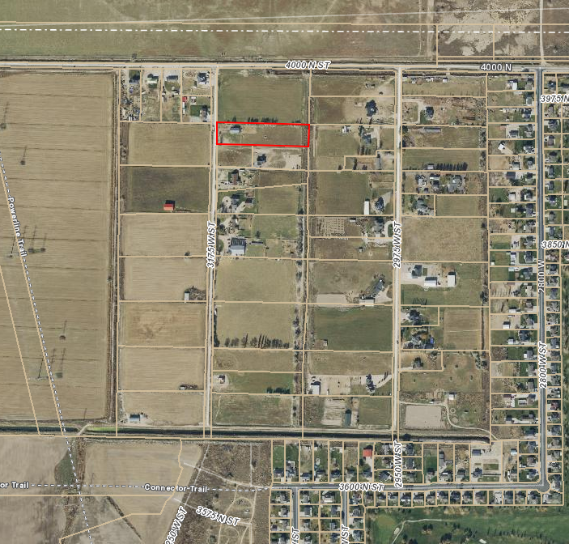

Exhibit A

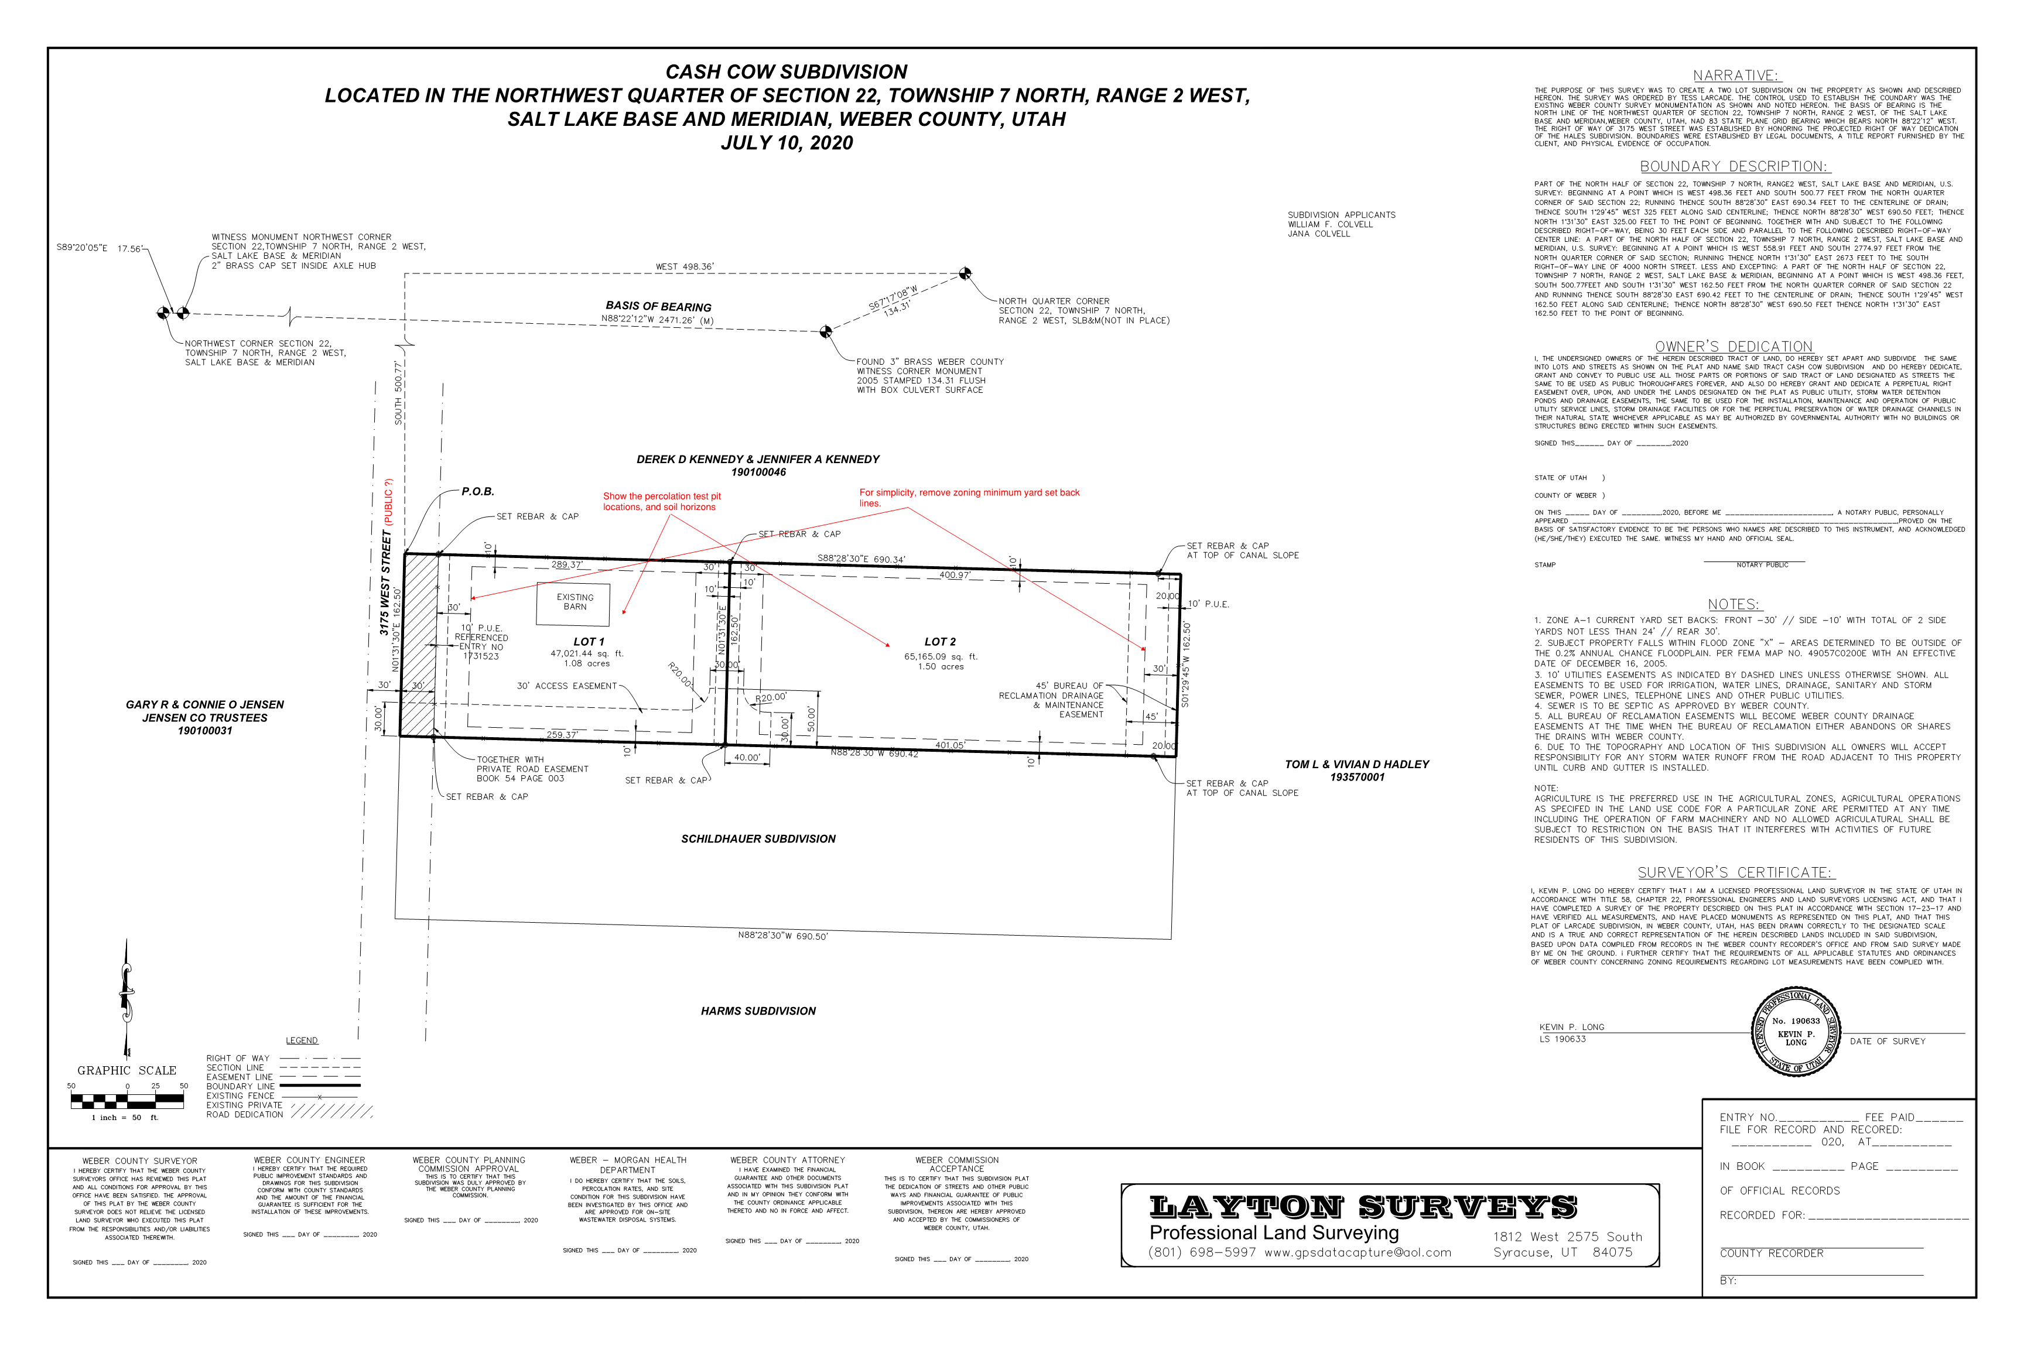

Exhibit B

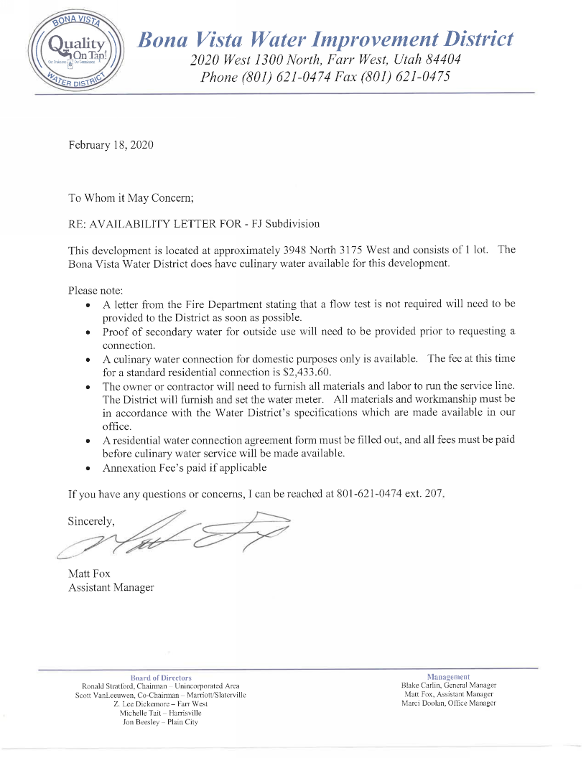

Exhibit C

