|  |  |
| --- | --- |
| **WC Logo.emf** | **Staff Report to the Weber County Commission**  *Weber County Planning Division* |
|  | |

****Synopsis****

****Application Information****

**Application Request:** A public hearing to consider and take action on a request to vacate public utility easements located within Henry Flats Cluster Subdivision.

**Agenda Date: Tuesday, September 18, 2018**

**Applicant:** Phil Hancock

**File Number:** EV2018-03

****Property Information****

**Approximate Address:** 400 S 4350 W, Taylor

**Project Area:** 11.89 Acres

**Zoning:** Agricultural (A-1)

**Existing Land Use:** Residential

**Proposed Land Use:** Residential

**Parcel ID:** 15-639-0001 through 15-639-0012

**Township, Range, Section:** T6N, R2W, Section 17

****Adjacent Land Use****

**North:** Residential **South:** Residential

**East:** Residential **West:** Residential

****Staff Information****

**Report Presenter: Felix Lleverino**

flleverino@webercountyutah.gov

**801-399-8767**

**Report Reviewer:** RK

Development History

Henry Flats Cluster Subdivision was recorded in the Weber County Recorder’s Office on August 28th 2017.

Background and Summary

The applicant has submitted a request to vacate the public utility easements located on the sides and rear of lots 1-6 and on the sides of lots 7-12 of Henry Flats Cluster Subdivision (see Exhibit B). The cause for the petition to vacate the easements in question is due to the easements no longer being necessary because all utilities are already in place. Gas and water lines are located within the public right of way. The power and phone lines are located within the front public utility easements.

The applicant has proposed to vacate the public utility easement by ordinance. Under the state code, Section 17-27a-609.5, the legislative body may adopt an ordinance granting a petition to vacate some or all of a public street, right-of-way, or easement if the legislative body finds that:

(a) good cause exists for the vacation; and

(b) neither the public interest nor any person will be materially injured by the vacation.

The vacating procedure found in Utah State Code 17-27a-208 and 17-27a-209.5 do not require a Planning Commission recommendation.

The following is the staff's analysis of the vacation request.

Analysis

*General Plan*: Vacating this easement will not have a negative effect on the Western Weber General Plan.

*Additional Standards*: The applicant has obtained consent letters from all owners within Henry Flat Cluster Subdivision, thereby meeting State Code Requirement 17-27a-609.5 (1), (b). The applicant has also gathered consent letters from Rocky Mountain Power, Questar Gas Company, and Century Link (see Exhibit D).

State Public Noticing Requirements have been met as outlined in state code Section 17-27a-208.

Staff Recommendation

Staff recommends approval of the request to vacate the 10-foot public utility easements along the sides and rear of lots 1-6 and on the sides of lots 7-12 within Henry Flats Cluster Subdivision; This recommendation for approval is based on the following findings:

1. Vacating the proposed easement will not have a negative effect on the Western Weber General Plan.
2. The public interest or any person will not be materially injured by the proposed vacation.
3. The proposed vacation will not be detrimental to the public health, safety, or welfare.
4. The proposed vacation will not deteriorate the environment of the general area so as to negatively impact surrounding properties and uses.
5. Access across public utility easements for adjacent developments to the west may be accomplished across the rear public utility easements on lots 7-12. Development to the east subdivision boundary will not take place due to the open space easement that was preserved as part of the cluster development.

Exhibits

1. Henry Flats Cluster Subdivision
2. Proposed areas to be vacated
3. Owner approval
4. Utility provider approval letters
5. Vacation ordinance**11kfjf**

Area Map

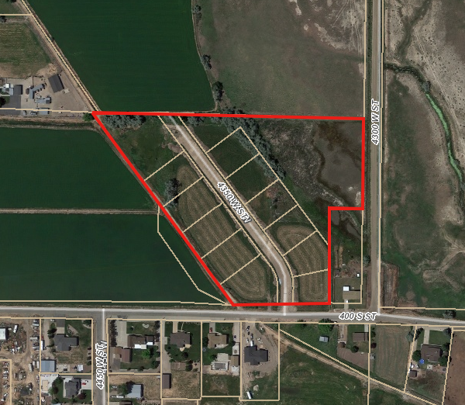

Exhibit A

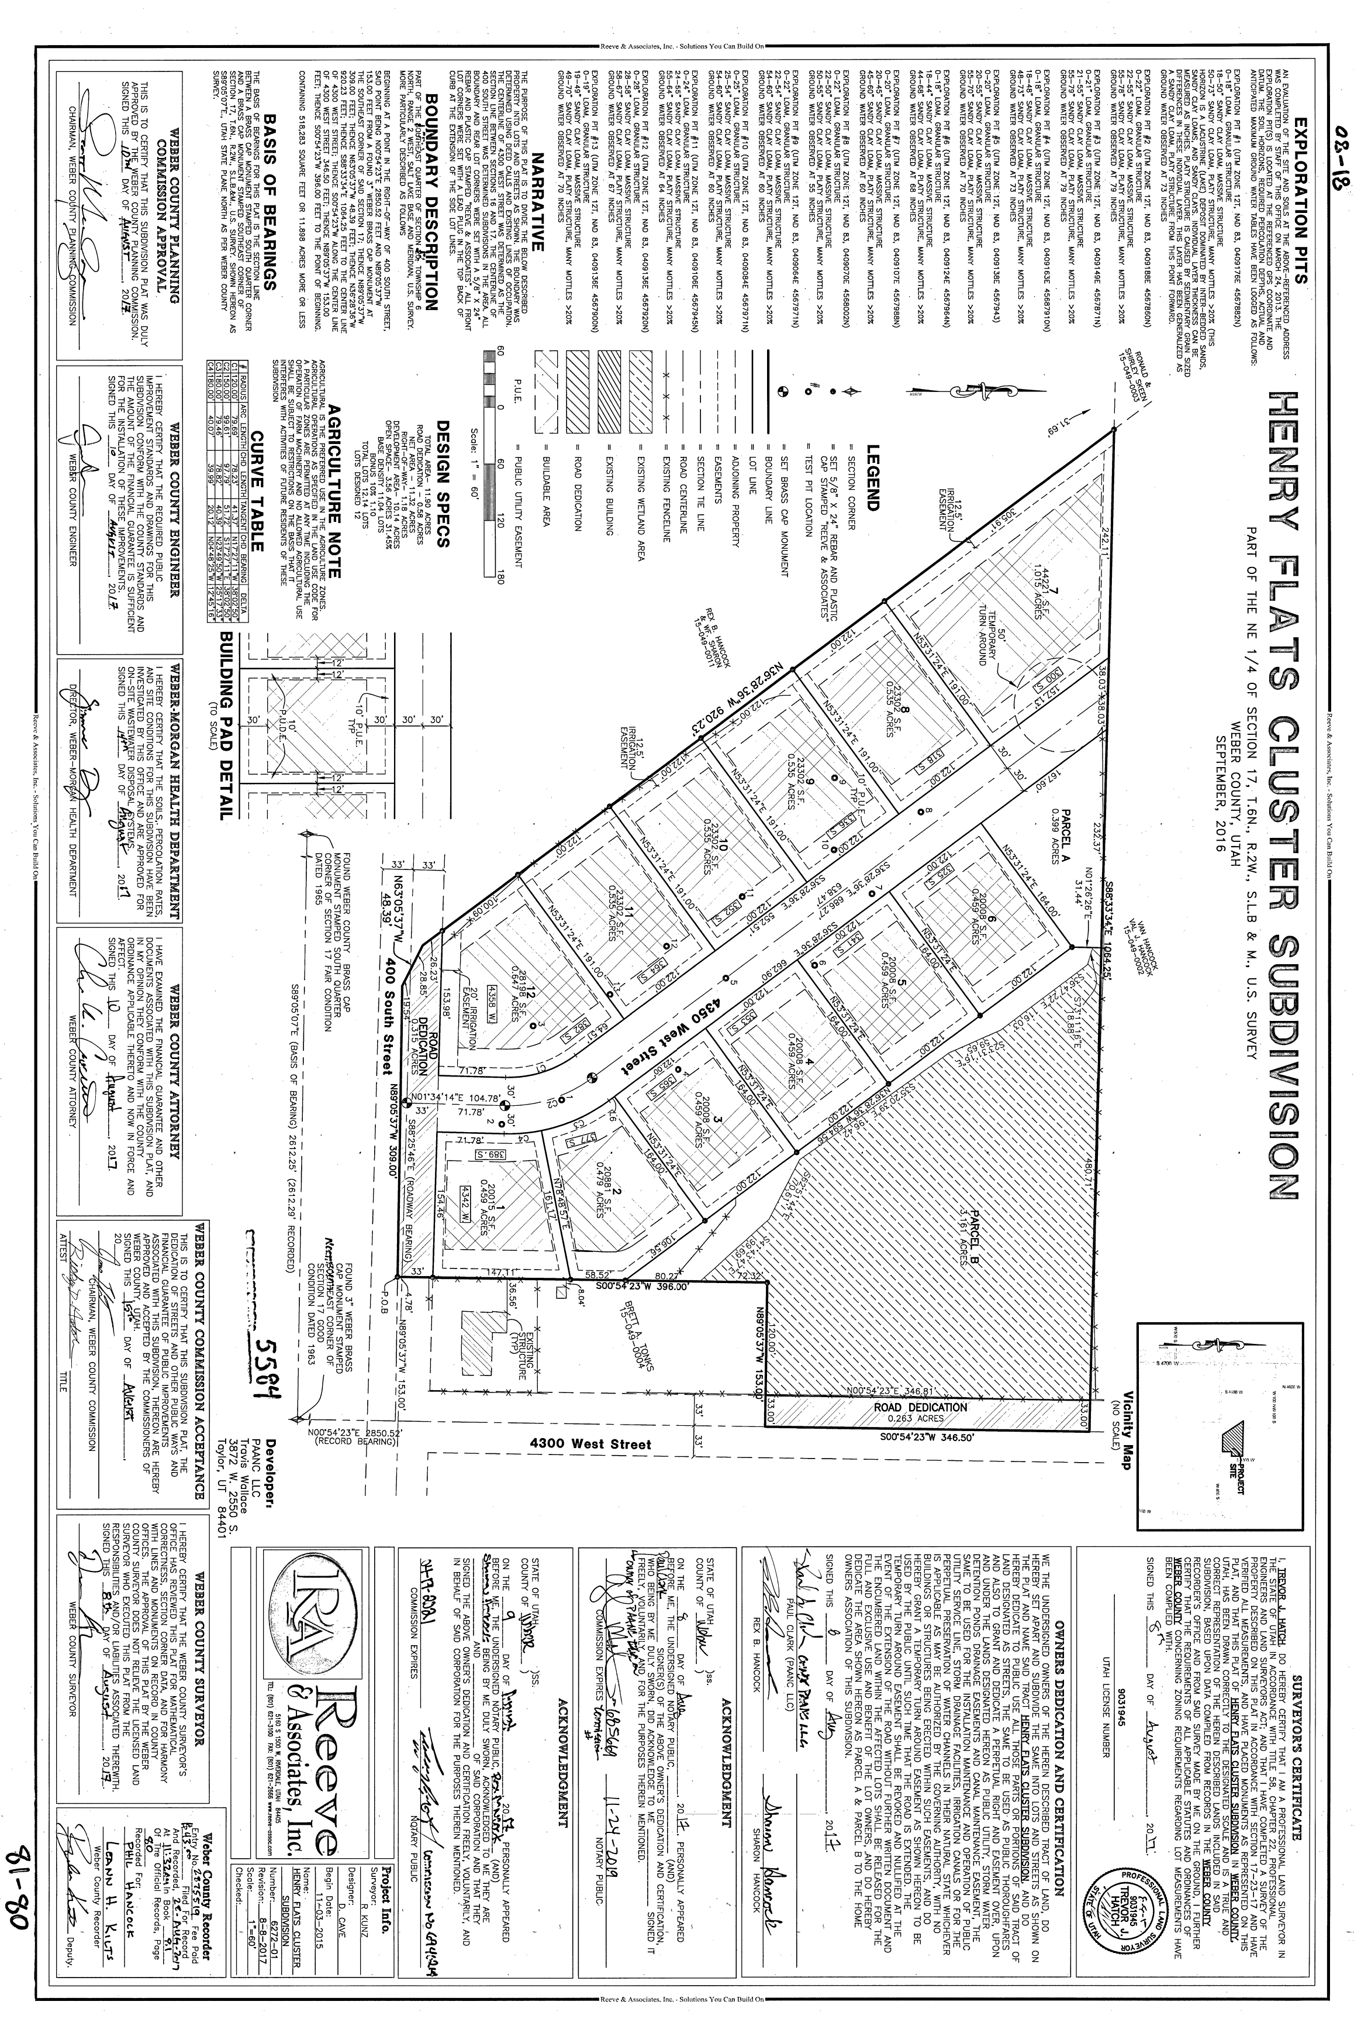

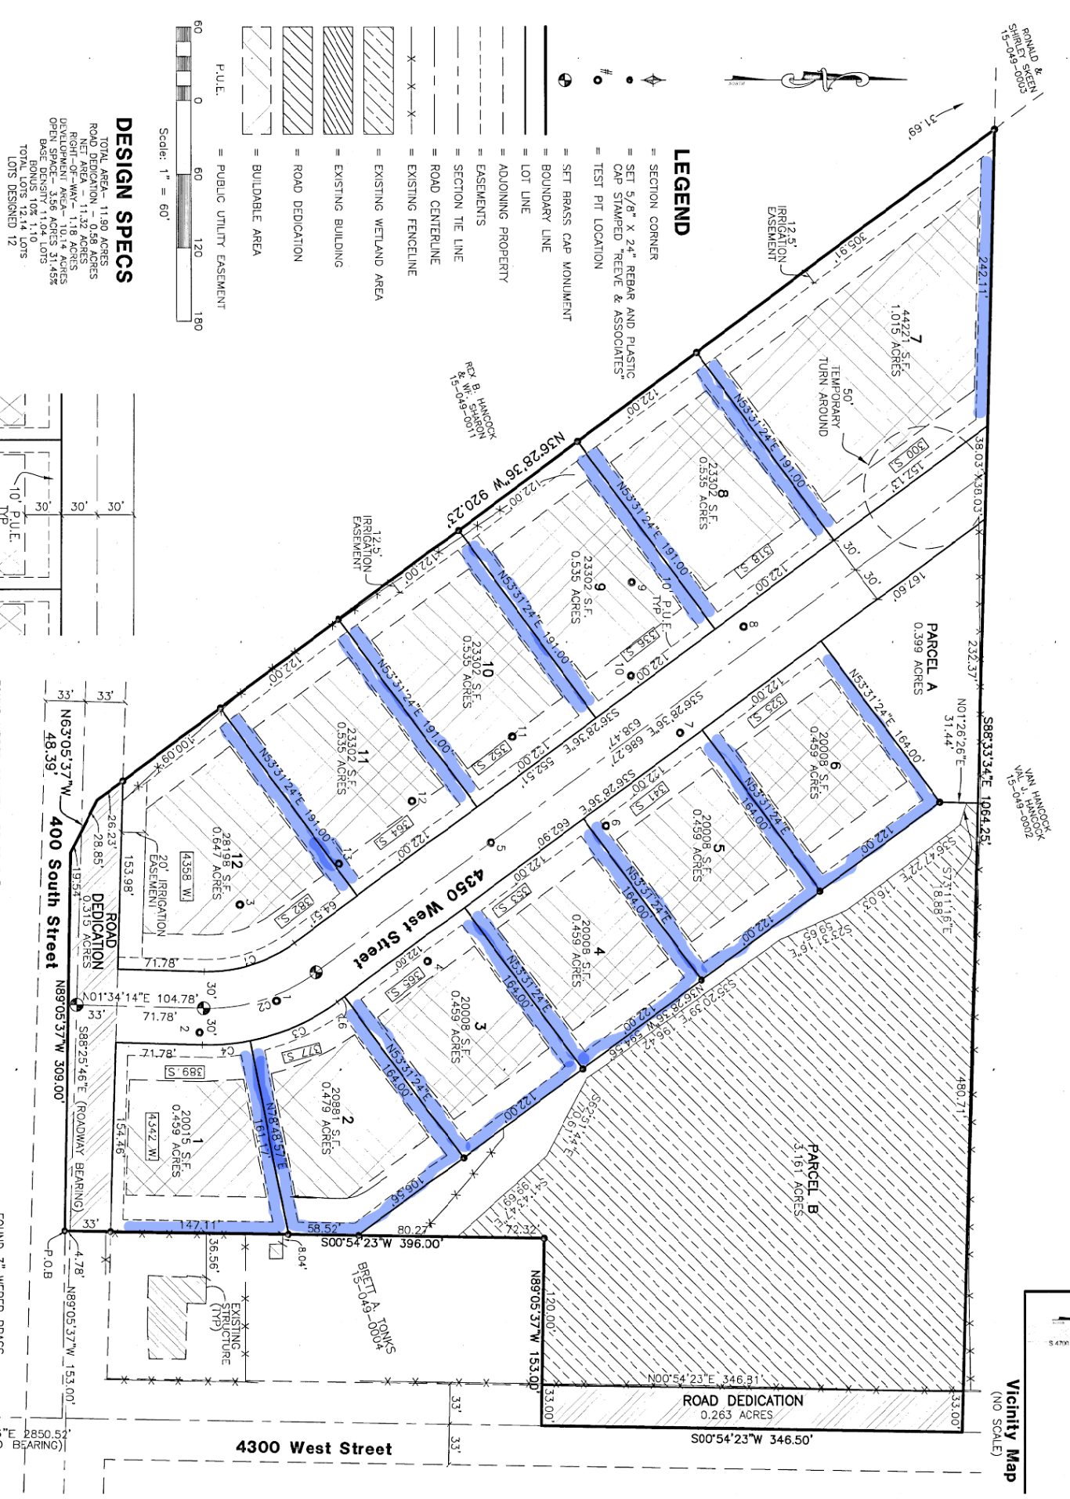Exhibit B

Exhibit C

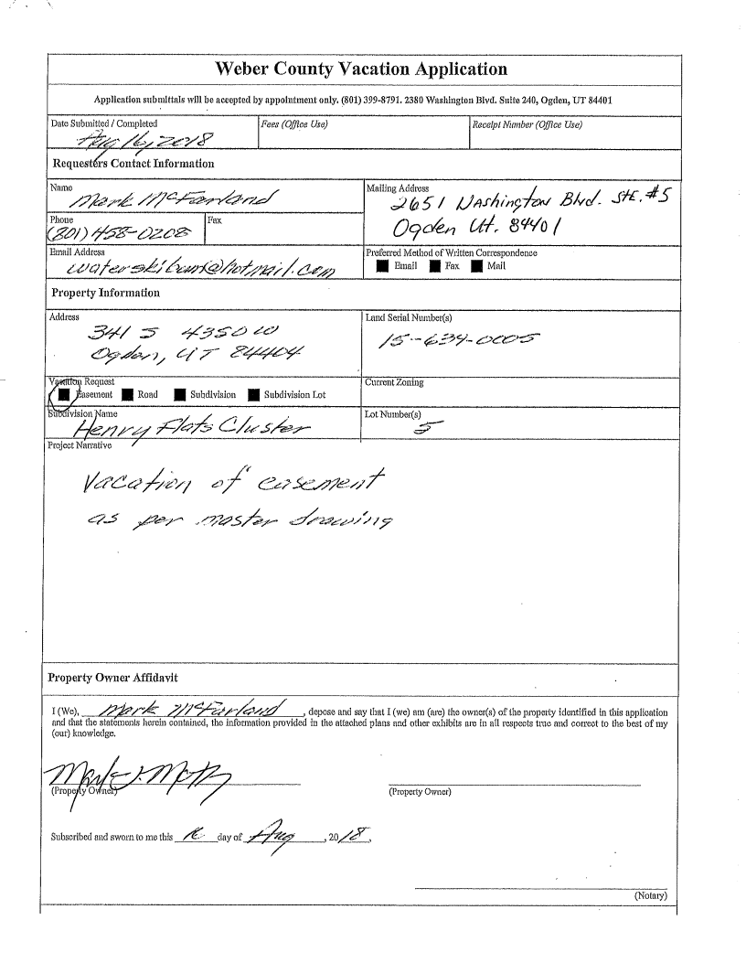

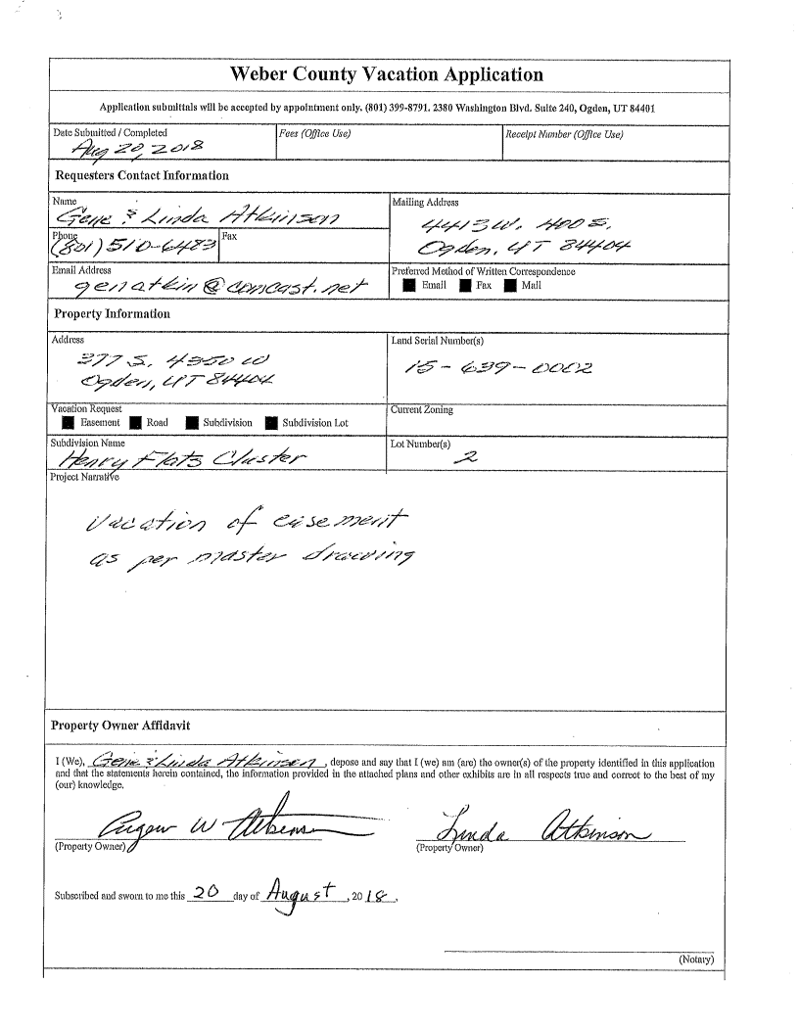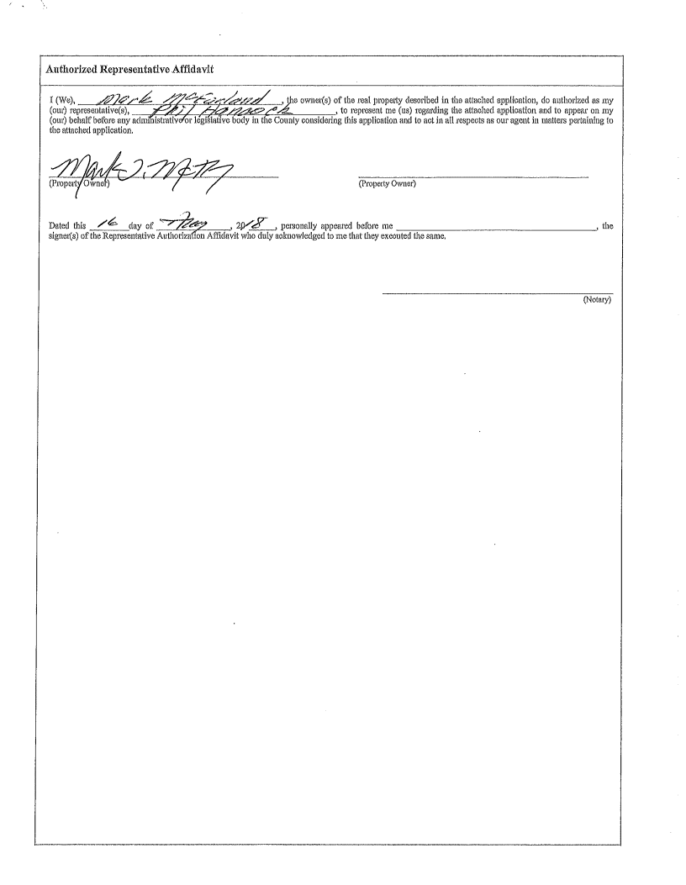

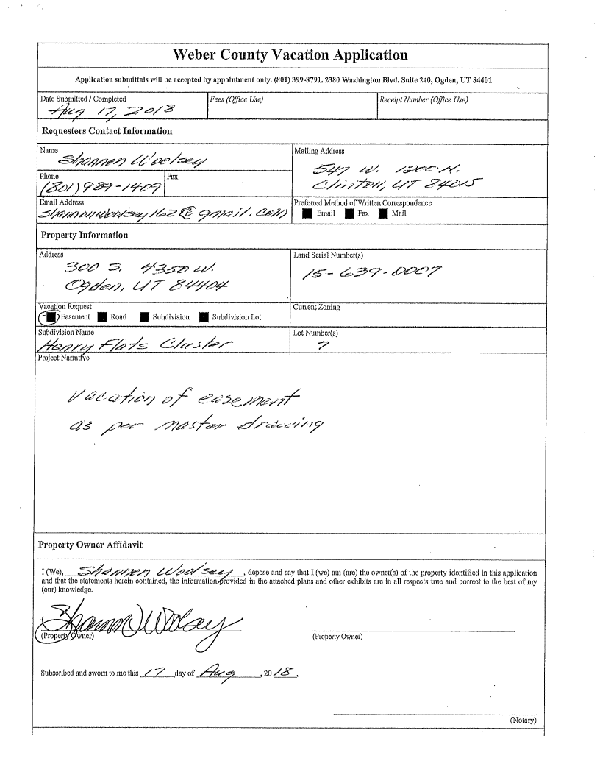

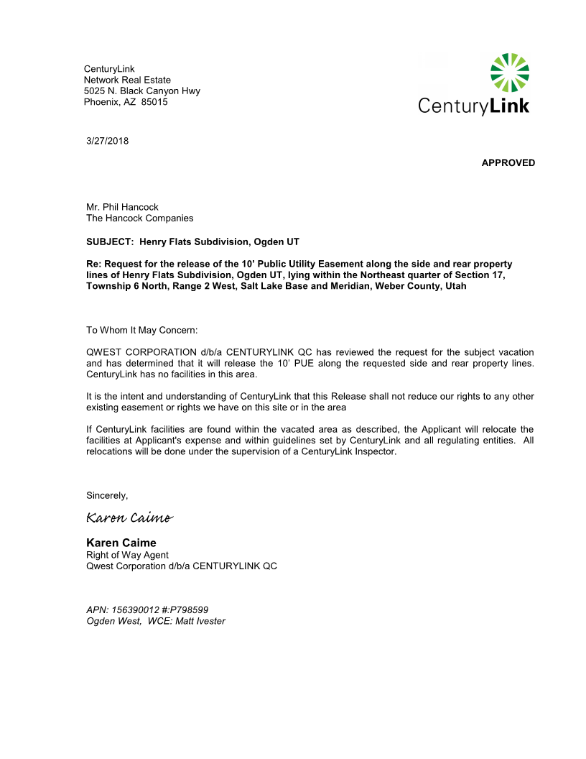Exhibit D

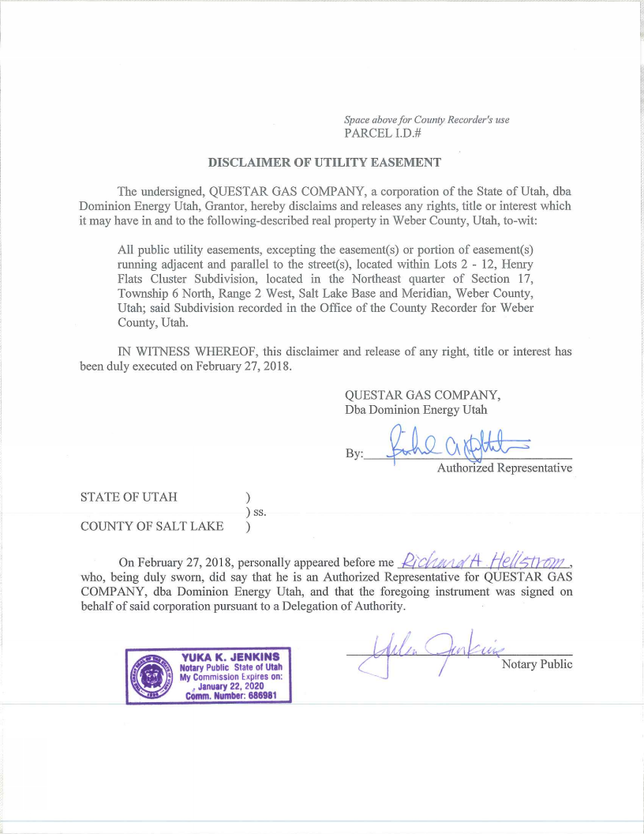 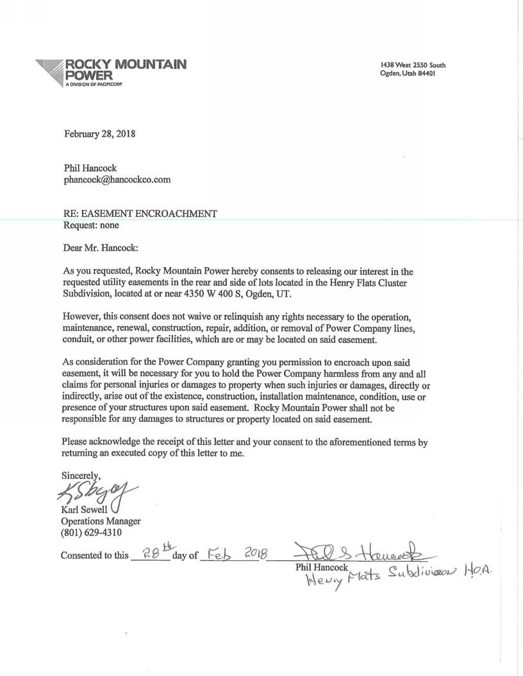

Exhibit E

**Ordinance**

**An ordinance of Weber County vacating public utility easement located on sides and rear of lots 1-6 and on the sides of lots 7-12 within Henry Flats Cluster Subdivision**

**Whereas,** H & A Development LLC, has filed a petition to vacate 10-foot wide public utility easements on the side and rear of lots 1-6 and on the sides of lots 7-12 within the Henry Flats Cluster Subdivision;

**Whereas,** after providing proper public notice, a public hearing was held on September 4, 2018, regarding the vacation of public utility easements on the sides and rear of lots 1-6 and on the sides of lots 7-12 within the Henry Flats Cluster Subdivision;

**Whereas,** The Weber County Engineering Department has been notified and has provided written approval of the vacation of the public utility easement;

**Whereas,** the vacation of the public utility easement will not substantially affect the West Central Weber County General Plan or the health, safety, and welfare of the general public;

**Now, Therefore,** the Weber County Board of Commissioners vacates the following:

**The public utility easements within Henry Flats Cluster Subdivision as described below are hereby vacated from the subdivision:**

Passed, adopted, and ordered published this day of , 2018, by the Weber County Board of Commissioners.

_____________________________________

James Harvey, Chair

Commissioner Harvey Voting

Commissioner Ebert Voting

Commissioner Jenkins Voting

ATTEST:

Ricky Hatch, CPA Weber County Clerk

