|  |  |
| --- | --- |
| **WC Logo.emf** | **Staff Report for Administrative Approval**  *Weber County Planning Division* |
|  | |

****Synopsis****

****Application Information****

**Application Request:** Request for final approval of Myers Subdivision, a three-lot subdivision, located in the AV-3 and CV-2 zones.

**Type of Decision: Administrative**

**Agenda Date: Wednesday, November 03, 2021**

**Applicant: Telford Myers**

**File Number:** UVM07082021

****Property Information****

**Approximate Address:** 5910 E 1900 N, Eden, UT, 84310

**Project Area:** 12.00 acres

**Zoning:** Agricultural Valley (AV-3), Commercial Valley (CV-2)

**Existing Land Use:** Residential/Agricultural

**Proposed Land Use:** Residential

**Parcel ID:** 22-049-0040, 22-049-0041

**Township, Range, Section:** T7N, R1E, Section 35 SE

****Adjacent Land Use****

**North:** Agricultural **South:** 1900 North St

**East:** Agricultural **West:** Residential/Agricultural

****Staff Information****

**Report Presenter: Tammy Aydelotte**

**taydelotte@co.weber.ut.us**

**Report Reviewer: RG**

Applicable Land Use Codes

* Weber County Land Use Code Title 106 (Subdivisions)
* Weber County Land Use Code Title 104 (Zones) Chapter 2 (AV-3 Zone)
* Weber County Land Use Code Title 104 (Zones) Chapter 20 (CV-2 Zone)

Background and Summary

The applicant is requesting final approval of Myers Subdivision, consisting of three lots, located at approximately 5910 E 1900 N, Eden in the AV-3 and CV-2 Zones. The proposed subdivision and lot configuration are in conformance with the applicable zoning and subdivision requirements as required by the Uniform Land Use Code of Weber County (LUC). The following is a brief synopsis of the review criteria and conformance with LUC.

Analysis

General Plan: The request is in conformance with the Ogden Valley General Plan as it is intended to preserve private property rights while also preserving the rural characteristics of the Valley.

Zoning: The subject property is located in the AV-3 zone, with lot 2 of the proposed subdivision showing in the CV-2 Zone. Single-family dwellings are a permitted use in the AV-3 Zone.

Lot area, frontage/width and yard regulations: In the LUC § 104-2-5, the AV-3 zone requires a minimum lot area of 3 acres for a single family dwelling and a minimum lot width of 150 feet. All lots in this proposed subdivision meet this requirement.

The following are setbacks for the AV-3 zone:

Front: 30’

Side: 20’

Rear: 30’

As part of the subdivision process, the proposal has been reviewed for compliance with the current subdivision ordinance in the LUC § 106-1, and the AV-3 zone standards in LUC § 104-2, as well as the CV-2 zone standards in LUC § 104-20. The proposed subdivision will dedicate sufficient right-of-way along 1900 North Street so as to meet the required half-width dedication for a 100’right-of-way.

Culinary water and sanitary sewage disposal: Weber-Morgan Health Department has performed the necessary soil testing to provide design requirements for on-site septic systems for each lot. A feasibility letter from Eden Waterworks has also been provided for culinary water. Eden Waterworks currently has no restrictions on using water shares for secondary purposes, however, Mr. Myers still needs to acquire additional shares to accommodate the three vacant lots he is proposing as part of this subdivision application. Eden Irrigation shares are currently being used for secondary purposes.

Review Agencies: To date, the proposed subdivision has been reviewed by the Planning Division and the Engineering Division. Weber Fire District has not yet reviewed this project. The Surveyor’s Office will submit a review once a final proposed plat has been submitted. All review agency requirements must be addressed and completed prior to this subdivision being recorded.

Tax Clearance: There are no outstanding tax payments related to these parcels. The 2021 property taxes are not considered due at this time, but will become due in full on November 30, 2021.

Staff Recommendation

Staff recommends final approval of Myers Subdivision, consisting of three lots located at approximately 5910 E 1900 N, Eden. This recommendation is subject to all review agency requirements prior to recording of the subdivision and the following condition:

1. Parcel number 22-0449-0040 (CV-2) is brought into compliance through a subdivision application, and other requirements related to a compliant business license, prior to recording this subdivision.

This recommendation is based on the following findings:

1. The proposed subdivision conforms to the Ogden Valley General Plan
2. The proposed subdivision complies with applicable county ordinances

Exhibits

1. Application
2. Proposed Subdivision Plat
3. Feasibility Letters

|  |
| --- |
|  |

****Area Map****

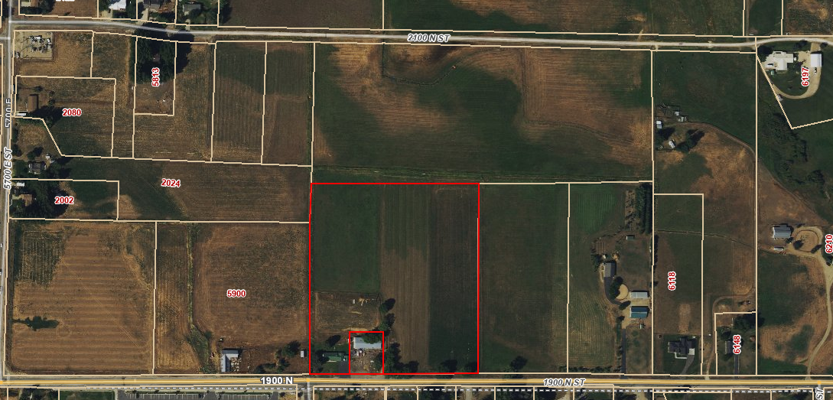

****Exhibit A – Application****

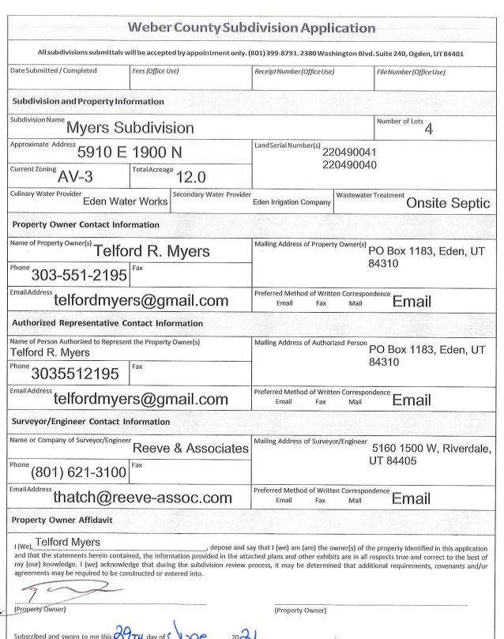

|  |
| --- |
|  |

****Exhibit B – Proposed Subdivision Plat****

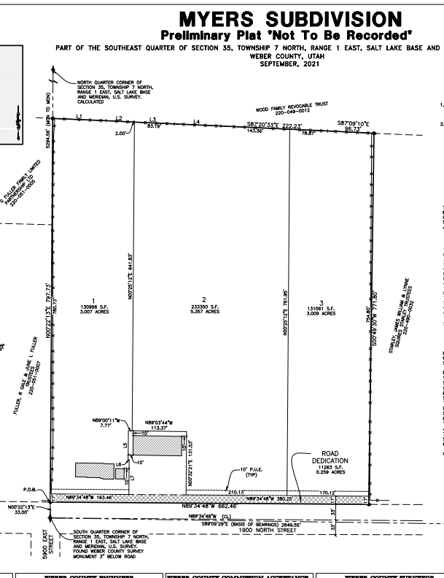

****Exhibit C – Feasibility Letters****



  
  
  