|  |  |
| --- | --- |
| **WC Logo.emf** | **Staff Report for Administrative Approval**  *Weber County Planning Division* |
|  | |

****Synopsis****

****Application Information****

**Application Request:** Consideration and action on a request for approval of a Building Parcel Designation for Lots 40 & 41 of the Retreat at Wolf Creek Subdivision Phase #3

**Type of Decision Administrative**

**Applicant:** James M O’Brien Trust

**Authorized Agent:** Eric Householder

**File Number: BPD 2016-2**

****Property Information****

**Approximate Address:** 5439, 5447 East Frazer’s Ridge Dr Eden, UT

**Project Area:** 0.76 Acres

**Zoning:** Residential Estate-20 (RE-20)

**Existing Land Use:** Vacant

**Proposed Land Use:** Single Family Dwelling

**Parcel ID:** 22-331-0011 & 22-331-0012

**Township, Range, Section:** Township 7 North, Range 1 East, Section 22

****Adjacent Land Use****

**North:** Residential **South:** Residential

**East:** Residential **West:** Residential

****Staff Information****

**Report Presenter: Felix Lleverino**

flleverino@co.weber.ut.us

801-399-8767

**Report Reviewer:** RK

Applicable Ordinances

* Title 101, Chapter 1, General Provisions, Section 7, Definitions
* Title 104, Chapter 3 Residential Estates Zones (RE-20)

Summary and Background

The Retreat at Wolf Creek Subdivision Phase 3 was established in the Eden area of the Ogden Valley and was recorded on June 27, 2015 (see Exhibit A). The subdivision consists of 20 lots that vary in size from 0.29 acres to 0.59 acres and is zoned Residential Estate (RE-20).

The applicant has submitted a site plan for a single family dwelling to be located at 5439, 5447 East Frazer’s Ridge Dr Eden, UT (see Exhibit B for the approved site plan and Exhibit D for the Notice of Decision). The applicant has applied for and receive approval of a “Building Parcel Designation” which is permitted and defined in the Uniform Land Use Code of Weber County, Utah (LUC) §101-1-7 as follows:

*“Building parcel designation means two or more lots within an approved subdivision are recognized as one lot for building purposes. This does not allow for the creation of additional lots, and the original lot lines as recorded do not change. The planning director can administratively approve a building parcel designation application.”*

The purpose of this request is to allow for the construction of a single family dwelling across the internal lot lines of Lots 40 and 41 in the Retreat at Wolf Creek Subdivision Phase 3. The applicant is now ready to start construction and is desirous to combine Lots 40 & 41 (see Exhibit A). Without a building parcel designation, the structure could not be built on Lot 40 or Lot 41 due to the size of the existing lots. The proposed application appears to meet the standards of the LUC for a building parcel designation. The following is staff’s evaluation of the request.

Analysis

*General Plan:* The Ogden Valley General Plan identifies the need to preserve private property rights while also preserving the rural characteristics of the Valley. Central to the approach is a combination of land uses in ‘community areas” around Liberty, Eden and East Huntsville and on the surrounding hillsides. *(see the 1998 Ogden Valley General Plan § 10 Land Use)*.

*Zoning:* The LUC §104-3 Residential Estates Zones (RE-20) has identified the need to provide and protect residential development at a low density in a semi-agricultural or rural environment. It is also to provide for certain rural amenities on larger minimum lots, in conjunction with the primary residential nature of the zone.

The RE-20 Zone has specific standards identified in LUC §104-3-7 that shall be met as part of the development process. Those standards are as follows:

* Minimum lot area: 20,000 Sq ft
* Minimum lot width: 100 ft
* Minimum yard setbacks:
* Front: 30’
* Side: 10 feet with total width of 2 side yards not less than 24 ft.
* Rear: 30’
* Building height:
* Minimum: 1 story
* Maximum: 35’

The building parcel designation will recognize Lots 40 and 41 as one for building purposes, the combined lots will contain approximately 0.76 acres, and no lot lines will change. Combining the lots by a building parcel designation will allow for the desired commercial development. If the building parcel designation is approved and the structure is built, the combination cannot be undone unless the building is removed from across the existing lot lines or a formal plat amendment is done to combine the existing lots.

Summary of Considerations

* Does the request meet the requirements of applicable ordinances?
* Should a Building Parcel Designation be allowed for these lots?

Staff Recommendation

Staff recommends approval of BPD2016-02, a request for approval of a building parcel designation for Lots 40 & 41 of The Retreat at Wolf Creek Subdivision Phase 3 to allow for the construction of a new single family dwelling at 5439, 5447 East Frazer’s Ridge Dr Eden, UT. This recommendation for approval is subject to all review agency requirements and with the following conditions:

1. A land use permit is required as part of the building permit process.

This recommendation is based on the following findings:

1. The proposed use conforms to the Ogden Valley General Plan.
2. The proposal complies with applicable County ordinances.
3. The lots meet the area and setback requirement of the RE-20 Zone.
4. No new lots are being created and the existing lot lines are not being changed.
5. The “Building Parcel Designation” will allow for a desirable sized commercial building to be located within the residential area of the Ogden Valley.
6. The proposal will not be detrimental to the public health, safety, or welfare.
7. The proposed design and use will not deteriorate the environment of the general area so as to negatively impact surrounding properties and uses.

Administrative Approval

Administrative final approval of BPD2016-02, a request for approval of a building parcel designation for Lots 40 & 41 of The Retreat at Wolf Creek Subdivision Phase 3 to allow for the construction of a new single family dwelling at 5439, 5447 East Frazer’s Ridge Dr Eden, UT is hereby granted based upon its compliance with the Weber County Land Use Code. This approval is subject to the requirements of applicable review agencies and the conditions of approval listed in this staff report.

Date of Administrative Approval: Wednesday, June 20 2016

________________________________________

Rick Grover

Weber County Planning Director

Exhibits

1. Retreat at Wolf Creek Subdivision Phase 3
2. Approved Plans
3. Notice of Decision for BDP2016-2
4. Building Parcel Designation Application

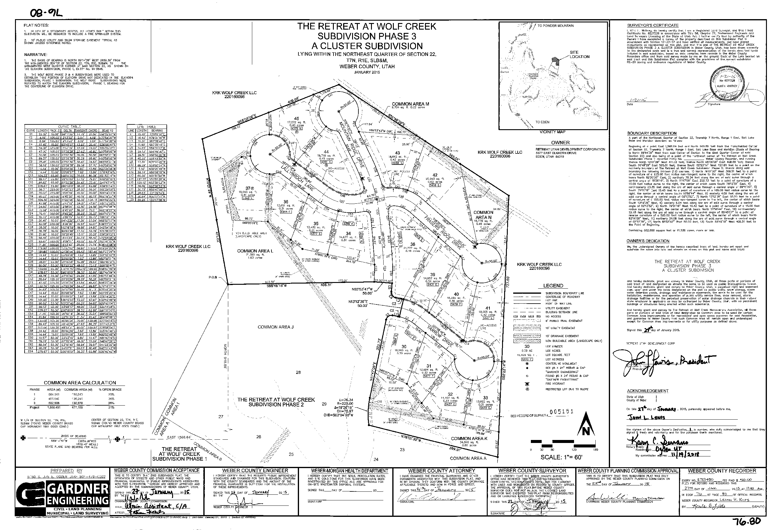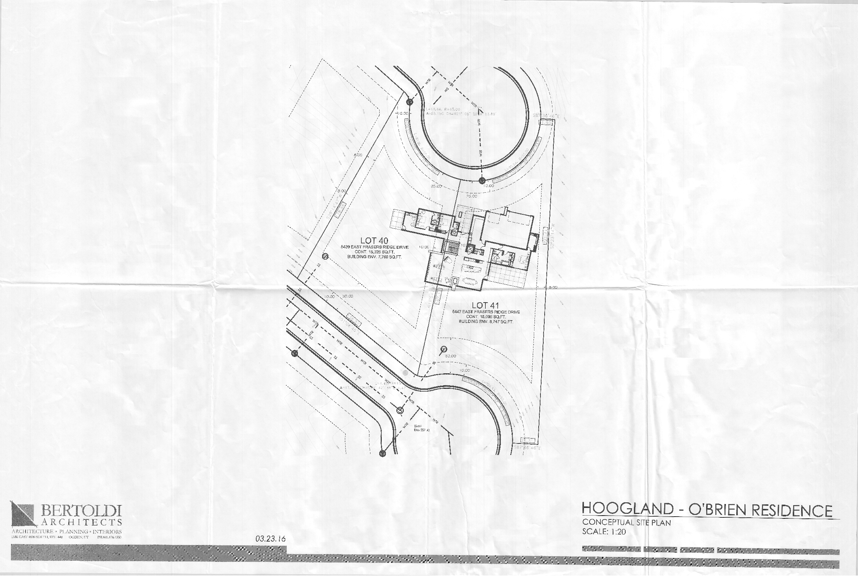

Administrative Approval

**NOTICE OF DECISION**

April 27, 2015

James M O’Brien Trust

c/o Eric Householder

Case No.: Building Parcel Designation 2016-02

You are hereby notified that your application for an a building parcel designation at 5439, 5447 East Frazer’s Ridge Dr Eden, UT, was reviewed and approved by the Weber County Planning Director on June 14 2016. The approval was granted subject to the following conditions:

1. A land use permit is required as part of the building permit process.

This recommendation is based on the following findings:

1. The proposed use conforms to the Ogden Valley General Plan.
2. The proposal complies with applicable County ordinances.
3. The lots meet the area and setback requirement of the RE-20 Zone.
4. No new lots are being created and the existing lot lines are not being changed.
5. The “Building Parcel Designation” will allow for a desirable sized single family dwelling to be located within the buildable area of the Ogden Valley.
6. The proposal will not be detrimental to the public health, safety, or welfare.
7. The proposed design and use will not deteriorate the environment of the general area so as to negatively impact surrounding properties and uses.

The next step in the process is to ensure complete compliance with the above listed conditions of approval. This letter is intended as a courtesy to document the status of your project. If you have further questions, please contact me at flleverino@co.weber.us.ut or 801-399-8767.

Respectfully

Felix Lleverino

*Weber County Planner II*

