|  |  |
| --- | --- |
| **WC Logo.emf** | **Staff Report to the Ogden Valley Planning Commission**  *Weber County Planning Division* |
|  | |

****Synopsis****

****Application Information****

**Application Request:** Consideration and action on a request for Final Approval of the Argyle Acres Subdivision (2 lot).

**Agenda Date: Tuesday, January 25, 2011**

**Applicant:** Dell and Sheila Argyle

**File Number:** UVA 113010

****Property Information****

**Approximate Address:** 7948 East 100 South Huntsville, Utah

**Project Area:** 12.98 Acres

**Zoning:** Agricultural Valley 3 Zone (AV-3)

**Existing Land Use:** Agriculture

**Proposed Land Use:** Residential

**Parcel ID:** 21-007-0001

**Township, Range, Section:** T6N, R2E, Sections 7,8,17 and 18

****Adjacent Land Use****

**North:** Agriculture **South:** Agriculture

**East:** Residential **West:** Agriculture

****Staff Information****

**Report Presenter:** Ben Hatfield

bhatfield@co.weber.ut.us

801-399-8766

**Report Reviewer:** SW

Applicable Ordinances

* Weber County Subdivision Ordinance
* Weber County Zoning Ordinance Chapter 5B (AV-3 Zone)

Background

The applicant is requesting final approval of the Argyle Acres Subdivision located at 7948 East 100 South. The proposed project occupies 12.98 acres and consists of 2 lots. The subdivision lies within the Agricultural Valley - 3 (AV-3) Zone, which requires 3 acres per dwelling and a minimum lot width of 150 feet.

**Lot Compliance to Applicable Ordinances:**

This subdivision does comply with all requirements of the AV-3 zone by providing a minimum of 3 acres and 150 feet of frontage for each lot.

**Other Agency Comments and Recommendations:** Culinary Water will be provided by private wells for each lot. Waste water treatment will be provided by a private septic system.

Summary of Planning Commission Considerations

Does this Subdivision meet the applicable County Ordinance requirements?

Conformance to the General Plan

The subdivision conforms to the General Plan by meeting the outline of permitted land uses and requirements, and the requirements of the zone in which it is located.

Conditions of Approval

* Requirements of the Weber County Engineering Division
* Requirements of the Weber County Survey Department
* Requirements of the Weber County Health Department
* Requirements of the Weber Fire District

Staff Recommendation

Staff recommends final approval subject to staff and other agency comments and recommendations.

Exhibits

1. Subdivision plat
2. Review agency letters

Map 1

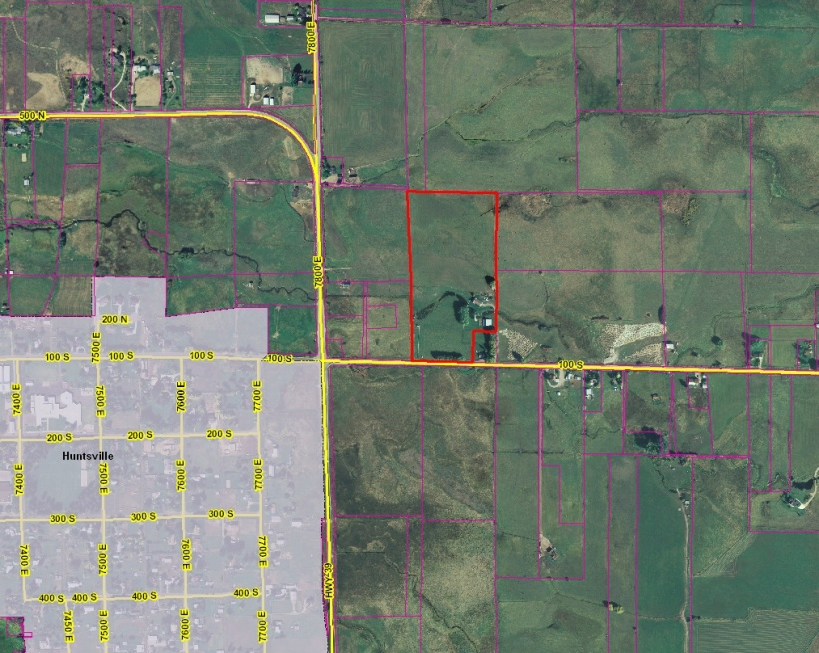

Map 2

