**Goat Rattler 100**

**Safety and Signage Plan**

The GR100 is a long 100 mile trail race that will cross a number of roads and trail junctions. In order to direct participants along the course, it will be marked with orange ribbon during the day and orange reflective ribbon after mile 40. We’ll have the wrong intersections marked with blue ribbon.

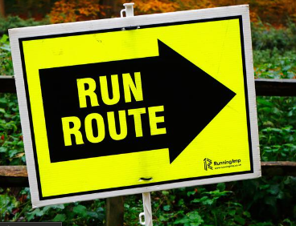

At important junctions, we’ll have directional signs as participants come up on the intersections that will look like this:

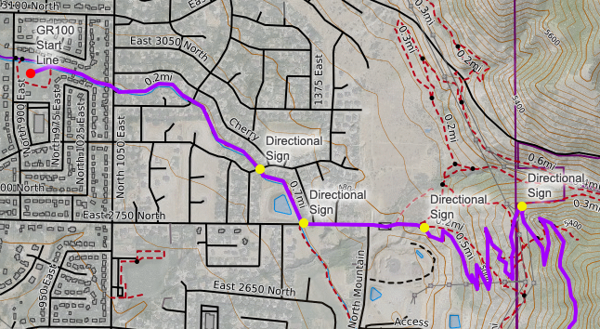

For example, signs will be placed at spots on the map indicated with the yellow dots:

A GPX file of the course will be available to participants to download to follow on their watches, phones or GPS device either via CalTopo maps or Strava.com

**Crews/Info**

A detailed YouTube video will be released in April and again a few weeks before the race to detail out the rules and polices of the course. Crews will be expected to follow these rules or they will subject their runner to disqualification. Information on course profiles, mileages between aid stations and what not will be available on the event website. Questions will be directed to the race director.

**Road Crossings**

The start of the race is at McGriff Park and will cross a number of streets in the first mile. Since the race will be on an established multi-use path, there are cross walks and flashing signs for pedestrians. We will station a volunteer to press the flashing sign button and warn traffic that there will be runners coming across the road. Runners will still be warned to look out for traffic like you would on any street crossing. N 1050 E crossing is usually the busiest and is only .30 of a mile from the start so there will be a large group of people coming through but will only be for 30 second to 1 min at the most. There are street crossings on 2925 N and 2850 N but these are residential streets with little traffic. We will post signs warning traffic there is a race going on and to look out for runners as well as volunteers to warn traffic.

27th Street to Buchanan to 29th street trailhead

As runners come off the trail at 27th street they will be required to run against traffic until taking a left on Buchanan Ave. Buchanan is a very wide road and runners will run against traffic straight to 29th street. Buchanan is a residential road with little traffic and a 25mph speed limit. There is a cul-de-sac at the end of 29th street that runners will stay to the left and no traffic lane will be crossed.

Wheeler Trailhead/Pineview Dam:

In coordination with UDOT’s Traffic Operations Engineer (Carrie Jacobsen), it’s recommended that the safest option for runners is to provide a vehicle shuttle from Wheeler trailhead where it meets Ogden Canyon Rd. Runners will then ride in that shuttle .38 mile to Shanghai Beach parking area and then run alongside the lakeside shoulder to Windsurfer Beach parking lot.

After runners refuel at windsurfer aid station, they will cross hwy 158. There are designated signs and flashing lights for runners to warn traffic that there are runners crossing the road. We will have signs and volunteers out on road to warn motorists to slow down and watch for runners.

North Ogden Divide:

The road crossing from north ogden divide to Ben Lomond trail is the last road crossing. There are permanent signs warning motorists already but we’ll have volunteers and signs out for safe crossing. We’ll also let participants know that cars have the right of way at this section and look both ways before crossing.

**North Fork Park:**

There are a number of road crossings in north fork park but each is marked and has frequent bike, foot and horse traffic that comes across. The first is at mile 87.5 at the south entrance parking lot. The second is at mile 88.05. The third is at mile 89. The 4th is at mile 92.07. The last is at 94.58. A lot of this section for the top 20-30 people will be done in the middle of the night so not a lot of traffic will be out. Throughout the day on Saturday, more bike, foot and motorist traffic will be out but signage and course marking will be out to warn motorists. Runners will also be trained to look before crossing.