|  |  |
| --- | --- |
| **WC Logo.emf** | **Staff Report to the Weber County Commission**  *Weber County Planning Division* |
|  | |

****Synopsis****

****Application Information****

**Application Request:** A public hearing to consider and take action on a request to vacate a 10-foot public utility easement located on the north side of Lot 5 of Gallop Bend Subdivision.

**Agenda Date: Tuesday, March 12, 2019**

**Applicant:** Cody Wilder

**File Number:** EV2019-01

****Property Information****

**Approximate Address:** 2436 S 3600 W, Ogden Utah, 84401

**Project Area:** .92 Acres

**Zoning:** Agricultural (A-1)

**Existing Land Use:** Residential

**Proposed Land Use:** Residential

**Parcel ID:** 15-635-0005

**Township, Range, Section:** T6N, R2W, Section 28

****Adjacent Land Use****

**North:** Residential **South:** Residential

**East:** Residential **West:** Residential

****Staff Information****

**Report Presenter: Felix Lleverino**

flleverino@webercountyutah.gov

**801-399-8767**

**Report Reviewer:** RK

Development History

Gallop Bend Subdivision was recorded in the Weber County Recorder’s Office on June 30, 2017.

Background and Summary

The applicant has submitted a request to vacate a 10-foot public utility easement located on the north side of the lot (see Exhibits A & B). The property owner is requesting the vacation of the public utility easement in order to allow for the placement of an accessory structure. Weber County Planning Division has provided notice to Rocky Mountain Power, Dominion Energy, Taylor West Weber Water and Central Weber Sewer Improvement District in the form of a postcard mailed notice.

The applicant has proposed to vacate the public utility easement by ordinance. Under Utah State Code, Section 17-27a-609.5, the legislative body may adopt an ordinance granting a petition to vacate some or all of a public street, right-of-way, or easement if the legislative body finds that:

(a) good cause exists for the vacation; and

(b) neither the public interest nor any person will be materially injured by the vacation.

The vacating procedure found in Utah State Code 17-27a-208 and 17-27a-209.5 do not require a Planning Commission recommendation.

The following is the staff's analysis of the vacation request.

Analysis

*General Plan*: Vacating this easement will not have a negative effect on the Western Weber General Plan.

*Additional Standards*: All State notice procedures have been followed for this petition to vacate. Any comments or objections to this proposal may be heard during a public hearing that is being held on this day.

*Agency Review*: The initial request was to vacate the north and east PUE. After a site visit, the Weber County Engineering Department is ready to approve the vacation of the north PUE only due to there being a need to maintain an area for stormwater drainage.

State Public Noticing Requirements have been met as outlined in state code Section 17-27a-208.

Staff Recommendation

Staff recommends approval of the request to vacate the 10-foot public utility easement located on north side of Lot 5 of Gallop Bend Subdivision. This recommendation for approval is subject to all review agency requirements and is based on the following condition:

1. The ordinance to vacate the public utility easement will be recorded.

This recommendation for approval is based on the following findings:

1. Vacating the proposed easement will not have a negative effect on the Western Weber General Plan.
2. The public interest or any person will not be materially injured by the proposed vacation.
3. The proposed vacation will not be detrimental to the public health, safety, or welfare.
4. The proposed vacation will not deteriorate the environment of the general area so as to negatively impact surrounding properties and uses.
5. The applicant has gathered consent letters from utility providers in the area.

Exhibits

1. Gallop Bend Subdivision Plat
2. Proposed areas to be vacated
3. Vacation Application
4. Vacation ordinance**11kfjf**

Area Map

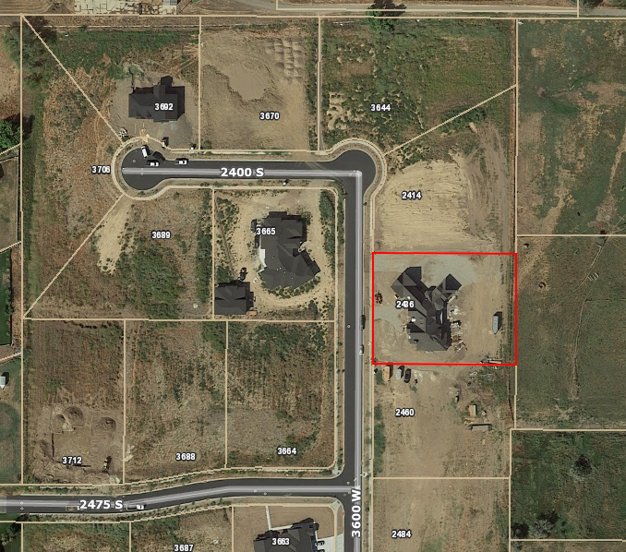

Exhibit A

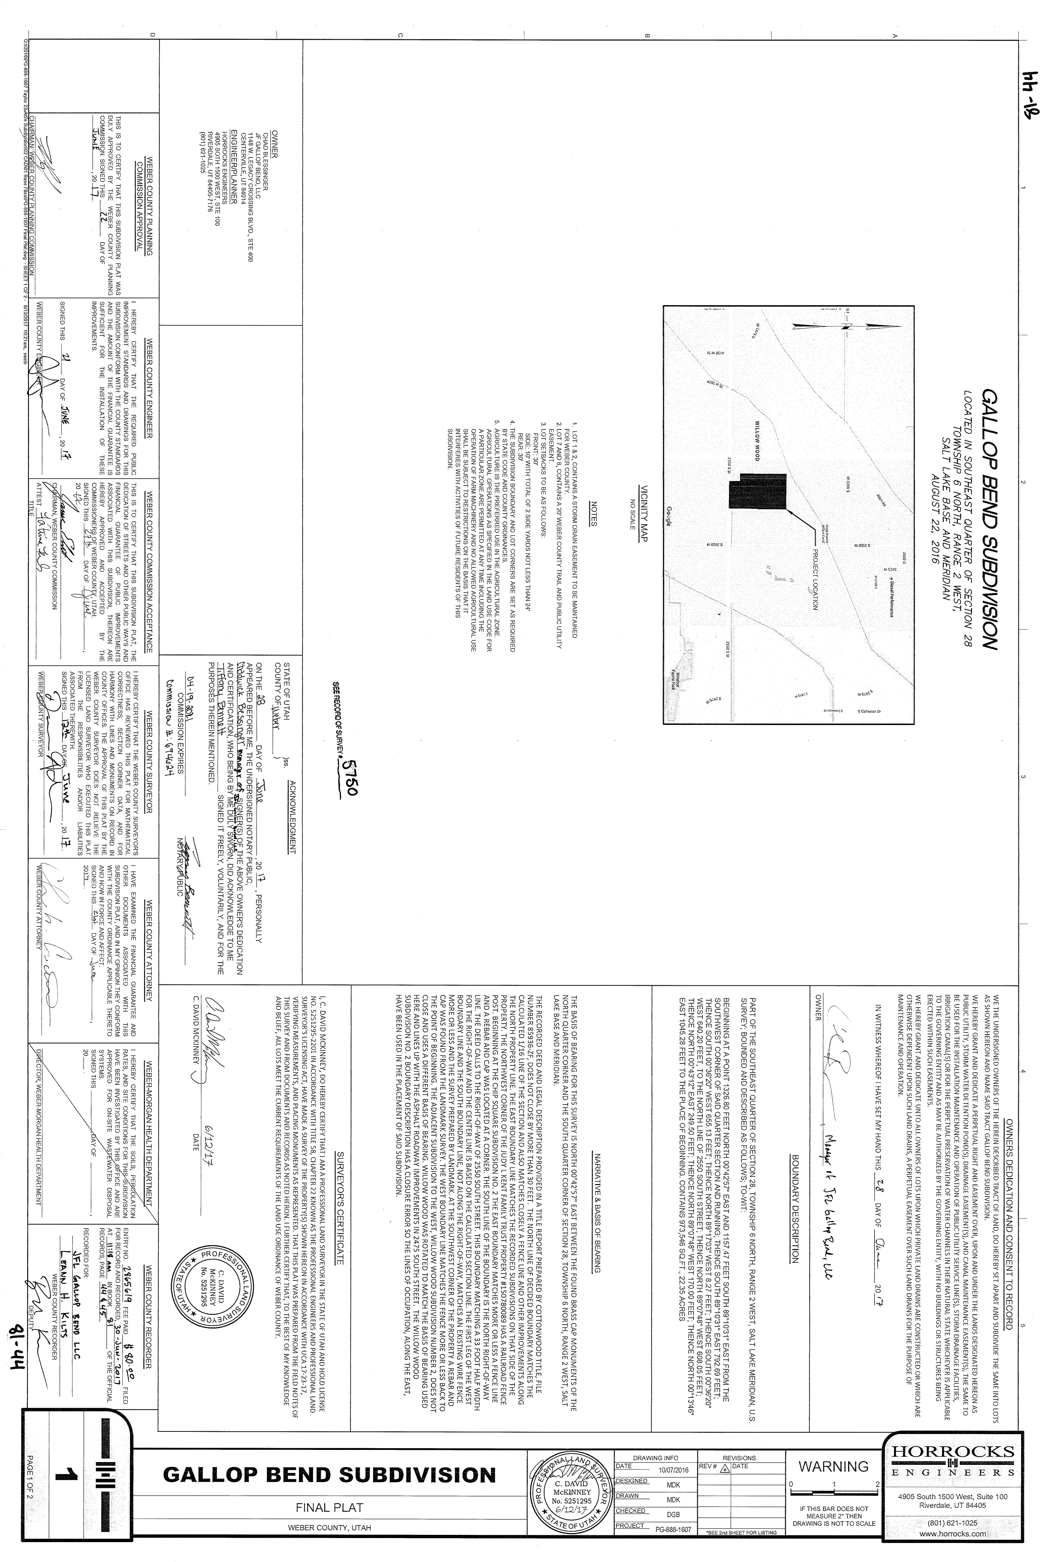

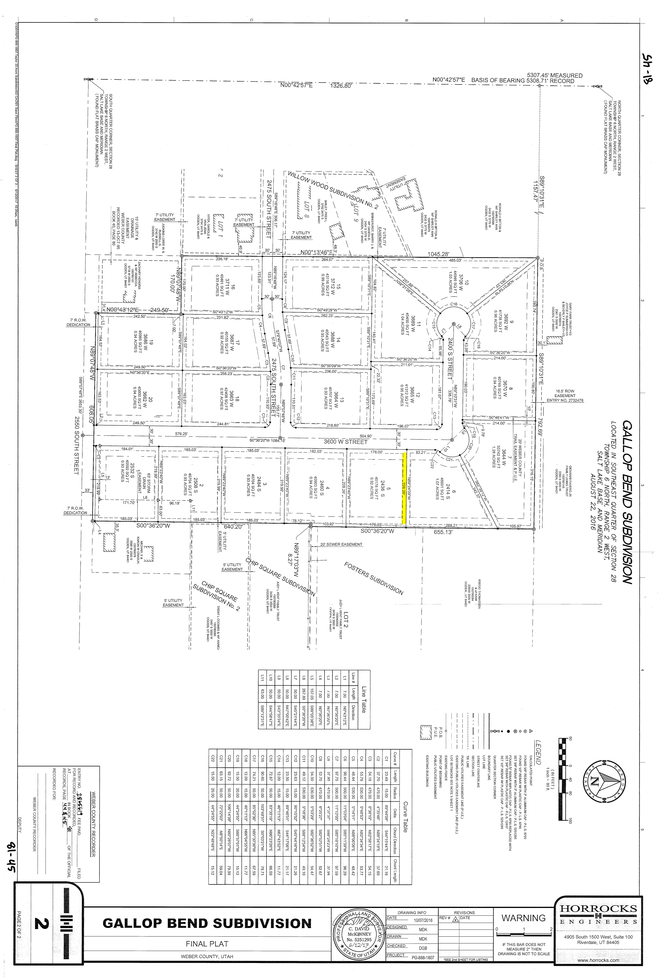

Exhibit B

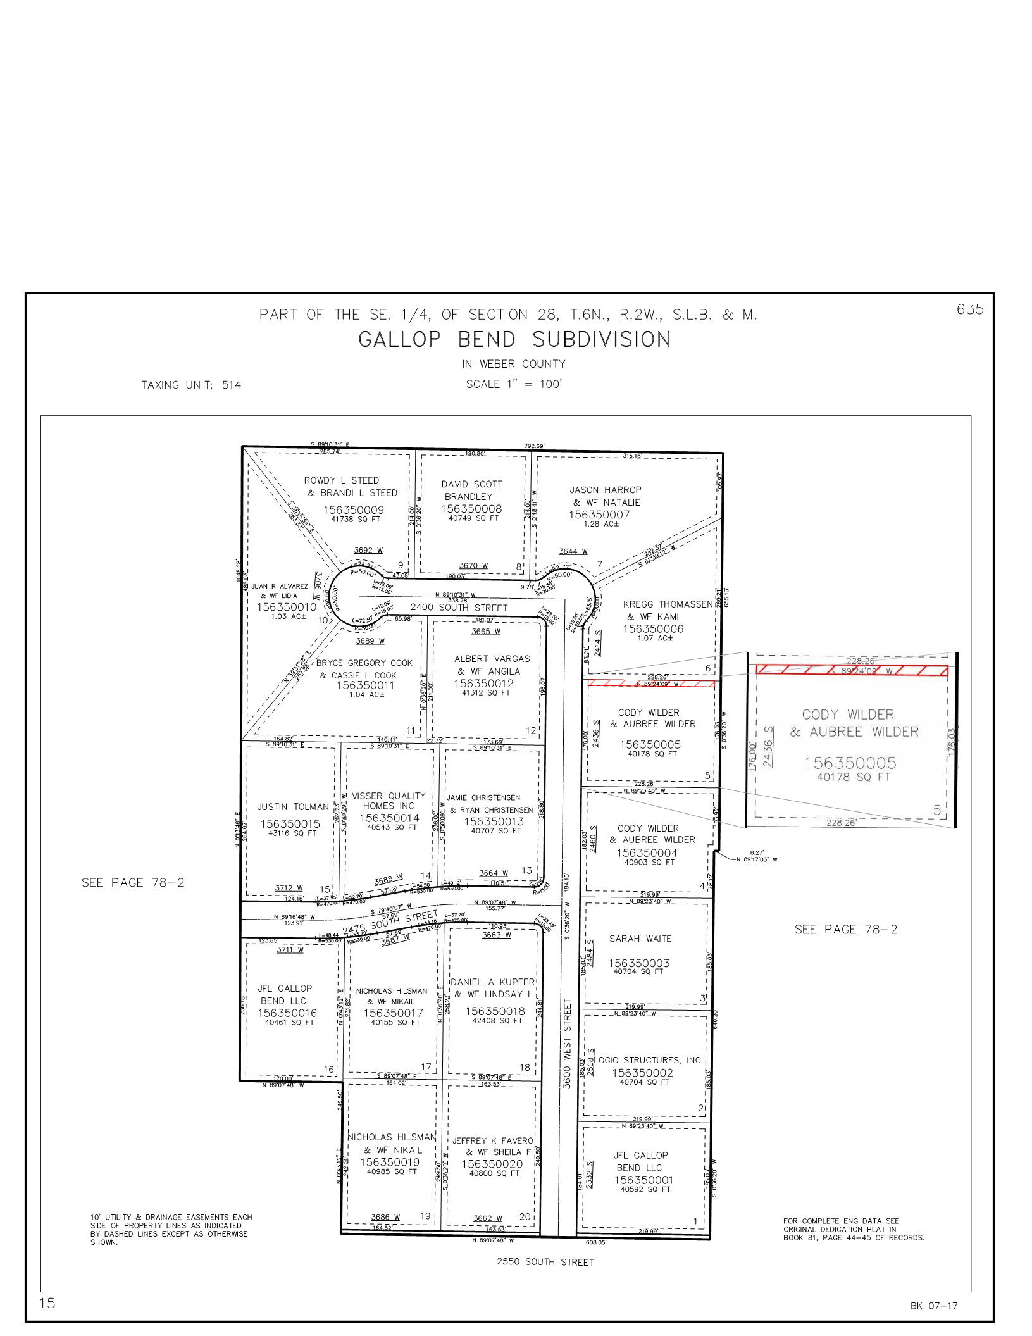

Exhibit C

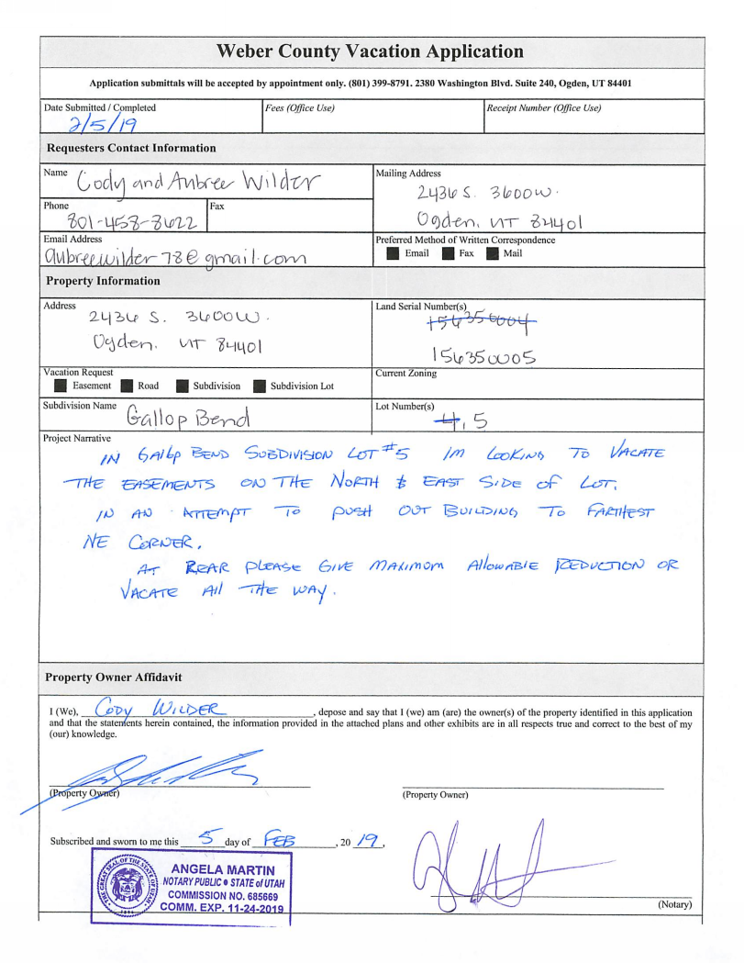

Exhibit D

