|  |  |
| --- | --- |
| **WC Logo.emf** | **Staff Report to the Weber County Commission**  *Weber County Planning Division* |
|  | |

****Synopsis****

****Application Information****

**Application Request:** Consideration and action on final approval of Hill View Acres Subdivision 2nd Amendment (3 lots) with a recommendation for the deferral of curb, gutter, and sidewalk improvements on Hill View Drive, and a recommendation for the vacation of all of lot 5 Hill View Acres Subdivision and that portion of lot 2 of Hill View Acres Subdivision that lies within Hill View Acres Subdivision 2nd Amendment including all public utility easements located therein.

**Agenda Date: Tuesday, January 14, 2014**

**Applicant:** Kelly Miles

**File Number:** LVH042913 and Subvac 2013-06

****Property Information****

**Approximate Address:** 6254 South 1575 East

**Project Area:** 2.18 acres

**Zoning:** RE-15

**Existing Land Use:** Residential

**Proposed Land Use:** Residential

**Parcel ID:** 070840005

**Township, Range, Section:** 5N 1W Sec 22

****Staff Information****

**Report Presenter:** Ben Hatfield

bhatfield@co.weber.ut.us

801-399-8766

**Report Reviewer:** SW

Applicable Ordinances

* Weber County Land Use Code Title 106 (Subdivisions)
* Weber County Land Use Code Title 104 (Zones) Chapter 3 (RE-15 Zone)

Type of Decision

**Administrative Decisions:** When the Planning Commission is acting as a land use authority, it is acting in an administrative capacity and has much less discretion. Examples of administrative applications are design reviews, flag lots, and subdivisions. Administrative applications must be approved by the Planning Commission if the application demonstrates compliance with the approval criteria.

Background

The applicant is requesting final approval of the Hill View Acres Subdivision 2nd Amendment (3 lots) with a recommendation for the deferral of curb, gutter, and sidewalk improvements on Hill View Drive, and a recommendation for the vacation of lot 5 of Hill View Acres Subdivision and that portion of lot 2 of Hill View Acres Subdivision that lies within the Hill View Acres Subdivision 2nd Amendment including all public utility easements located therein, located at 6254 South 1575 East.

The applicant is requesting to realign lot lines in a different configuration as to create one new building lot. This three lot subdivision amendment is on 2.18 acres and is located in the RE-15 Zone. The RE-15 Zone requires a minimum of 15,000 square feet in area and a lot width of 100 feet per dwelling. These lots meet these requirements. There are existing homes on proposed lots 8 and 9, lot 7 is the proposed new lot.

The proposed lot will receive culinary water services from the Uintah Water and Sewer District but this area of the district does not provide sewer. These lots have individual septic systems. No new fire hydrants are required as two exist in the area. Secondary water shares from Weber Basin Water Conservancy will be used for this subdivision.

Summary of County Commission Considerations

* Does the subdivision meet the requirements of applicable Weber County ordinances?

Conformance to the General Plan

The proposed subdivision meets the requirements of applicable Weber County ordinances and conforms to the General Plan.

Planning Commission Recommendations

The Western Weber Planning Commission unanimously recommended final approval of this subdivision amendment and the vacation of the existing lots and public utility easements with the recommendation for a deferral of curb, gutter, and sidewalk improvements on Hill View Drive on May 14, 2013.

Staff Recommendation

Staff recommends final approval for Hill View Acres Subdivision 2nd Amendment (3 lots) with a recommendation for the deferral of curb, gutter, and sidewalk improvements on Hill View Drive, and a recommendation for the vacation of lot 5 and that portion of lot 2 of Hill View Acres Subdivision that lies within Hill View Acres Subdivision 2nd Amendment including all public utility easements located therein.

Exhibits

1. Original Hill View Acres Subdivision
2. Proposed plat for Hill View Acres Subdivision 2nd Amendment
3. Vacation Ordinance

Maps

****Adjacent Land Use****

**North:** Agricultural **South:** Residential

**West:** Agricultural **East:** Agricultural

Map 1

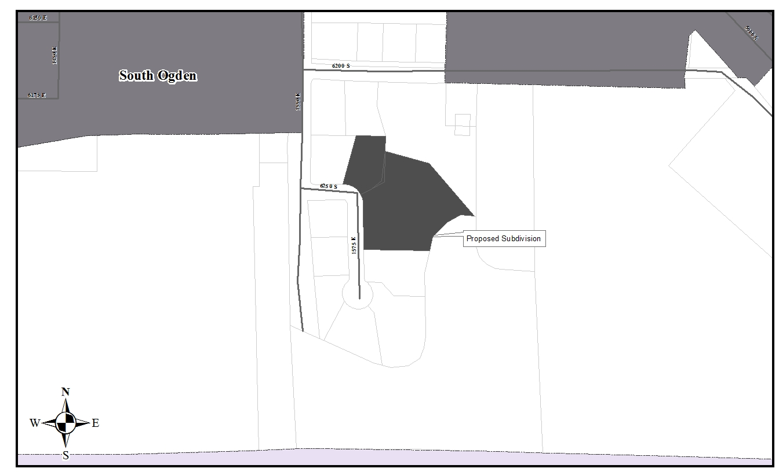

Map 2

