|  |  |
| --- | --- |
| **WC Logo.emf** | **Staff Report to the Ogden Valley Planning Commission**  *Weber County Planning Division* |
|  | |

****Synopsis****

****Application Information****

**Application Request:** Consideration and action on a request for approval of a Conditional Use Permit to establish a Conference/Education Center.

**Agenda Date: Tuesday, December 07, 2010**

**Applicant:** ATK Aerospace Systems

**File Number:** CUP 2010-22

****Property Information****

**Approximate Address:** 890 Ogden Canyon

**Project Area:** Approximately 46 acres

**Zoning:** Forest Residential Zone (FR-1)

**Existing Land Use:** Private Conference Center

**Proposed Land Use:** Public Conference/Education Center

**Parcel ID:** 20-017-0009

**Township, Range, Section:** T6N, R1E, Section 16

****Adjacent Land Use****

**North:** Forest/ Residential **South:** Forest

**East:** Forest **West:** Forest/ Residential

****Staff Information****

**Report Presenter:** Ben Hatfield

bhatfield@co.weber.ut.us

801-399-8766

**Report Reviewer:** SW

Applicable Ordinances

* Zoning Ordinance Chapter 12 Forest Residential Zone (FR-1)
* Zoning Ordinance Chapter 18C Ogden Valley Architectural, Landscape and Screening Standards
* Zoning Ordinance Chapter 22C (Conditional Use)
* Zoning Ordinance Chapter 24 Parking and Loading Space, Vehicle Traffic and Access Regulations
* Zoning Ordinance Chapter 28 Nonconforming Buildings, Uses, and Parcels
* Zoning Ordinance Chapter 32B Ogden Valley Signs
* Zoning Ordinance Chapter 36 Design Review

Background

The applicant is requesting approval of a Conditional Use Permit to establish a Conference/Education Center. A Conference/ Education Center is listed as a conditional use in the FR-1 Zone. The proposed site area contains approximately 46 acres and has access from Highway 39 in the Ogden Canyon.

The lodge on this property was first constructed in 1904. For the first 40 years this property has had a variety of uses such as a resort hotel, summer home, restaurant, and tavern. Since 1960 the property has been used by the current owners (ATK Aerospace Systems) as a conference center for company events. The owners would like to continue hosting private corporate events and open up the opportunity for the public to reserve and host events at the lodge as well. The ATK Conference Center has a variety of meeting rooms where training and instruction can be given. It also has a large dining area where meals are served.

Due to this properties history there are many nonconformities related to the lodge and the sites conditions. Staff did have concerns for the parking needs associated with having public using the facilities. Staff has determined that the nearest parking standard for this use would be 30 spaces (Reception Center). The applicant has indicated on the site plan and from past experience that the parking area can accommodate 39 parking spaces. Staff has determined through a series of aerial photos that and scale of the site plan that the site can comply with the requirement.

Staff does have a concern for public safety regarding parking on a portion of the property across the highway from the lodge. Staff suggests one condition to the permit to be, that this area not be used as a parking area for public events due the safety concerns with pedestrians crossing the highway.

There are no concerns from the Weber County Health Department, Building Inspection Department, or the Weber Fire District. The applicant is working with the Engineering Division to resolve their concerns.

Summary of Planning Commission Considerations

* Does the proposed use meet the requirements of applicable County Ordinances?
* Are there any potentially detrimental effects that can be mitigated by imposing conditions of approval, and if so, what are the appropriate conditions?

In order for a conditional use permit to be approved it must meet the requirements listed under “Criteria for Issuance of Conditional Use Permit.” The Planning Commission needs to determine if the proposed Conference/Education Center meets these requirements. The applicant has provided a response to the criteria below which is attached as Exhibit B.

**Chapter 22C-4**

Criteria for Issuance of Conditional Use Permit: Conditional uses shall be approved on a case-by-case basis. The Planning Commission shall not authorize a conditional use permit unless evidence is presented to establish:

1. Reasonably anticipated detrimental effects of a proposed conditional use can be substantially mitigated by the proposal or by the imposition of reasonable conditions to achieve compliance with applicable standards. Examples of potential negative impacts are odor, vibration, light, dust, smoke, or noise.
2. That the proposed use will comply with the regulations and conditions specified in the Zoning Ordinance and other applicable agency standards for such use.

After reviewing this conditional use request staff has determined that the criteria listed above have been met in the following ways:

1. Because this site has operated as a private conference center for many years, and the only change is to now allow the public to host events. No new reasonably anticipated detrimental effects need to be further mitigated, other than not allowing public parking on property across the highway.
2. The proposed use meets the use, area, lot width, and setback requirements of the FR-1 Zone.

Conformance to the General Plan

This use does not affect the Ogden Valley General Plan.

Conditions of Approval

* Requirements of the Weber County Engineering Division
* Requirements of the Weber County Health Department
* Requirements of the Weber County Building Inspection Department
* Requirements of the Weber Fire District
* No public parking being allowed on property across the highway

Staff Recommendation

Staff recommends approval of CUP 2010-22 for a Conference/Education Center with one additional condition, of public parking not being allowed on property across the highway. This recommendation is subject to the requirements of staff and other review agencies. This recommendation is based on:

* The proposed use being permitted in and meeting the requirements of the FR-1 zone,
* The historic location, existing nonconformities, and site plan, being in compliance with applicable County Ordinances as listed in the staff report.

Exhibits

1. Site plan
2. Applicant’s narrative and application

Map 1

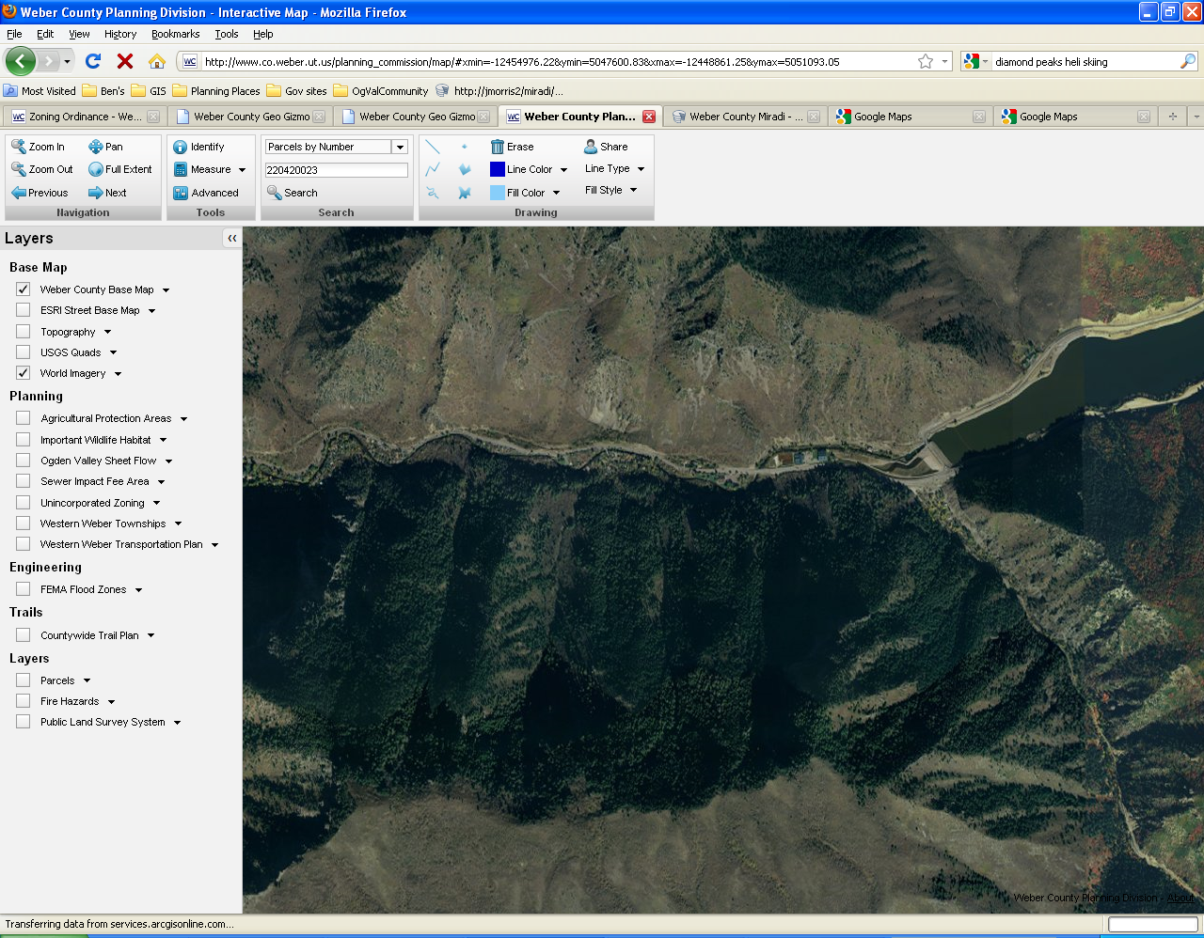

Map 2

