Letter of Deferral – Curb, Gutter and Sidewalk

Date: April 22, 2016
RE: McLean Subdivision, West Weber
771 S. 4100 W.
Dear Weber County Planning Commission,
In the development of the single lot subdivision, we have been requested to provide a curb, gutter and sidewalk along the property line on 4100 W. We have noticed that the only sidewalks for West Weber are located north of our property about 400 S. on 4100 W. There are four newer homes that have been constructed and have sidewalks only. We would like to request an exemption from the curb, gutter, and sidewalk until others on our street are required to also provide a curb and gutter. We are, however, filling in the ditch along the property so that there will be no open canals.

Sincerely,

Susan McLean
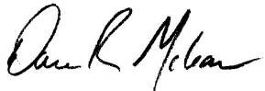
Dale McLean

